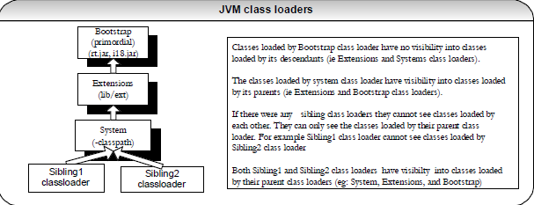

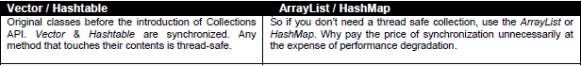

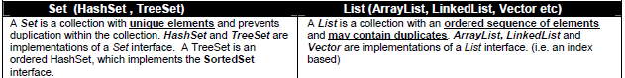

**Use:**

**it**.remove(); // removes the current object via the Iterator “**it**” which has a reference to

// your underlying collection “myCollection”. Also can use solutions 1-3.

**Avoid:**

**myCollection**.remove(myObject); // avoid by-passing the Iterator. When it.next() is called, can throw the exception

// **ConcurrentModificationException**



