**Blog**

TEST PLAN

**VERSION HISTORY**

|  |  |  |  |  |  |
| --- | --- | --- | --- | --- | --- |
| **Version #** | **Write by** | **Revision Date** | **Approved By** | **Approval Date** | **Outline** |
| 1.0 | *Vladyslav Kliucharov* | *08/28/2022* | Mykhailo Kurshakov | *08/31/2022* | Test Plan create |
|  |  |  |  |  |  |
|  |  |  |  |  |  |

**TABLE OF CONTENTS**

INTRODUCTION 4

1. TEST OBJECTIVE 6
2. TEST CRITERIA 6
   1. Suspension Criteria 6
   2. Exit Criteria 6
3. RESOURCE PLANNING 6
   1. System Resource 6
   2. Human Resource 7
4. TEST ENVIRONMENT 7
5. SCHEDULE & ESTIMATION 8
   1. All project task and estimation 8
   2. Schedule to complete these tasks 9
6. TEST DELIVERABLES 9
   1. Before testing phase 9
   2. During the testing 9
   3. After the testing cycles is over 9

# INTRODUCTION

The Test Plan is designed to prescribe the scope, approach, resources, and schedule of all testing activities of the Blog application.

The plan identifies the items to be tested, the features to be tested, the types of testing to be performed, the personnel responsible for testing, the resources and schedule required to complete testing, and the risks associated with the plan.

# TEST OBJECTIVE

The test objectives are to verify the functionality of the Blog, the main focus is on testing the blog operation such as Account Management, adding new users, delete existed users, editing existing posts, and adding comments to the posts. That will guarantee all these operations can work normally in the real business environment.

# TEST CRITERIA

## Features to be tested

|  |  |  |
| --- | --- | --- |
| **Features** | **Action** | **Notes** |
| Adding new users | Response time, Throughout/s | Admin role |
| Delete existed users | Response time, Throughout/s | Admin role |
| Edit existing posts | Response time, Throughout/s | Editor role |
| Add comments to the posts | Response time, Throughout/s | Anonimus role |

### Add new user

Main operations:

Open homepage – Go to localhost/blog

Login - click "admin" -> enter “admins” credentials

Add user - click the "users" tab -> click sub-tab "users" -> click icon "new" -> fill all required fields -> select user role -> click save

### Delete existed users

Main operations:

Open homepage – Go to localhost/blog

Login - click "admin" -> enter “admins” credentials

Add user - click the "users" tab -> click sub-tab "users" -> select any user from list -> click “bin” icon

### Edit existed post

Main operations:

Open homepage – Go to localhost/blog

Login - click "admin" -> enter “editor” credentials

Edit posts – click the “content” tab -> click on any posts -> edit any information -> click save

### Add comments to the posts

Main operations:

Open homepage – Go to localhost/blog

Add comment to posts from list – click on any post from list -> fill all required fields -> click “save comment”

## Non-Functional Requirements

|  |  |  |
| --- | --- | --- |
| **NRF** | **Value** | **Notes** |
| Number of virtual users | 100 | For 3 groups |
| Number of created posts | 1000 |  |
| Average response time for transaction | < 3 sec |  |
| Error rate for all transaction | < 2% |  |
| Throughout in second | > 10 req/sec |  |

## Suspension Criteria

1. If the team members report that there are **10%** of test cases **failed**, suspend testing until the development team fixes all the failed cases.
2. Test environment issues (not ready, any trouble with accessing to it etc.)
3. Not stable version of the application
4. Test data issues (no test user or wrong credentials, incomplete data

## Exit Criteria

Specifies the criteria that denote a **successful** completion of a test phase

1. **Run** rate is mandatory to be **100%** unless a clear reason is given.
2. **Pass** rate is **90%,** achieving the pass rate is **mandatory**.
3. Test plan is complete/updated and approved by Company and the client.
4. Correct version is installed in performance testing environment, i.e. the version previously functionally tested and fixed if needed
5. Test data is complete and in the performance testing environment in sufficient time to allow test scripts to be completed.
6. Test accounts have been created in the performance testing environment in sufficient time to allow test scripts to be completed.
7. Test scripts complete.

# RESOURCE PLANNING

## System Resource

|  |  |  |
| --- | --- | --- |
| **No** | **Resources** | **Description** |
| **1.** | Server | Need a Database server which install MySQL server Web server which install Apache Server |
| **2.** | Test tool | Develop a Test tool which can auto generate the test result to the pre- defined form and automated test execution |
| **3.** | Network | Setup a LAN Gigabit and 1 internet line with the speed at least 5 Mb/s |
| **4.** | Computer | At least 4 computer run Windows 7, Ram 2GB, CPU 3.4GHZ |

## Human Resource

|  |  |  |
| --- | --- | --- |
| **No** | **Member** | **Tasks** |
| **1.** | Test Manager | Manage the whole project Define project directions  Acquire appropriate resources |
| **2.** | Test | Identifying and describing appropriate test techniques/tools/automation architecture  Verify and assess the Test Approach  Execute the tests, Log results, Report the defects. Outsourced members |
| **3.** | Developer in Test | Implement the test cases, test program, test suite etc. |
| **4.** | Test Administrator | Builds up and ensures test environment and assets are managed and maintained  Support Tester to use the test environment for test execution |
| **5.** | SQA members | Take in charge of quality assurance  Check to confirm whether the testing process is meeting specified requirements |

## 3.3 Test Environment

The Test Environment should be setup as figure below

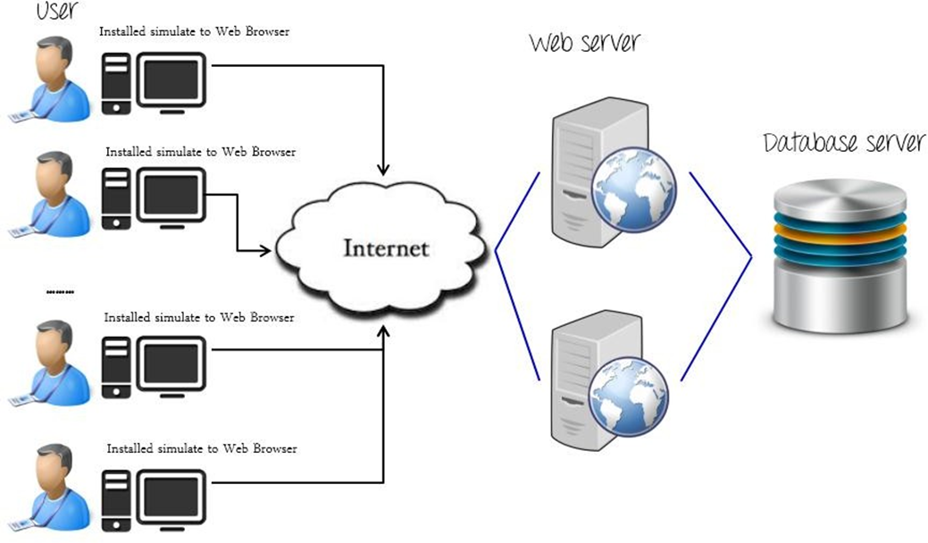

# SCHEDULE & ESTIMATION

## All project task and estimation

|  |  |  |
| --- | --- | --- |
| **Task** | **Members** | **Estimate effort** |
| Create the test specification | Test Designer | 170 man-hour |
| Perform Test Execution | Tester, Test Administrator | 80 man-hour |
| Test Report | Tester | 10 man-hour |
| Test Delivery |  | 20 man-hour |
| **Total** |  | **280 man-hour** |

## Schedule to complete these tasks

|  |  |  |  |
| --- | --- | --- | --- |
| **Plan Details** | | | |
| **Release #** | Major release | **Release number** | 1.0 |
| **Start date** | 24/04/2022 | **Duration** | 12 weeks |
| **Status** | Approve | **Risk level** | Medium |
|  |  | **Planned release date** | 31/08/2022 |

# TEST DELIVERABLES

Test deliverables are provided as below

## Before testing phase

* Test plans document.
* Test cases documents
* Test Design specifications.

## During the testing

* Test Tool
* Simulators.
* Test Data
* Test Trace-ability Matrix
* Error logs and execution logs.

## After the testing cycles is over

* **Test Results/reports**
* Defect Report
* Installation/ Test procedures guidelines

## Release notes