**Blog**

**Test Strategy**

**Revision History**

|  |  |  |  |
| --- | --- | --- | --- |
| Date | Version | Author | Description |
| 08/31.2022 | V1 | Vladyslav Kliucharov |  |
|  |  |  |  |
|  |  |  |  |
|  |  |  |  |

Table of Contents

1. Scope 3

2. Test Approach 4

3. Test Environment 5

4. Testing Tools 6

5. Release Control 7

6. Risk Analysis 8

7. Review and Approvals 9

# Scope

## Review and Approvals

|  |  |
| --- | --- |
| Author: | Vladyslav Kliucharov |
| Contributors: | Kelis Franks |
| Reviewer | Lorelei Ramsey |
| Reviewer | Harlee Berg |
| Approver | Mykhailo Kurshakov |

## Schedule & Estimation

|  |  |  |
| --- | --- | --- |
| **Task** | **Members** | **Estimate effort** |
| **Create the test specification** | Test Designer | 170 man-hour |
| **Perform Test Execution** | Tester, Test Administrator | 80 man-hour |
| **Test Report** | Tester | 10 man-hour |
| **Test Delivery** |  | 20 man-hour |
| **Total** |  | **280 man-hour** |

### Items not to be tested

* The functionality of the whole application:
  + Account tariff plan (Family, Student)
  + Payment methods
  + “Car Thing” feature

# Test Approach

## Test process

The testing process is a sequential flow of various testing activities that are to be executed to ensure maximum results from software testing.  It ensures that all the testing processes are carried out in an orderly and planned manner. This document describes the different steps involved in the testing process.

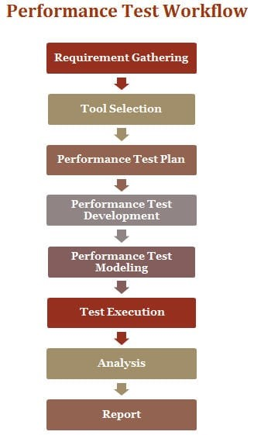

## Test types assumed for conducting

### Load test (description)

Load test is a kind of the most regular test to check the benchmark of the application and its components. Usually, is running after finding all critical/major functional bugs and in a stable prod-like environment.

* Purpose:
  + Measure and analyze performance metrics (response time, error rate) and system behavior under defined load.
  + Compare performance metrics with thresholds/previous results.
  + Collected metrics:
    - Measurements, collected during performance test by load tool:
      * Response time statistics (Minimum, average, 90% percentiles, maximum response time, Response time standard deviation).
      * Total, pass and fail counts.
      * System throughput.
      * Throughput/response time trends.

### Capacity testing (description)

Should be performed to find the number of virtual users which the application support in a stable state. The test can be performed as one of the first main tests and should be performed after significant changes in the application or its configuration.

* Purpose:
  + Measure and analyze performance metrics (response time, error rate) and system behavior under defined load.
  + Compare performance metrics with thresholds/previous results.
  + Collected metrics:
    - Measurements, collected during performance test by load tool:
      * Response time statistics (Minimum, average, 90% percentiles, maximum response time, Response time standard deviation).
      * Total, pass and fail counts.
      * System throughput.
      * Throughput/response time trends.

### Stress testing (description)

Stress testing is supposed to run occasionally to check the application’s stability under high load. Can be performed close to after the code complete or by special request.

* Purpose:
  + Measure and analyze performance metrics (response time, error rate) and system behavior under defined load.
  + Compare performance metrics with thresholds/previous results.
  + Collected metrics:
    - Measurements, collected during performance test by load tool:
      * Response time statistics (Minimum, average, 90% percentiles, maximum response time, Response time standard deviation).
      * Total, pass and fail counts.
      * System throughput.
      * Throughput/response time trends.

### Stability testing (description)

Supposed a long time running the test with the load lower than average. Should be performed occasionally after significant code changes or by special request to make sure the application’s responsiveness and key performance indicators do not change significantly after a long time running, and to check on memory leak as well.

* Purpose:
  + Measure and analyze performance metrics (response time, error rate) and system behavior under defined load.
  + Compare performance metrics with thresholds/previous results.
  + Collected metrics:
    - Measurements, collected during performance test by load tool:
      * Response time statistics (Minimum, average, 90% percentiles, maximum response time, Response time standard deviation).
      * Total, pass and fail counts.
      * System throughput.
      * Throughput/response time trends.

## Roles and responsibilities of each team member

This table shows the staffing assumptions for the project.

|  |  |
| --- | --- |
| Human Resources | |
| Workers | Comments |
| **Project Manager:**  Zidan Penn | * Developing a project plan, including activities, milestones, deadlines, resources needed, and cost estimates * Reviewing project proposals to identify potential risks and challenges * Establishing project goals and objectives, and developing a project plan based on input from stakeholders |
| **Developers**  Kirk Sanchez  Raphael Lin  Kasper Warner  Kelis Franks  Lorelei Ramsey  Harlee Berg | * Developing the project scope based on the client’s needs, using concepts such as time, cost, quality, and risk management * Coordinating with client representatives throughout the project to ensure that all parties are in agreement with decisions made along the way * Working with architects, engineers, and contractors to oversee construction projects from start to finish |
| **Performance analytics:**  Ieuan Gregory  Shivani Mcguire | * Building models to test different business scenarios to determine how they would impact the business * Conducting research on new technologies related to their field, such as artificial intelligence or big data analytics * Working with management to develop and implement reporting systems for the company’s operations * Presenting findings from research projects to management teams |
| **QA tester:**  Ieuan Gregory  Shivani Mcguire | * Communicating with management regarding progress on projects or issues that may require their attention * Developing automated testing tools for standard operating procedures to ensure that they are followed consistently over time * Working with programmers to develop new software features and fixing bugs in existing programs * Evaluating the effectiveness of existing quality assurance programs and recommending changes where necessary |
| **Database administrator:**  Lexie Peel  Connah Rollins | * Participating in strategic planning activities to ensure that the database management department’s activities align with company goals * Ensuring that data is backed up regularly to prevent loss due to computer crashes or hardware failure * Designing new databases or modifying existing ones to meet clients’ needs |

## Testing approach

Brief representation of the infrastructure. The focus is on using "JMeter" for creating a distributed testing scenario and an "Influx" database for data collection. For visualization received result will be used "Grafana". "Telegraf" will be collecting all data about server work.

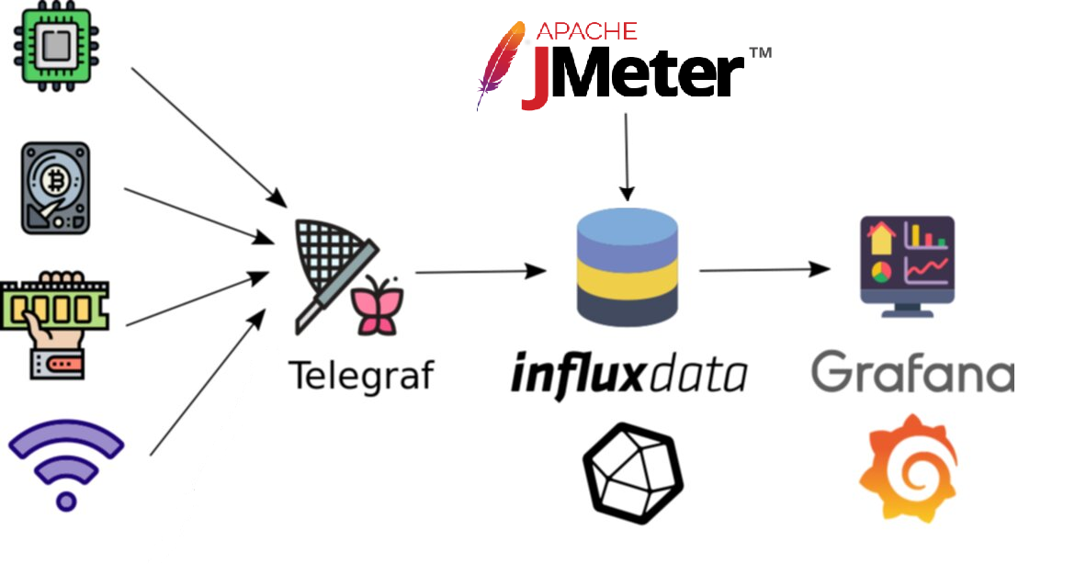

# Test Environment

Environment for performance testing:

The number of users supported in the environment, and access roles for each test user.

Software and hardware requirements like operating system, memory, free disk space, number of systems, etc.

The database clone from the prod environment (for example tables, rows, and columns (not use real user data))

Test data backup and restore, including the baseline functionality backup and virtual user's data (for example account credentials and payment methods).

|  |  |
| --- | --- |
| **Name** | **Description** |
| DEV | Used by developers. May have unstable changes and can be used by QAs only in case of some intermediate changes to be checked. |
| QA | Environment for automation testing. Performance, Regression and Smoke suite running. |
| STAGE | Demo and PO verification |
| PROD | Production environment, Security Testing before going Live. |

# Testing Tools

For performance testing, platform usage is supposed.

It includes:

|  |  |  |
| --- | --- | --- |
| **Module** | **Software** | **Description** |
| Metrics visualization | Grafana | The module that visualizes all metrics on the custom dashboards |
| Data collector | InfluxDB | The module that collect all metrics from server |
| Load generator | Apache Jmeter (NON-GUI) | Module for load-scripts execution., API testing |
| Script creation tool | Apache Jmeter | Module for load-scripts creation., API testing. |

# Release Control

|  |  |  |  |
| --- | --- | --- | --- |
| **Plan Details** | | | |
| **Plan Owner** | John Weak | **Role** | PM |
| **Submitted on** | 25/04/2022 | **Submitted to** | Jade Law |
| **Release type** | Major release | **Release number** | 1.0 |
| **Status** | Approve | **Risk level** | Medium |
| **Owner of release** | Caren Jose | **Start date** | 24/04/2022 |
| **Duration** | 12 weeks | **Planned release date** | 31/08/2022 |

# Risk Analysis

|  |  |  |  |  |
| --- | --- | --- | --- | --- |
| Risk ID | Risks description | Probability | Influence | Effect on Cost/ Schedule/Quality |
| 1 | Late submission of information, delays in document approval by the Customer | Medium | High | Schedule |
| 2 | Incorrect or incomplete stated requirements | High | High | Cost, Schedule |
| 3 | Additional changes in the requirements during development | High | High | Cost, Schedule |
| 4 | Tight time limits that influence the testing flow | High | High | Cost, Schedule, Quality |
| 5 | QA Lead / developer fell ill at the most critical time. No time for staff training. | Low | High | Schedule |
| 6 | The number of bugs significantly exceeds the expected number. | High | High | Cost, Schedule, Quality |

Reduce the level of possible risks:

1) We Need to clarify the person from the customer side who will have the power to resolve emergency cases

2) The requirements should be verified before development has started

3) To resolve additional changes in the requirements during development it should be discussed with the dev team and architect team, how it will influence on the system in the future

4) To resolve the tight time limits, testing should be started as faster as can, and test documentation should be created in the early stage, in case a lack of time only on crucial features should be tested

5) In case QA Lead/developer fell ill, part of the crucial work should be assigned to another team member with the appropriate ability to resolve case, if the case has not high priority can be put on hold

6) In case of a number of bugs significantly exceeds the expected quantity, the dev team should rest assured that is not a server-side issue or DB. QA team should make sanity testing. the last added features. A possible solution restores the system to the previous version