



Databases

Team: 110

**─**

**A: Domain Deﬁnition**

## A1

The bakery operates as a retail establishment that specializes in the production and sale of baked goods. These baked goods may include various types of bread, pastries, cakes, cookies, and other related products. The bakery typically serves customers who visit the physical store to make purchases or place orders. It may also provide catering services for events.

*Important data that the database must store include information related to:*

**Products**: Details about the diﬀerent products oﬀered, such as their names, prices, and ingredients.

**Inventory**: Inventory management data, including the quantity of each ingredient and product on hand.

**Staﬀ**: Information about employees, including their names, employee IDs, and work shifts.

**Orders:** Records of customer orders, including the items ordered, quantities, and order status.

**Recipes**: Recipes for baking products, specifying the required ingredients and quantities.

**Ingredients:** Information about the ingredients used in baking, including names, units, and available quantities.

## A2

The context of the bakery documentation is centered around a small bakery business. It is situated in a local neighborhood and aims to provide high-quality baked goods to its customers. The bakery operates during speciﬁc hours, typically opening in the morning and closing in the evening.

The bakery serves a diverse customer base, including individuals looking for freshly baked goods for daily consumption, as well as customers who place special orders for occasions such as birthdays and weddings. In addition to its walk-in customers, the bakery may oﬀer online ordering and delivery services.

The bakery staﬀ consists of bakers, salespeople who work in shifts to ensure the smooth operation of the bakery. Employees are responsible for baking, serving customers, managing inventory, and maintaining a clean and welcoming environment.

The bakery relies on a well-managed inventory of ingredients to ensure that it can produce its products consistently. It also keeps track of its ﬁnancial performance through recording sales and expenses.

# B: Conceptual Modeling

## B2: Initial solution

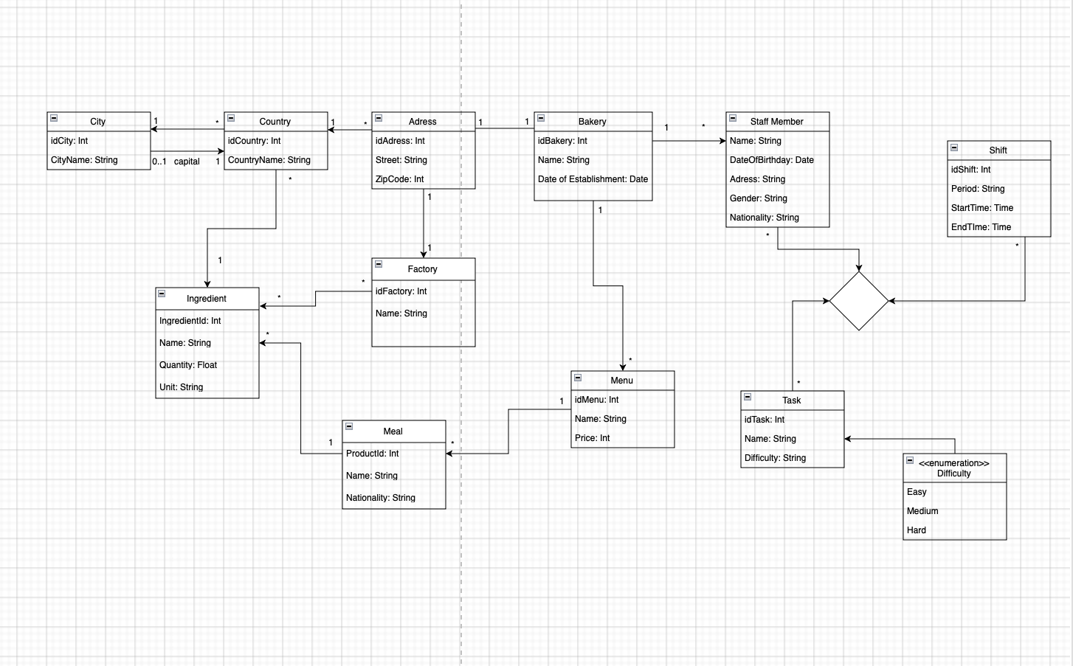

**B3: Final solution**

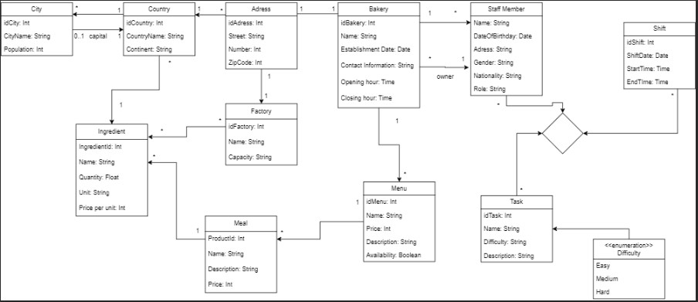

## B4: AI reﬁnements

AI was used to reﬁne most aspects of the conceptual model. It was mainly used to add more appropriate ﬁelds to the diﬀerent tables. In addition, it helped in changing/adding a few relations as well as modifying a few of our prior ﬁelds.

# C: Generative AI integration

## C1

In the process of conceptual modeling for the bakery, a generative AI tool called "GPT-3" was employed. It was used to help generate textual descriptions, explanations, and deﬁnitions related to various aspects of the bakery system, including its components, processes, and interactions.

## C2

1. Prompt 1:

Task: Generate a description of the bakery's core products and their ingredients.

Prompt: "Please describe the core products oﬀered by the bakery, including their names and primary ingredients."

1. Prompt 2:

Task: Generate a description of the bakery's order processing workﬂow.

Prompt: "Explain the typical workﬂow for processing customer orders at the bakery, from order placement to order fulﬁllment."

1. Prompt 3:

Task: Generate a brief overview of the bakery's staﬀ management.

Prompt: "Provide a concise overview of how the bakery manages its staﬀ, including roles and responsibilities."

1. Prompt 4:

Task: Generate a description of the bakery's revenue tracking methods.

Prompt: "Describe the methods employed by the bakery to track its revenue and ﬁnancial performance."

1. Prompt 5:

Task: Generate an overview of the bakery's customer engagement strategies.

Prompt: "Explain how the bakery engages with its customers, both in-store and through online channels, to build customer loyalty."

## C3

### Strengths:

Eﬃciency: GPT-3 provided responses quickly, which can be a time-saving advantage in the documentation process.

Variety: The AI generated diverse descriptions for diﬀerent aspects of the bakery, demonstrating versatility.

Coherence: The generated text was generally coherent and grammatically correct, making it suitable for documentation purposes.

Useful Content: The AI generated content that covered essential aspects of the bakery, helping to create a comprehensive documentation outline.

### Limitations:

Accuracy: While GPT-3's responses were generally accurate, it may not always provide entirely precise or up-to-date information.

Lack of Context: The AI doesn't possess real-world context, so it may generate information that isn't relevant or speciﬁc enough for the bakery's unique requirements.

Revisions Required: Human review and editing were necessary to ensure that the generated content aligned with the speciﬁc nuances of the bakery's operations.

Absence of Visual Elements: GPT-3 generates text only, and it doesn't create visual elements like diagrams, charts, or UML representations, which are also important in documentation.