# Sprint 1 completion

The following flux detailed in the user specification is completed in an altered form:

### Registration

* 1. The user should complete their name and agree to data handling, then click the “Next” button.

* 1. The system will request an email from the user.
  2. The user should complete the email.

* 1. The system will do an internal format verification of the email.
  2. The system will request a database entry for the given information.
  3. The database should send an e-mail to the given address containing a link.
  4. The user should click on the link.

* 1. The database website should display a “success” page.

* 1. The user should return to the system and enter their phone number.

* 1. The system will forward the phone number to the database.
  2. Steps 1 - 7 of the “OTP sending” flux will be taken.
  3. The database should send an email asking the user to change their password, containing a link.

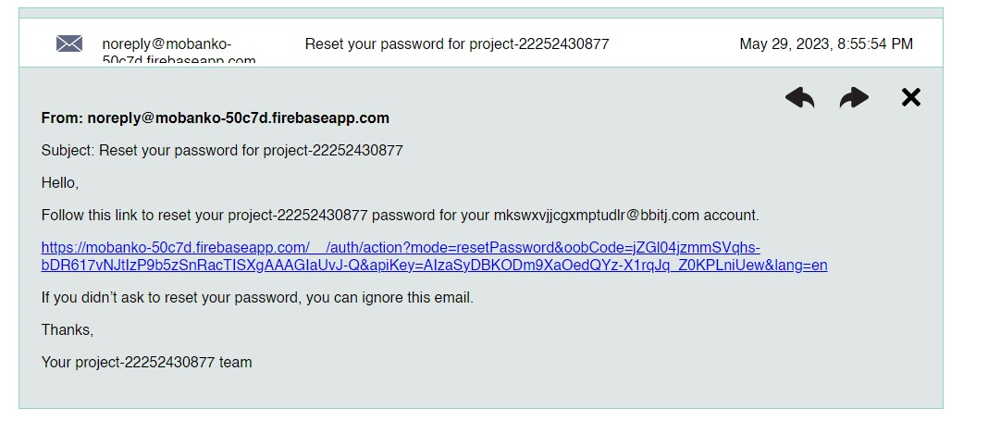

* 1. The user should click on that link.
  2. The database website should display a not-a-robot test.
  3. The user should complete the test.
  4. The database should confim and reply by displaying a new page.
  5. The user should complete the new page with their password, and then confirm it on the next page. A screenshot of a login page

     Description automatically generated with medium confidence

Post-condition: the user is registered, authenticated and able to access their pre-made account. Barring rearrangements, alternate fluxes and preconditions are identical.

### OTP sending

### The database website should display a human verification puzzle.

1. The user should complete the puzzle.
2. The database website should display success and send a numerical code via SMS. A picture containing text, screenshot, font, design

   Description automatically generated
3. The system will display the "Input code" screen.

1. The user should input the code received.
2. The application will send the code back to the database.
3. The database will validate the code and send a confirmation message.

The following fluxes detailed in the user specification are completed:

1. Fast-forward authentication

2. Biometric authentication flux

# Sprint 2 targets

Performing transfers from one account to another is the target for the next sprint (2 weeks).