Dual-energy X-rays absorptiometry using a 2D digital radiography detector. Application to bone densitometry
Jean-Marc Dinten, Christine Robert-Coutant, Michel Darboux

LETI-CEA-Direction de la recherche technologique, Département des systèmes pour l'information et la santé, CEA-Grenoble, 38054 Grenoble Cedex 9 France

ABSTRACT

Dual Energy X-Rays Absorptiometry (DXA) is commonly used to separate soft tissues and bone contributions in radiographs. This decomposition leads to bone mineral density (BMD) measurement. Most clinical systems use pencil or fan collimated X-Rays beam with mono detectors or linear arrays. On these systems BMD is computed from bi-dimensional (2D) images obtained by scanning. Our objective is to take advantage of the newly available flat panels detectors and to propose a DXA approach without scanning, based on the use of cone beam X-Rays associated with a 2D detector. This approach yields bone densitometry systems with an equal X and Y resolution, a fast acquisition and a reduced risk of patient motion.Scatter in this case becomes an important issue. While scattering is insignificant on collimated systems, its level and geometrical structure may severely alter BMD measurement on cone beam systems. In our presentation an original DXA method taking into account scattering is proposed. This new approach leads to accurate BMD values.In order to evaluate the accuracy of our new approach, a phantom representative of the spine regions tissue composition (bone, fat , muscle) has been designed. The comparison between the expected theoretical and the reconstructed BMD values validates the accuracy of our method. Results on anthropomorphic spine and hip regions are also presented.
Keywords : osteodensitometry, DXA, dual-energy X-ray, absorptiometry, bone mineral measurement, X-ray imaging

1. Introduction

Dual-energy X-ray absorptiometry is a reference technique to measure bone mineral density ^{1, 2} and is widely used for the diagnosis and follow-up of osteoporosis. On DXA systems, two radiographic images are acquired at two different energies, using one X-ray spectrum centered on the photoelectric domain (about 40-50 KeV) and the other in the Compton area (about 100 KeV). The computation of a quantitative bone density image takes advantage of the difference in the variation of the attenuation coefficients (photoelectric / Compton) at these two energies for the different body components.
On most DXA systems, the acquisition of these radiographic images require a scan in one or two directions, depending on the geometry of the detection system. One direction at least is required for fan-beam systems using a line-collimated X-ray source and a linear array of detectors. Two directions are required for pencil-beam systems using a point-collimated X-ray source and a single collimated detector. The purpose of this paper is to describe the use of a 2D detector that does not require scanning to build up the image of a site of interest, such as the lumbar spine or the hip. The benefit in acquisition time is obvious, thus reducing motion artifacts. Since such a system only needs two X-rays flashes to make an exam, it will be referred to as "flash-beam DEXA" in this paper. The main technical challenge of this geometry is that scatter due to the patient cannot be eliminated by collimators, thus is has to be measured, modeled, and subtracted.
The paper is structured as follows. First, the physical concepts of bone densitometry are presented. Then the Flash beam system is presented. Finally results are shown.
2. PHYSICAL concepts OF dual-energy bone mineral densitometry

2.1 bone mineral density equation for the Monochromatic case
DXA was preceded by dual-photon absorptiometry (DPA), in which radionuclide sources were used instead of a X-ray generator. If a monochromatic, collimated source emits a number of photons 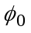, then the number of photons impinging on a collimated detector, after attenuation by a mass M (g/cm²) of an object of mass attenuation coefficient (cm²/g), is ³:
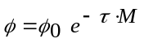 . (Beer-Lambert law) (1)
If the system is able to provide a measurement of and a measurement 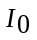of , then the computation of 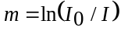 provides a measurement of the attenuation, often referred to as a "log-measurement" for the monochromatic case. Thus acquisitions at two energies through a patient made of soft tissue and bone provide two linear equations :
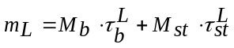 (2)
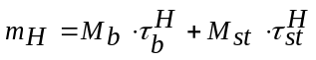, (3)
where subscripts b and st stand for "bone" and "soft tissue" respectively, and L and H are for "low-energy" and "high-energy". This system of equations can be solved if the attenuation coefficients are known, and the equation for bone mineral density is generally written as follows :
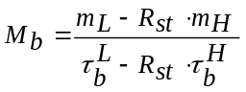, (4)
where
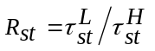. (5)
A symmetric expression can be written for soft tissue.
Since R essentially expresses the photoelectric-to-Compton ratio, it is characteristic of the atomic number of the material. The exact value of R depends on the couple of energies used. Table 1 shows R-values for different materials :
Table 1. R-values for various materials at (50 KeV, 110 KeV).

 | 50 KeV | 110 KeV | R
Adipose tissue (ICRU) | 0,2117 | 0,1647 | 1,29
Lucite | 0,2069 | 0,1594 | 1,30
Water (H₂O) | 0,2261 | 0,1657 | 1,36
Muscle, skeletal (ICRU) | 0,2255 | 0,1641 | 1,37
Aluminium | 0,3658 | 0,1618 | 2,26
Ca_apatite | 0,5828 | 0,1872 | 3,11

This table shows that the R-value for soft tissue at these energies can vary from 1.29 for 100% fat to 1.37 for 100% lean. This introduces to one the possible sources of errors in DXA, which is the variation in tissue composition, since the fat distribution is not homogeneous in the body, nor from patient to patient.
As it will be detailed later, many other phenomena can disturb the basic osteodensitometry equation (4), among which scattered radiation from the patient, and, with X-ray sources, beam hardening due to X-ray polychromaticity.
2.2 baseline correction
A way to correct for a variation in soft tissue composition is to adjust the value of 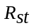 in equation (4) to the effective fat ratio corresponding to the patient, taking advantage of the prior knowledge that the images contain "bone" areas and "soft tissue only" areas. A "baseline" area is selected as a soft tissue area surrounding the bone area. Computing as
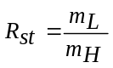 (6)
in the baseline area ensures that 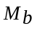 is null in the baseline area, which should be physically true. Under a hypothesis of continuity, the bone value computed with this same value of is correct in the bone area. In order to use this method the baseline area must exist, that is to say the bone must be surrounded by enough soft tissue, which is not always the case for instance with hip measurements on thin patients. The continuity hypothesis is sometimes violated by the influence of fat in bone marrow.
A non-null value for in the soft tissue area may be due to many other errors, as for instance an error on the value ⁴, a residual error due to scatter, or, with X-ray generators, a polychromaticity effect. The baseline subtraction is a simple operation that may - at least partially - correct for these errors, but it should not be considered as a magic operation. The beam-hardening problem is more efficiently corrected by a non-linear calibration, as it will be detailed now.
2. 3 polychromatic case : Beam hardening corrections
The use of an X-ray tube allows a greater flux of photons than radionuclides but since the spectra are not monochromatic (see figure 1), their transmission through the patient are subject to beam hardening. Beam hardening corrections are usually based on an experimental calibration of the system with two basis materials, using non-linear models of the measurement derived from the work of Alvarez ^{5, 6} and described for instance by Lehman ⁷ or Brody ⁸.
Examples of X-ray spectra are shown in fig. 1; they are derived from an optimisation study by Sorenson ⁹ and they include the detector efficiency for a Gd₂O₂S scintillator (Lanex Fast). The 50 KeV discontinuity in the low-energy spectrum is due to the scintillator absorption K-edge; the 55.6 KeV discontinuity is due to K-edge of the holmium filter.
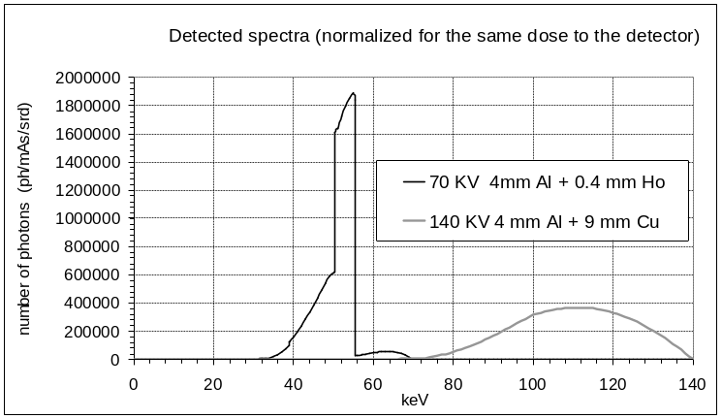
Figure 1: Example of switched source X-ray spectra for DXA (simulation of detected spectra)
A log-measurement of attenuation for a spectrum in the 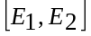 energy range on a ray path r can be written as follows :
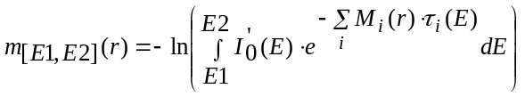 , (7)
where the function
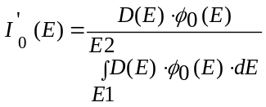 (8)
represents at the same time the variations of the incident spectrum 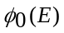 and of the detector efficiency 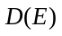. Function 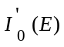 is similar in shape to the spectra of fig. 1, but it is normalized so that 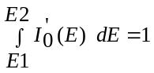. For a monochromatic system, 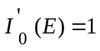 and 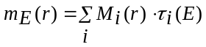. For a polychromatic system, the relationship between the surfacic masses M and the log-measurement is not linear anymore. The polychromatic measurements become :
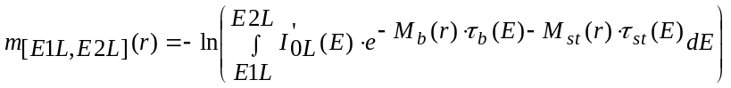 (9)
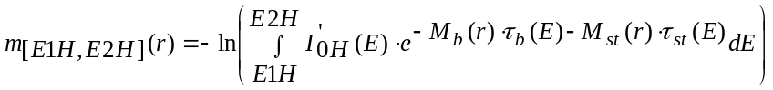 (10)
The inverse relationship can be modeled by polynomial functions, the coefficients of which are estimated by an experimental calibration procedure :
(11)
(12)
Dual-energy measurement data 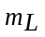and 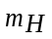are acquired on calibration samples made of pairs of materials representing mixtures of bone and soft tissue of known masses 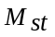 and . Then coefficients 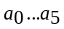 and 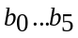 are estimated by a regression procedure. The use of an experimental calibration eliminates the need for the exact knowledge of the X-ray spectra and for the basis material attenuation coefficients. Other models have been described ¹⁰⁻¹², but conventional calibration with 2nd-order polynomials gives good results for our application, in which the coefficients for 2nd-degree terms remain low since the spectra have a reasonably narrow shape.
Since the use of real bone and soft tissue is not feasable in practice, a decomposition into "basis materials" such as lucite and a bone-like material (which is a mixture of hydroxyapatite and resin) is used. This decomposition allows for the beam hardening correction, then the conversion to bone and soft tissue is performed by linear combinations of basis materials images ⁷.
3. DUAL ENERGY flash beam BONE DENSITOMETRY

3.1 ACQUISITION SYSTEM
The acquisition system is similar to a conventional radiographic system, except that the detector is a 2D digital flat panel (see Figure 2) made of a Gd₂O₂S scintillator coupled to a grid of amorphous silicon photodiodes. The detector provides 512 x 512 pixels, each pixel is 0.4 mm on a side. The source-to-detector distance is large, thus the distortions due to conicity are negligible.
The switched X-ray tube delivers two successive X-ray flashes at 70 and 140 KV. To realize DEXA acquisitions, specific filters have been added in order to ensure that low and high energies acquisitions are respectively representative of photoelectric and Compton interactions. The chosen filter lead to well separated low energy and high energy spectra as shown on Figure 1.
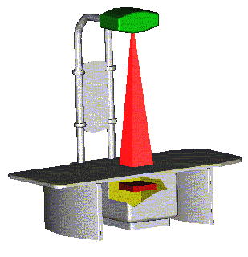
X-Rays generator
Filters
2D digital flat panel
Figure 2 : DEXA flash-beam acquisition system

3.2 main difference between flash beam and pencil or fan beam systems : scatter level
Two different photons flux contribute to the energy deposed at a pixel of the detector ¹³ (see Figure 3) :
- the primary photons which have not interacted with the patient and provide information about the attenuation along a source-to-detector pixel ray path (equation (1));
- the scattered photons, which have undergone one or several scattering interactions within the patient.

Object
+
=
Acquired
image
Primary flux image
Scattered flux image

Incident flux

Figure 3 : Scatter contribution in the acquisition

Pencil and fan-beam systems use ad hoc collimation in order to limit the contribution of scatter to the measurement. Combination of X-rays beam and of detector collimation prevents scatter generation in pencil beam systems : scatter is only generated along the beam of irradiation and, moreover, as its direction differs from the source - detector alignment it is stopped by the collimators and does not reach the detector (see Figure 4).
Collimated
X-Rays Source

Scatter

Primary

Collimated
Detector

Figure 4 : Principle of scatter rejection on a pencil beam system

On a fan beam system, combination of X-rays and detector slice collimation allow to make approximately the same assumption. However, slice collimations lead to higher scatter generation and to less efficient rejection at the detector level, and compared to a pencil beam system some scattered photons reach the detector. This phenomenon yields errors in bone density evaluation, particularly for overweight patients.
With bi-dimensional detectors scatter becomes an important issue, as discussed by Fivez for instance ¹⁴. A 2D radiograph of the lumbar spine region contains more than three times more signal due to the scattered flux than to the primary flux. To limit this scattering level an antiscatter grid is used. As this grid has to ensure a compromise between transmission of primary flux and scatter rejection, even behind an antiscatter grid a significant scatter level reaches the 2D detector.
To evaluate this level, a geometric phantom representative of a spine region has been used. This phantom is described on Figure 5. Scatter has been estimated by using the beam stop technique ¹⁵. Scatter is first estimated locally behind each ball, then a spline surface is fitted on these local scatter values in order to get an estimation of the scatter fraction on the whole image.
Figure 7 show profiles of the total (primary + scatter) flux image, the primary flux image and the scatter flux image. We can notice that even behind an antiscatter grid the scatter level is higher than the primary level for high energy and is about half of the primary level for low energy. Moreover, these profiles show that scatter is related to the 3D geometry of the observed object and generates a geometrical deformation of the radiograph (scatter is higher in the middle than on the edges).
The phantom is a lucite box (simulating fat) filled with water (simulating muscle), and a lucite tube containing four cylinders (3 cm diameter) made of a mixture of solid water and of different hydroxyapatite concentrations (simulating different bones density). The hydroxyapatite respective volumic densities are : 0.532; 0.412; 0.282; 0.202 g / cm³. The phantom dimensions are representative of those of a spine region.

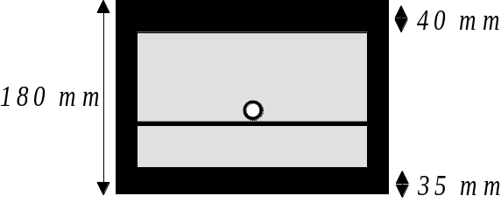

Figure 5 : Schematic of the geometric phantom as seen from a side. Black parts are in lucite, white part is a hydroxyapatite-solid water mixture cylinder, grey is water. The hydroxyapatite cylinders are enclosed in a lucite tube.

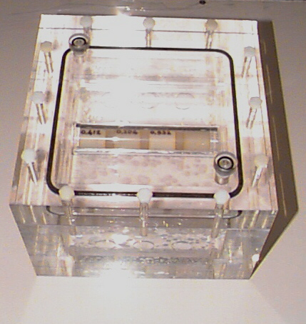

Figure 6: Photograph of the geometric phantom (seen from top)

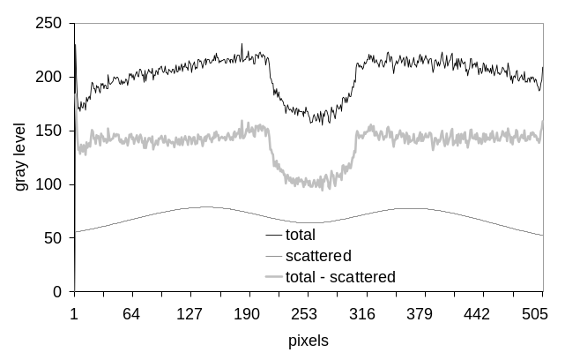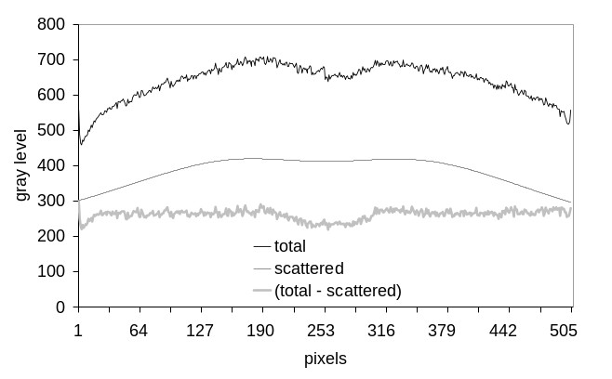
Figure 7: Profiles across one of the "bone" cylinders on the geometric phantom (after offset and gain correction). Left: low-energy, Right : high-energy

One of the major challenges of the measurement of bone mineral density with a flash beam system is to manage the bias in level and geometry induced by the scattered flux.
3.3 Offset and gain correction
A conventional offset and gain correction is applied to the raw radiographs. The offset correction is a subtraction of a dark images. The gain correction is a normalization by the image of the non-attenuated beam , in order to correct for the spatial nonuniformities of the X-ray beam and of the detector response. After these corrections, the image is homogeneous enough ( is spatially invariant) to allow the use of the same basis materials decomposition functions for the whole image.
3.4 Scatter processing
The use of the beam stops technique to estimate scatter on patient examinations is not realistic, because attenuation data would be missing under the beam stops area, thus a second acquisition would be necessary in order to cover the entire field. This two steps procedure would increase both the examination time and the dose delivered to the patient.
We have developed a scatter compensation method relying on the use of an analytical model of scatter. This model expresses scatter as a function of the acquired flux. We had previously developed this kind of approach for mammographic images enhancement ¹⁶. The method used to process scatter for bone densitometry measurement is a generalization of this previous approach to lumbar and hip regions.
3.5 DUAL ENERGY calibration of a 2D system
As the acquisitions for the dual-energy calibration are realized off-line and without patient, they can be scatter-corrected by estimating scatter thanks to a beam stop technique ¹⁵.
The basis materials used are lucite and a bone-like material made of a mixture of resin and hydroxyapatite. Dual-energy data is acquired on different combinations of these two materials. This is illustrated by the graph in figure 8. From this calibration data , it is possible to estimate the polynomial coefficients in equations (11) an (12).
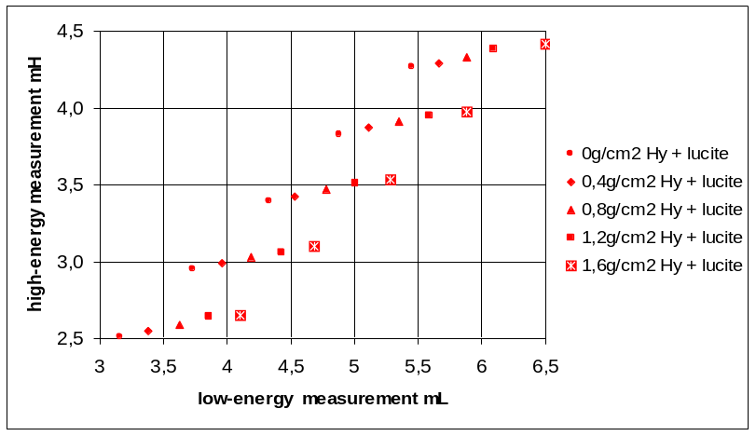
Figure 8: Example of calibration points from which the calibration polynomials are determined

3.6 Results

The whole dual X rays processing previously described has been applied to low and high energy acquisitions of the geometrical spine phantom presented on figure 6, including a baseline subtraction in order to correct for the decomposition of water into hydroxyapatite and lucite. Since the composition of this phantom is accurately known, the theoretical profiles of hydroxyapatite surfacic masses can be computed for each simulated vertebra. Figure 9 shows a comparison between the theoretical profiles and the reconstructed profiles. The density is slightly underestimated for the denser cylinder, which is probably due to a limitation of the calibration area (for this experiment the calibration standards went up to 1.6 g/cm² hydroxyapatite and did not cover the 1.8 g/cm² area). For the other cylinders the densities are quite correct. These profiles show that our processing, and more specifically scattering management in the calibration step and in the dual-energy processing step, leads to accurate reconstructions.
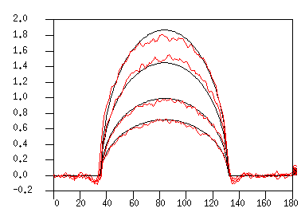
g/cm2 hydroxyapatite
pixels

Figure 9 : Reconstructed and theoretical surfacic masses (g/cm² hydroxyapatite) for each "bone" cylinder of the geometrical phantom

In order to evaluate our approach for clinical applications, our whole process has been applied to an anthropomorphic phantom. Figure 10 shows raw low and high energy acquisitions of the spine region realized with the flash beam DEXA system. The non uniformity in these images show the patient morphology variations and influence of scatter. Figure 11 shows the reconstructed bone density maps obtained for a spine region and an hip region. The flat level of the background region can be remarked on these reconstructions. This confirms that the variations in patient thickness, as well as the scattering influence, have been well managed.

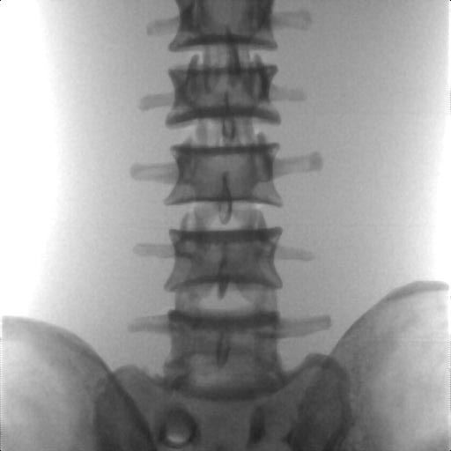 | 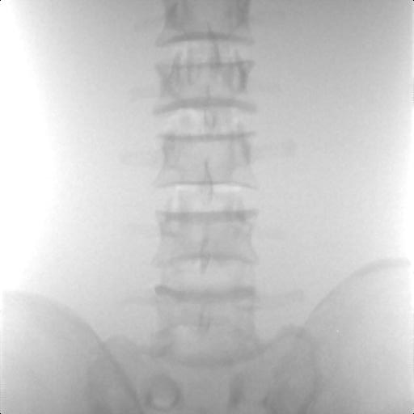
Low Energy Acquisition | High Energy Acquisition

Figure 10 : Spine region acquisitions on an anthropomorphic phantom (corrected for offset and gain)

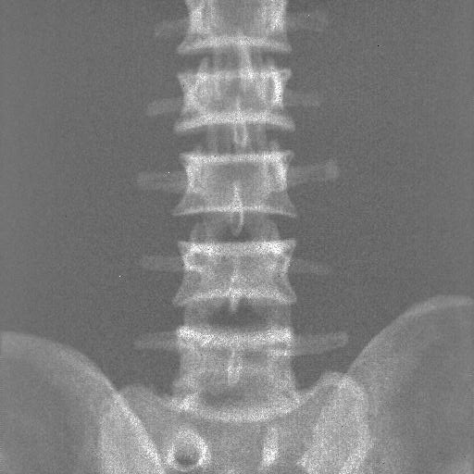 | 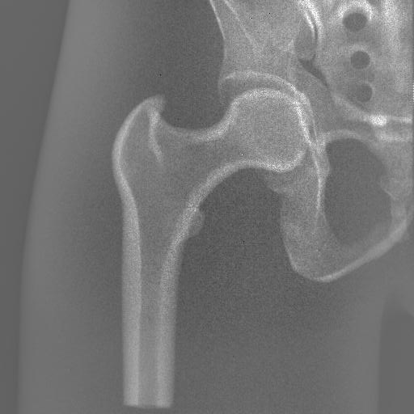
Spine region | Hip region

Figure 11 : Reconstructed Bone Density Map

4. CONCLUSION
Most of DEXA bone densitometry clinical systems are based on a pencil- or fan-beam acquisition geometry. This geometry leads to low and high energy acquisitions free of scattered X-rays. The drawback of these systems is then the need for a mechanical scan to cover the entire region of interest (spine or hip). A cone-beam geometry, with a 2D detector, would suppress this mechanical scanning, and significantly improve the examination comfort by reducing it to only two X-ray flashes (Flash Beam DEXA). However, the cone-beam geometry induces a significant level of scattering, which has to be correctly managed in the dual-energy processing to determine accurate bone density values.
Today, clinical cone-beam DEXA systems have only been proposed for thin anatomical regions (forearm, heel). In this paper, we have shown results on phantoms representative of a thicker anatomical region (spine, hip) that thanks to an analytical based management of scatter, as well as in the calibration step as in the processing step, accurate values of bone density can be obtained. To complete the Flash Beam DEXA evaluation, its robustness to patients composition or morphology variations will be estimated.

References

- G.E. Blake, H.W. Wahner, I. Fogelman, The Evaluation of osteoporosis : Dual Energy Xray Absorptiometry and Utrasound in Clinical Practice 2nd edition, Martin Dunitz Ed. ISBN 1-85317-472-6
- A.Pietrobelli, C. Formica, Z. Wang, S.B.Heymsfield, Dual-energy absorptiometry body composition model : review of physical concepts, Am J Physiol. 1996 Dec;271(6 Pt 1):E941-51
- E.C. Mc Cullough, "Photon Attenuation in Computed Tomography", Medical Physics, Vol 2, No 6, Nov/Dec 1975 pp. 307-321
- J.A.Sorenson, "Effects of nonmineral tissues on measurement of bone mineral content by dual-photon absorptiometry", Med Phys 17(5) Sep/Oct 1990 p 905-912
- R.E. Alvarez et A. Macovski, "Energy selective reconstructions in X-ray computerized tomography", Phys. Med. Biol. Vol. 21, PP. 733-744, 1976
- R.E. Alvarez, E.Seppi, "A comparison of noise and dose in conventional and energy selective CT", IEEE Trans. Nucl. Sci. Vol NS-26, N°2, April 79
- L.A. Lehmann, R.E. Alvarez, A. Macovski, W.R. Brody, N.J. Pelc, S.J. Rieder, A.L. Hall, "Generalized image combinations in dual KVP digital radiography" , Med. Phys 8(5), Sept./Oct. 1981.
- W.R.Brody, G.Butt, A. Hall, A. Macovski, "A method for selective tissue and bone visualization using dual-energy scanned projection radiography", Med.Phys. 8(3) pp 353-357, 1981
- J.A. Sorenson, P.R Duke, S.W Smith, " Simulation studies of dual-energy X-ray absorptiometry", Med. Phys. 16 (1) pp 75-80, 1989
- H.N.Cardinal, A.Fenster, "An accurate method for direct dual-energy calibration and decomposition", Med Phys 17 (3), May/jun 90 p327-341
- H.N.Cardinal, A.Fenster, "Analytic approximation of the log-signal and log-variance functions of x-ray imaging systems, with application to dual-energy imaging", Med Phys 18 (5), Sep/oct 91 p867-879
- K-Shih Chuang and H.K. Huang, "Comparison of four dual energy image decompositon methods", Phys. Med. Biol., 1988, Vol.33, N°4, 455-466
- G.F.Knoll, Radiation measurement and detection, second edition, John Wileys & sons ed., 1989, ISBN 0-471-81504-7
- C.M. Fivez, P.Wambacq, P.Suetens, E.Schoeters, "A calibration phantom for dual-energy basis material absorption measurement", SPIE vol 2708 pp 599-608 Medical imaging 1996 : physics of medical imaging
- F.C. Wagner, A. Macovski, D. Nishima,”Dual x-ray projection imaging : two sampling schemes for the correction of scattered radiation” Med. Phys., 1988; 15:732-748
- J.M. Volle, J.M. Dinten, “Physical model based restoration of mammographies”, Proc. SPIE Vol. 3336, pg. 641-650, Medical Imaging 1998, Physics of Medical Imaging, J.T. Dobbins, M. Boone, Editors

