Студент: Епанешников В. С.
Группа: М80-206Б-19
Номер по списку: 9

Тема: Знакомство с языком МИКРОЛИСП.
Отображение программ из МИКРОЛИСПа в С++.

Лабораторная работа N3
Распечатка файла coin21.ss
>
; coin21
; Епанешников М80-206Б-19

(define VARIANT 9)
(define LAST-DIGIT-OF-GROUP-NUMBER 6)
(define KINDS-OF-COINS 7)

(define (first-denomination kinds-of-coins)
(cond((= kinds-of-coins 1) 1)
((= kinds-of-coins 2) 2)
((= kinds-of-coins 3) 3)
((= kinds-of-coins 4) 5)
((= kinds-of-coins 5) 10)
((= kinds-of-coins 6) 15)
((= kinds-of-coins 7) 20)
(else 0))
)

(define (count-change amount)
(display "______")
(newline)
(display " amount: ")
(newline)
(display "KINDS-OF-COINS: ")
(display KINDS-OF-COINS)
(newline)
(let(
(largest-coin (first-denomination KINDS-OF-COINS))
)
(display "largest-coin: ")
(display largest-coin)
(newline)
(if(and (> amount 0) (> KINDS-OF-COINS 0) (> largest-coin 0))
(let()
(display "List of coin denominations: ")
(denomination-list KINDS-OF-COINS)
(display "count-change= ")
(cc amount KINDS-OF-COINS)
)
(let()
(display "Improrer parametr value!")
(newline)
(display "count-change =") -1)
)
)
)

(define (pier? x? y?)
(not (or x? y?))
)

(define (cc amount kinds-of-coins)
(cond((= amount 0) 1)
((pier? (< amount 0) (= kinds-of-coins 0))
(+ (cc amount (- kinds-of-coins 1))
(cc (- amount (first-denomination kinds-of-coins)) kinds-of-coins)))
(else 0))
)

(define (denomination-list kinds-of-coins)
(if(= kinds-of-coins 0) (let() (newline) 0)
(let()
(display (first-denomination kinds-of-coins))
(display " ")
(denomination-list (- kinds-of-coins 1))
)
)
)

(define (GR-AMOUNT)
(remainder (+ (* 100 LAST-DIGIT-OF-GROUP-NUMBER) VARIANT) 231)
)

(display "Variant ")
(display VARIANT)
(newline)
(newline)
(display (count-change 100))
(newline)
(display (count-change (GR-AMOUNT)))
(newline)
(set! KINDS-OF-COINS 13)
(display (count-change 100))
(newline)
(display "(c) Epaneshnikov V.S. 2021")
(newline)

Распечатка файла coin21. cpp
>
// Епанешников 206
// coin21.cpp
#include "mlisp.h"

extern double VARIANT;
extern double LAST__DIGIT__OF__GROUP__NUMBER;
extern double KINDS__OF__COINS;
double first__denomination(double kinds__of__coins);
double count__change(double amount);
bool pier_Q(bool x_Q, bool y_Q);
double cc(double amount, double kinds__of__coins);
double denomination__list(double kinds__of__coins);
double GR__AMOUNT();

double VARIANT = 9.;
double LAST__DIGIT__OF__GROUP__NUMBER = 6.;
double KINDS__OF__COINS = 7.;

double first__denomination(double kinds__of__coins){
return
( kinds__of__coins == 1. ? 1.
: kinds__of__coins == 2. ? 2.
: kinds__of__coins == 3. ? 3.
: kinds__of__coins == 4. ? 5.
: kinds__of__coins == 5. ? 10.
: kinds__of__coins == 6. ? 15.
: kinds__of__coins == 7. ? 20.
: 0.
);
}

double count__change(double amount){
display( "______\n amount: ");
display( amount);
newline();
display( "KINDS-OF-COINS: ");
display( KINDS__OF__COINS);
newline();
{
double largest__coin (first__denomination( KINDS__OF__COINS));
display( "largest-coin: ");
display( largest__coin);
newline();
return
( amount > 0. &&
KINDS__OF__COINS > 0. &&
largest__coin > 0. ?
( display( "List of coin denominations: "),
denomination__list( KINDS__OF__COINS),
display( "count-change= "),
cc(amount, KINDS__OF__COINS)
)
: (display("Improper parameter value!\ncount-change= "), -1.)
);
}
}

bool pier_Q(bool x_Q, bool y_Q){
return !(x_Q || y_Q);
}

double cc(double amount, double kinds__of__coins){
return
( amount == 0. ? 1.
: pier_Q(amount < 0., kinds__of__coins == 0.) ?
cc(amount, kinds__of__coins - 1.) +
cc(amount - first__denomination(kinds__of__coins),
kinds__of__coins)
: 0.
);
}

double denomination__list(double kinds__of__coins){
return ( kinds__of__coins== 0 ? (newline() , 0.)
: (display(first__denomination(kinds__of__coins)),
display(" "),
denomination__list(kinds__of__coins - 1.)
)
);
}

double GR__AMOUNT(){
return
remainder(100. * LAST__DIGIT__OF__GROUP__NUMBER + VARIANT,
231);
}

int main(){
display ("Variant ");
display (VARIANT);
newline();
newline();
display (count__change(100.) ); newline();
display (count__change(GR__AMOUNT()) ); newline();
KINDS__OF__COINS=13.;
display (count__change(100.) ); newline();
display ("(c) Epaneshnikov V.S. 2021\n");

std::cin.get();
return 0;
}

Скриншот запуска в C++
>
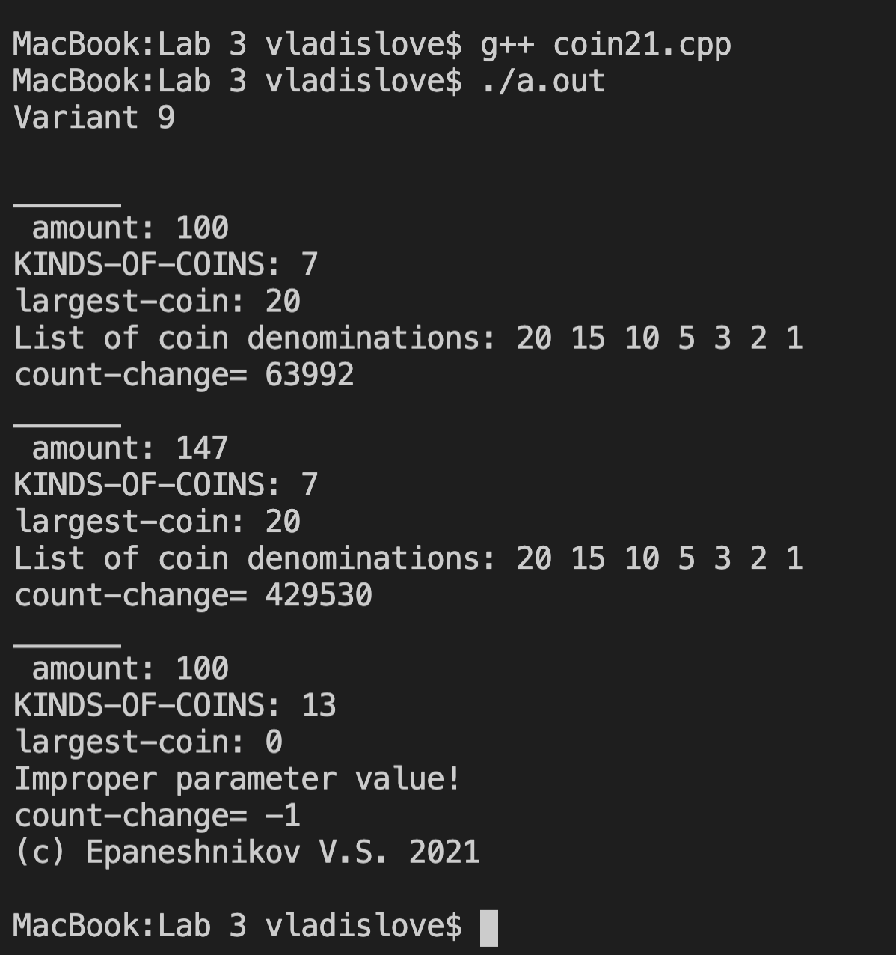

Скриншот запуска в DrRacket.
>
