**Tema:** Analiza datelor culese pe parcursul unui studiu clinic cu privire la eficiența unui medicament administrat în tratarea diverselor probleme de sănătate precum alergii, răceală, gripă etc.

***Aplicație APEX***

1. **Final_Heath_1**

* Tabela/view țintă: **OLAP_FACT_FINAL_HEALTH_STATE**
* Tip: Report
* URL: <http://localhost:8080/ords/clinical_data/r/clinical-data/final-heath-1?session=2119466508022>
* Printscreen

1. **Health_State_Regions_1**

* Tabela/view tinta: OLAP_VIEW_FHEALTH_STATE_SITE_REGIONS
* Tip: Report
* URL: <http://localhost:8080/ords/clinical_data/r/clinical-data/health-state-regions-1?session=2119466508022>
* Printscreen:

1. **Health_State_Age_Visits**

* Tabela/view tinta: **OLAP_VIEW_FHEALTH_STATE_AGE_VISITS**
* Tip: Report
* URL: <http://localhost:8080/ords/clinical_data/r/clinical-data/health-state-age-visits?session=2119466508022>
* Fraza SQL:

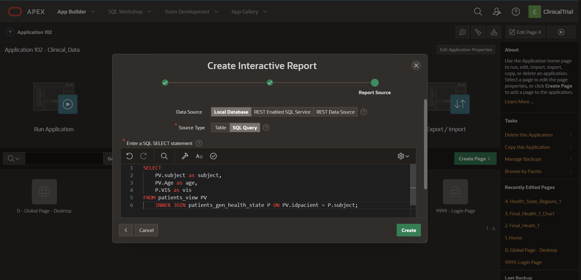

* Printscreen

