# ESTIMATION OF THE BIOLOGICAL AGE OF HUMAN BONES USING MACHINE LEARNING

*Volodymyr Slipchenko*

*Department of Digital Technologies in Energy1*

*ORCID: https://orcid.org/0000-0002-3405-0781*

*ddpolytechnic2016@gmail.com*

*Liubov Poliahushko*

*Department of Digital Technologies in Energy1*

*ORCID: https://orcid.org/0000-0003-3287-8523*

*Scopus Author ID 58246840200*

*liubovpoliagushko@gmail.com*

*Vladyslav Shatylo*

*Department of Digital Technologies in Energy1*

*ORCID: https://orcid.org/0000-0001-5395-2097*

*Scopus Author ID 58247671300*

*v.shatylo@kpi.ua*

*Volodymyr Rudyk*

*Department of Digital Technologies in Energy1*

*ORCID: https://orcid.org/0009-0004-4774-6579*

*rudykviv@gmail.com*

*1National Technical University of Ukraine “Igor Sikorsky Kyiv Polytechnic Institute”*

*6 Polytechnichna St., Kyiv, Ukraine, 03056*

## Abstract

This article explores the issue of assessing the biological age of human bones using machine learning methods and neural networks. Biological age is an indicator that demonstrates the degree of aging of the human body, taking into account not only the number of days since birth but also the biological characteristics of the body or individual organs. Accurate determination of this indicator will help medical professionals understand patients' conditions and detect osteoporosis early. The study aims to find the best method for assessing the biological of human bones, providing the highest accuracy and quality of assessment. The object of study is machine learning methods and neural networks. The subject of study is the use of machine learning and neural networks as a means of assessing the biological age of human bones based on numerical data on the condition of the skeletal system. Body mass index, data on bone mass density, and the fracture risk assessment tool of various bones in the body, as well as the trabecular bone score, were chosen as biomarkers. The correlation of biomarkers with age was verified using Pearson [nonlinearity and Pearson correlation] and Spearman correlation coefficients. The training part of the processed dataset was fed into various machine learning models based on different methods (linear regression, k-nearest neighbors, boosting, ensembles, etc.), followed by accuracy testing on the test set. Additionally, the method for assessing biological age based on two neural networks and the Klemera-Doubal method was tested. As a result of the research, the chosen set of models and machine learning methods for assessing the biological age of human bones based on data on the condition of the skeletal system was tested. The best results were shown by machine learning models based on the boosting method, such as XGBRegressor, LGBMRegressor, and CatBoostRegressor, with MAE ranging from 2.1 to 2.2 and a correlation coefficient from 0.93 to 0.94, which indicates high accuracy given the limited dataset. The scientific novelty of the research is the first use of a method based on two consecutive neural networks for bone data. Although this method showed worse results than machine learning models, the difference is not significant, indicating the versatility of the method. The study also provided important information on determining the BA of bones based on data from Ukrainian citizens, contributing to the development of the biological age field in Ukraine.

**Keywords**: biological age, bone age, BMD, neural networks, machine learning.

## Introduction

One of the most common bone diseases in humans is osteoporosis. It can be characterized as a widespread age-related disease associated withф low bone mass density (BMD) and systemic disruption [розпад] of bone mass and microarchitecture, predisposing individuals to an increased risk of fractures [1].

In the USA, about 10 million Americans over the age of 50 suffer from osteoporosis, and another 34 million are at increased risk of developing it. In the UK, one in two women and one in five men over the age of 50 are affected [2]. In India, various studies indicate that 25% to 62% of postmenopausal women (approximately over 50 years old) also suffer from osteoporosis [3].

For Ukrainian citizens, the data is similarly alarming: according to studies by the D.F. Chebotarev Institute of Gerontology and the Ukrainian Scientific Medical Center for Osteoporosis Problems, osteoporosis is observed in 13% of women aged 50-59 years, in 25% of women aged 60-69 years, 50% in the 70-79 age group, and in 53% of those aged 80-89 years [4].

Osteoporosis often develops unnoticed [непомічений] until it leads to the first bone fracture, which causes severe pain and sometimes even disability. Such a fracture is frequently called a sentinel [дозорный] fracture [5]. After such a fracture, the risk of subsequent injuries is extremely high. Therefore, it is crucial to diagnose the disease in time and begin effective treatment. Fortunately, there are effective treatments and preventive measures for osteoporosis, such as antiresorptive [антирезорбтивный] drugs [6] and teriparatide drugs [7].

Many studies link osteoporosis with the aging processes of the human body [8, 9], and as mentioned above, the vast majority of osteoporosis patients are over 50 years old. These are useful data indicating a connection between a person's chronological age (CA) and the condition of their musculoskeletal system, particularly the skeleton. However, the biological age (BA) of bones can differ from the chronological age and more accurately indicate bone aging separately from other parts of the body.

It is also worth noting [варто відзначити] that BA differs from bone age, the determination of which is a common practice during the examination of children or adolescents [adolescents]. Bone age is usually determined using X-rays of the left hand, fingers, and wrist, which are compared with a set of standard images in the Greulich and Pyle atlas [10]. This indicator is a marker that indicates growth and development rate rather than bone aging.

In general, BA characterizes the physical condition of the human body and the degree of its aging based on a selected set of biomarkers. Biomarkers are specific indicators of the body's condition, which can be various data such as blood tests, ultrasound, and X-ray results, physical activity data, etc. [11, 12].

If BA is determined solely based on data on the condition of the body's bones, it is possible to abstract from other organs and assess only the biological age of the human skeleton. An accurate value of such an indicator would provide reliable information about the condition of a person's bones and their degree of aging, which, in turn, would become an effective indicator for diagnosing and determining the risks of developing osteoporosis.

Effective determination of BA is a complex task that has been worked on since the last century. Many modern studies use mathematical and statistical methods, such as the Klemera-Doubal method (KDM), multiple linear regression, and principal component analysis [13]. However, in recent years, machine learning methods and algorithms have been added to these [14, 15].

The quality of BA assessment using machine learning methods is usually determined by the correlation coefficient between CA and BA, but classic metrics such as the coefficient of determination (), mean absolute error (MAE) and mean squared error (MSE) are also applied.

With the emergence and spread of machine learning, it has been actively used for various tasks, including determining biological age. Most of such studies follow a similar algorithm: initial data processing, analysis and identification of key biomarkers, model or neural network training, and evaluation of training results and assessment metrics.

In the article [16], a new ST-Res Net model based on the existing Res Net was presented. The experiments determined that the MAE was 0.455, which surpassed the results obtained from classical machine learning methods.

In [17], the authors developed and tested a new two-stage neural network for determining the BA of bones. The network was tested on a dataset of 14,236 X-ray images and showed an MAE of 4.586 months.

Lateral cephalograms are also used as input data for determining the BA of bones [18]. The trained network was tested on 180 test set samples and the coefficient of determination of the proposed method for the actual and estimated bone age was 0.983.

Most works focus on using ideal X-ray images. However, due to outdated X-ray devices or the unique structure of the human skeleton, images are not always of high quality. In [19], a method for assessing the BA of bones based on poor-quality X-ray images was presented. Their connected neural networks system, BoNet+, showed an MAE of 0.76 years, which is a high result considering the blurriness or incompleteness of the images.

In 2022, Ukrainian researchers from the D.F. Chebotarev State Institute of Gerontology NAMS of Ukraine proposed a mathematical model for determining the BA of bones, taking into account indicators of bone mass density and bone quality [20]. The results demonstrated that the developed model has a correlation coefficient between chronological age and BA of 0.78, a coefficient of determination of 0.615, and a standard error (SE) of 8.16 years.

As can be seen, most studies use different approaches and input data, from X-ray images to numerical indicators of similar examinations. The use of images as input data significantly complicates the development and increases the assessment time. Modern neural networks can analyze X-ray images of most people, but they will either specialize in images from one specific model or line of X-ray devices or lose accuracy in recognition when trained on one model and tested on real data from another. Additionally, the quality of the image, which can distort assessment results, should be considered.

Therefore, in our opinion, the best option is to use numerical data obtained from a qualified doctor who can process images from any device and provide reliable results and indicator values. A neural network or machine learning model trained on such data will be able to work anywhere in the world with any X-ray equipment.

Such a system today can help determine the BA of the human skeletal system with high accuracy and provide information about delays in bone development or excessive aging. This, in turn, will give doctors information about the prospects for the development of bone diseases, such as osteoporosis.

## Materials and methods

### **2.1. Dataset**

The dataset on the bone system condition of patients was obtained from the D.F. Chebotarev Institute of Gerontology of the National Academy of Sciences of Ukraine. It consists of 10 biomarkers obtained from women aged 40 to 92 years. The average age of the patients is 62.1 years. The age distribution is as follows: 381 individuals aged 40 to 49 years, 943 individuals aged 50 to 59 years, 1206 individuals aged 60 to 69 years, 603 individuals aged 70 to 79 years, 149 individuals aged 80 to 89 years, and 2 individuals aged 90 to 99 years.

The dataset includes such indicators as the chronological age of the patient, body mass index (BMI), the fracture risk assessment tool score (FRAX) for all bones and only hip, data on the bone mass density of the lumbar spine, right and left femoral neck, proximal right and left femur, radial bone, as well as the trabecular bone score.

### **2.2. Methods**

For working with the dataset, the pandas library [21] and scipy [22] were used. For working with machine learning methods and algorithms, the sklearn library [23] was utilized, and the work with neural networks was carried out using the tensorflow library [24].

The machine learning models tested on the selected dataset were models from the sklearn, xgboost [25], lightgbm [26], and catboost [27] libraries. All of them are based on a variety of the most popular methods, from the simplest K-nearest neighbors and Decision tree to boosting and ensemble methods such as Gradient Boosting, AdaBoost and others.

These are various popular models based on different algorithms, including linear regression models, k-nearest neighbors, decision trees, ensemble methods, and others.

To select the best input parameters for the machine learning models, ensuring their maximum efficiency, the GridSearchCV method [28] was used.

Additionally, the selected data was also tested using the method for calculating biological age (BA) presented in our previous work [29]. The main idea of this method is the application of the optimized Klemera-Doubal method (KDM) [30] to find the target variable for training a neural network that determines the BA, and subsequently using another neural network to adjust the BA indicator. This method showed high results on data from the general human blood test, so it is advisable to try its application on other datasets.

For assessing the quality of biological age determination, classic machine learning metrics such as Mean Squared Error (MSE), Mean Absolute Error (MAE), as well as the correlation coefficient between chronological and biological age, are used. The correlation coefficient is a typical indicator of accuracy in researching and assessing biological age.

### **2.3. Pre-processing**

For data normalization, the StandardScaler [31] from the sklearn library was used, which brings all values to the range from -1 to 1 with a mean of 0 using the formulas:







where z is the scale value; x is the current value; μ is the mean value; n is the number of elements; σ is the standard deviation.

### **2.4. Correlations**

For finding correlation coefficients, the pearsonr and spearmanr methods from the scipy library were used. Their feature is that they allow obtaining the p-value in addition to the correlation coefficient itself.

The Pearson correlation coefficient is calculated using the formula:



where *r* is a Pearson `s correlation coefficient; and  are data points;  is the mean of the x-values; ** is the mean of the y-values.

The Spearman correlation coefficient is calculated using the formula:



where *r* is a Spearman`s rank correlation coefficient; n is the number of points in the dataset;  is the square of the difference in the ranks of the two coordinates for each point .

However, individual correlation coefficient values are not reliable indicators of the relationship between variables. To prove the statistical significance of the parameters, a p-value is additionally calculated. For this, the t-statistics value is first calculated using the formula:



After obtaining the t-statistics value, we can calculate the degrees of freedom (the number of data points in the dataset minus 2) and use the t-distribution to obtain the p-value. The correlation is considered statistically significant if the p-value is not less than the significance level (most often the α value is 0.05).

## Results and discussion

### **3.1. Pre-processing and selection biomarkers**

Before testing the selected machine learning methods, an analysis, and preparation of the dataset were conducted. Due to the small number of individuals over 90 years old, their data was removed. Additionally, data for individuals with missing chronological age and those with missing values for more than two biomarkers were deleted.

Due to the limited amount of data, it was decided not to discard rows where only two biomarker values were missing. Instead, the remaining dataset rows were sorted by chronological age and subjected to polynomial interpolation of null values. These missing values were replaced with values characteristic of the respective age group. After interpolation, the dataset was randomly sorted. As a result, a dataset of 3273 rows was obtained, each containing the chronological age of the individual and the values of 10 biomarkers (Fig. 1).

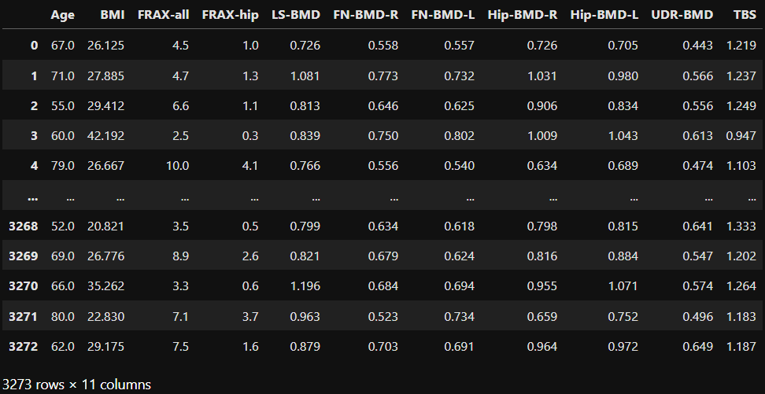

Fig 1. Dataset after initial processing

Table 1 presents the results of the initial analysis of the prepared dataset, namely the mean value of each biomarker and its standard error.

Table 1

Information about biomarkers

|  |  |  |  |
| --- | --- | --- | --- |
| Biomarker name | Unit | Mean | SE |
| Bone mass index (BMI) |  | 27.968 | 0.095 |
| 10-year probability of major osteoporotic fractures (FRAX-all) | % | 6.552 | 0.065 |
| 10-year probability of hip fractures (FRAX-hip) | % | 1.832 | 0.037 |
| Lumbar spine bone mineral density (LS-BMD) |  | 0.905 | 0.003 |
| Femoral right neck bone mineral density (FN-BMD-R) |  | 0.696 | 0.002 |
| Femoral left neck bone mineral density (FN-BMD-L) |  | 0.690 | 0.002 |
| Proximal right femur (hip) bone mineral density (Hip-BMD-R) |  | 0.863 | 0.003 |
| Proximal left femur (hip) bone mineral density (Hip-BMD-L) |  | 0.867 | 0.003 |
| Bone mineral density ultra-distal radius of the forearm (UDR-BMD) |  | 0.593 | 0.002 |
| The trabecular bone scores (TBS) | units | 1.254 | 0.002 |

To check the correlation between biomarkers and age, correlation coefficients were determined using the Pearson (4) and Spearman (5) methods, as well as parameters to confirm statistically significant correlations: p-value and t-statistics (6). Table 2 demonstrates the obtained results. Due to the small dataset size, the decision was made to retain all indicators, as each of them has at least a 0.1 score for at least one of the coefficients.

Table 2

Results of assessment of correlation of biomarkers to age

|  |  |  |  |  |  |  |
| --- | --- | --- | --- | --- | --- | --- |
| Biomarker name | Pearson`s correlation | Pearson`s p-value | Pearson`s t-statistics | Spearman`s correlation | Spearman`s p-value | Spearman`s t-statistics |
| BMI | 0.094 |  | 5.4028 | 0.132 |  | 7.6265 |
| FRAX-all | 0.457 |  | 29.4100 | 0.533 |  | 36.0154 |
| FRAX-hip | 0.566 |  | 39.3118 | 0.718 | 0 | 58.9315 |
| LS-BMD | -0.177 |  | -10.3073 | -0.184 |  | -10.7098 |
| FN-BMD-R | -0.404 |  | -25.2551 | -0.397 |  | -24.7255 |
| FN-BMD-L | -0.412 |  | -25.8514 | -0.403 |  | -25.1747 |
| Hip-BMD-R | -0.328 |  | -19.8328 | -0.313 |  | -18.8262 |
| Hip-BMD-L | -0.3 |  | -17.9652 | -0.289 |  | -17.2774 |
| UDR-BMD | -0.562 |  | -38.8337 | -0.572 |  | -39.9089 |
| TBS | -0.434 |  | -27.5350 | -0.452 |  | -29.0045 |

Before starting the training of selected machine learning methods for biological age estimation, the data set was divided into training (80%, 2618 samples) and test (20%, 655 samples) samples. Each biomarker in both samples was standardized using the StandardScaler method (1-3) (Fig. 2).



Fig 2. Standardized dataset

### **3.2. Find best parameters**

Next, the best parameters for training the selected machine learning models were searched using the GridSearchCV method, with the scoring parameter set to neg_mean_squared_error. Table 3 shows the input data for the selected models, with which they demonstrate the best accuracy metrics.

Table 3

The best input parameters found for the selected models

|  |  |
| --- | --- |
| Model`s name | Best parameters |
| KNeighborsRegressor | 'n_neighbors': 15 |
| GradientBoostingRegressor | 'max_depth': 5, 'n_estimators': 300 |
| RandomForestRegressor | 'max_depth': 20, 'n_estimators': 500 |
| XGBRegressor | 'learning_rate': 0.1, 'max_depth': 5, 'n_estimators': 200 |
| LGBMRegressor | 'learning_rate': 0.1, 'max_depth': 5, 'n_estimators': 200 |
| CatBoostRegressor | 'depth': 5, 'iterations': 500, 'learning_rate': 0.1 |
| AdaBoostRegressor | 'estimator': XGBRegressor(), 'learning_rate': 0.1, 'n_estimators': 200 |
| BaggingRegressor | 'max_samples': 1.0, 'n_estimators': 200 |
| BayesianRidge | 'alpha_1': 1e-08, 'alpha_2': 1e-06, 'lambda_1': 1e-06, 'lambda_2': 1e-08 |
| ElasticNet | 'alpha': 0.01, 'l1_ratio': 0.5, 'max_iter': 500 |
| PLSRegression | 'n_components': 5 |
| DecisionTreeRegressor | 'max_depth': 30, 'min_samples_split': 10 |
| Lasso | 'alpha': 0.01 |
| MLPRegressor | 'activation': 'relu', 'alpha': 0.001, 'hidden_layer_sizes': (50, 50), 'max_iter': 1000, 'solver': 'adam' |

In addition to the machine learning models, the method for assessing biological age presented in our previous work [29] was also tested. However, due to changes in the dataset and the number of parameters, corresponding changes were made to the architecture of the neural networks (Fig. 3).

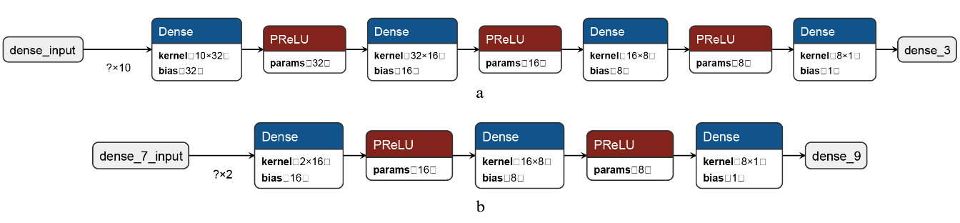

Fig. 3.Architectures of the developed neural networks:

a – for biological age; b – for correction of biological age

Thus, the network for determining biological age using KDM received: an input layer with 10 input parameters (corresponding to the number of biomarkers) and 32 neurons, a hidden layer with 16 neurons, another hidden layer with 8 neurons, and an output layer with 1 neuron. After each layer except the output layer, an additional layer with the PReLU activation function was added, which is an improved version of the classic ReLU. Adagrad optimizer with learning_rate=0.1 was used, and MSE loss function.

The network for correcting the biological age value had the following architecture: an input layer with 2 input parameters and 16 neurons, a hidden layer with 8 neurons, and an output layer with 1 neuron. Similar to the network for determining biological age, PReLU activation layers, Adagrad optimizers, and MSE loss function were used, but with learning_rate=0.3.

### **3.3. Results of model testing**

After determining the best parameters, they were immediately passed to the selected models, and their training was initiated. A comprehensive comparative analysis of all tested models and methods is provided in Table 4, as well as in the form of correlation graphs (Fig. 4).

Table 4.

Full characteristics of the tested models

|  |  |  |  |  |  |
| --- | --- | --- | --- | --- | --- |
| Model`s name | Pearson`s correlation coeficient | MSE | MAE |  | Learning time, s |
| KNeighborsRegressor | 0.76 | 39.748 | 4.849 | 0.581 | 0.032 |
| GradientBoostingRegressor | 0.93 | 12.515 | 2.212 | 0.868 | 3.421 |
| RandomForestRegressor | 0.93 | 13.353 | 2.137 | 0.859 | 13.729 |
| XGBRegressor | 0.93 | 13.094 | 2.251 | 0.862 | 0.180 |
| LGBMRegressor | 0.93 | 12.075 | 2.227 | 0.872 | 0.062 |
| CatBoostRegressor | 0.94 | 11.493 | 2.148 | 0.879 | 0.694 |
| AdaBoostRegressor | 0.93 | 12.161 | 2.217 | 0.872 | 22.300 |
| BaggingRegressor | 0.93 | 13.351 | 2.138 | 0.859 | 5.570 |
| BayesianRidge | 0.71 | 46.488 | 5.301 | 0.509 | 0.005 |
| ElasticNet | 0.71 | 46.542 | 5.304 | 0.509 | 0.003 |
| PLSRegression | 0.71 | 46.725 | 5.309 | 0.507 | 0.006 |
| DecisionTreeRegressor | 0.89 | 20.269 | 2.776 | 0.786 | 0.031 |
| Lasso | 0.71 | 46.470 | 5.300 | 0.510 | 0.005 |
| MLPRegressor | 0.90 | 17.972 | 2.596 | 0.810 | 8.164 |
| Two neural network and KDM | 0.90 | 21.566 | 3.491 | 0.767 | 19.300 |

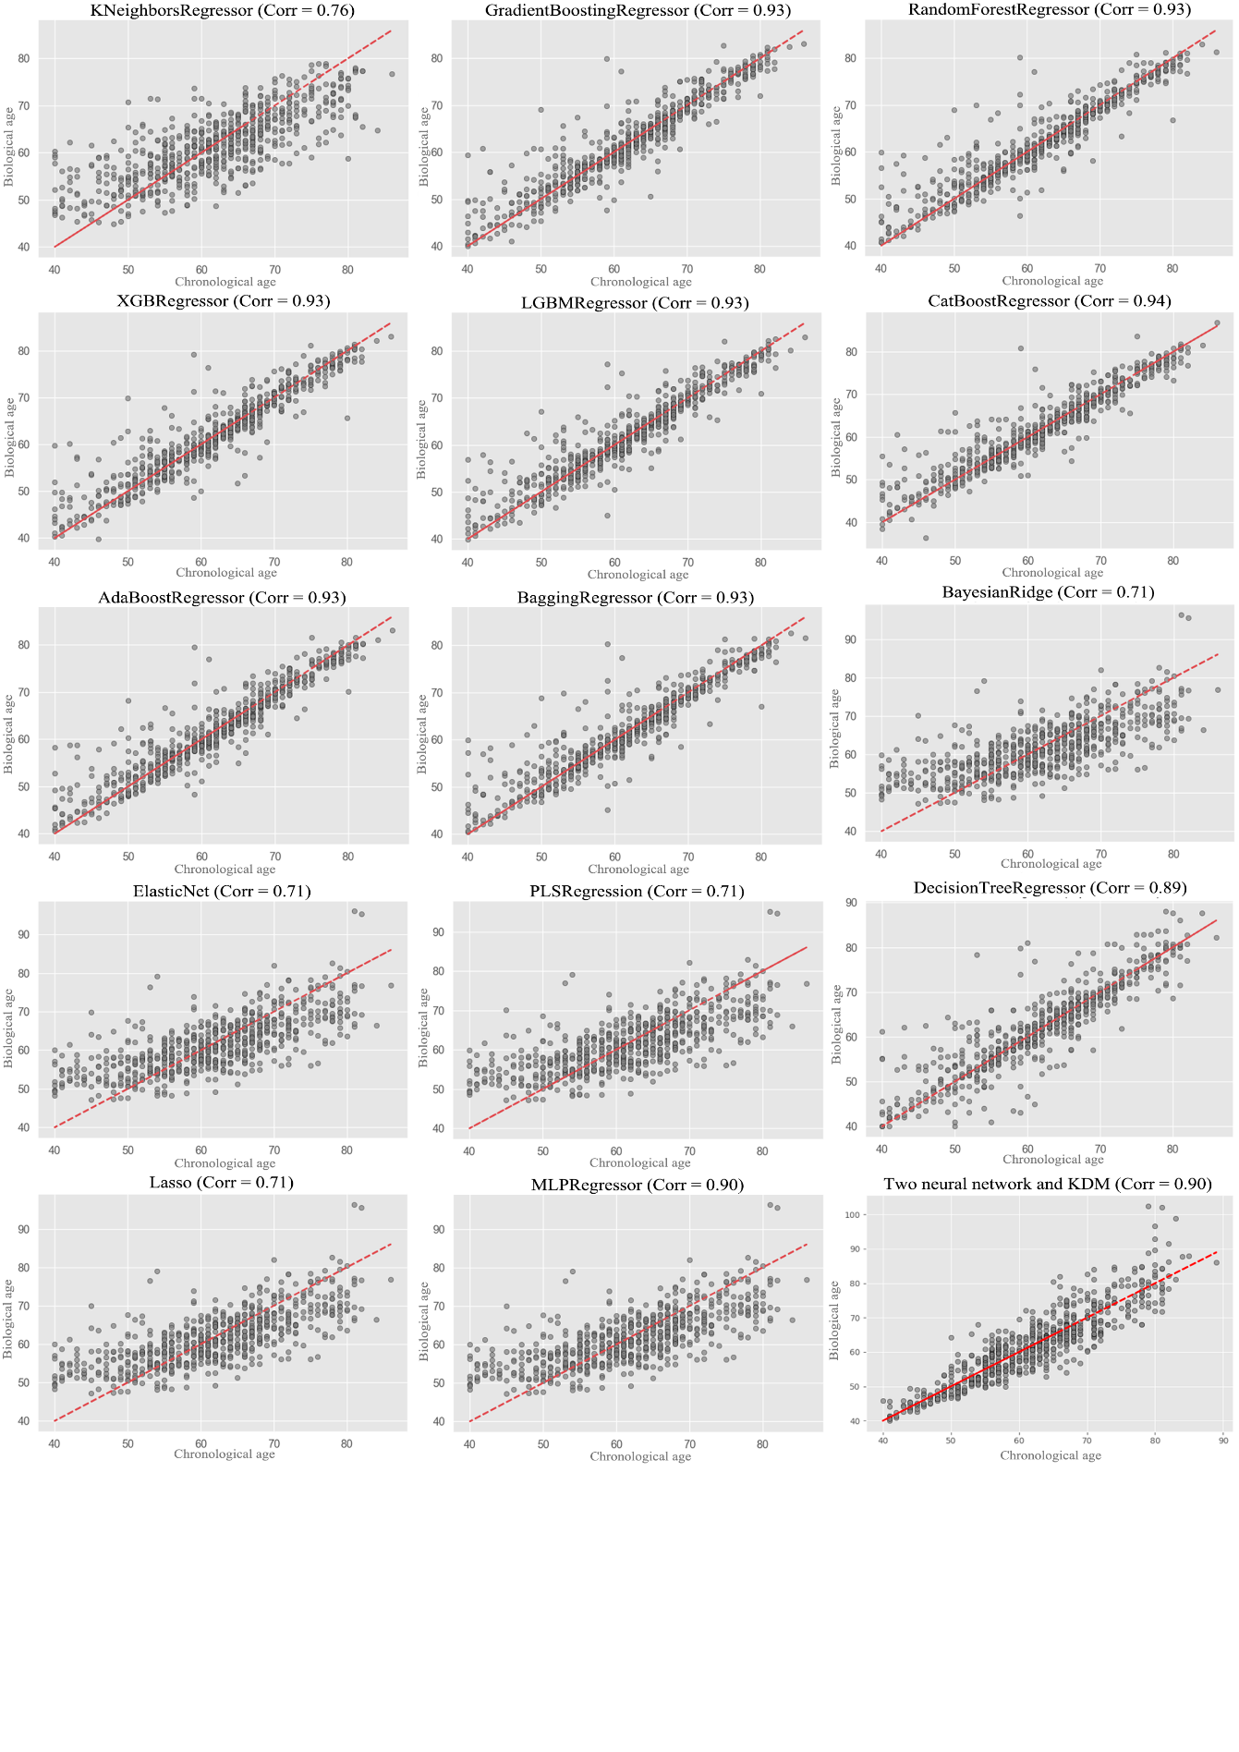

Fig. 4.Correlations of estimated biological age and chronological age

The ensemble models based on boosting, namely XGBRegressor, LGBMRegressor, and CatBoostRegressor, showed the best results in terms of accuracy and speed. Their correlation coefficient between chronological and biological age is above 0.9, with MSE ranging from 11.5 to 13, MAE from 2.1 to 2.2, and from 0.86 to 0.88, with training times of less than 1 second.

### **3.4. Discussion**

In a similar study [32], conducted on the same dataset, researchers compared the accuracy of the multiple linear regression (MLR) model and their neural network model based on a multilayer perceptron (MLP) with one hidden layer, using Statistica 7.0 software.

The obtained results were as follows: MLR showed an MAE of 4.81 and a correlation coefficient between biological and chronological age of 0.77, while the MLP model showed an MAE of 3.67 with a correlation coefficient of 0.88.

Our application of the method for determining biological age based on using two neural networks (the second for correcting the estimation) exceeded the obtained results with an MAE of 3.49 and a correlation coefficient of 0.90. At the same time, the tested machine learning models such as XGBRegressor, LGBMRegressor, and CatBoostRegressor, showed even better results: MAE from 2.1 to 2.2, correlation coefficient from 0.93 to 0.94. This demonstrates the advantage of using the selected methods and the value of this research.

## Conclusions

As a result of the conducted study, the following conclusions were drawn:

* Bone mineral density indicators have a sufficient correlation with a person's age to accurately and effectively determine their biological age based on bone data.
* Classical machine learning methods, such as KNeighborsRegressor, BayesianRidge, ElasticNet, Lasso, and others, poorly suit the determination of a person's biological age based on their bone condition data. In contrast, ensemble methods based on boosting, namely XGBRegressor, LGBMRegressor, CatBoostRegressor, perform well in this task and demonstrate high speed and accuracy.
* Machine learning models selected as the best for determining biological age based on bone data exhibit higher accuracy compared to similar studies on the same dataset.
* A large number of different models and approaches for determining the biological age of Ukrainian citizens based on bone data were tested, which is an important contribution to the development of the field of biological age research in Ukraine.

## Conflict of interest

The authors declare that there is no conflict of interest in relation to this paper, as well as the published research results, including the financial aspects of conducting the research, obtaining and using its results, as well as any non-financial personal relationships.

## Financing

The study was performed without financial support.

## Data availability

Data will be made available on reasonable request.

## Use of artificial intelligence

The authors confirm that they did not use artificial intelligence technologies when creating the current work.

## Acknowledgments

Thanks to the “D.F. Chebotarev Institute of Gerontology of the National Academy of Medical Sciences of Ukraine” for the provided data.

**References**

1. Föger-Samwald, U., Kerschan-Schindl, K., Butylina, M., Pietschmann, P. (2022). Age Related Osteoporosis: Targeting Cellular Senescence. International Journal of Molecular Sciences, 23 (5), 15. https://doi.org/10.3390/ijms23052701
2. Clynes, M. A., Harvey, N. C., Curtis, E. M., Fuggle, N. R., Dennison, E. M., Cooper, C. (2020). The epidemiology of osteoporosis. British Medical Bulletin, 133 (1), 19. https://doi.org/10.1093/bmb/ldaa005
3. Rajan, R., Paul, J., Kapoor, N., Cherian, K., Paul, T. (2020). Postmenopausal osteoporosis – An Indian perspective. Current Medical Issues, 18 (2), 98–104. https://doi.org/10.4103/cmi.cmi_5_20
4. Rekalov D. (2020). Osteoporosis: current state of the problem. Health of Ukraine, 7 (6), 29. Available at: https://health-ua.com/multimedia/4/6/5/8/3/1588860387.pdf
5. Amin, U., McPartland, A., O’Sullivan, M., Silke, C. (2023). An overview of the management of osteoporosis in the aging female population. Women’s Health, 19 (3), 19. https://doi.org/10.1177/17455057231176655
6. Wang, Q. Y., Ding, N., Dong, Y. H., Wen, Z. X., Chen, R., Liu, S. Y. et al. (2021). Pharmacological Treatment of Osteoporosis in Elderly People: A Systematic Review and Meta-Analysis. Gerontology, 67 (6), 639–649. https://doi.org/10.1159/000514449
7. Sfeir, J. G., Pignolo, R. J. (2021). Pharmacologic Interventions for Fracture Risk Reduction in the Oldest Old: What Is the Evidence? JBMR Plus, 5 (10), 9. https://doi.org/10.1002/jbm4.10538
8. Chandra, A., Rajawat, J. (2021). Skeletal aging and osteoporosis: Mechanisms and therapeutics. International Journal of Molecular Sciences, 22 (7), 25. https://doi.org/10.3390/ijms22073553
9. Pignolo, R. J., Law, S. F., Chandra, A. (2021). Bone Aging, Cellular Senescence, and Osteoporosis. JBMR Plus, 5 (4), 14. https://doi.org/10.1002/jbm4.10488
10. Koc, U., Taydaş, O., Bolu, S., Elhan, A. H., Karakas, S. P. (2021). The Greulich-Pyle and Gilsanz-Ratib atlas method versus automated estimation tool for bone age: a multi-observer agreement study. Japanese Journal of Radiology, 39 (3), 267–272. https://doi.org/10.1007/s11604-020-01055-8
11. Diebel, L., Rockwood, K. (2021). Determination of Biological Age: Geriatric Assessment vs Biological Biomarkers. Current Oncology Reports, 23 (9), 8. https://doi.org/10.1007/s11912-021-01097-9
12. Li, Z., Zhang, W., Duan, Y., Niu, Y., Chen, Y., Liu, X. et al. (2023). Progress in biological age research. Frontiers in Public Health, 11, 14. https://doi.org/10.3389/fpubh.2023.1074274
13. Bafei, S. E. C., Shen, C. (2023). Biomarkers selection and mathematical modeling in biological age estimation. NPJ Aging, 9 (13), 9. https://doi.org/10.1038/s41514-023-00110-8
14. Ni, X., Zhao, H., Li, R., Su, H., Jiao, J., Yang, Z. et al. (2023). Development of a model for the prediction of biological age. Computer Methods and Programs in Biomedicine, 240, 12. https://doi.org/10.1016/j.cmpb.2023.107686
15. Rahman, S. A., Adjeroh, D. A. (2019). Estimating Biological Age from Physical Activity using Deep Learning with 3D CNN. 2019 IEEE International Conference on Bioinformatics and Biomedicine, 1100–1103. https://doi.org/10.1109/BIBM47256.2019.8983251
16. Chen, X., Li, J., Zhang, Y., Lu, Y., Liu, S. (2020). Automatic feature extraction in X-ray image based on deep learning approach for determination of bone age. Future Generation Computer Systems, 110, 795–801. https://doi.org/10.1016/j.future.2019.10.032
17. Mao, X., Hui, Q., Zhu, S., Du, W., Qiu, C., Ouyang, X. at al. (2023). Automated Skeletal Bone Age Assessment with Two-Stage Convolutional Transformer Network Based on X-ray Images. Diagnostics, 13 (11), 1837. https://doi.org/10.3390/diagnostics13111837
18. Seo, H., Hwang, J. J., Jung, Y. H., Lee, E., Nam, O. H., Shin, J. (2023). Deep focus approach for accurate bone age estimation from lateral cephalogram. Journal of Dental Sciences, 18(1), 34–43. https://doi.org/10.1016/j.jds.2022.07.018
19. Guo, J., Zhu, J., Du, H., Qiu, B. (2020). A bone age assessment system for real-world X-ray images based on convolutional neural networks. Computers and Electrical Engineering, 81. https://doi.org/10.1016/j.compeleceng.2019.106529
20. Grygorieva, N. V., Dubetska, H. S., Koshel, N. M., Pisaruk, A. V., Antoniuk-Shcheglova, I. A. (2022). Mathematical model of the bone biological age based on the bone mineral density and quality indicex and Ukrainian FRAX model. Pain, Joints, Spine, 12(1), 16–22. https://doi.org/10.22141/pjs.12.1.2022.324
21. Pandas. Available at: https://pandas.pydata.org/
22. SciPy. Available at: https://scipy.org/
23. Scikit-learn. scikit-learn: machine learning in Python. Scikit-learn.org. Available at: https://scikit-learn.org/stable/
24. TensorFlow. Available at: https://www.tensorflow.org/
25. XGBoost Documentation. Available at: https://xgboost.readthedocs.io/en/stable/
26. Welcome to LightGBM’s documentation! Available at: https://lightgbm.readthedocs.io/en/stable/
27. catboost/catboost. GitHub. Available at: https://github.com/catboost/catboost
28. sklearn.model_selection. Available at: https://scikit-learn.org/stable/modules/generated/sklearn.model_selection.GridSearchCV.html
29. Slipchenko, V. H., Poliahushko, L. H., Shatylo, V. V., Rudyk, V. I. (2023). Machine learning for human biological age estimation based on clinical blood analysis. Applied Aspects of Information Technology, 6(4), 431–442. https://doi.org/10.15276/aait.06.2023.29
30. Levine, M. E. (2013). Modeling the rate of senescence: Can estimated biological age predict mortality more accurately than chronological age? Journals of Gerontology - Series A Biological Sciences and Medical Sciences, 68(6), 667–674. https://doi.org/10.1093/gerona/gls233
31. sklearn.preprocessing.StandardScaler. Available at: https://scikit-learn.org/stable/modules/generated/sklearn.preprocessing.StandardScaler.html
32. Grygorieva, N. V., Pisaruk, A. V., Gurianov, V. H., Musiіenko, A. S., Shatylo, V. V. (2023). Assessment of the bone biological age using multiple regression and neural network analysis. Pain, Joints, Spine, 13(4), 241–247. https://doi.org/10.22141/pjs.13.4.2023.394