1)Added new project appveyor

<https://www.appveyor.com/docs/deployment/github/>

Токены шифровались в appveyor

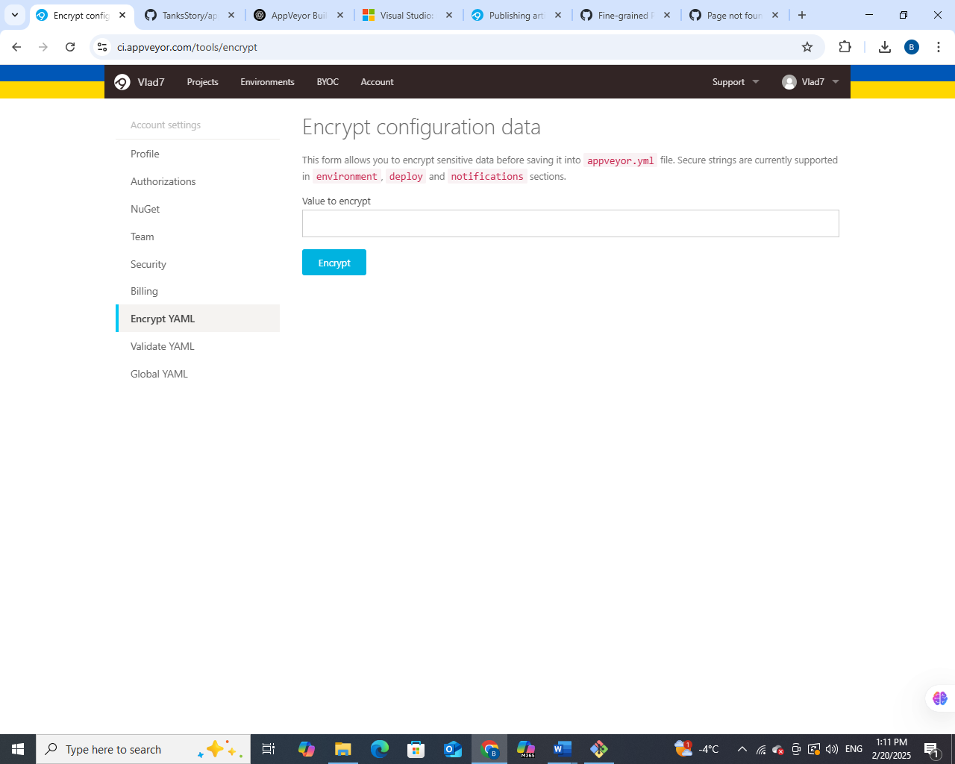

<https://stackoverflow.com/questions/48359909/unable-to-deploy-artifact-from-appveyor-to-github> - не працює