SSD

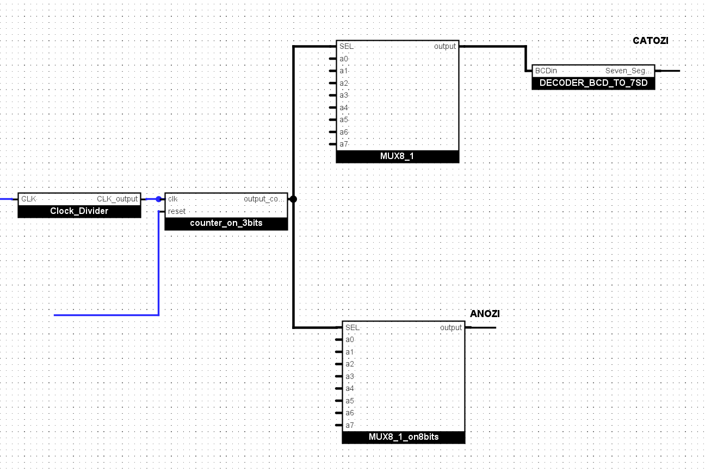

From the reference manual, we made a frequency divider of 1 milisecond so it selects the right seven segment display without the eye observing the change. We used 2 MUX on 3 bits with the addresses on 8 bits and a BCD decoder.

Btn ctrl

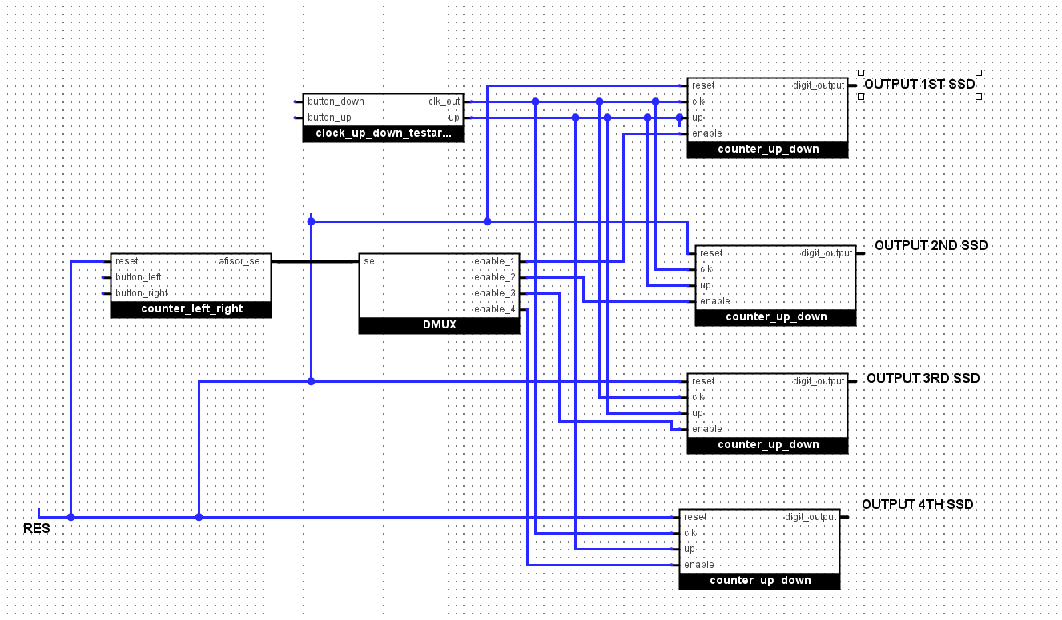

For the button controller, we basically control which of the digits given to the ssd we increase or decrease.

We use 1 counter to either select left or right, from 0 to 3, that is also the selection, which Is selecting which counter up/down is selected, that displays numbers from 0 to 9.

BTN AND SSD

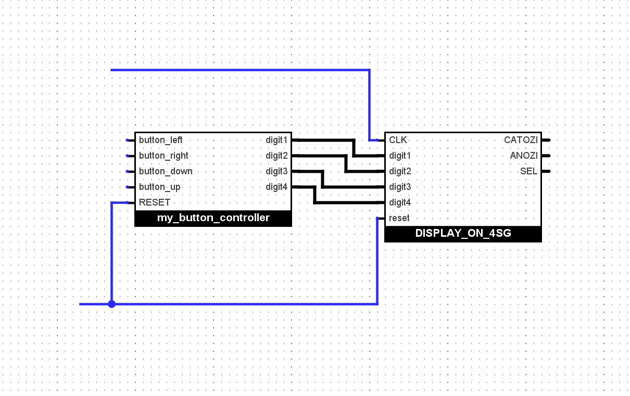

This is the connection between the button controller and the seven segment display.

DISPENSAR MONEY

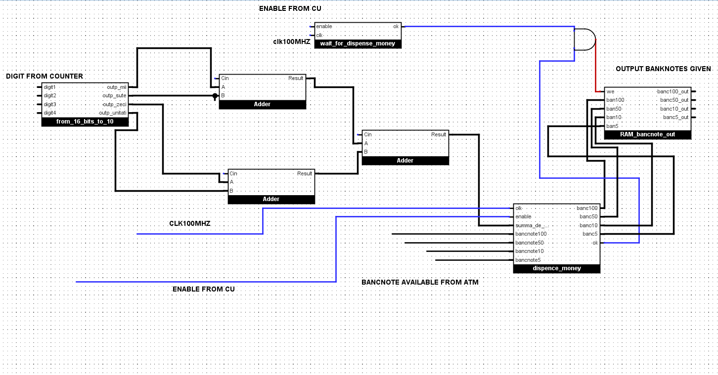

For the money dispenser, we have an output to tell how many banknotes of 100, 50, 10 or 5 to be given, if the withdrawn amount is less or equal than 1000$ and if it is a multiple of 5.I make use of the 100mHz clock to make the greedy algorithm for the distribution of banknotes, and I have a counter which counts 1000 clock cycles, and when it reaches 1000, the output would be that the dispenser is done, and we can then go to a next state, either to withdraw the money or to go intro error, depending on the generated ok signal, which indicates if the conditions were met.