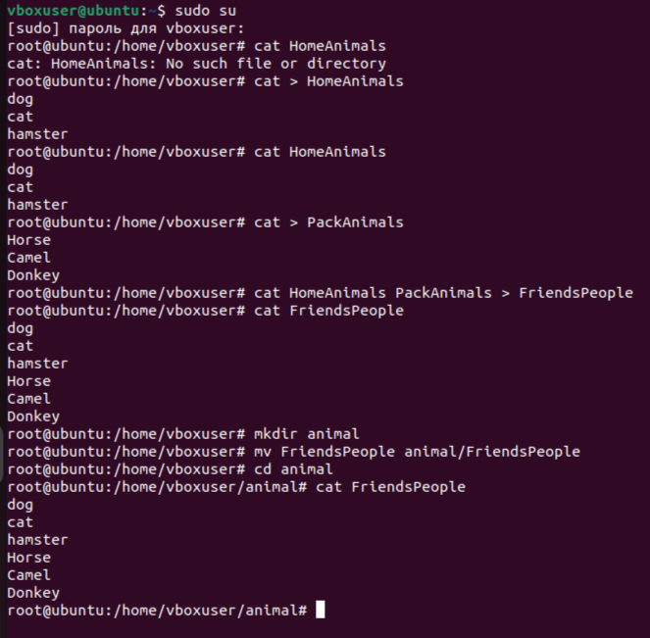

CREATE TABLE people_friends (ID SERIAL PRIMARY KEY,Typs VARCHAR);

INSERT INTO people_friends (Typs) VALUES ('Домашние животные'),('Вьючные животные');

CREATE TABLE home_animals (ID SERIAL PRIMARY KEY,Typs VARCHAR);

INSERT INTO home_animals (Typs) VALUES ('Собаки'),('Кошки'),('Хомяки');

CREATE TABLE pack_animals (ID SERIAL PRIMARY KEY,Typs VARCHAR);

INSERT INTO pack_animals (Typs) VALUES ('Лошади'),('Верблюды'),('Ослы');

CREATE TABLE dog (ID SERIAL PRIMARY KEY,LastName VARCHAR, Comand VARCHAR, BirthDate DATE);

INSERT INTO dog (LastName, Comand, BirthDate) VALUES ('Шарик','Сидеть','2021-05-01'),

('Бобик','Лежать','2017-02-13');

CREATE TABLE cat (ID SERIAL PRIMARY KEY, LastName VARCHAR, Comand VARCHAR, BirthDate DATE);

INSERT INTO cat (LastName, Comand, BirthDate) VALUES ('Мурзик','кушать','2021-05-01'),

('Муся','Кушать','2017-02-13');

CREATE TABLE hamster (ID SERIAL PRIMARY KEY, LastName VARCHAR, Comand VARCHAR, BirthDate DATE);

INSERT INTO hamster (LastName, Comand, BirthDate) VALUES ('Хома','Ничего не знает','2022-05-01'),

('Феррари','Вперед','2022-02-13');

CREATE TABLE horse (ID SERIAL PRIMARY KEY, LastName VARCHAR, Comand VARCHAR, BirthDate DATE);

INSERT INTO horse (LastName, Comand, BirthDate) VALUES ('Красотка','Сидеть','2015-05-01'),

('Спирит','Вперед','2013-02-13');

CREATE TABLE camel (ID SERIAL PRIMARY KEY, LastName VARCHAR, Comand VARCHAR, BirthDate DATE);

INSERT INTO camel (LastName, Comand, BirthDate) VALUES ('Боря','Сидеть','2016-05-01'),

('Горбатый','Вперед','2014-02-13');

CREATE TABLE donkeys (ID SERIAL PRIMARY KEY, LastName VARCHAR, Comand VARCHAR, BirthDate DATE);

INSERT INTO donkeys (LastName, Comand, BirthDate) VALUES ('Ишак','Голос','2016-05-01'),

('Формула','Вперед','2014-02-13');

DROP TABLE IF EXISTS camel CASCADE;

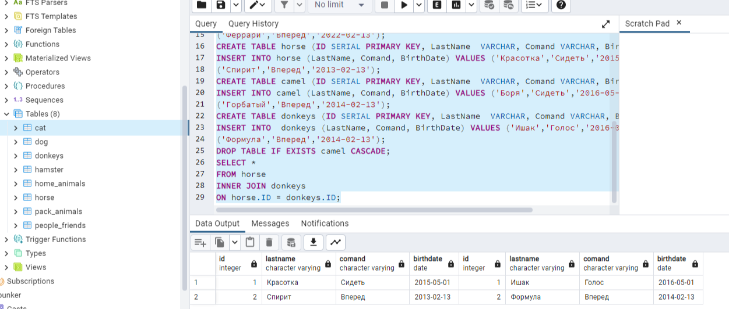

create table newTable AS (

select LastName,

Comand,

BirthDate

from horse union

select LastName,

Comand,

BirthDate

from donkeys);

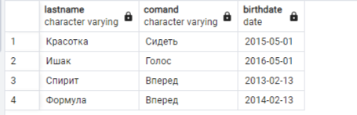

create table youngAnimals AS (

select LastName,

Comand,

BirthDate,

((((extract(year from current_date) - extract (year from BirthDate))*12)+ ((extract(month from current_date) - extract(month from(BirthDate))))))AS age

from horse

where((((extract(year from current_date) - extract (year from BirthDate))*12)+ ((extract(month from current_date) - extract(month from(BirthDate))))))<=36 and ((((extract(year from current_date) - extract (year from BirthDate))*12)+ ((extract(month from current_date) - extract(month from(BirthDate))))))>=12

union

select LastName,

Comand,

BirthDate,

((((extract(year from current_date) - extract (year from BirthDate))*12)+ ((extract(month from current_date) - extract(month from(BirthDate))))))AS age

from donkeys

where ((((extract(year from current_date) - extract (year from BirthDate))*12)+ ((extract(month from current_date) - extract(month from(BirthDate))))))<=36 and ((((extract(year from current_date) - extract (year from BirthDate))*12)+ ((extract(month from current_date) - extract(month from(BirthDate))))))>=12

union

select LastName,

Comand,

BirthDate,

((((extract(year from current_date) - extract (year from BirthDate))*12)+ ((extract(month from current_date) - extract(month from(BirthDate))))))AS age

from cat

where ((((extract(year from current_date) - extract (year from BirthDate))*12)+ ((extract(month from current_date) - extract(month from(BirthDate))))))<=36 and ((((extract(year from current_date) - extract (year from BirthDate))*12)+ ((extract(month from current_date) - extract(month from(BirthDate))))))>=12

union

select LastName,

Comand,

BirthDate,

((((extract(year from current_date) - extract (year from BirthDate))*12)+ ((extract(month from current_date) - extract(month from(BirthDate))))))AS age

from dog

where ((((extract(year from current_date) - extract (year from BirthDate))*12)+ ((extract(month from current_date) - extract(month from(BirthDate))))))<=36 and ((((extract(year from current_date) - extract (year from BirthDate))*12)+ ((extract(month from current_date) - extract(month from(BirthDate))))))>=12

union

select LastName,

Comand,

BirthDate,

((((extract(year from current_date) - extract (year from BirthDate))*12)+ ((extract(month from current_date) - extract(month from(BirthDate))))))AS age

from hamster

where ((((extract(year from current_date) - extract (year from BirthDate))*12)+ ((extract(month from current_date) - extract(month from(BirthDate))))))<=36 and ((((extract(year from current_date) - extract (year from BirthDate))*12)+ ((extract(month from current_date) - extract(month from(BirthDate))))))>=12

);

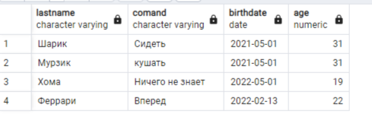

create table Animal AS (

select LastName,

Comand,

BirthDate,

'horse' as typ

from horse union

select LastName,

Comand,

BirthDate,

'donkey' as typ

from donkeys union

select LastName,

Comand,

BirthDate,

'cat' as typ

from cat union

select LastName,

Comand,

BirthDate,

'dog' as typ

from dog union

select LastName,

Comand,

BirthDate,

'hamster' as typ

from hamster)

;

