**Bug 1**

**Summary:**

Main menu rebuilt incorrect after quit of Feed mini-game in endless mode

**Steps:**

1. Launch the app
2. Start Feed mini game
3. Waste all hearts
4. Continue in endless mode
5. Exit from mini game
6. Pay attention to the main menu icons

**Actual result:**

Main menu goes out of the screen

**Expected result:**

Mein menu not changed

**Device/ Version:**

Redmi Note 9 Android 10

App version 1.1.0 (2874)

**Priority:** High

**Attachments: 1.mp4**

**Bug 2**

**Summary:**

Iguana in Feed mini game becomes invisible after opening notification panel

**Steps:**

1. Launch the app
2. Start feed mini game
3. Lose 1 heart
4. Open notification panel while new game timer counting
5. Close notification panel

**Actual result:**

Iguana becomes invisible

**Expected result:**

Iguana visible

**Device/ Version:**

Redmi Note 9 Android 10

App version 1.1.0 (2874)

**Priority:** Medium

**Attachments: 2.mp4**

**Bug 3**

**Summary:**

Able to add not verified TikTok account in Social Accounts in Settings

**Steps:**

1. Launch the App
2. Open Settings
3. Open Social Accounts
4. Click Connect Tiktok
5. Enter random(not relevant) username and click connect

**Actual result:**

Tiktok account connected

**Expected result:**

TikTok account not connected, warning notification appeared under Input Field

**Device/ Version:**

Redmi Note 9 Android 10

App version 1.1.0 (2874)

**Priority:** High

**Attachments: 3.mp4**

**Bug 4**

**Summary:**

Russian translation issues

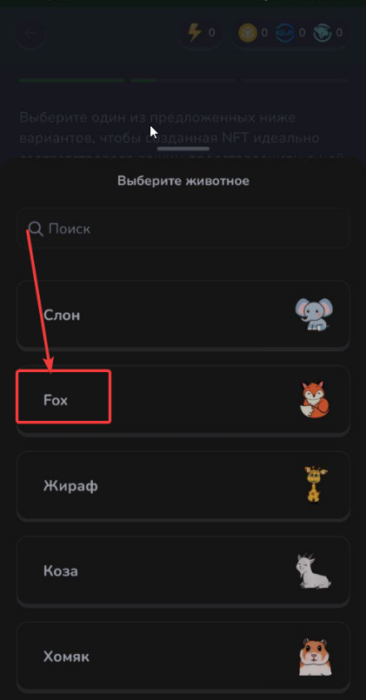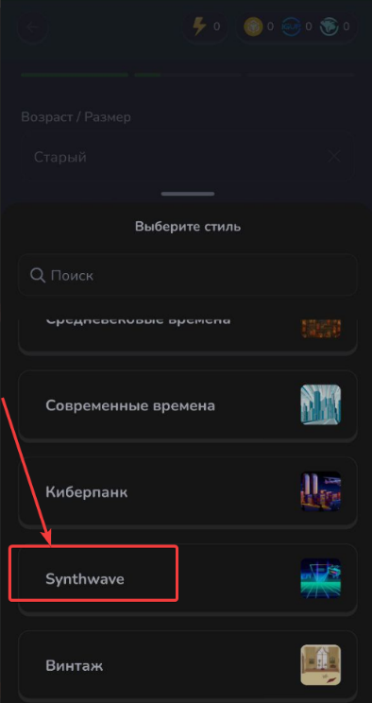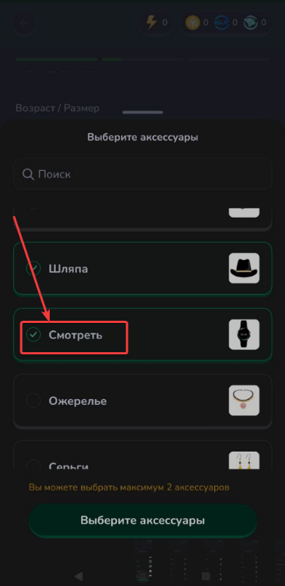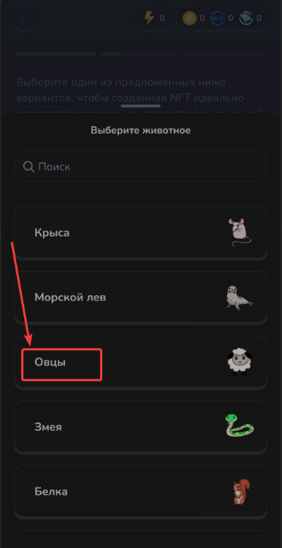**Description:**

**Actual result:**

Texts not translated in russian or translated not correct

**Expected result:**

Texts translated correct

**Device/ Version:**

Redmi Note 9 Android 10

App version 1.1.0 (2874)

**Priority:** Low

**Bug 5**

**Summary:**

Ukrainian translation issues

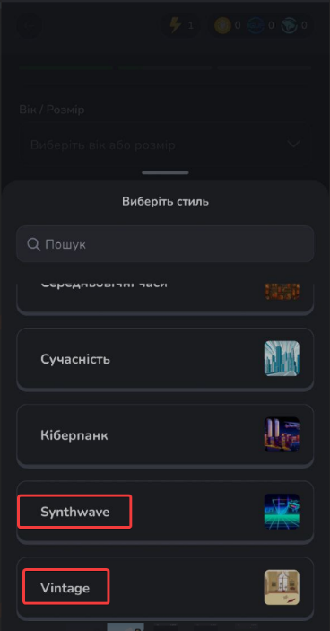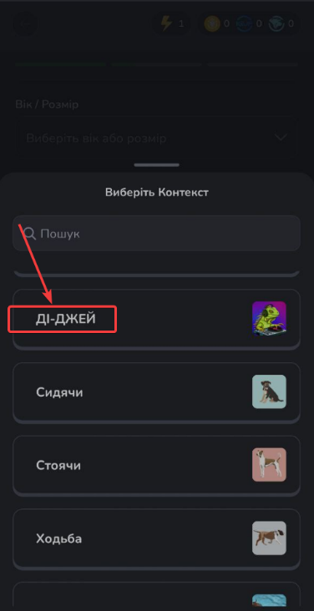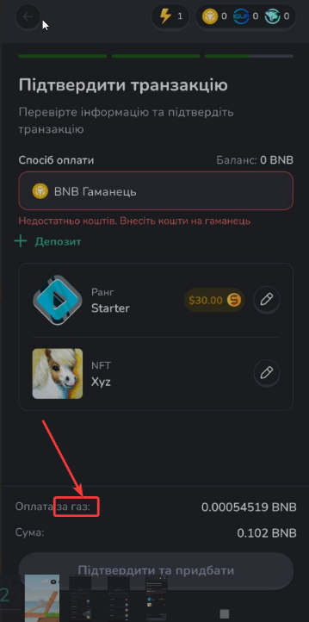**Description:**

**Actual result:**

Text not translated in russian or translated not correct

**Expected result:**

Texts translated correct

**Device/ Version:**

Redmi Note 9 Android 10

App version 1.1.0 (2874)

**Priority:** low