ГУАП
КАФЕДРА № 42
ОТЧЕТ
ЗАЩИЩЕН С ОЦЕНКОЙ
ПРЕПОДАВАТЕЛЬ
старший преподаватель |  |  |  | Д.О. Шевяков
должность, уч. степень, звание |  | подпись, дата |  | инициалы, фамилия

ОТЧЕТ О ЛАБОРАТОРНОЙ РАБОТЕ №2
Создание приложения интернета вещей и веб-интерфейса
по курсу: ИНТЕРНЕТ ВЕЩЕЙ

РАБОТУ ВЫПОЛНИЛ
СТУДЕНТ гр. № | 4321 |  |  |  | Д.Ю. Бычков
 |  |  | подпись, дата |  | инициалы, фамилия
Санкт-Петербург 2026

1 Цель работы
Приобретение навыков создания и запуска приложения интернета вещей.

2 Задание
Вариант задания: Умный дом.
Создать приложение на Flask. Реализовать классы и их иерархию, согласно сданной первой лабораторной работе, показать работу методов этих классов. (Не нужно писать предполагаемый метод целиком, на данном этапе достаточно вывести в лог сервера сообщение о том, что метод был запущен).

3 Результат проделанной работы
В ходе работы были созданы соответствующие классы и методы. На рисунке 1 продемонстрирован лог успешно выполненных методов класса. На рисунке 2 продемонстрировано информирование на сайте о успешном выполнении функционала. На рисунке 3 изображена реализация класса умных штор.
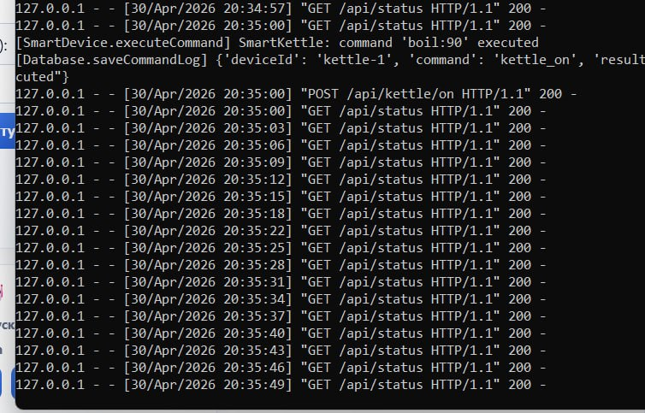
Рисунок 1 — Лог выполнения методов
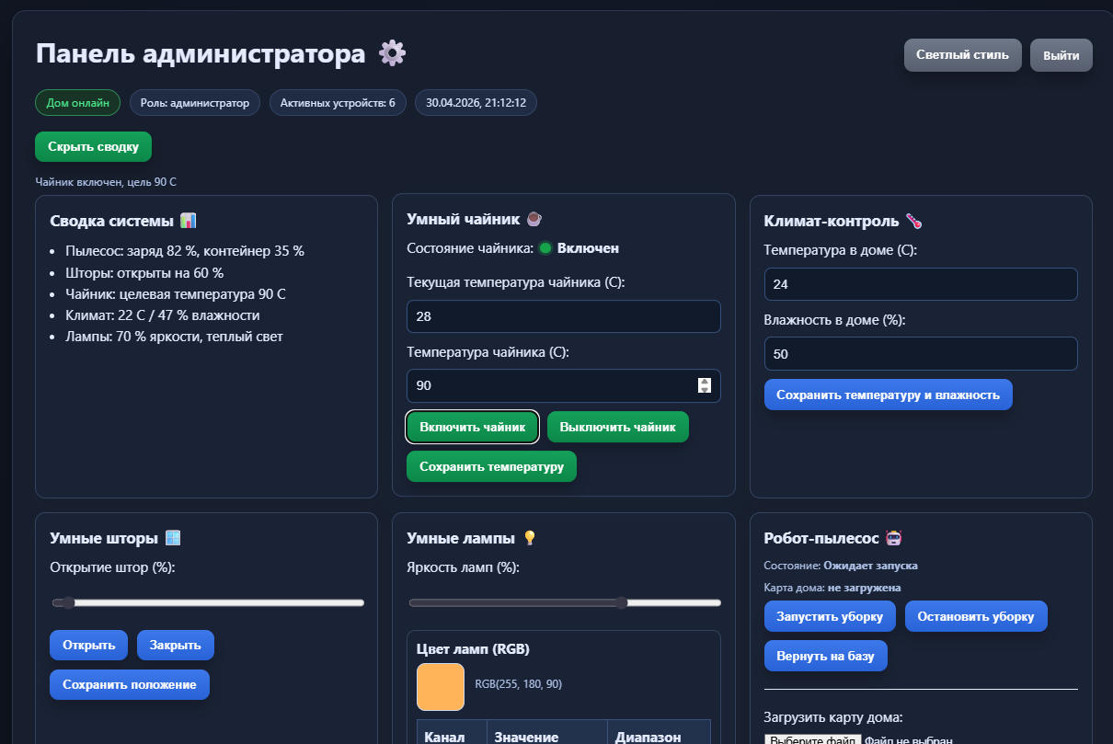
Рисунок 2 — Включение чайника на веб-сервере
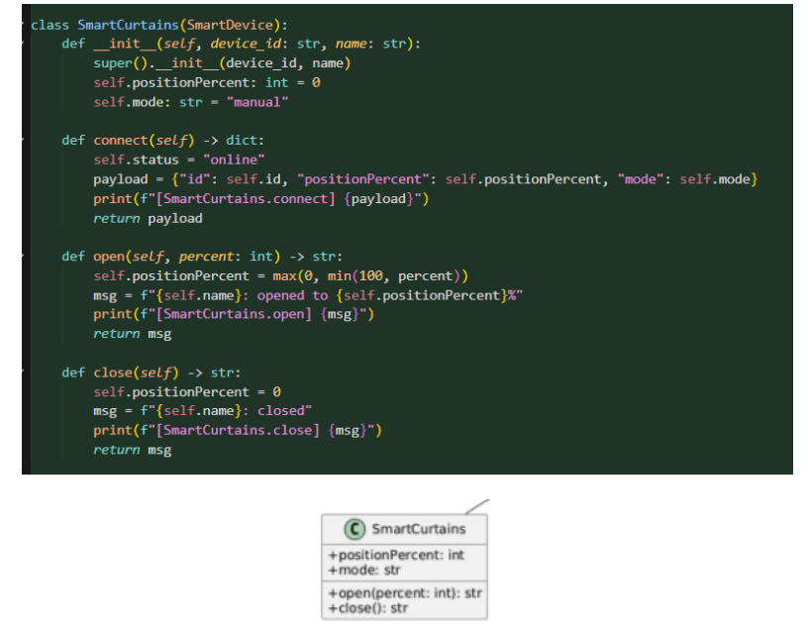
Рисунок 3 — Пример реализации класса из прошлой лабораторной работы

4 Вывод
В ходе выполнения лабораторной работы были приобретены навыки создания и запуска приложения интернета вещей.

ПРИЛОЖЕНИЕ А
Листинг кода файла things.py:
import abc
from typing import Any

classef __init__( SmartDevice(abc.ABC):
dself, device_id: str, name: str):
self.id: str = device_id
self.name: str = name
self.status: str = "offline"
self.schedule: list = []
print(f"[SmartDevice.__init__] created {self.name} ({self.id})")

@abc.abstractmethod
def connect(self) -> dict:
pass

def executeCommand(self, command: str) -> str:
self.status = f"executed: {command}"
msg = f"{self.name}: command '{command}' executed"
print(f"[SmartDevice.executeCommand] {msg}")
return msg

def saveSchedule(self, scheduleData: list) -> str:
self.schedule = list(scheduleData)
msg = f"{self.name}: schedule saved ({len(self.schedule)} items)"
print(f"[SmartDevice.saveSchedule] {msg}")
return msg

def updateSchedule(self, scheduleData: list) -> str:
self.schedule = list(scheduleData)
msg = f"{self.name}: schedule updated ({len(self.schedule)} items)"
print(f"[SmartDevice.updateSchedule] {msg}")
return msg

class RobotVacuum(SmartDevice):
def __init__(self, device_id: str, name: str):
super().__init__(device_id, name)
self.batteryLevel: int = 85
self.dustContainerLevel: int = 20
self.roomMapVersion: int = 1
self.roomMap: list = ["hall", "kitchen", "bedroom"]

def connect(self) -> dict:
self.status = "online"
payload = {"id": self.id, "status": self.status, "batteryLevel": self.batteryLevel}
print(f"[RobotVacuum.connect] {payload}")
return payload

def startCleaning(self, mode: str, roomMap: list) -> str:
self.status = f"cleaning ({mode})"
msg = f"{self.name}: cleaning started, mode={mode}, rooms={roomMap}"
print(f"[RobotVacuum.startCleaning] {msg}")
return msg

def updateRoomMap(self, newRoomMap: list) -> str:
self.roomMapVersion += 1
self.roomMap = list(newRoomMap)
msg = f"{self.name}: room map updated to v{self.roomMapVersion}"
print(f"[RobotVacuum.updateRoomMap] {msg}")
return msg

def goToDock(self) -> str:
self.status = "docked"
msg = f"{self.name}: returned to dock"
print(f"[RobotVacuum.goToDock] {msg}")
return msg

class SmartCurtains(SmartDevice):
def __init__(self, device_id: str, name: str):
super().__init__(device_id, name)
self.positionPercent: int = 0
self.mode: str = "manual"

def connect(self) -> dict:
self.status = "online"
payload = {"id": self.id, "positionPercent": self.positionPercent, "mode": self.mode}
print(f"[SmartCurtains.connect] {payload}")
return payload

def open(self, percent: int) -> str:
self.positionPercent = max(0, min(100, percent))
msg = f"{self.name}: opened to {self.positionPercent}%"
print(f"[SmartCurtains.open] {msg}")
return msg

def close(self) -> str:
self.positionPercent = 0
msg = f"{self.name}: closed"
print(f"[SmartCurtains.close] {msg}")
return msg

class SmartKettle(SmartDevice):
def __init__(self, device_id: str, name: str):
super().__init__(device_id, name)
self.waterLevelMl: int = 1200
self.targetTemperature: int = 90
self.currentWaterTemperature: float = 25.0
self.isBoiling: bool = False

def connect(self) -> dict:
self.status = "online"
payload = {
"id": self.id,
"waterLevelMl": self.waterLevelMl,
"targetTemperature": self.targetTemperature,
"currentWaterTemperature": self.currentWaterTemperature,
"isBoiling": self.isBoiling,
}
print(f"[SmartKettle.connect] {payload}")
return payload

def boil(self, targetTemp: int) -> str:
self.targetTemperature = targetTemp
self.currentWaterTemperature = float(targetTemp)
self.isBoiling = True
msg = f"{self.name}: boiled to {self.targetTemperature} C"
print(f"[SmartKettle.boil] {msg}")
self.isBoiling = False
return msg

def keepWarm(self, minutes: int) -> str:
msg = f"{self.name}: keep warm for {minutes} minutes"
print(f"[SmartKettle.keepWarm] {msg}")
return msg

def getCurrentWaterTemperature(self) -> float:
print(f"[SmartKettle.getCurrentWaterTemperature] {self.currentWaterTemperature}")
return self.currentWaterTemperature

class TemperatureControl(SmartDevice):
def __init__(self, device_id: str, name: str):
super().__init__(device_id, name)
self.temperature: float = 22.0
self.targetTemperature: float = 24.0

def connect(self) -> dict:
self.status = "online"
payload = {"id": self.id, "temperature": self.temperature, "targetTemperature": self.targetTemperature}
print(f"[TemperatureControl.connect] {payload}")
return payload

def setTargetTemperature(self, temp: float) -> str:
self.targetTemperature = float(temp)
msg = f"{self.name}: target temperature set to {self.targetTemperature} C"
print(f"[TemperatureControl.setTargetTemperature] {msg}")
return msg

def getCurrentTemperature(self) -> float:
print(f"[TemperatureControl.getCurrentTemperature] {self.temperature}")
return self.temperature

class HumidityControl(SmartDevice):
def __init__(self, device_id: str, name: str):
super().__init__(device_id, name)
self.humidity: float = 45.0
self.targetHumidity: float = 50.0

def connect(self) -> dict:
self.status = "online"
payload = {"id": self.id, "humidity": self.humidity, "targetHumidity": self.targetHumidity}
print(f"[HumidityControl.connect] {payload}")
return payload

def setTargetHumidity(self, humidity: float) -> str:
self.targetHumidity = float(humidity)
msg = f"{self.name}: target humidity set to {self.targetHumidity} %"
print(f"[HumidityControl.setTargetHumidity] {msg}")
return msg

def getCurrentHumidity(self) -> float:
print(f"[HumidityControl.getCurrentHumidity] {self.humidity}")
return self.humidity

class SmartLighting(SmartDevice):
def __init__(self, device_id: str, name: str):
super().__init__(device_id, name)
self.brightness: int = 70
self.colorTemperature: int = 3500

def connect(self) -> dict:
self.status = "online"
payload = {
"id": self.id,
"brightness": self.brightness,
"colorTemperature": self.colorTemperature,
}
print(f"[SmartLighting.connect] {payload}")
return payload

def setBrightness(self, value: int) -> str:
self.brightness = max(0, min(100, value))
msg = f"{self.name}: brightness set to {self.brightness}%"
print(f"[SmartLighting.setBrightness] {msg}")
return msg

def setColorTemperature(self, value: int) -> str:
self.colorTemperature = max(2000, min(6500, value))
msg = f"{self.name}: color temperature set to {self.colorTemperature}K"
print(f"[SmartLighting.setColorTemperature] {msg}")
return msg

class Database:
def __init__(self, name: str):
self.name: str = name
self.deviceScheduleList: dict[str, list] = {}
self._deviceData: dict[str, list] = {}
self._commandLog: list[dict[str, str]] = []
print(f"[Database.__init__] db '{self.name}' initialized")

def saveData(self, deviceId: str, payload: dict) -> None:
self._deviceData.setdefault(deviceId, []).append(payload)
print(f"[Database.saveData] {deviceId}: {payload}")

def saveCommandLog(self, deviceId: str, command: str, result: str) -> None:
entry = {"deviceId": deviceId, "command": command, "result": result}
self._commandLog.append(entry)
print(f"[Database.saveCommandLog] {entry}")

def saveDeviceSchedule(self, deviceId: str, scheduleData: list) -> None:
self.deviceScheduleList[deviceId] = list(scheduleData)
print(f"[Database.saveDeviceSchedule] {deviceId}: {scheduleData}")

def getDeviceHistory(self, deviceId: str) -> list:
history = self._deviceData.get(deviceId, [])
print(f"[Database.getDeviceHistory] {deviceId}: {len(history)} records")
return history

class MainControlUnit:
def __init__(self, database: Database):
self.deviceList: list[SmartDevice] = []
self.command_queue: list[dict] = []
self._database = database
print("[MainControlUnit.__init__] main control unit created")

def addDevice(self, device: SmartDevice) -> str:
self.deviceList.append(device)
msg = f"Device '{device.name}' added"
print(f"[MainControlUnit.addDevice] {msg}")
return msg

def dltDevice(self, deviceId: str) -> str:
before = len(self.deviceList)
self.deviceList = [d for d in self.deviceList if d.id != deviceId]
after = len(self.deviceList)
msg = "Device deleted" if after < before else "Device not found"
print(f"[MainControlUnit.dltDevice] {deviceId}: {msg}")
return msg

def createCommand(self, deviceId: str, command: str) -> dict:
payload = {"deviceId": deviceId, "command": command}
self.command_queue.append(payload)
print(f"[MainControlUnit.createCommand] {payload}")
return payload

def getData(self, deviceId: str) -> dict:
device = next((d for d in self.deviceList if d.id == deviceId), None)
if device is None:
print(f"[MainControlUnit.getData] {deviceId}: not found")
return {"error": "device not found"}
data = device.connect()
print(f"[MainControlUnit.getData] {deviceId}: {data}")
return data

def sentToDataBase(self, payload: dict) -> None:
deviceId = str(payload.get("deviceId", "unknown"))
self._database.saveData(deviceId, payload)
print(f"[MainControlUnit.sentToDataBase] payload sent for {deviceId}")

def dispatchCommand(self, deviceId: str, command: str) -> str:
device = next((d for d in self.deviceList if d.id == deviceId), None)
if device is None:
result = "device not found"
self._database.saveCommandLog(deviceId, command, result)
print(f"[MainControlUnit.dispatchCommand] {deviceId}: {result}")
return result
result = device.executeCommand(command)
self._database.saveCommandLog(deviceId, command, result)
return result

class ChildUI:
def __init__(self, mcu: MainControlUnit):
self._mcu = mcu

def showBasicStatus(self, data: dict) -> None:
print(f"[ChildUI.showBasicStatus] {data}")

def controlAllowedDevices(self) -> str:
msg = "ChildUI: control of allowed devices enabled"
print(f"[ChildUI.controlAllowedDevices] {msg}")
return msg

def sendCommand(self, deviceId: str, command: str) -> bool:
result = self._mcu.dispatchCommand(deviceId, command)
ok = "not found" not in result
print(f"[ChildUI.sendCommand] device={deviceId}, ok={ok}")
return ok

class ParentUI:
def __init__(self, mcu: MainControlUnit):
self._mcu = mcu

def showFullStatus(self, data: dict) -> None:
print(f"[ParentUI.showFullStatus] {data}")

def configureAutomationRules(self) -> str:
msg = "ParentUI: automation rules configured"
print(f"[ParentUI.configureAutomationRules] {msg}")
return msg

def sendCommand(self, deviceId: str, command: str) -> bool:
result = self._mcu.dispatchCommand(deviceId, command)
ok = "not found" not in result
print(f"[ParentUI.sendCommand] device={deviceId}, ok={ok}")
return ok

def build_system() -> dict[str, Any]:
db = Database("SmartHomeDB")
mcu = MainControlUnit(db)

devices: list[SmartDevice] = [
RobotVacuum("vacuum-1", "RobotVacuum"),
SmartCurtains("curtains-1", "SmartCurtains"),
SmartKettle("kettle-1", "SmartKettle"),
TemperatureControl("temp-1", "TemperatureControl"),
HumidityControl("humidity-1", "HumidityControl"),
SmartLighting("light-1", "SmartLighting"),
]
for device in devices:
mcu.addDevice(device)

child_ui = ChildUI(mcu)
parent_ui = ParentUI(mcu)

return {
"db": db,
"mcu": mcu,
"devices": devices,
"child_ui": child_ui,
"parent_ui": parent_ui,
}

Файла app.py
from flask import Flask, jsonify, render_template, request

import things

app = Flask(__name__, template_folder="server", static_folder="server", static_url_path="")

system = things.build_system()
db = system["db"]
mcu = system["mcu"]
devices = system["devices"]
child_ui = system["child_ui"]
parent_ui = system["parent_ui"]

robot = devices[0]
curtains = devices[1]
kettle = devices[2]
temperature = devices[3]
humidity = devices[4]
lighting = devices[5]

runtime_state = {
"kettle_on": False,
"vacuum_state": "Ожидает запуска",
"map_name": "",
"lights_on": True,
"light_rgb": {"r": 255, "g": 180, "b": 90},
"scene_last_saved": "",
}

@app.route("/")
def home():
return render_template("index.html")

@app.route("/index.html")
def index_html():
return render_template("index.html")

@app.route("/admin.html")
def admin_html():
return render_template("admin.html")

@app.route("/user.html")
def user_html():
return render_template("user.html")

def _make_status() -> dict:
if runtime_state["kettle_on"]:
kettle.currentWaterTemperature = min(float(kettle.targetTemperature), kettle.currentWaterTemperature + 2.0)
if kettle.currentWaterTemperature >= float(kettle.targetTemperature):
runtime_state["kettle_on"] = False
kettle.isBoiling = False
else:
kettle.currentWaterTemperature = max(24.0, kettle.currentWaterTemperature - 1.0)

return {
"kettle": {
"is_on": runtime_state["kettle_on"],
"state_text": "Включен" if runtime_state["kettle_on"] else "Выключен",
"current_temp": kettle.currentWaterTemperature,
"target_temp": kettle.targetTemperature,
},
"vacuum": {
"state": runtime_state["vacuum_state"],
"battery": robot.batteryLevel,
"map_name": runtime_state["map_name"] or "не загружена",
},
"curtains": {"position_percent": curtains.positionPercent},
"lights": {
"brightness": lighting.brightness,
"color_temp": lighting.colorTemperature,
"rgb": runtime_state["light_rgb"],
"is_on": runtime_state["lights_on"],
"state_text": "Включены" if runtime_state["lights_on"] else "Выключены",
},
"climate": {
"temperature": temperature.temperature,
"target_temperature": temperature.targetTemperature,
"humidity": humidity.humidity,
"target_humidity": humidity.targetHumidity,
},
"devices": [d.name for d in mcu.deviceList],
"scene_last_saved": runtime_state["scene_last_saved"],
}

@app.route("/api/status")
def api_status():
return jsonify(_make_status())

@app.route("/api")
@app.route("/api/")
def api_root():
return jsonify({"ok": True, "message": "LR2 API is running", "status": _make_status()})

@app.route("/api/kettle/on", methods=["POST"])
def api_kettle_on():
payload = request.get_json(silent=True) or {}
target = int(payload.get("target_temp", kettle.targetTemperature))
kettle.targetTemperature = max(40, min(100, target))
kettle.isBoiling = True
runtime_state["kettle_on"] = True
msg = kettle.executeCommand(f"boil:{kettle.targetTemperature}")
db.saveCommandLog(kettle.id, "kettle_on", msg)
return jsonify({"ok": True, "message": f"Чайник включен, цель {kettle.targetTemperature} C"})

@app.route("/api/kettle/off", methods=["POST"])
def api_kettle_off():
kettle.isBoiling = False
runtime_state["kettle_on"] = False
msg = kettle.executeCommand("off")
db.saveCommandLog(kettle.id, "kettle_off", msg)
return jsonify({"ok": True, "message": "Чайник выключен"})

@app.route("/api/kettle/target", methods=["POST"])
def api_kettle_target():
payload = request.get_json(silent=True) or {}
target = int(payload.get("target_temp", kettle.targetTemperature))
kettle.targetTemperature = max(40, min(100, target))
msg = f"Целевая температура чайника сохранена: {kettle.targetTemperature} C"
return jsonify({"ok": True, "message": msg, "target_temp": kettle.targetTemperature})

@app.route("/api/curtains/open", methods=["POST"])
def api_curtains_open():
payload = request.get_json(silent=True) or {}
percent = int(payload.get("percent", 100))
result = curtains.open(percent)
return jsonify({"ok": True, "message": result, "position": curtains.positionPercent})

@app.route("/api/curtains/close", methods=["POST"])
def api_curtains_close():
result = curtains.close()
return jsonify({"ok": True, "message": result, "position": curtains.positionPercent})

@app.route("/api/curtains/set", methods=["POST"])
def api_curtains_set():
payload = request.get_json(silent=True) or {}
percent = int(payload.get("percent", curtains.positionPercent))
percent = max(0, min(100, percent))
result = curtains.open(percent)
return jsonify({"ok": True, "message": f"Положение штор сохранено: {percent}%", "position": curtains.positionPercent, "result": result})

@app.route("/api/lights/apply", methods=["POST"])
def api_lights_apply():
payload = request.get_json(silent=True) or {}
brightness = int(payload.get("brightness", lighting.brightness))
r = int(payload.get("r", runtime_state["light_rgb"]["r"]))
g = int(payload.get("g", runtime_state["light_rgb"]["g"]))
b = int(payload.get("b", runtime_state["light_rgb"]["b"]))
lighting.setBrightness(brightness)
runtime_state["light_rgb"] = {
"r": max(0, min(255, r)),
"g": max(0, min(255, g)),
"b": max(0, min(255, b)),
}
avg = int((runtime_state["light_rgb"]["r"] + runtime_state["light_rgb"]["g"] + runtime_state["light_rgb"]["b"]) / 3)
lighting.setColorTemperature(2000 + int((avg / 255) * 4500))
return jsonify({"ok": True, "message": "Настройки ламп применены", "lights": _make_status()["lights"]})

@app.route("/api/lights/on", methods=["POST"])
def api_lights_on():
runtime_state["lights_on"] = True
if lighting.brightness == 0:
lighting.setBrightness(70)
return jsonify({"ok": True, "message": "Лампы включены", "lights": _make_status()["lights"]})

@app.route("/api/lights/off", methods=["POST"])
def api_lights_off():
runtime_state["lights_on"] = False
lighting.setBrightness(0)
return jsonify({"ok": True, "message": "Лампы выключены", "lights": _make_status()["lights"]})

@app.route("/api/vacuum/start", methods=["POST"])
def api_vacuum_start():
runtime_state["vacuum_state"] = "Запущен"
result = robot.startCleaning("auto", robot.roomMap)
return jsonify({"ok": True, "message": result, "state": runtime_state["vacuum_state"]})

@app.route("/api/vacuum/pause", methods=["POST"])
def api_vacuum_pause():
runtime_state["vacuum_state"] = "Ожидает запуска"
return jsonify({"ok": True, "message": "Уборка приостановлена", "state": runtime_state["vacuum_state"]})

@app.route("/api/vacuum/dock", methods=["POST"])
def api_vacuum_dock():
runtime_state["vacuum_state"] = "Ожидает запуска"
result = robot.goToDock()
return jsonify({"ok": True, "message": result, "state": runtime_state["vacuum_state"]})

@app.route("/api/map/upload", methods=["POST"])
def api_map_upload():
payload = request.get_json(silent=True) or {}
map_name = str(payload.get("map_name", "")).strip()
if not map_name:
return jsonify({"ok": False, "message": "Имя карты не передано"}), 400
runtime_state["map_name"] = map_name
robot.updateRoomMap(["hall", "kitchen", "bedroom"])
return jsonify({"ok": True, "message": f"Карта '{map_name}' загружена", "map_name": map_name})

@app.route("/api/map/view")
def api_map_view():
map_name = runtime_state["map_name"]
if not map_name:
return jsonify({"ok": False, "message": "Карта дома еще не загружена"}), 404
return jsonify({"ok": True, "message": f"Открыта карта: {map_name}", "map_name": map_name})

@app.route("/api/devices")
def api_devices():
return jsonify({"ok": True, "devices": [d.name for d in mcu.deviceList]})

@app.route("/api/devices/add", methods=["POST"])
def api_devices_add():
payload = request.get_json(silent=True) or {}
name = str(payload.get("name", "")).strip()
if not name:
return jsonify({"ok": False, "message": "Пустое имя устройства"}), 400
device_id = f"custom-{len(mcu.deviceList) + 1}"
new_device = things.SmartLighting(device_id, name)
mcu.addDevice(new_device)
return jsonify({"ok": True, "message": f"Устройство '{name}' добавлено", "devices": [d.name for d in mcu.deviceList]})

@app.route("/api/devices/remove", methods=["POST"])
def api_devices_remove():
payload = request.get_json(silent=True) or {}
index = int(payload.get("index", -1))
if index < 0 or index >= len(mcu.deviceList):
return jsonify({"ok": False, "message": "Некорректный индекс"}), 400
name = mcu.deviceList[index].name
del mcu.deviceList[index]
return jsonify({"ok": True, "message": f"Устройство '{name}' удалено", "devices": [d.name for d in mcu.deviceList]})

@app.route("/api/climate/apply", methods=["POST"])
def api_climate_apply():
payload = request.get_json(silent=True) or {}
t = float(payload.get("target_temperature", temperature.targetTemperature))
h = float(payload.get("target_humidity", humidity.targetHumidity))
msg_t = temperature.setTargetTemperature(t)
msg_h = humidity.setTargetHumidity(h)
return jsonify({"ok": True, "message": f"{msg_t}; {msg_h}", "climate": _make_status()["climate"]})

@app.route("/api/scene/save", methods=["POST"])
def api_scene_save():
payload = request.get_json(silent=True) or {}
name = str(payload.get("name", "")).strip() or "Без названия"
scene_dt = f"{payload.get('date', '')} {payload.get('time', '')}".strip()
runtime_state["scene_last_saved"] = f"{name} ({scene_dt})"
return jsonify({"ok": True, "message": f"Сценарий '{name}' сохранен", "scene": runtime_state["scene_last_saved"]})

@app.route("/demo")
def demo():
print("\n===== LR2 DEMO START =====")

robot = devices[0]
curtains = devices[1]
kettle = devices[2]
temperature = devices[3]
humidity = devices[4]
lighting = devices[5]

results = {
"connect": [device.connect() for device in devices],
"robot": [
robot.startCleaning("eco", ["hall", "kitchen"]),
robot.updateRoomMap(["hall", "kitchen", "bedroom", "bathroom"]),
robot.goToDock(),
],
"curtains": [curtains.open(65), curtains.close()],
"kettle": [kettle.boil(95), kettle.keepWarm(15), kettle.getCurrentWaterTemperature()],
"temperature": [temperature.setTargetTemperature(23.5), temperature.getCurrentTemperature()],
"humidity": [humidity.setTargetHumidity(48.0), humidity.getCurrentHumidity()],
"lighting": [lighting.setBrightness(80), lighting.setColorTemperature(4200)],
"schedules": [
kettle.saveSchedule(["07:00 boil 90C"]),
lighting.updateSchedule(["20:00 brightness 40%"]),
],
}

cmd1 = mcu.createCommand("kettle-1", "boil:95")
cmd2 = mcu.createCommand("light-1", "setBrightness:80")
res1 = mcu.dispatchCommand("kettle-1", "boil:95")
res2 = mcu.dispatchCommand("light-1", "setBrightness:80")
data_temp = mcu.getData("temp-1")
mcu.sentToDataBase({"deviceId": "temp-1", "value": data_temp})
db.saveDeviceSchedule("kettle-1", ["07:00 boil 90C"])
history = db.getDeviceHistory("temp-1")

child_ok = child_ui.sendCommand("curtains-1", "open:50")
child_ui.controlAllowedDevices()
child_ui.showBasicStatus(mcu.getData("curtains-1"))

parent_ok = parent_ui.sendCommand("light-1", "setColorTemperature:4000")
parent_ui.configureAutomationRules()
parent_ui.showFullStatus(mcu.getData("light-1"))

report = {
"results": results,
"mcu": {
"created_commands": [cmd1, cmd2],
"dispatch_results": [res1, res2],
"queue_size": len(mcu.command_queue),
},
"database": {"history_temp_count": len(history)},
"ui": {"child_send_ok": child_ok, "parent_send_ok": parent_ok},
}

print("===== LR2 DEMO END =====\n")
return jsonify(report)

if __name__ == "__main__":
app.run(debug=True)

