1. **Операции сложения по модулю**

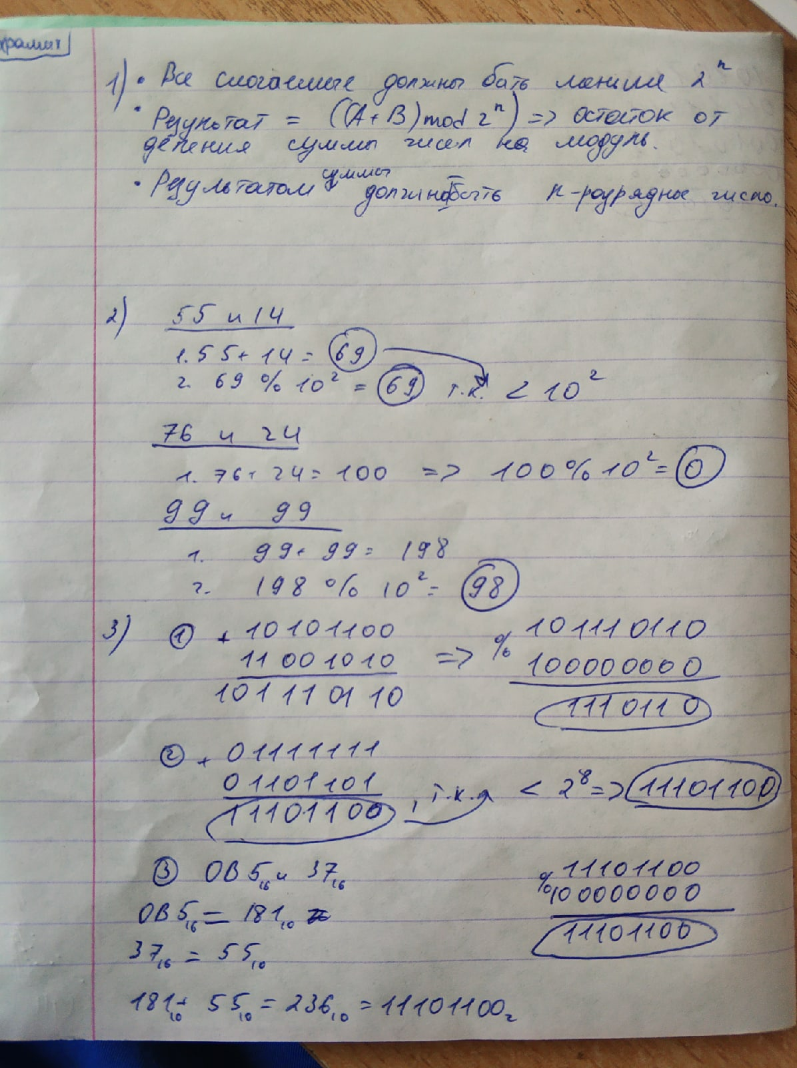

1. **Задания 7-8 из 6-й лабораторной работы №6**

1) Синтезировать структурную схему генератора ПСП на основе регистров сдвига с линейной обратной связью:

a)3210

С(x) = 1 + cx + cx^2 + cx^3 – полином

1

2

3

0 1 2 3 4

001|100|110|011|001

Период:4

б)420

С(x) = 1 + cx^2 + cx^4

1

2

3

4

0 1 2 3 4 5 6

0001|1000|0100|1010|0101|0010|0001

Период:6

в)5410

C(x) = 1 + cx + cx^4 + cx^5

1

2

3

4

5

0 1 2 3 4 5 6 7 8

00001|10000|11000|11100|11110|01111|00111|00011|00001

Период:8

г)520

С(x) = 1 + cx^2 + cx^5

1

2

3

4

5

0 1 2 3 4 5 6 7 8 9 10 11

00001|10000|01000|10100|01010|10101|11010|11101|01110|10111|11011|01101|

12 13 14 15 16 17 18 19 20 21 22 23

00110|00011|10001|11000|11100|11110|11111|01111|00111|10011|11001|01100|

24 25 26 27 28 29 30 31

10110|01011|00101|10010|01001|00100|00010|00001

Период:31

д)84320

С(x) = 1 + cx^2 + cx^3 + cx^4 + cx^8

8

1

2

3

4

5

6

7

0 1 2 3 4 5 6 7

00000001|10000000|01000000|10100000|11010000|01101000|00110100|00011010

8 9 10 11 12 13 14 15

10001101|11000110|11100011|11110001|01111000|10111100|01011110|00101111

16 17 18 19 20 21 22 23

00010111|00001011|10000101|11000010|11100001|11110000|11111000|11111100

24 25 26 27 28 29 30 31

11111110|11111111|01111111|00111111|10011111|01001111|00100111|00010011

32 33 34 35 36 37 38 39

00001001|10000100|01000010|10100001|01010000|00101000|10010100|11001010

40 41 42 43 44 45 46 47

11100101|11110010|11111001|01111100|10111110|01011111|10101111|01010111

48 49 50 51 52 53 54 55

10101011|01010101|10101010|11010101|11101010|01110101|00111010|00011101

56 57 58 59 60 61 62 63

00001110|00000111|10000011|11000001|01100000|00110000|00011000|10001100

64 65 66 67 68 69 70 71

01000110|10100011|01010001|10101000|11010100|01101010|00110101|10011010

72 73 74 75 76 77 78 79

11001101|01100110|00110011|10011001|01001100|10100110|11010011|11101001

80 81 82 83 84 85 86 87

11110100|11111010|11111101|01111110|10111111|11011111|11101111|11110111

88 89 90 91 92 93 94 95

01111011|00111101|10011110|11001111|01100111|10110011|11011001|11101100

96 97 98 99 100 101 102 103

01110110|10111011|11011101|11101110|01110111|00111011|10011101|01001110

104 105 106 107 108 109 110 111

10100111|01010011|10101001|01010100|00101010|10010101|01001010|10100101

112 113 114 115 116 117 118 119

01010010|00101001|00010100|10001010|01000101|00100010|10010001|01001000

120 121 122 123 124 125 126 127

10100100|11010010|01101001|10110100|01011010|00101101|00010110|10001011

128 129 130 131 132 133 134 135

11000101|01100010|00110001|10011000|11001100|11100110|01110011|00111001

136 137 138 139 140 141 142 143

10011100|11001110|11100111|11110011|01111001|00111100|00011110|10001111

144 145 146 147 148 149 150 151

11000111|01100011|10110001|11011000|01101100|00110110|00011011|00001101

152 153 154 155 156 157 158 159

10000110|01000011|00100001|00010000|10001000|01000100|10100010|11010001

160 161 162 163 164 165 166 167

11101000|01110100|10111010|01011101|10101110|11010111|11101011|11110101

168 169 170 171 172 173 174 175

01111010|10111101|11011110|01101111|10110111|11011011|11101101|11110110

176 177 178 179 180 181 182 183

11111011|01111101|00111110|00011111|00001111|10000111|11000011|01100001

184 185 186 187 188 189 190 191

10110000|01011000|00101100|10010110|11001011|01100101|10110010|01011001

192 193 194 195 196 197 198 199

10101100|11010110|01101011|10110101|11011010|01101101|10110110|01011011

200 201 202 203 204 205 206 207

10101101|01010110|00101011|00010101|00001010|00000101|10000010|01000001

208 209 210 211 212 213 214 215

00100000|10010000|11001000|11100100|01110010|10111001|11011100|01101110

216 217 218 219 220 221 222 223

00110111|10011011|01001101|00100110|10010011|01001001|00100100|10010010

224 225 226 227 228 229 230 231

11001001|01100100|00110010|00011001|00001100|00000110|00000011|10000000

232 233 234 235 236 237 238 239

11000000|11100000|01110000|10111000|01011100|00101110|10010111|01001011

240 241 242 243 244 245 246 247

00100101|00010010|10001001|11000100|11100010|01110001|00111000|00011100

248 249 250 251 252 253 254 255

10001110|01000111|00100011|00010001|00001000|00000100|00000010|00000001

Период:255

2) Определить первые 12 бит ПСП, задаваемого формально в виде чисел 5410, если начальные состояния ячеек (слева-направо) соответствуют последовательности 10101.

5410

C(x) = 1 + cx + cx^4 + cx^5

1

2

3

4

5

0 1 2 3 4 5 6 7 8 9 10 11

1010**1**|0101**0**|1010**1**|0101**0**|1010**1**|0101**0**|1010**1**|0101**0**|1010**1**|0101**0**|1010**1**|0101**0**|

Ответ: 101010101010.