Requirements Document

1. Introduction

The name of the project is TaskOrgBot. It will be designed for those, who would like to organize their tasks in a simple and comfortable way. Tasks will be sorted using so called The Eisenhower Method, where tasks are sorted by urgency and importance, and thus will be completed.

1. User Requirements
   1. Software Interfaces

The product will be written in Python using Telegram API.

* 1. User Interfaces

Specify the logical characteristics of each interface between the software product and its users. This is a description of how the system will interact with its users.

The user will interact with bot through following commands:  
1) /new – user adds new task to the list, e. g.

*/new* call mom on Monday with high priority

*/new* feed the cat in 8 hours with high priority

2) /all – shows list of all tasks.

3) /delete – deletes specified task.

*/delete* 5

*/delete* 1

When the time comes, bot should send notification saying what should user do, e. g. "call mom" or "feed the cat".

* 1. User Characteristics

This application is quite simple, so it will be suitable for all user, who has her or his own phone number and Telegram account and application on the mobile phone, tablet or desktop computer. And also basic English knowledge is necessary.

* 1. Assumptions and Dependencies

The application works only through internet connection, hence the bot's performance will depend on internet speed and connection.

1. System Requirements
   1. Functional Requirements

All tasks will be sorted using The Eisenhower Method. Here is the picture, describing it:

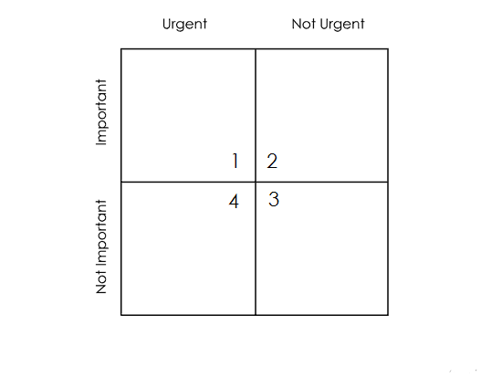

It means that tasks are then handled as follows:

1. First you should do Important/Urgent quadrant.
2. Than you should do Important/Not Urgent quadrant.
3. After that you do Unimportant/Urgent quadrant.
4. And finally do Unimportant/Not Urgent quadrant.
   1. Non-Functional Requirements
      1. Software Quality Attributes

The application should be simple and intuitive for users. Notification should always come on time. Bot should correctly understand the commands.