Conference Management

***Team:*** Echipa-Team

***Members:***

* *Nițu Răzvan*
* *Ovadiuc Vlad*
* *Pașca Vanessa*
* *Pașcu Maria*
* *Petrea Alexandra*

***Team leader:***

*Nițu Răzvan*

*Contents*

*Presentation of the project requirements* 3

*Used technologies* 4

*User manual* 5

*Diagrams* 9

The application allows registration of 6 tipes of users:

1. User
2. Listener
3. Author
4. Speaker
5. Chair/Co-Chair
6. Reviewer

1. **Application functionalities:**

Depending on what type of user are logged in, next functionalities are available:

* + 1. User:
  + registration
  + login
  + pay registration
    1. Author:
  + login
  + add abstract
  + add paper
    1. Listener:
  + login
  + attend sessions
    1. Speaker:

* + login
  + add presentation
    1. Reviewer:
  + registration
  + login
  + bid
  + review
    1. Chair:
  + registration
  + login
  + assign papers
  + see members
  + see users

# Used technologies

1. **Database server**: *PostgresSQL*
2. **Programming language**:
3. **Front-end**: *Java with Angular, HTML, CSS*
4. **Back-end**: *Java, Spring*
5. **ORM**: *Hibernate*
6. **Tools used for diagram creation**: *draw.io and StarUML*
7. **Version control**: *Bitbucket*
8. **Task management**: *Trello*
9. **GUI creation**:  *HTML, CSS*
10. **Client-server communication**: *tomcat 9.0.19*

Installation Process

What you need to get stated:

1. Intellij Ultimate
2. Tomcat 9.0.19
3. Node.js

To get the application, you need to make a new folder in your computer and to open a GitBash, in which you have to run the following command: git clone https://bitbucket.org/iss_9x5/good-project/src/master/

In PgAdmin, create a database named iss. The Tables are created automatically.

Now that you have the project, open it in Intellij. Let it buld the Gradle artifacts and then try to buld it. Next step, click on Run -> Edit Configuration . There you must add a template for Tomcat (in which you must provide the path to the installation of the tomcat on your computer) and the same thing for Angular, but specifying the path for Node.js.

Now you should be able to run the Tomcat which will open a webpage http://localhost:8080/ . The 404 error is not an issue. After that, in the project right-click on the webapp folder -> Open In Terminal -> run : npm install. When it’s done run : npm start. That should compile successfully and provide an URL to <http://localhost:4200/> and that is the actual webpage for our application.

User Manual

The first page contains the information about the conference and 4 buttons : Login as User , Login as PCMember, SignUp as User and SignUp as PCMember. The first step would be a signUp, and here is an example of registration as User.

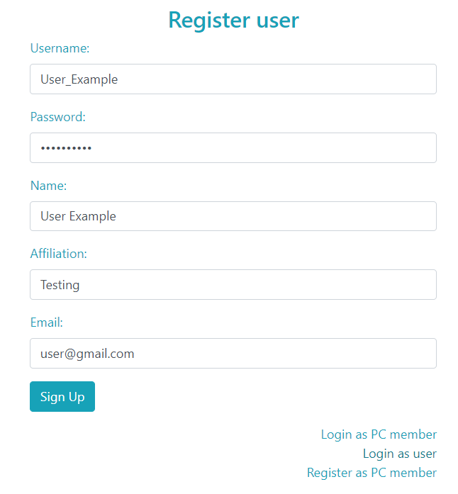

After registration, you provide the username and the password in the LogIn form and press LogIn button. That will redirect to the welcome page of each user:

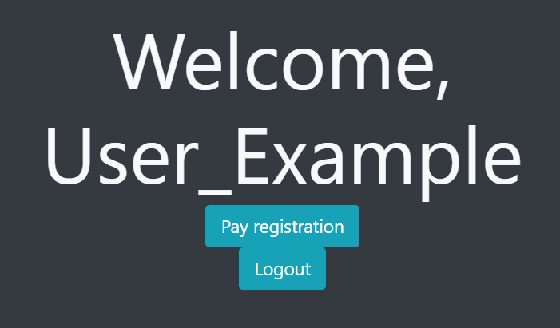

If you want to participate at the conference, you should Pay registration, which will make you a Listener and not a simple User. After paying the registration fee, you will be redirected to the welcome page for Listeners: 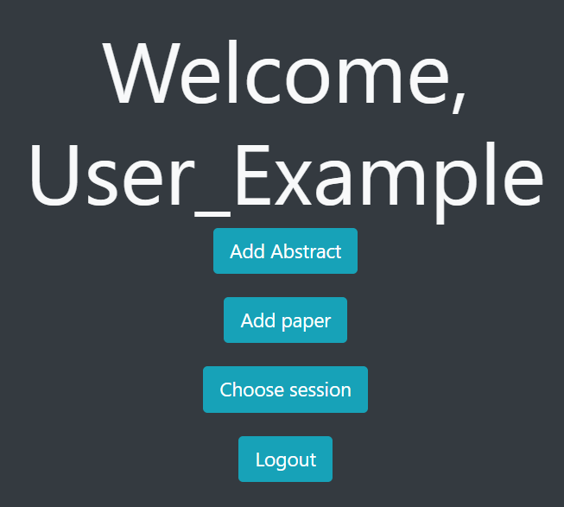

Now, if you just want to participate at the conference, you can Choose the session you want to participate to. But, if you want to be on stage, you have to Add an Abstract of your work,and after the bidding process, if the paper is accepted, the next step is to add the paper and to be reviewed :

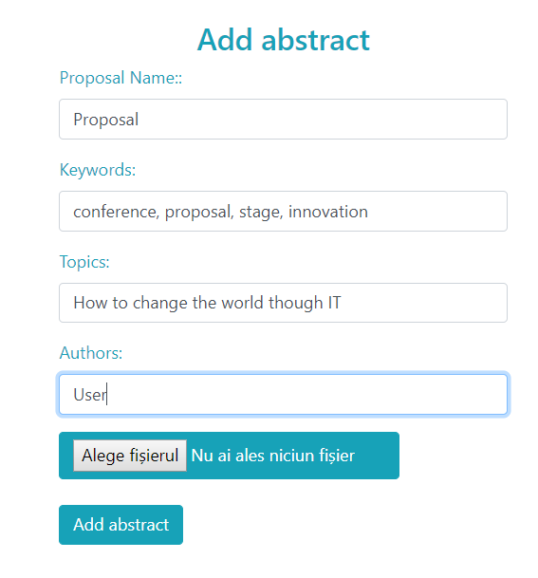

Now, you are an Author, not just a simple Listener.As Author, you can see information about the status of your work, meaning that you see the status of your abstract/paper. Also, the option to participate as Listener to session and to view in which section you will be on stage and in which you will be in public.

You can upload a presentation after your paper is accepted in the conference by PCMembers.

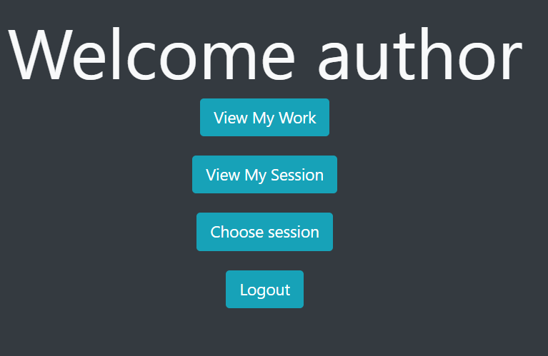

As PCMember, you should also register and Login, which is the same as for the user. After you LogIn, you will be redirected to the home page for PCMember:

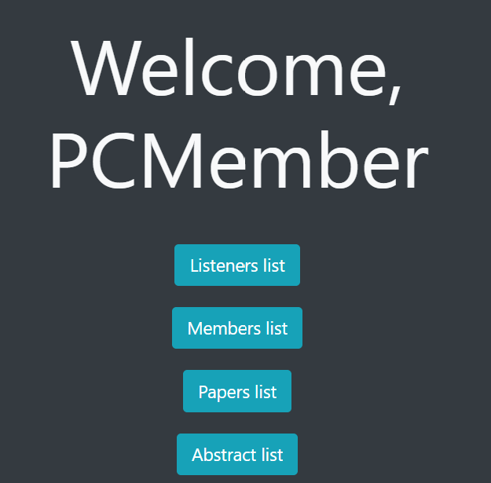

As PCMember, you can see the lists for Abstracts and Papers and also for Listeners and other PCMembers. As Reviewer, you can bid for abstracts and review papers. To do that, you just select yout opinion on an abstract/paper from the list:

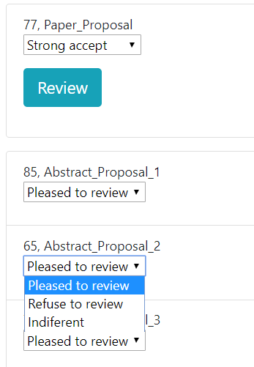

Depending on these results from all reviewers, the status of author’s paper change in accepted/rejected and the authors can see that in their account.

A conference also has a Chair and CoChairs. They are just some PCMembers that cand decide more important things like assigning a paper to a reviewer, and in case of major differences between reviewer, they can re-assign the paper. They can decide even the sessions of the conference and change details about the conference.

