UCLA Document
XID
X00202628
NAME
Vlad Pocris
PROJECT TITLE
RenCloud

Use Cases and Logical Architecture

Section 1: Each Use Case:

Title (goal) | Login
Primary Actor | User/Content creator
Story | Suppose the user want’s to log in for the first time. He can register by using the app or he can login if already done so.

Title (goal) | Uploading Files
Primary Actor | User/Content creator
Story | Suppose the user want’s to upload the project files, He could press a button that would manually mount the NFS volume to it’s computer device

Title (goal) | Specifying the render settings
Primary Actor | User/Content creator
Story | The user should pick the render settings before starting the render process.

Title (goal) | Starting/Finishing Render
Primary Actor | User/Content creator
Story | After successful upload the user wants to start the render process. He press the start button and wait for a notification that would confirm the status.

Title (goal) | Payment
Primary Actor | User/Content creator
Story | How much would the user have to pay using the service? Pay-As-You-Go implementation derived from prices from the cloud.

Section 2: Logical Architecture
LOGIN
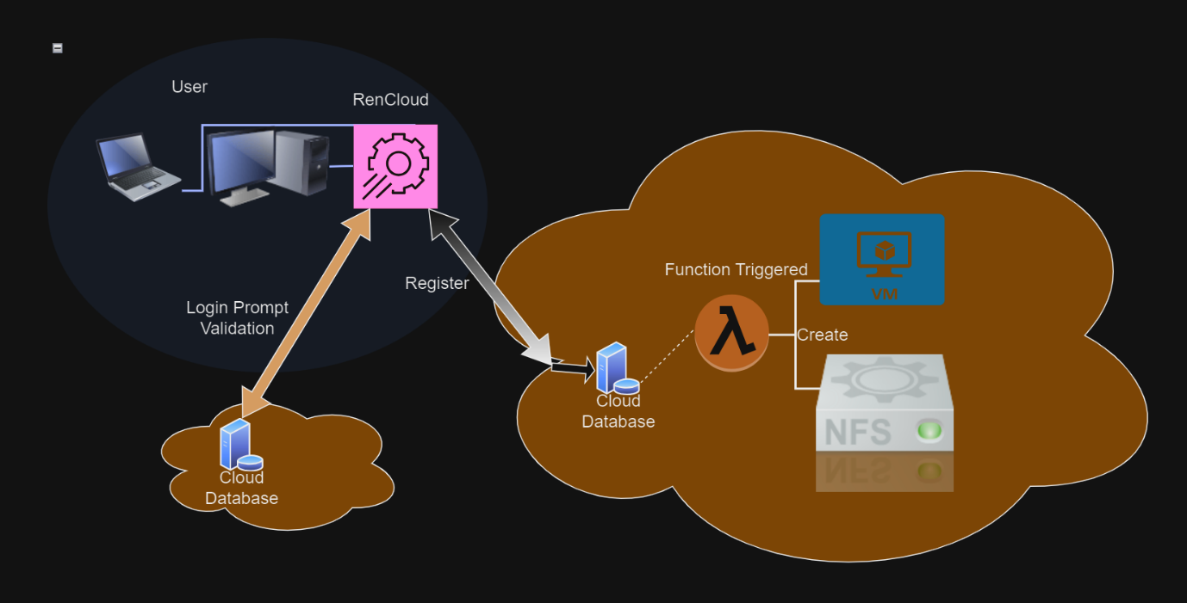

Files Upload
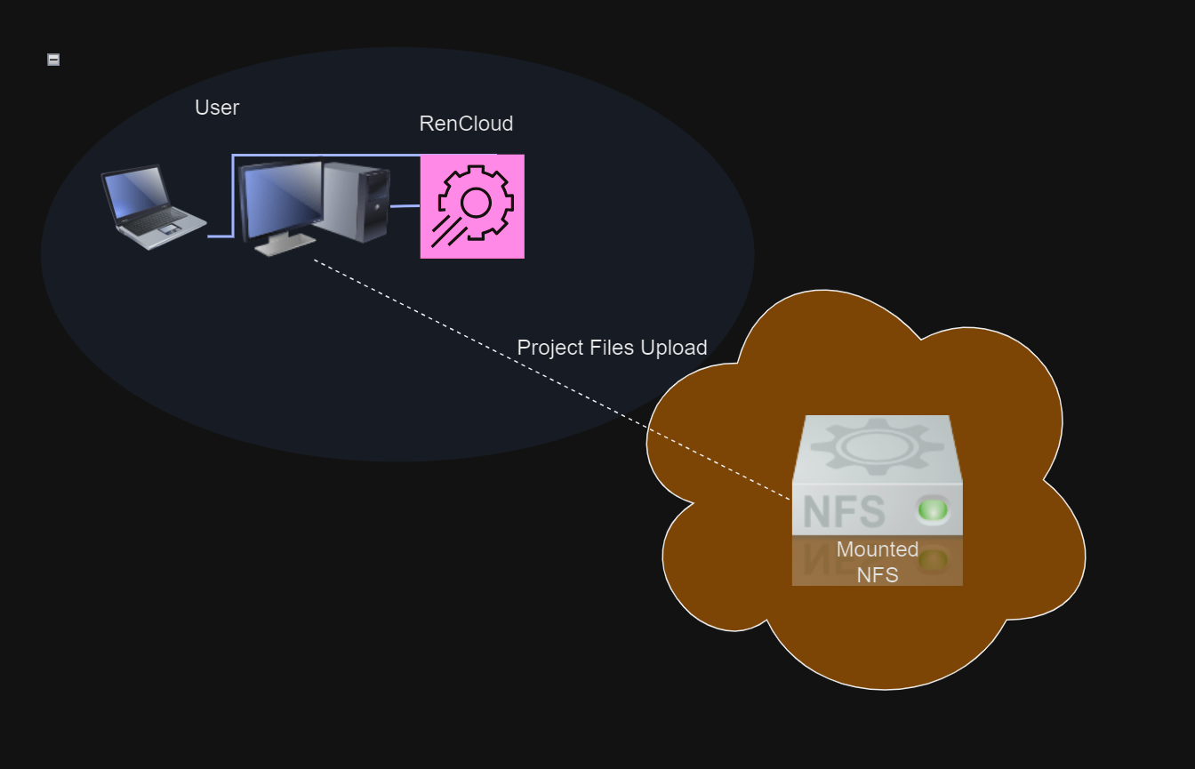

Render Settings
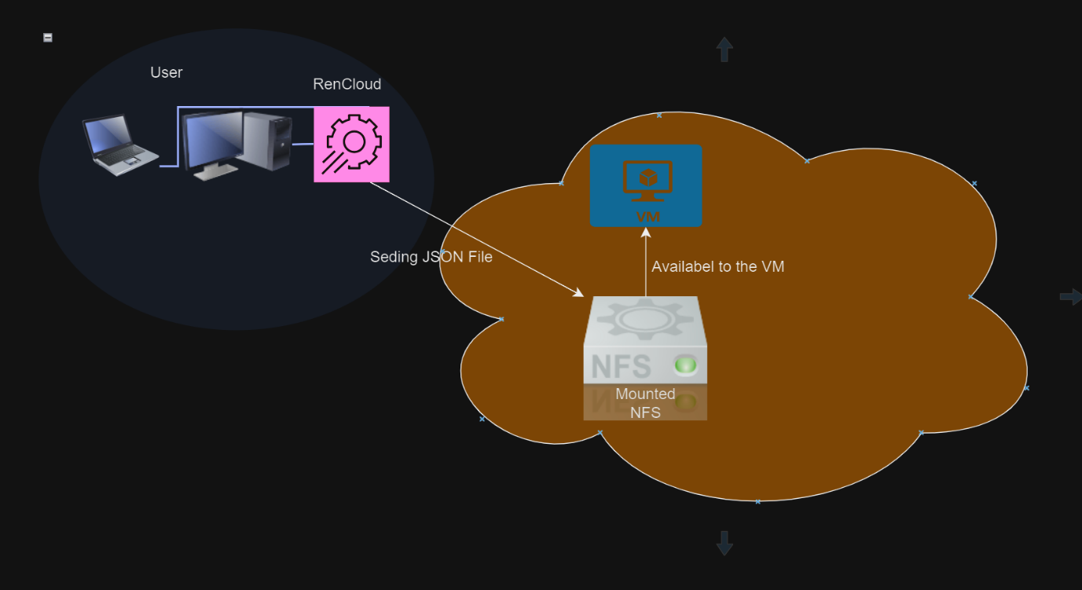

Start/Finishing Render
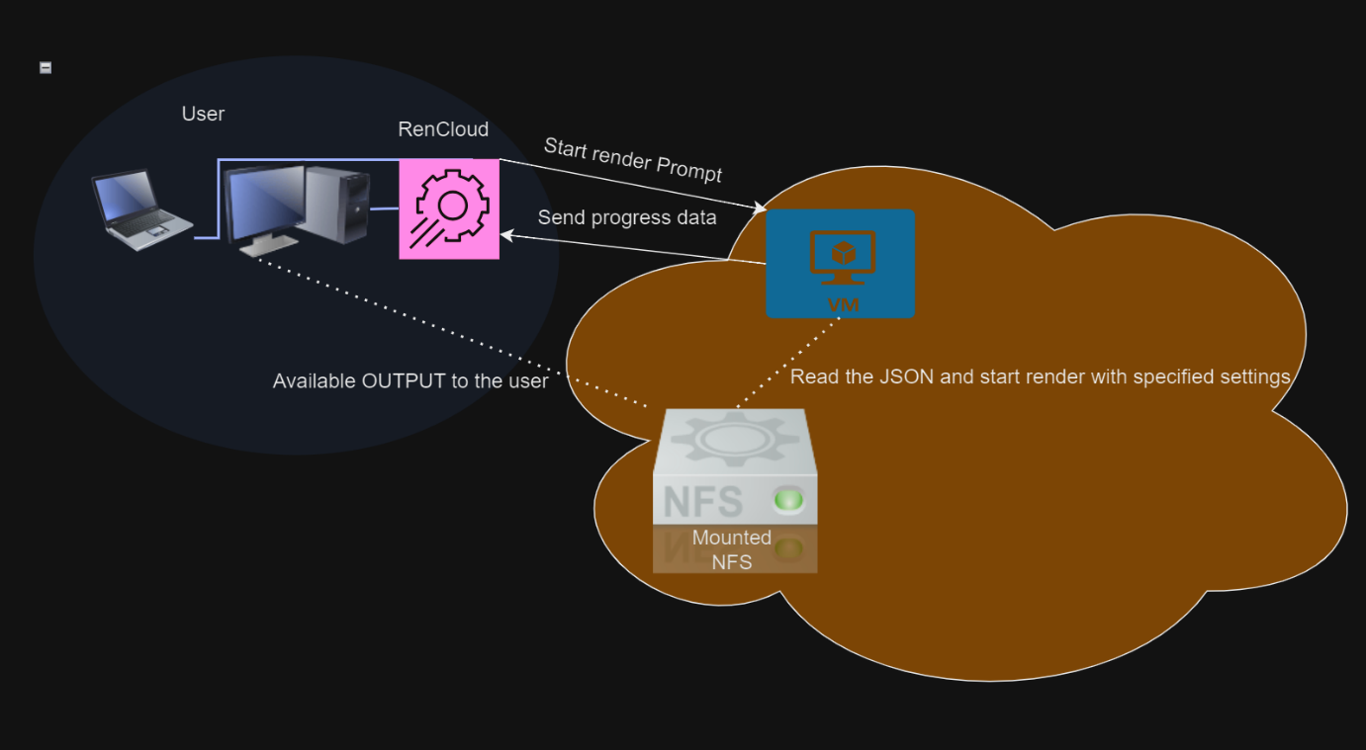

Payment
