**ML Project: Cabbage and weed detection**

1. **Overview**

This project implements a machine learning model to Create a cabbage/weed object detector with YOLO. Creation of a cabbage/weed object detector with YOLO. It uses a dataset of custom videos containing cabbage and weed to train and the model.

1. **DATA:**

**I use 8 videos containing cabbage and weed. Then videos are converted to frames using Python script (). Data set Cabbage/weed creation with Vott (Microsoft).**

* 1. **Create annotations for object detector of images.**

1. **Data preparation**
   1. **Split data set to folders – train and test**
   2. **Annotation of train and test sets of images.**
   3. **Convert Json files from Vott format to YOLO format**
2. **Train YOLO object detector with train set (images in train with train.json)**

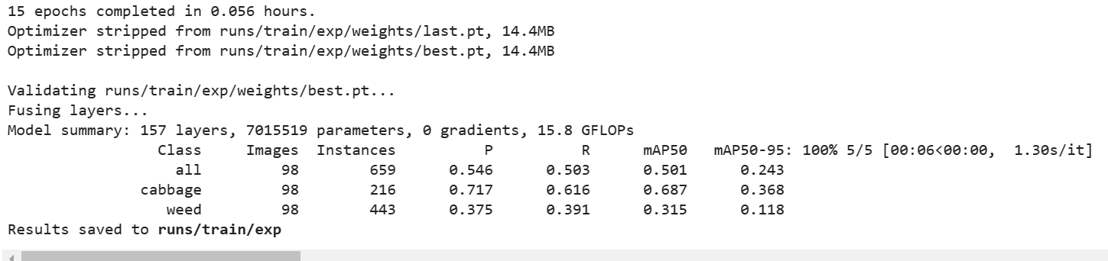

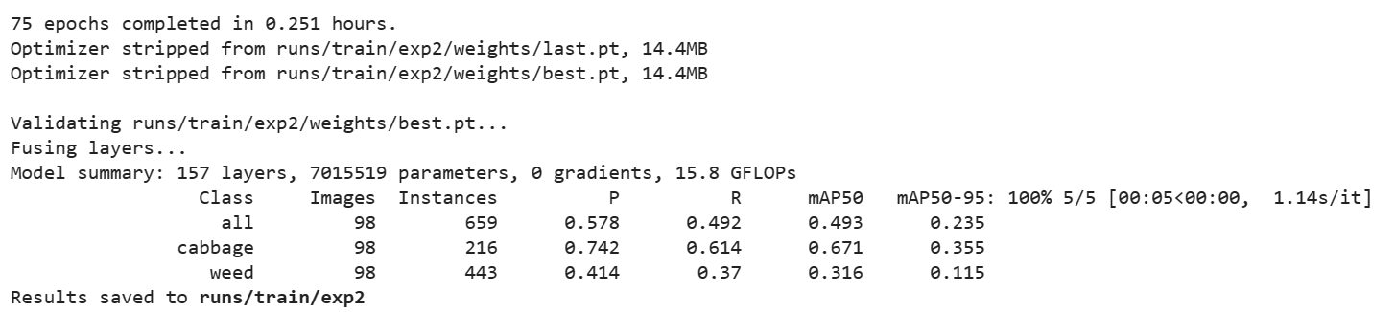

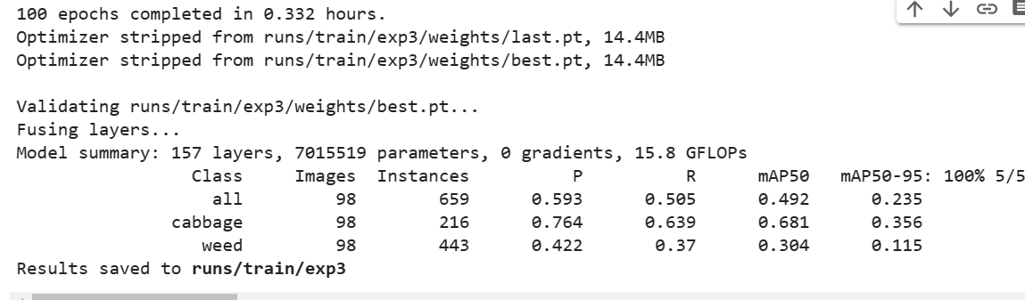

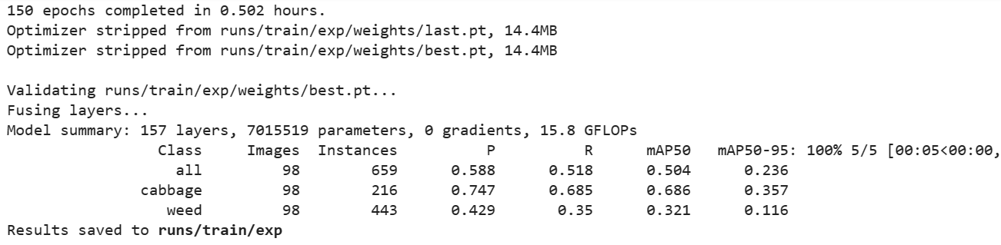

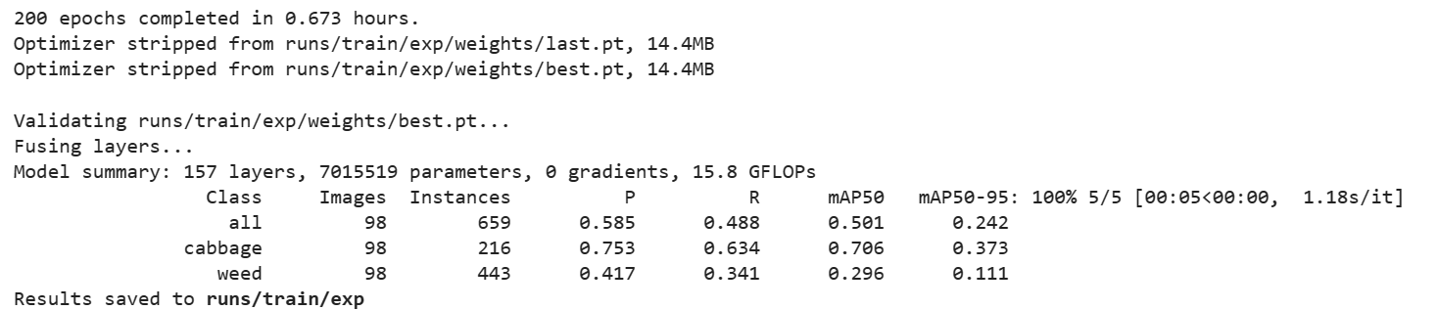

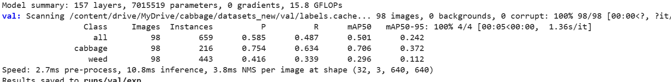

1. **Evaluate trained object detector on test set**