

Honorato C. Perez, Sr. Memorial Science High School 37th Founding Anniversary

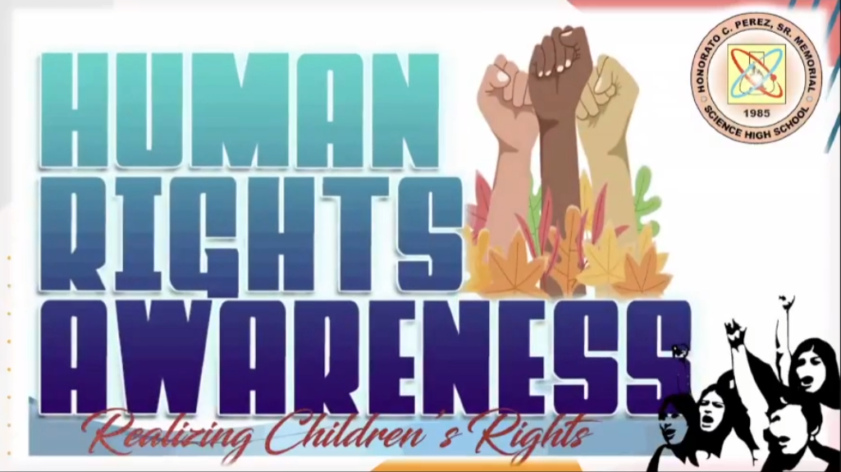

Human Rights Awareness: Realizing Children's Right

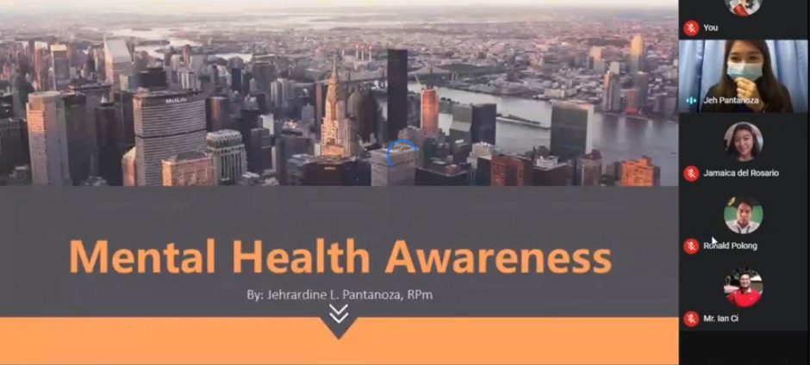

Mental Health Awareness Webinar with Jehrardine L. Pantanoza, RPm a Psychometrician in Dr. Paulino J. Garcia Memorial Research and Medical Center