1st Content

Honorato C. Perez Sr. Memorial Science High School is very proud to have spawned countless number of professionals whose character and talents significantly put the school on the map of leading institutions in the land. The good name it is enjoying today is a validation of its 37 years of excellent service for the students, the best learning place there is for the honing of their values and discipline while pursuing their mathematical, scientific and linguistic inclinations Now, Honorato C. Perez, Sr. Memorial Science High School through the efforts of dedicated teachers who are imbued with the principles and ideas of modern teaching will continue to improve itself in order to serve the YOUTH: the country's future leaders and professionals. They are, after all, the Hope of our Motherland.

3rd Content



### Online Learning

### With the lockdown of Luzon, the University shifted to online delivery of learning, both through synchronous and asynchronous means, in consonance with the guidelines released by the Philippine Commission on Higher Education.

### 

### HCPSMSHS becomes Vaccination Center

In 2021, The school campus opened, particularly the Gymnasium, to be a vaccination center in partnership with the Local Government of the City of Cabanatuan.

4th Content

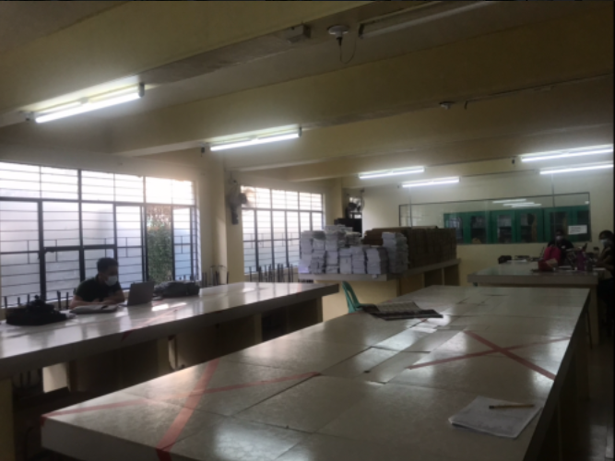

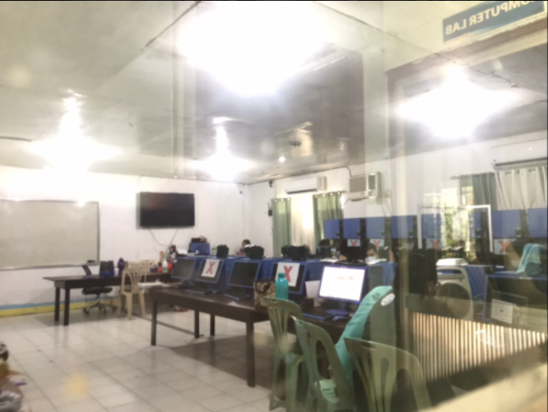

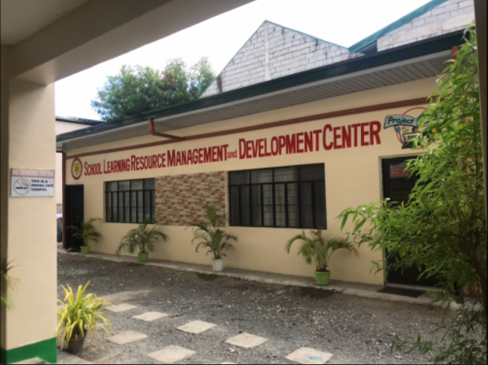

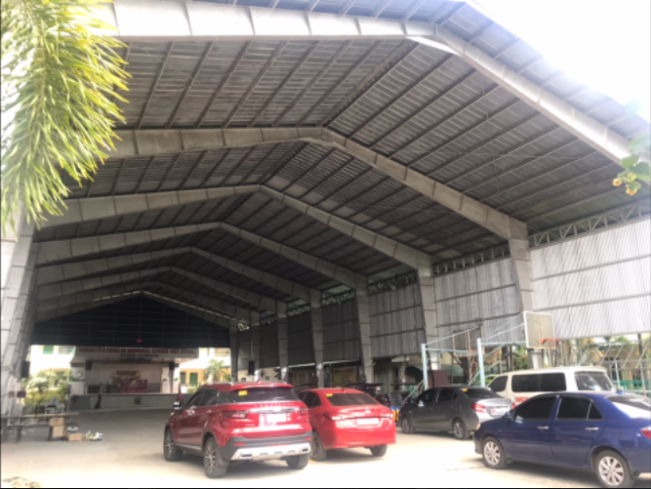

School facilities are one of the basic educational requirements, and it is necessary to maintain safe and high-quality school facilities from the perspective of maintaining and improving educational levels in line with the developmental stage. The quality of education depends on school facilities and instructional material. It is the process of students learning. The quality of a school’s environment and its facilities has a strong influence on students’ learning. Besides regular use in organizing and managing a school’s activities, records of a school’s physical facilities and material resources such as furniture and equipment can provide data to derive many indicators for assessing the quality of education in a school. School facilities can actually have a substantive impact on learning process.