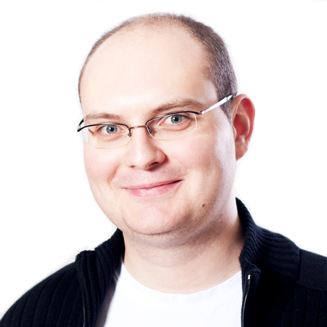
Vlad Ureche
Scala Team at EPFL (LAMP)
School of Computer and Communication Sciences
Swiss Federal Institute of Technology (EPFL)
Email: vlad.ureche@gmail.com
Web: vladureche.ro

Education

09/2010 - present Scala Team at EPFL (LAMP), Lausanne, Switzerland
PhD student under the supervision of Prof. Martin Odersky.

09/2004 - 08/2009 Polytechnic University of Bucharest, Romania
Obtained the 5 year B.Sc. degree with a specialization in Operating Systems and Compilers. The degree is equivalent to M.Eng.

Work and Project Experience

09/2010 - present Research Assistant, Scala Team at EPFL (LAMP), Lausanne, Switzerland

Based on my research, I developed a Scala compiler plugin that improves performance for numeric applications by up to 20x. Example targets include speeding up Scala collections by 2-3x, the Spark big data platform by 40% and performance-oriented code by up to 10x.

The project website is scala-miniboxing.org and it has been presented at:

- Spark Summit Europe 2015 (Amsterdam, Netherlands)
- Devoxx UK 2015 (London, UK)
- ScalaDays 2014 (Berlin, Germany) and 2015 (San Francisco, CA, US)
- PNWScala 2014 (Portland, OR, US)
- Scala Bay Area Meetup 2014 (Mountain View, CA, US)

02/2010 - 07/2010 Internship, Dependable Systems Lab (DSLab) at EPFL, Lausanne, Switzerland

Developed the management scripts for the Cloud9 distributed bug finding tool. In the process, I diagnosed a Linux kernel live-lock that only occurred when running in the cloud, a difficult problem that required careful instrumentation and a good understanding of the kernel memory management routines.

Based on my work, the Cloud9 system found a memory bug in the curl download manager, a piece of software commonly used on servers and embedded devices.

04/2009 - 8/2009 Internship, Adobe Systems, Bucharest, Romania – Analysis Software

Developed big data analytics to better understanding of how Adobe software is used. The highlight of the internship was streamlining the Apache Nutch web crawler, allowing it to crawl 10x more websites compared to the open-source version at the time.

Awards

- Distinguished Artifact Award for the project implementation and documentation, OOPSLA 2015, Pittsburgh, PA
- 7th place in the international Windows Embedded Student Challenge contest, sponsored by Microsoft, 2006, Redmond, WA
- Silver Medal at the International Physics Olympiad, 2004, Pohang, South Korea

Documented on scala-miniboxing.org/example_linkedlist.html and scala-miniboxing.org/example_rrbvector.html
Explained at speakerdeck.com/vladureche/data-centric-metaprogramming-at-spark-summit-eu-2015
Explained at io.pellucid.com/blog/optimistic-respecialization-attempt-6
Now part of the Microsoft Imagine Cup contest, www.imaginecup.com

