Министерство образования Республики Беларусь

Учреждение образования
«Белорусский государственный университет
информатики и радиоэлектроники»

Факультет компьютерных систем и сетей
Кафедра ПОИТ

Дисциплина «Теория информации»

ОТЧЁТ
к лабораторной работе №2
Вариант 15

Студент группы №451001
Волынец В.И.
Руководитель, преподаватель
Болтак С.В.

Минск 2026

Задание: Реализовать систему потокового шифрования и дешифрования для файла с любым содержимым (с любым расширением) с помощью генератора ключевой последовательности на основе линейного сдвигового регистра с обратной связью LFSR(размерность регистра согласно выданному варианту. Начальное состояние регистра ввести с клавиатуры. Поле для ввода состояния регистра должно игнорировать любые символы кроме 0 и 1. Вывести на экран сгенерированный ключ (последовательность из 0 и 1), исходный файл и зашифрованный файл в двоичном виде. На диск сохранить зашифрованный/расшифрованный файл в виде потока байтов. Программа не должна быть написана в консольном режиме. Результат работы программы – зашифрованный/расшифрованный файл.

Используемый примитивный многочлен
Пример работы LFSR по тактам

 | Регистр |  |  |  |  |  |  |  |  |  |  |  |  |  |  |  |  |  |  |  |  |  |  |  |  |  |  |  |  |  |  |  |  |  |  |  |  | xor
 | 37 | 36 | 35 | 34 | 33 | 32 | 31 | 30 | 29 | 28 | 27 | 26 | 25 | 24 | 23 | 22 | 21 | 20 | 19 | 18 | 17 | 16 | 15 | 14 | 13 | 12 | 11 | 10 | 9 | 8 | 7 | 6 | 5 | 4 | 3 | 2 | 1
1 | 1 | 1 | 1 | 1 | 1 | 1 | 1 | 1 | 1 | 1 | 1 | 1 | 1 | 1 | 1 | 1 | 1 | 1 | 1 | 1 | 1 | 1 | 1 | 1 | 1 | 1 | 1 | 1 | 1 | 1 | 1 | 1 | 1 | 1 | 1 | 1 | 1 | 0
2 | 1 | 1 | 1 | 1 | 1 | 1 | 1 | 1 | 1 | 1 | 1 | 1 | 1 | 1 | 1 | 1 | 1 | 1 | 1 | 1 | 1 | 1 | 1 | 1 | 1 | 1 | 1 | 1 | 1 | 1 | 1 | 1 | 1 | 1 | 1 | 1 | 0 | 0
3 | 1 | 1 | 1 | 1 | 1 | 1 | 1 | 1 | 1 | 1 | 1 | 1 | 1 | 1 | 1 | 1 | 1 | 1 | 1 | 1 | 1 | 1 | 1 | 1 | 1 | 1 | 1 | 1 | 1 | 1 | 1 | 1 | 1 | 1 | 1 | 0 | 0 | 1
4 | 1 | 1 | 1 | 1 | 1 | 1 | 1 | 1 | 1 | 1 | 1 | 1 | 1 | 1 | 1 | 1 | 1 | 1 | 1 | 1 | 1 | 1 | 1 | 1 | 1 | 1 | 1 | 1 | 1 | 1 | 1 | 1 | 1 | 1 | 0 | 0 | 1 | 1
5 | 1 | 1 | 1 | 1 | 1 | 1 | 1 | 1 | 1 | 1 | 1 | 1 | 1 | 1 | 1 | 1 | 1 | 1 | 1 | 1 | 1 | 1 | 1 | 1 | 1 | 1 | 1 | 1 | 1 | 1 | 1 | 1 | 1 | 0 | 0 | 1 | 1 | 0
6 | 1 | 1 | 1 | 1 | 1 | 1 | 1 | 1 | 1 | 1 | 1 | 1 | 1 | 1 | 1 | 1 | 1 | 1 | 1 | 1 | 1 | 1 | 1 | 1 | 1 | 1 | 1 | 1 | 1 | 1 | 1 | 1 | 0 | 0 | 1 | 1 | 0 | 0
7 | 1 | 1 | 1 | 1 | 1 | 1 | 1 | 1 | 1 | 1 | 1 | 1 | 1 | 1 | 1 | 1 | 1 | 1 | 1 | 1 | 1 | 1 | 1 | 1 | 1 | 1 | 1 | 1 | 1 | 1 | 1 | 0 | 0 | 1 | 1 | 0 | 0 | 1
8 | 1 | 1 | 1 | 1 | 1 | 1 | 1 | 1 | 1 | 1 | 1 | 1 | 1 | 1 | 1 | 1 | 1 | 1 | 1 | 1 | 1 | 1 | 1 | 1 | 1 | 1 | 1 | 1 | 1 | 1 | 0 | 0 | 1 | 1 | 0 | 0 | 1 | 1
9 | 1 | 1 | 1 | 1 | 1 | 1 | 1 | 1 | 1 | 1 | 1 | 1 | 1 | 1 | 1 | 1 | 1 | 1 | 1 | 1 | 1 | 1 | 1 | 1 | 1 | 1 | 1 | 1 | 1 | 0 | 0 | 1 | 1 | 0 | 0 | 1 | 1 | 0
10 | 1 | 1 | 1 | 1 | 1 | 1 | 1 | 1 | 1 | 1 | 1 | 1 | 1 | 1 | 1 | 1 | 1 | 1 | 1 | 1 | 1 | 1 | 1 | 1 | 1 | 1 | 1 | 1 | 0 | 0 | 1 | 1 | 0 | 0 | 1 | 1 | 0 | 0
11 | 1 | 1 | 1 | 1 | 1 | 1 | 1 | 1 | 1 | 1 | 1 | 1 | 1 | 1 | 1 | 1 | 1 | 1 | 1 | 1 | 1 | 1 | 1 | 1 | 1 | 1 | 1 | 0 | 0 | 1 | 1 | 0 | 0 | 1 | 1 | 0 | 0 | 0
12 | 1 | 1 | 1 | 1 | 1 | 1 | 1 | 1 | 1 | 1 | 1 | 1 | 1 | 1 | 1 | 1 | 1 | 1 | 1 | 1 | 1 | 1 | 1 | 1 | 1 | 1 | 0 | 0 | 1 | 1 | 0 | 0 | 1 | 1 | 0 | 0 | 0 | 0
13 | 1 | 1 | 1 | 1 | 1 | 1 | 1 | 1 | 1 | 1 | 1 | 1 | 1 | 1 | 1 | 1 | 1 | 1 | 1 | 1 | 1 | 1 | 1 | 1 | 1 | 0 | 0 | 1 | 1 | 0 | 0 | 1 | 1 | 0 | 0 | 0 | 0 | 0
14 | 1 | 1 | 1 | 1 | 1 | 1 | 1 | 1 | 1 | 1 | 1 | 1 | 1 | 1 | 1 | 1 | 1 | 1 | 1 | 1 | 1 | 1 | 1 | 1 | 0 | 0 | 1 | 1 | 0 | 0 | 1 | 1 | 0 | 0 | 0 | 0 | 0 | 0
15 | 1 | 1 | 1 | 1 | 1 | 1 | 1 | 1 | 1 | 1 | 1 | 1 | 1 | 1 | 1 | 1 | 1 | 1 | 1 | 1 | 1 | 1 | 1 | 0 | 0 | 1 | 1 | 0 | 0 | 1 | 1 | 0 | 0 | 0 | 0 | 0 | 0 | 0
16 | 1 | 1 | 1 | 1 | 1 | 1 | 1 | 1 | 1 | 1 | 1 | 1 | 1 | 1 | 1 | 1 | 1 | 1 | 1 | 1 | 1 | 1 | 0 | 0 | 1 | 1 | 0 | 0 | 1 | 1 | 0 | 0 | 0 | 0 | 0 | 0 | 0 | 0
17 | 1 | 1 | 1 | 1 | 1 | 1 | 1 | 1 | 1 | 1 | 1 | 1 | 1 | 1 | 1 | 1 | 1 | 1 | 1 | 1 | 1 | 0 | 0 | 1 | 1 | 0 | 0 | 1 | 1 | 0 | 0 | 0 | 0 | 0 | 0 | 0 | 0 | 0
18 | 1 | 1 | 1 | 1 | 1 | 1 | 1 | 1 | 1 | 1 | 1 | 1 | 1 | 1 | 1 | 1 | 1 | 1 | 1 | 1 | 0 | 0 | 1 | 1 | 0 | 0 | 1 | 1 | 0 | 0 | 0 | 0 | 0 | 0 | 0 | 0 | 0 | 0
19 | 1 | 1 | 1 | 1 | 1 | 1 | 1 | 1 | 1 | 1 | 1 | 1 | 1 | 1 | 1 | 1 | 1 | 1 | 1 | 0 | 0 | 1 | 1 | 0 | 0 | 1 | 1 | 0 | 0 | 0 | 0 | 0 | 0 | 0 | 0 | 0 | 0 | 0
20 | 1 | 1 | 1 | 1 | 1 | 1 | 1 | 1 | 1 | 1 | 1 | 1 | 1 | 1 | 1 | 1 | 1 | 1 | 0 | 0 | 1 | 1 | 0 | 0 | 1 | 1 | 0 | 0 | 0 | 0 | 0 | 0 | 0 | 0 | 0 | 0 | 0 | 0
21 | 1 | 1 | 1 | 1 | 1 | 1 | 1 | 1 | 1 | 1 | 1 | 1 | 1 | 1 | 1 | 1 | 1 | 0 | 0 | 1 | 1 | 0 | 0 | 1 | 1 | 0 | 0 | 0 | 0 | 0 | 0 | 0 | 0 | 0 | 0 | 0 | 0 | 1
22 | 1 | 1 | 1 | 1 | 1 | 1 | 1 | 1 | 1 | 1 | 1 | 1 | 1 | 1 | 1 | 1 | 0 | 0 | 1 | 1 | 0 | 0 | 1 | 1 | 0 | 0 | 0 | 0 | 0 | 0 | 0 | 0 | 0 | 0 | 0 | 0 | 1 | 1
23 | 1 | 1 | 1 | 1 | 1 | 1 | 1 | 1 | 1 | 1 | 1 | 1 | 1 | 1 | 1 | 0 | 0 | 1 | 1 | 0 | 0 | 1 | 1 | 0 | 0 | 0 | 0 | 0 | 0 | 0 | 0 | 0 | 0 | 0 | 0 | 1 | 1 | 0
24 | 1 | 1 | 1 | 1 | 1 | 1 | 1 | 1 | 1 | 1 | 1 | 1 | 1 | 1 | 0 | 0 | 1 | 1 | 0 | 0 | 1 | 1 | 0 | 0 | 0 | 0 | 0 | 0 | 0 | 0 | 0 | 0 | 0 | 0 | 1 | 1 | 0 | 0
25 | 1 | 1 | 1 | 1 | 1 | 1 | 1 | 1 | 1 | 1 | 1 | 1 | 1 | 0 | 0 | 1 | 1 | 0 | 0 | 1 | 1 | 0 | 0 | 0 | 0 | 0 | 0 | 0 | 0 | 0 | 0 | 0 | 0 | 1 | 1 | 0 | 0 | 1
26 | 1 | 1 | 1 | 1 | 1 | 1 | 1 | 1 | 1 | 1 | 1 | 1 | 0 | 0 | 1 | 1 | 0 | 0 | 1 | 1 | 0 | 0 | 0 | 0 | 0 | 0 | 0 | 0 | 0 | 0 | 0 | 0 | 1 | 1 | 0 | 0 | 1 | 1
27 | 1 | 1 | 1 | 1 | 1 | 1 | 1 | 1 | 1 | 1 | 1 | 0 | 0 | 1 | 1 | 0 | 0 | 1 | 1 | 0 | 0 | 0 | 0 | 0 | 0 | 0 | 0 | 0 | 0 | 0 | 0 | 1 | 1 | 0 | 0 | 1 | 1 | 0
28 | 1 | 1 | 1 | 1 | 1 | 1 | 1 | 1 | 1 | 1 | 0 | 0 | 1 | 1 | 0 | 0 | 1 | 1 | 0 | 0 | 0 | 0 | 0 | 0 | 0 | 0 | 0 | 0 | 0 | 0 | 1 | 1 | 0 | 0 | 1 | 1 | 0 | 0
29 | 1 | 1 | 1 | 1 | 1 | 1 | 1 | 1 | 1 | 0 | 0 | 1 | 1 | 0 | 0 | 1 | 1 | 0 | 0 | 0 | 0 | 0 | 0 | 0 | 0 | 0 | 0 | 0 | 0 | 1 | 1 | 0 | 0 | 1 | 1 | 0 | 0 | 1
30 | 1 | 1 | 1 | 1 | 1 | 1 | 1 | 1 | 0 | 0 | 1 | 1 | 0 | 0 | 1 | 1 | 0 | 0 | 0 | 0 | 0 | 0 | 0 | 0 | 0 | 0 | 0 | 0 | 1 | 1 | 0 | 0 | 1 | 1 | 0 | 0 | 1 | 1
31 | 1 | 1 | 1 | 1 | 1 | 1 | 1 | 0 | 0 | 1 | 1 | 0 | 0 | 1 | 1 | 0 | 0 | 0 | 0 | 0 | 0 | 0 | 0 | 0 | 0 | 0 | 0 | 1 | 1 | 0 | 0 | 1 | 1 | 0 | 0 | 1 | 1 | 1
32 | 1 | 1 | 1 | 1 | 1 | 1 | 0 | 0 | 1 | 1 | 0 | 0 | 1 | 1 | 0 | 0 | 0 | 0 | 0 | 0 | 0 | 0 | 0 | 0 | 0 | 0 | 1 | 1 | 0 | 0 | 1 | 1 | 0 | 0 | 1 | 1 | 1 | 1
33 | 1 | 1 | 1 | 1 | 1 | 0 | 0 | 1 | 1 | 0 | 0 | 1 | 1 | 0 | 0 | 0 | 0 | 0 | 0 | 0 | 0 | 0 | 0 | 0 | 0 | 1 | 1 | 0 | 0 | 1 | 1 | 0 | 0 | 1 | 1 | 1 | 1 | 1
34 | 1 | 1 | 1 | 1 | 0 | 0 | 1 | 1 | 0 | 0 | 1 | 1 | 0 | 0 | 0 | 0 | 0 | 0 | 0 | 0 | 0 | 0 | 0 | 0 | 1 | 1 | 0 | 0 | 1 | 1 | 0 | 0 | 1 | 1 | 1 | 1 | 1 | 1
35 | 1 | 1 | 1 | 0 | 0 | 1 | 1 | 0 | 0 | 1 | 1 | 0 | 0 | 0 | 0 | 0 | 0 | 0 | 0 | 0 | 0 | 0 | 0 | 1 | 1 | 0 | 0 | 1 | 1 | 0 | 0 | 1 | 1 | 1 | 1 | 1 | 1 | 1
36 | 1 | 1 | 0 | 0 | 1 | 1 | 0 | 0 | 1 | 1 | 0 | 0 | 0 | 0 | 0 | 0 | 0 | 0 | 0 | 0 | 0 | 0 | 1 | 1 | 0 | 0 | 1 | 1 | 0 | 0 | 1 | 1 | 1 | 1 | 1 | 1 | 1 | 1
37 | 1 | 0 | 0 | 1 | 1 | 0 | 0 | 1 | 1 | 0 | 0 | 0 | 0 | 0 | 0 | 0 | 0 | 0 | 0 | 0 | 0 | 1 | 1 | 0 | 0 | 1 | 1 | 0 | 0 | 1 | 1 | 1 | 1 | 1 | 1 | 1 | 1 | 1
38 | 0 | 0 | 1 | 1 | 0 | 0 | 1 | 1 | 0 | 0 | 0 | 0 | 0 | 0 | 0 | 0 | 0 | 0 | 0 | 0 | 1 | 1 | 0 | 0 | 1 | 1 | 0 | 0 | 1 | 1 | 1 | 1 | 1 | 1 | 1 | 1 | 1 | 0
39 | 0 | 1 | 1 | 0 | 0 | 1 | 1 | 0 | 0 | 0 | 0 | 0 | 0 | 0 | 0 | 0 | 0 | 0 | 0 | 1 | 1 | 0 | 0 | 1 | 1 | 0 | 0 | 1 | 1 | 1 | 1 | 1 | 1 | 1 | 1 | 1 | 0 | 0
40 | 1 | 1 | 0 | 0 | 1 | 1 | 0 | 0 | 0 | 0 | 0 | 0 | 0 | 0 | 0 | 0 | 0 | 0 | 1 | 1 | 0 | 0 | 1 | 1 | 0 | 0 | 1 | 1 | 1 | 1 | 1 | 1 | 1 | 1 | 1 | 0 | 0 | 0
41 | 1 | 0 | 0 | 1 | 1 | 0 | 0 | 0 | 0 | 0 | 0 | 0 | 0 | 0 | 0 | 0 | 0 | 1 | 1 | 0 | 0 | 1 | 1 | 0 | 0 | 1 | 1 | 1 | 1 | 1 | 1 | 1 | 1 | 1 | 0 | 0 | 0 | 1
42 | 0 | 0 | 1 | 1 | 0 | 0 | 0 | 0 | 0 | 0 | 0 | 0 | 0 | 0 | 0 | 0 | 1 | 1 | 0 | 0 | 1 | 1 | 0 | 0 | 1 | 1 | 1 | 1 | 1 | 1 | 1 | 1 | 1 | 0 | 0 | 0 | 1 | 0
43 | 0 | 1 | 1 | 0 | 0 | 0 | 0 | 0 | 0 | 0 | 0 | 0 | 0 | 0 | 0 | 1 | 1 | 0 | 0 | 1 | 1 | 0 | 0 | 1 | 1 | 1 | 1 | 1 | 1 | 1 | 1 | 1 | 0 | 0 | 0 | 1 | 0 | 1
44 | 1 | 1 | 0 | 0 | 0 | 0 | 0 | 0 | 0 | 0 | 0 | 0 | 0 | 0 | 1 | 1 | 0 | 0 | 1 | 1 | 0 | 0 | 1 | 1 | 1 | 1 | 1 | 1 | 1 | 1 | 1 | 0 | 0 | 0 | 1 | 0 | 1 | 1
45 | 1 | 0 | 0 | 0 | 0 | 0 | 0 | 0 | 0 | 0 | 0 | 0 | 0 | 1 | 1 | 0 | 0 | 1 | 1 | 0 | 0 | 1 | 1 | 1 | 1 | 1 | 1 | 1 | 1 | 1 | 0 | 0 | 0 | 1 | 0 | 1 | 1 | 0
46 | 0 | 0 | 0 | 0 | 0 | 0 | 0 | 0 | 0 | 0 | 0 | 0 | 1 | 1 | 0 | 0 | 1 | 1 | 0 | 0 | 1 | 1 | 1 | 1 | 1 | 1 | 1 | 1 | 1 | 0 | 0 | 0 | 1 | 0 | 1 | 1 | 0 | 1
47 | 0 | 0 | 0 | 0 | 0 | 0 | 0 | 0 | 0 | 0 | 0 | 1 | 1 | 0 | 0 | 1 | 1 | 0 | 0 | 1 | 1 | 1 | 1 | 1 | 1 | 1 | 1 | 1 | 0 | 0 | 0 | 1 | 0 | 1 | 1 | 0 | 1 | 0
48 | 0 | 0 | 0 | 0 | 0 | 0 | 0 | 0 | 0 | 0 | 1 | 1 | 0 | 0 | 1 | 1 | 0 | 0 | 1 | 1 | 1 | 1 | 1 | 1 | 1 | 1 | 1 | 0 | 0 | 0 | 1 | 0 | 1 | 1 | 0 | 1 | 0 | 0
49 | 0 | 0 | 0 | 0 | 0 | 0 | 0 | 0 | 0 | 1 | 1 | 0 | 0 | 1 | 1 | 0 | 0 | 1 | 1 | 1 | 1 | 1 | 1 | 1 | 1 | 1 | 0 | 0 | 0 | 1 | 0 | 1 | 1 | 0 | 1 | 0 | 0 | 1
50 | 0 | 0 | 0 | 0 | 0 | 0 | 0 | 0 | 1 | 1 | 0 | 0 | 1 | 1 | 0 | 0 | 1 | 1 | 1 | 1 | 1 | 1 | 1 | 1 | 1 | 0 | 0 | 0 | 1 | 0 | 1 | 1 | 0 | 1 | 0 | 0 | 1 | 0
51 | 0 | 0 | 0 | 0 | 0 | 0 | 0 | 1 | 1 | 0 | 0 | 1 | 1 | 0 | 0 | 1 | 1 | 1 | 1 | 1 | 1 | 1 | 1 | 1 | 0 | 0 | 0 | 1 | 0 | 1 | 1 | 0 | 1 | 0 | 0 | 1 | 0 | 0
52 | 0 | 0 | 0 | 0 | 0 | 0 | 1 | 1 | 0 | 0 | 1 | 1 | 0 | 0 | 1 | 1 | 1 | 1 | 1 | 1 | 1 | 1 | 1 | 0 | 0 | 0 | 1 | 0 | 1 | 1 | 0 | 1 | 0 | 0 | 1 | 0 | 0 | 0
53 | 0 | 0 | 0 | 0 | 0 | 1 | 1 | 0 | 0 | 1 | 1 | 0 | 0 | 1 | 1 | 1 | 1 | 1 | 1 | 1 | 1 | 1 | 0 | 0 | 0 | 1 | 0 | 1 | 1 | 0 | 1 | 0 | 0 | 1 | 0 | 0 | 0 | 0
54 | 0 | 0 | 0 | 0 | 1 | 1 | 0 | 0 | 1 | 1 | 0 | 0 | 1 | 1 | 1 | 1 | 1 | 1 | 1 | 1 | 1 | 0 | 0 | 0 | 1 | 0 | 1 | 1 | 0 | 1 | 0 | 0 | 1 | 0 | 0 | 0 | 0 | 1
55 | 0 | 0 | 0 | 1 | 1 | 0 | 0 | 1 | 1 | 0 | 0 | 1 | 1 | 1 | 1 | 1 | 1 | 1 | 1 | 1 | 0 | 0 | 0 | 1 | 0 | 1 | 1 | 0 | 1 | 0 | 0 | 1 | 0 | 0 | 0 | 0 | 1 | 1
56 | 0 | 0 | 1 | 1 | 0 | 0 | 1 | 1 | 0 | 0 | 1 | 1 | 1 | 1 | 1 | 1 | 1 | 1 | 1 | 0 | 0 | 0 | 1 | 0 | 1 | 1 | 0 | 1 | 0 | 0 | 1 | 0 | 0 | 0 | 0 | 1 | 1 | 1
57 | 0 | 1 | 1 | 0 | 0 | 1 | 1 | 0 | 0 | 1 | 1 | 1 | 1 | 1 | 1 | 1 | 1 | 1 | 0 | 0 | 0 | 1 | 0 | 1 | 1 | 0 | 1 | 0 | 0 | 1 | 0 | 0 | 0 | 0 | 1 | 1 | 1 | 1
58 | 1 | 1 | 0 | 0 | 1 | 1 | 0 | 0 | 1 | 1 | 1 | 1 | 1 | 1 | 1 | 1 | 1 | 0 | 0 | 0 | 1 | 0 | 1 | 1 | 0 | 1 | 0 | 0 | 1 | 0 | 0 | 0 | 0 | 1 | 1 | 1 | 1 | 1
59 | 1 | 0 | 0 | 1 | 1 | 0 | 0 | 1 | 1 | 1 | 1 | 1 | 1 | 1 | 1 | 1 | 0 | 0 | 0 | 1 | 0 | 1 | 1 | 0 | 1 | 0 | 0 | 1 | 0 | 0 | 0 | 0 | 1 | 1 | 1 | 1 | 1 | 1
60 | 0 | 0 | 1 | 1 | 0 | 0 | 1 | 1 | 1 | 1 | 1 | 1 | 1 | 1 | 1 | 0 | 0 | 0 | 1 | 0 | 1 | 1 | 0 | 1 | 0 | 0 | 1 | 0 | 0 | 0 | 0 | 1 | 1 | 1 | 1 | 1 | 1 | 1

Тестирование
Текстовый файл test1.txt

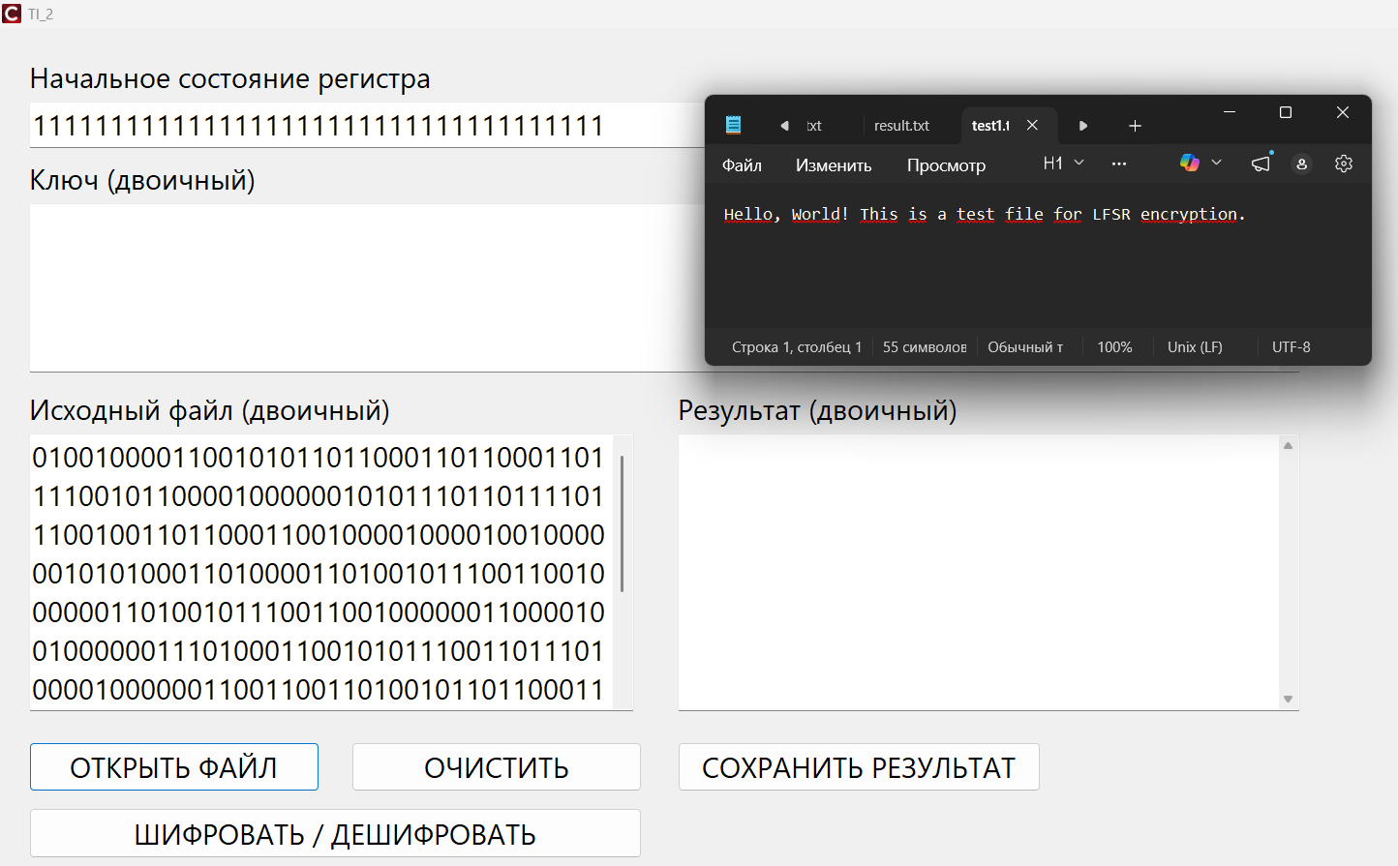

После шифрования записываем результат в result1.txt, предсказуемо получаем кракозябры. Начало ключа совпадает с началом ключа из таблицы.
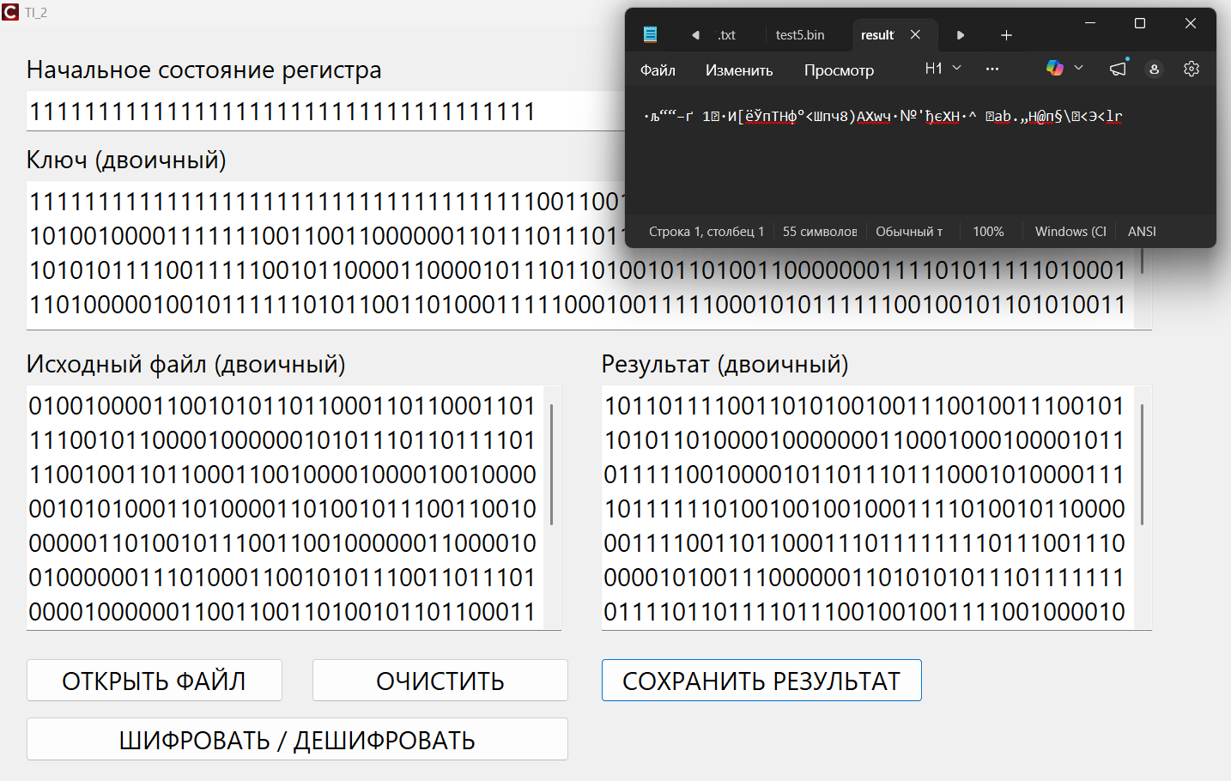
Дешифруем зашифрованное в тот же result1.txt, снова получаем исходный текст
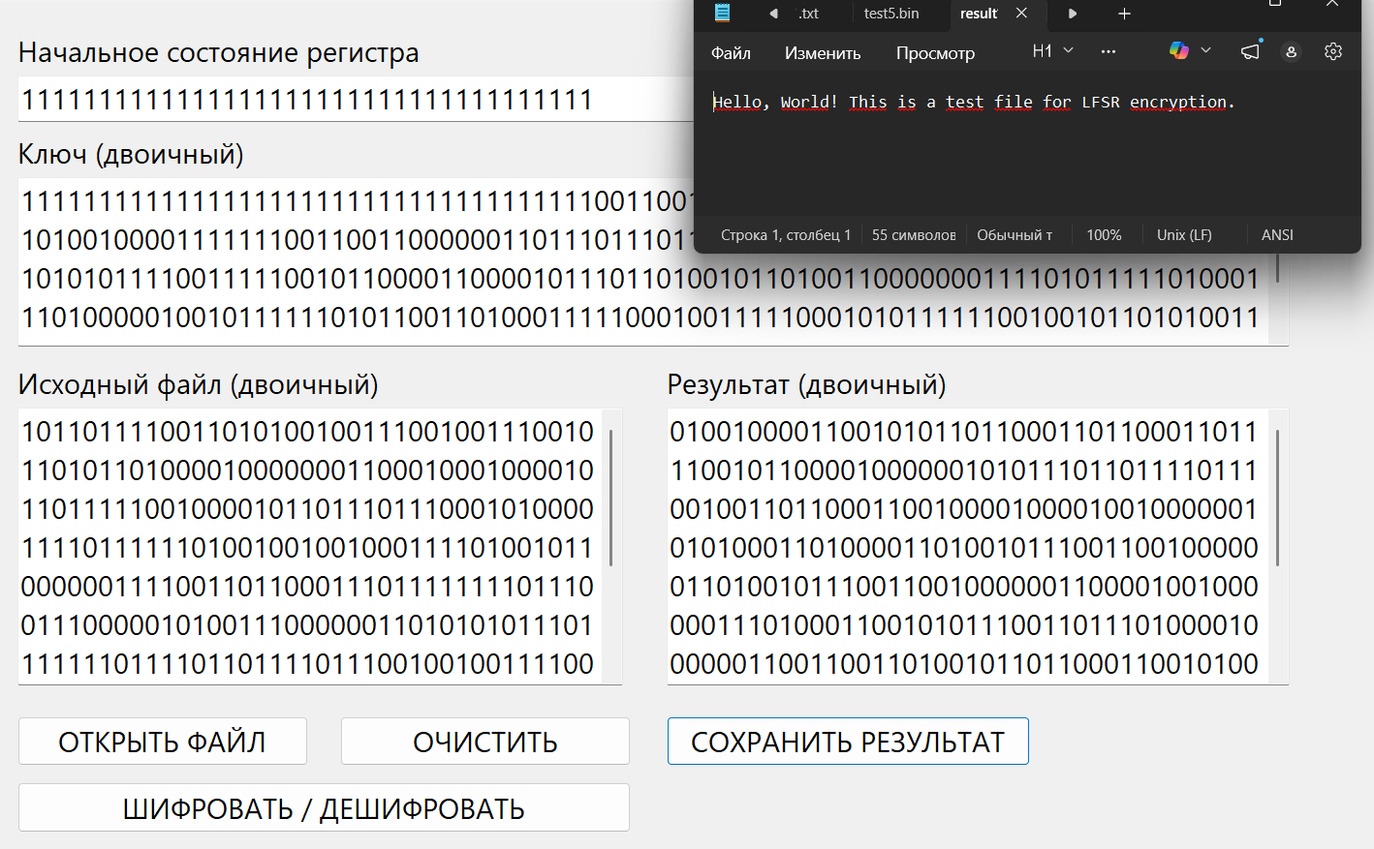

Графический файл test2.jpg
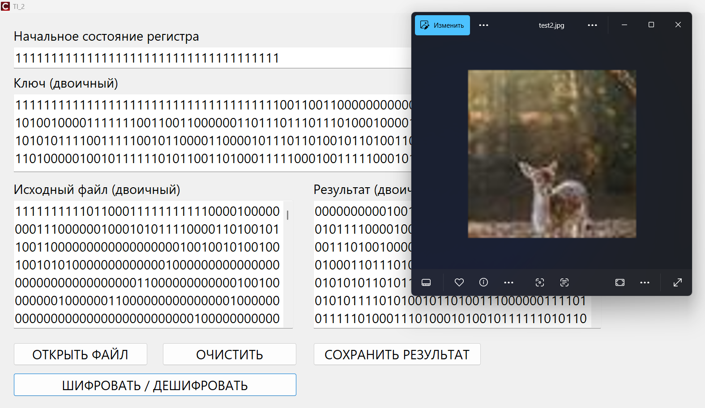

После шифрования записываем результат в result2.jpg, предсказуемо получаем неоткрывающийся файл. Начало ключа совпадает с началом ключа из таблицы.

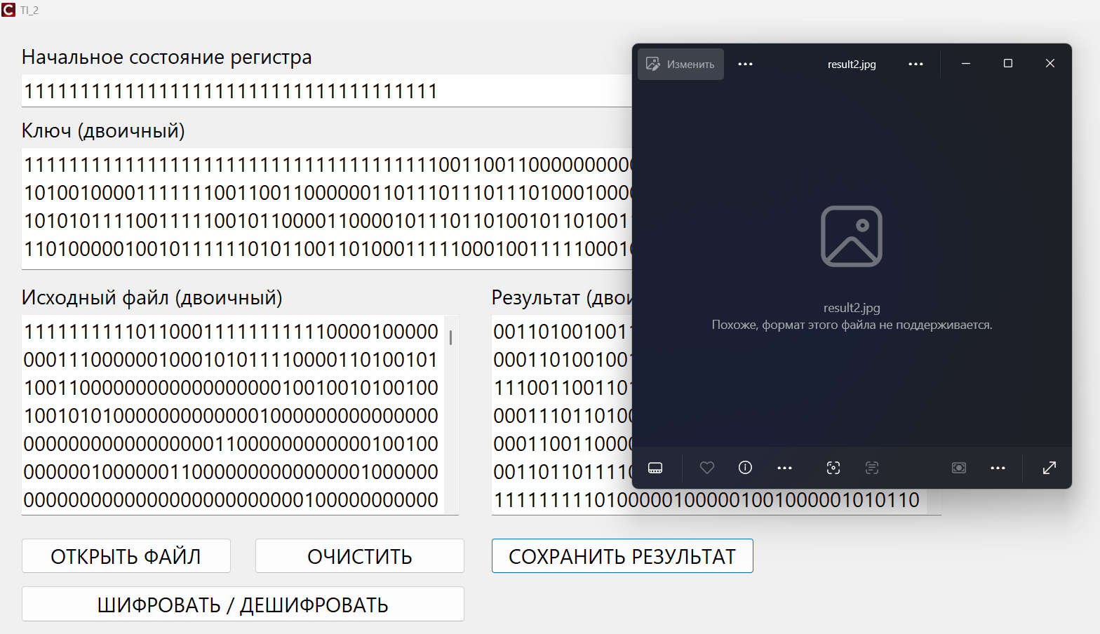

Дешифруем зашифрованное в тот же result2.jpg, снова получаем исходное изображение
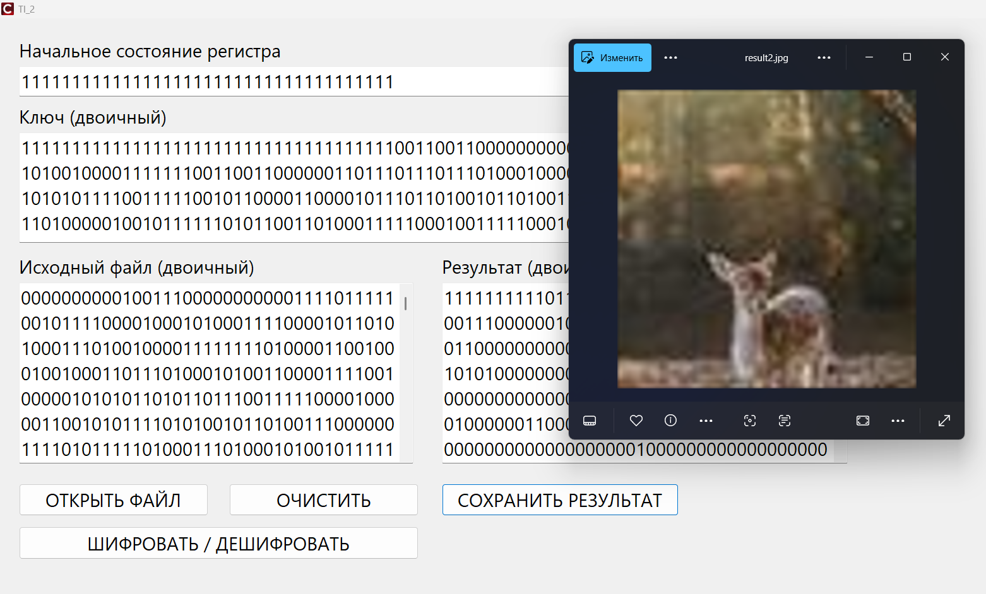

Аудио файл test3.wav
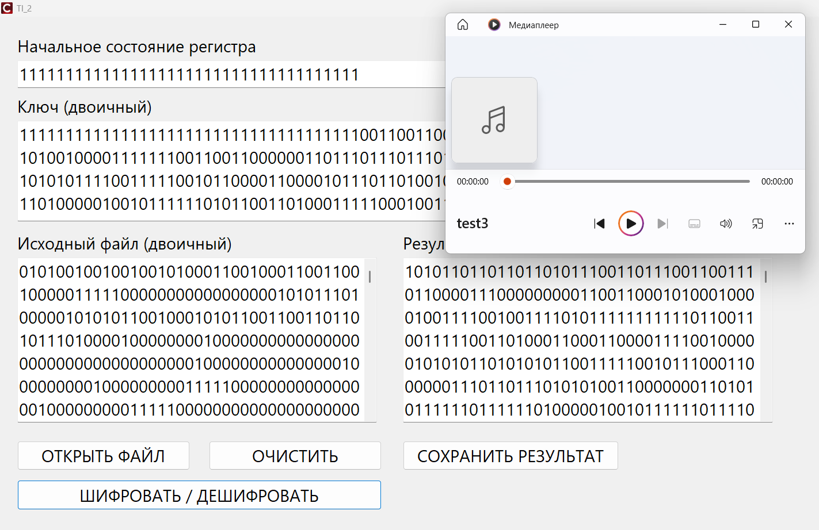
После шифрования записываем результат в result3.wav, предсказуемо получаем неоткрывающийся файл. Начало ключа совпадает с началом ключа из таблицы.



Дешифруем зашифрованное в тот же result3.wav, снова получаем исходный аудиофайл.

