Skolkovo Institute of Science and Technology
Assignment 10
Signal Blackouts: Tracking a City Shuttle through GNSS Dropouts
Lucky Team (Team 7):
Ilya Niafiodau,
Vladislav Zagorodnyuk,
Zhanar Sirgebayeva
Skoltech, 2026

Objective
The aim of this assignment is to keep a city shuttle localized and to forecast its path when the GNSS fixes are randomly missing. We develop a Kalman filter that bridges the measurement gaps, make predictions 6 steps ahead, and verify whether the errors calculated by the filter match the true errors for different probabilities of gaps.
1. Trajectory generation
First, we import the libraries and define the constants of the assignment. The seed of the random number generator is fixed, so that the figures and the numbers in this report can be reproduced.
import numpy as np
from matplotlib import pyplot as plt
from pathlib import Path

# defining the constants
VARIANCE_A = 0.2**2
VARIANCE_ETA = 20**2
SIGMA_A = np.sqrt(VARIANCE_A)
SIGMA_ETA = np.sqrt(VARIANCE_ETA)

POINTS = 200
M_RUNS = 500
M_PRED = 7

T = 1
X_INIT = 5
V_INIT = 1

# probability of a measurement gap: the main case and the cases for comparison
P_GAP = 0.2
P_GAPS_COMPARE = [0.3, 0.5, 0.7]

# fixed seed, so that the plots and the numbers in the report do not change after re-running
np.random.seed(7)

steps = np.arange(POINTS * T, step = T)

The true trajectory of the shuttle is perturbed by a normally distributed random acceleration a_{i} with variance σ_{a}² = 0.2² (m/s²)²:
The measurements of the coordinate are z_{i} = x_{i} + η_{i}, where η_{i} is normally distributed noise with variance σ_{η}² = 20² m². To simulate the GNSS dropouts, at every step a uniformly distributed random variable ξ_{i} is generated, and the measurement is considered missing if ξ_{i} ≤ P:
The function that generates the true trajectory is taken from assignment 6, and the function for the measurements also generates the gaps.
# a function to generate a true trajectory of the shuttle with the random acceleration a_i (from assignment 6)
def generate_true_trajectory(size=POINTS, init_coord=X_INIT, init_velocity=V_INIT, sigma_a=SIGMA_A, t=T):
traj_points = np.zeros(size)
velocity_points = np.zeros(size)
traj_points[0] = init_coord
velocity_points[0] = init_velocity

for i in range(1, size):
acceleration = np.random.normal(loc=0.0, scale=sigma_a)
traj_points[i] = traj_points[i-1] + velocity_points[i-1] * t + acceleration * t**2 / 2
velocity_points[i] = velocity_points[i-1] + acceleration * t

return traj_points, velocity_points

# a function to generate measurements z_i = x_i + eta_i with gaps:
# the measurement is missing (NaN) if the random variable xi_i <= p_gap
def generate_measurements(true_trajectory, p_gap, sigma_eta=SIGMA_ETA):
measurements = true_trajectory + np.random.normal(loc=0.0, scale=sigma_eta, size=true_trajectory.size)
xi = np.random.uniform(0.0, 1.0, size=true_trajectory.size)
measurements[xi <= p_gap] = np.nan
return measurements

The generated true trajectory is saved to the file trajectory.csv, so that the whole team works with the same data and the trajectory can be reused. If the file already exists, the trajectory is loaded from it and is never overwritten.
# the true trajectory is saved to a file, so that it can be reused;
# it is generated only if the file does not exist, so the saved trajectory is never overwritten
TRAJECTORY_FILE = Path("trajectory.csv")

if TRAJECTORY_FILE.exists():
trajectory_data = np.loadtxt(TRAJECTORY_FILE, delimiter=",", skiprows=1)
true_traj, true_vel = trajectory_data[:, 1], trajectory_data[:, 2]
else:
true_traj, true_vel = generate_true_trajectory()
np.savetxt(TRAJECTORY_FILE, np.column_stack((steps, true_traj, true_vel)),
delimiter=",", header="time,x,V", comments="", fmt="%.17g")

2. Kalman filter algorithm to estimate the state vector X_{i}
The state vector X_{i} contains the coordinate and the velocity of the shuttle. The state-space model is the same as in assignment 6:
# state-space model of the shuttle
PHI = np.array([[1, T],
[0, 1]])

G = np.array([[T**2 / 2],
[T]])

H = np.array([[1, 0]])

Q = G @ G.T * VARIANCE_A
R = np.array([[VARIANCE_ETA]])

# initial conditions
X_0_0 = np.array([[2],
[0]])
P_0_0 = np.array([[100, 0],
[0, 100]])

The Kalman filter is a recurrent algorithm with two procedures, prediction and filtration:
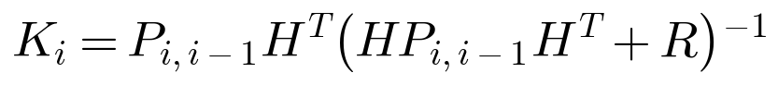
When the measurement is missing, there is no new information to refine the estimate, so the filtration step is skipped, and the recurrent process continues with the extrapolated values:
Compared to assignment 6, the only change in the filter is this check of the measurement.
# Kalman filter (from assignment 6) that works with measurement gaps
def kalman_filter(measurements, phi, h, q, r, x_0_0, p_0_0):
size = measurements.size

x_pred = np.zeros((size, 2, 1)) # predicted state X_{i,i-1}
p_pred = np.zeros((size, 2, 2)) # prediction error covariance P_{i,i-1}
x_filt = np.zeros((size, 2, 1)) # filtered state X_{i,i}
p_filt = np.zeros((size, 2, 2)) # filtration error covariance P_{i,i}
k = np.zeros((size, 2, 1)) # filter gain K_i

identity = np.eye(2)
x_prev = x_0_0
p_prev = p_0_0

for i in range(size):
# prediction
x_pred[i] = phi @ x_prev
p_pred[i] = phi @ p_prev @ phi.T + q

# filtration, only if the measurement is available
if np.isnan(measurements[i]):
x_filt[i] = x_pred[i]
p_filt[i] = p_pred[i]
else:
k[i] = p_pred[i] @ h.T @ np.linalg.inv(h @ p_pred[i] @ h.T + r)
x_filt[i] = x_pred[i] + k[i] * (measurements[i] - h @ x_pred[i])
p_filt[i] = (identity - k[i] @ h) @ p_pred[i]

x_prev = x_filt[i]
p_prev = p_filt[i]

return x_pred, p_pred, x_filt, p_filt, k

At every time step i we also make predictions m − 1 = 6 steps ahead. The filtered estimate is extrapolated without measurements, and the error covariance matrix is propagated as in the hint of the assignment: the unavailable P_{i+1,i+1} is replaced by the last available P_{i+1,i}, and so on:
# predictions m-1 steps ahead X_{i+m-1,i} and their error covariance matrices P_{i+m-1,i}
def predict_ahead(x_filt, p_filt, phi, q, steps_ahead=M_PRED - 1):
x_pred_m = np.zeros_like(x_filt)
p_pred_m = np.zeros_like(p_filt)

for i in range(x_filt.shape[0]):
x, p = x_filt[i], p_filt[i]
for _ in range(steps_ahead):
x = phi @ x
p = phi @ p @ phi.T + q
x_pred_m[i] = x
p_pred_m[i] = p

return x_pred_m, p_pred_m

To plot the results, we extend the plotting function from assignment 8: the missing measurements are shown as gray stripes, and the prediction x_{i+6,i} is plotted at the time it refers to. The second function plots the filtered velocity and the calculated errors σ = √P(1,1) of one realization.
# a function to shade the time steps where the measurement is missing
def shade_gaps(ax, measurements, step_size=T):
for j, i in enumerate(np.where(np.isnan(measurements))[0]):
ax.axvspan((i - 0.5) * step_size, (i + 0.5) * step_size, color="gray", alpha=0.2, linewidth=0,
label="Measurement gap" if j == 0 else None)

# a function to plot a true trajectory, measurements, the filtered estimate
# and the (m-1)-step ahead prediction (from assignment 8)
def plot_filter_results(true_traj, measurements, x_filt, x_pred_m, title, step_size=T):
steps = np.arange(true_traj.size * step_size, step = step_size)
shift = M_PRED - 1
fig, ax = plt.subplots(figsize=(12, 5))
shade_gaps(ax, measurements, step_size)
ax.plot(steps, true_traj, color="green", linewidth=1.5, label="True Trajectory $x_i$")
ax.scatter(steps, measurements, color="red", s=6, alpha=0.6, label="Measurements $z_i = x_i + \\eta_i$")
ax.plot(steps, x_filt, color="blue", linewidth=1.5, label="Kalman Filter Estimate $x_{i,i}$")
ax.plot(steps[shift:], x_pred_m[:-shift], color="purple", linewidth=1.2,
label=f"Predicted estimate $x_{{i+{shift},i}}$")
ax.set_title(title)
ax.set_xlabel("Time, s")
ax.set_ylabel("Coordinate x, m")
ax.grid(True, color="black", linewidth=0.3)
ax.legend(frameon=True)
fig.tight_layout()
plt.show()

# a function to plot the filtered velocity and the calculated errors of one realization
def plot_velocity_and_calc_errors(true_vel, measurements, x_filt, p_filt, p_pred_m, title, step_size=T):
steps = np.arange(true_vel.size * step_size, step = step_size)
shift = M_PRED - 1
fig, axes = plt.subplots(2, 1, figsize=(12, 9))

axes[0].plot(steps, true_vel, color="green", linewidth=1.5, label="True velocity $V_i$")
axes[0].plot(steps, x_filt[:, 1, 0], color="blue", linewidth=1.5, label="Filtered estimate $V_{i,i}$")
axes[0].set_title(f"{title}: Velocity")
axes[0].set_ylabel("Velocity V, m/s")

axes[1].plot(steps, np.sqrt(p_filt[:, 0, 0]), color="blue", linewidth=1.5,
label="Calculated error $\\sigma_{x_{i,i}}$")
axes[1].plot(steps[shift:], np.sqrt(p_pred_m[:-shift, 0, 0]), color="purple", linewidth=1.5,
label=f"Calculated error $\\sigma_{{x_{{i+{shift},i}}}}$")
axes[1].axhline(SIGMA_ETA, color="red", linestyle="--", linewidth=1, label="Measurement error $\\sigma_\\eta$")
axes[1].set_title(f"{title}: Calculated Errors of the Coordinate")
axes[1].set_ylabel("Estimation error, m")

for ax in axes:
shade_gaps(ax, measurements, step_size)
ax.set_xlabel("Time, s")
ax.grid(True, color="black", linewidth=0.3)
ax.legend(frameon=True)
fig.tight_layout()
plt.show()

We run the filter on the saved trajectory with measurement gaps occurring with the probability P = 0.2. The results are shown in Figures 1 and 2.
# one realization: the saved true trajectory, measurements with gaps, filtered estimates and 6-step ahead predictions
measurements = generate_measurements(true_traj, P_GAP)
x_pred, P_pred, x_filt, P_filt, K = kalman_filter(measurements, PHI, H, Q, R, X_0_0, P_0_0)
x_pred_m, P_pred_m = predict_ahead(x_filt, P_filt, PHI, Q)

plot_filter_results(true_traj, measurements, x_filt[:, 0, 0], x_pred_m[:, 0, 0],
f"Kalman Filter with Measurement Gaps, P = {P_GAP}: Coordinate")
plot_velocity_and_calc_errors(true_vel, measurements, x_filt, P_filt, P_pred_m,
f"Kalman Filter with Measurement Gaps, P = {P_GAP}")

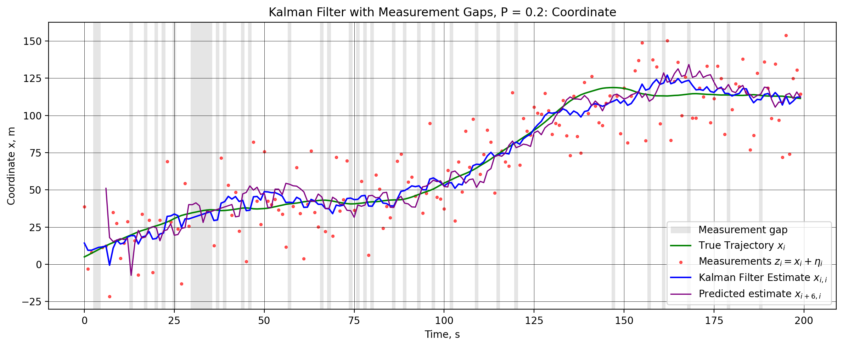
Figure 1 – True trajectory, measurements with gaps (gray stripes), filtered estimate and 6-step ahead prediction of the shuttle’s coordinate, P = 0.2.
In this realization 38 of 200 measurements (19%) are missing, and the longest blackout lasts 6 s (30–35 s). During a blackout the filtered estimate continues along a straight line with the last estimated velocity, since X_{i,i} = ΦX_{i−1,i−1}, and it is corrected as soon as the measurements return. The 6-step ahead prediction follows the true trajectory, but it is noisier than the filtered estimate, because it extrapolates the velocity estimate over 6 s. After 150 s, when the shuttle stops, both estimates overshoot the true trajectory by about 10 m, since the velocity estimate lags behind the true velocity.
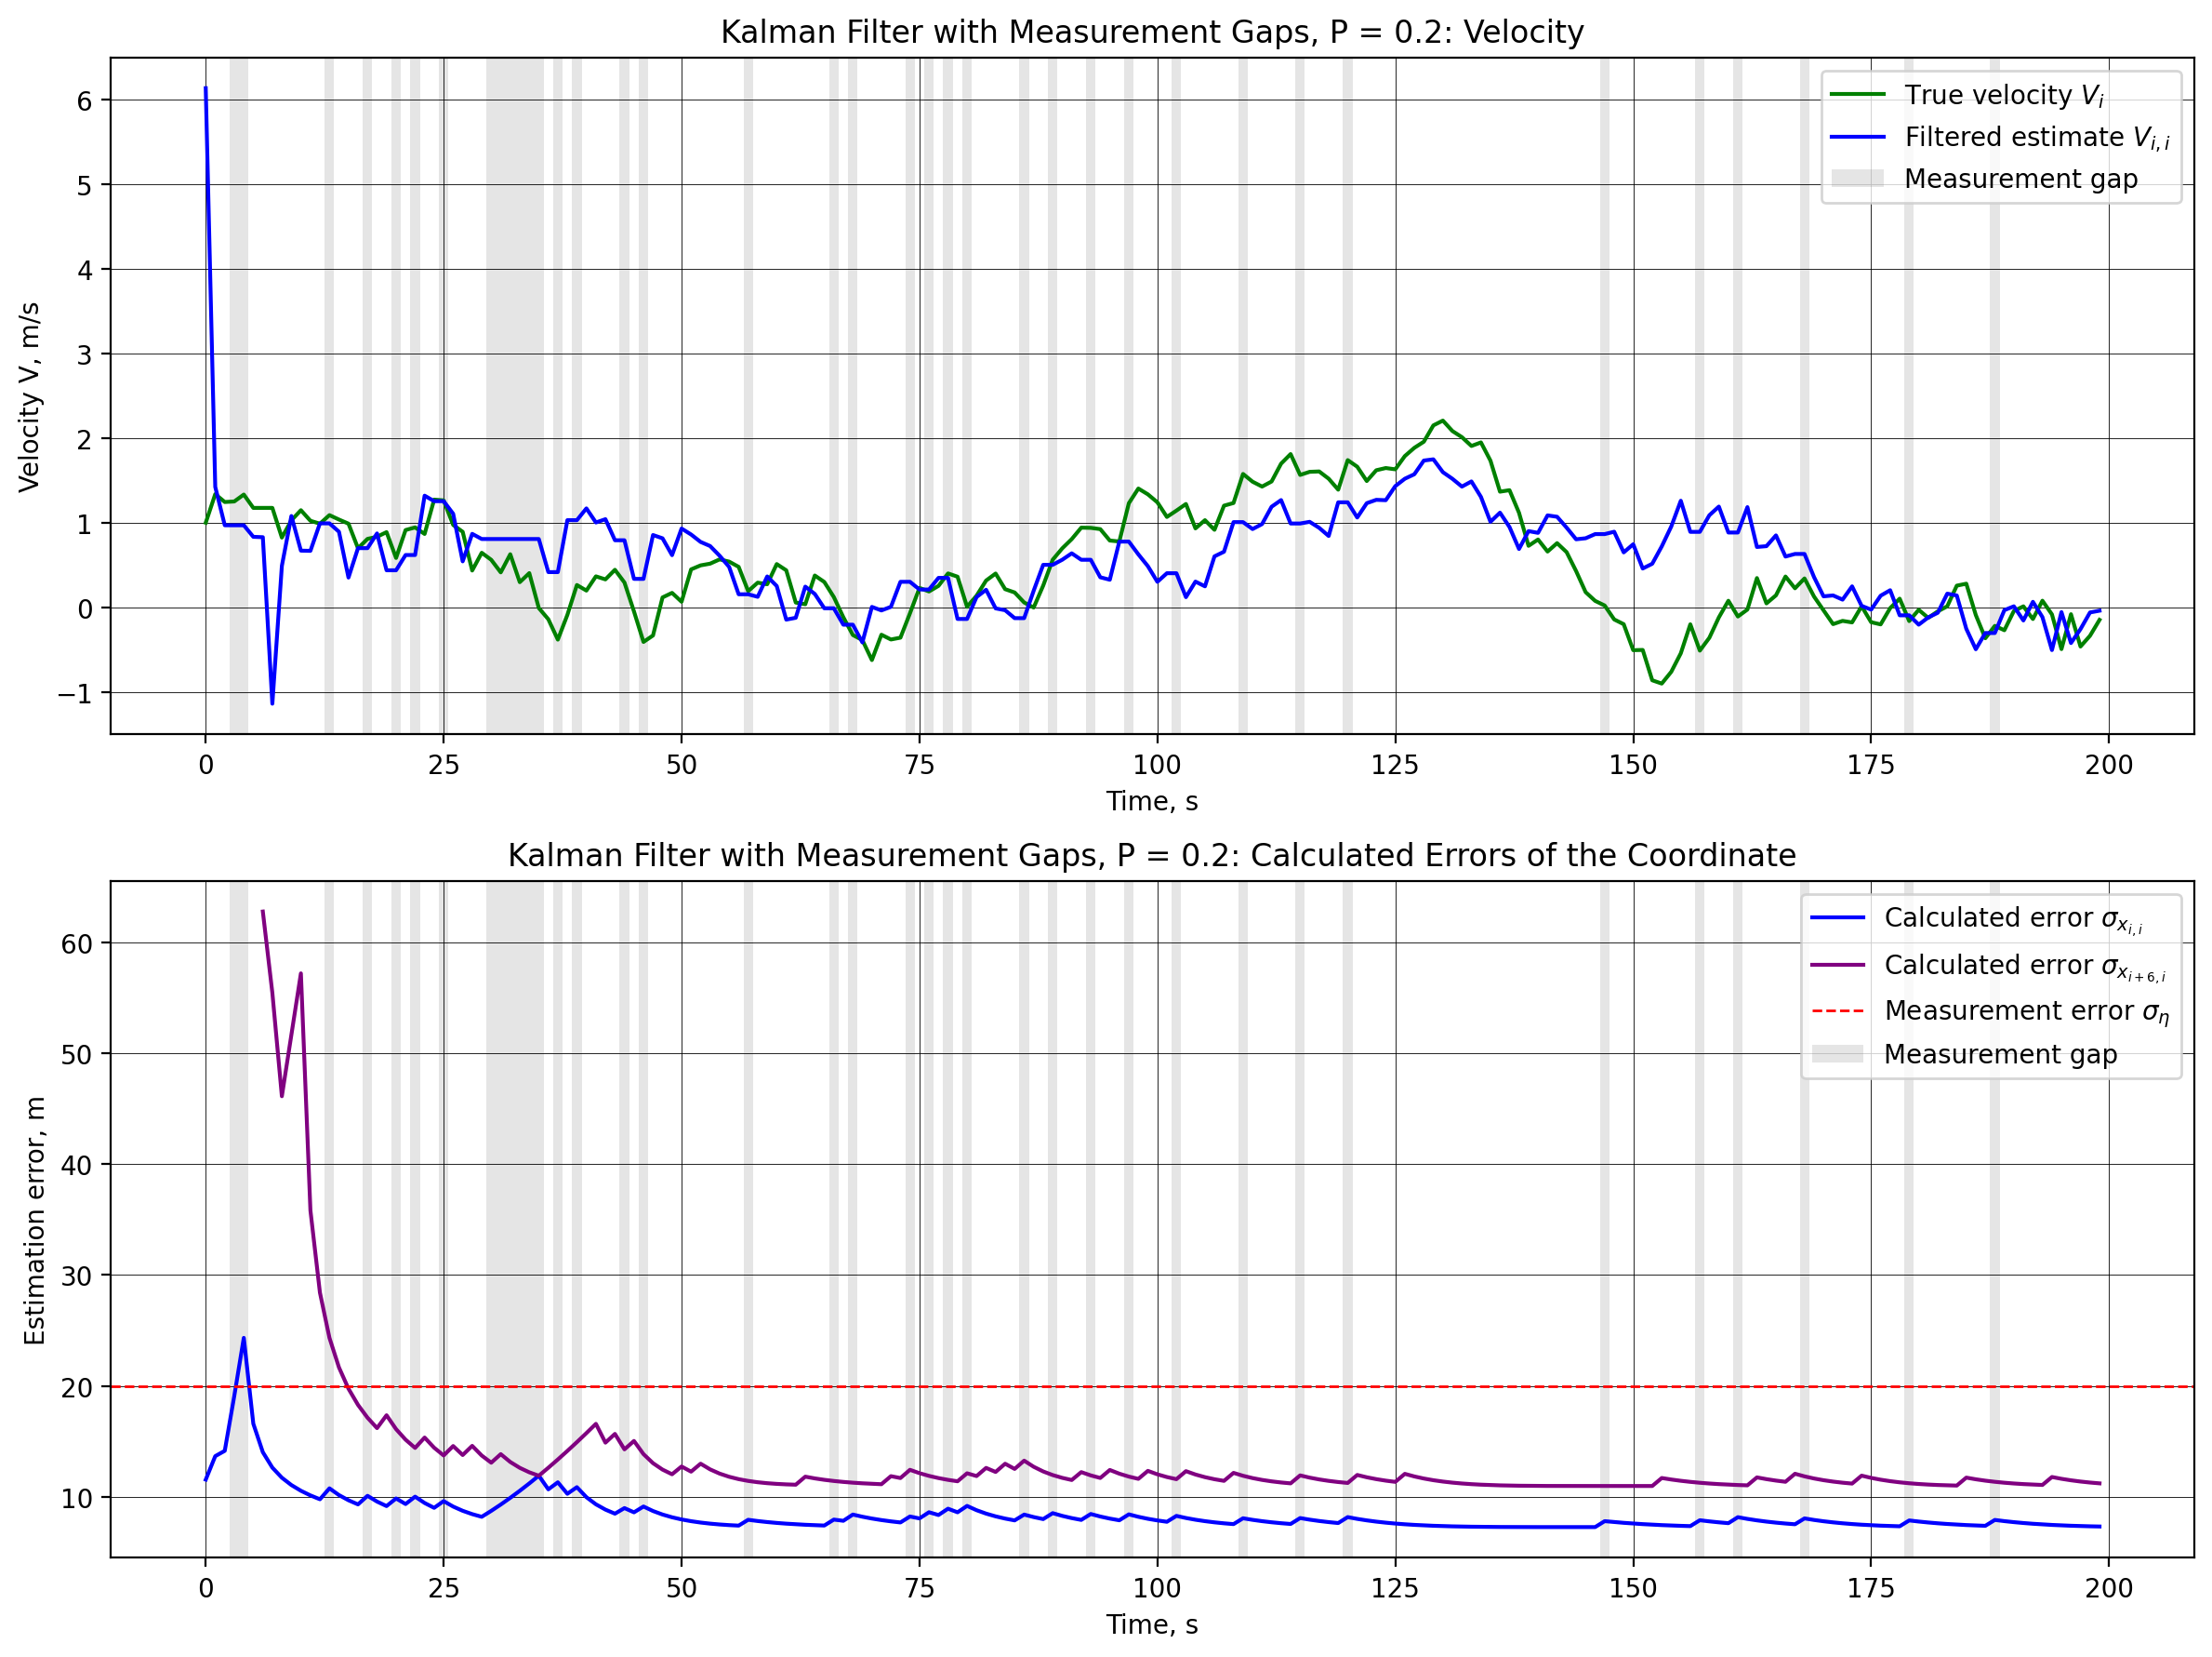
Figure 2 – Filtered estimate of the velocity (top) and calculated errors of the filtered estimate and the 6-step ahead prediction of the coordinate (bottom) for the same realization, P = 0.2.
After the initial transient (a spike up to 6 m/s at the first step), the velocity estimate follows the true velocity with a mean absolute deviation of 0.44 m/s after 50 s. The calculated errors show how the uncertainty changes in real time: σ(x_{i,i}) grows during every blackout, because P_{i,i} = P_{i,i−1} and Q is added at every step without measurements, and it drops when the measurements return. During the longest blackout it rises from about 8 m to 12 m. After 50 s it varies between 7.3 and 9.2 m for the filtered estimate and between 11.0 and 13.3 m for the 6-step ahead prediction, staying below σ_{η} = 20 m.
3. Error estimation
To obtain the true errors, we run the filter M = 500 times, and in every run a new true trajectory and new measurements with new gaps are generated. The true error of an estimate x̂_{i} (the filtered estimate x_{i,i}, the 1-step ahead prediction x_{i+1,i} or the 6-step ahead prediction x_{i+6,i}) is
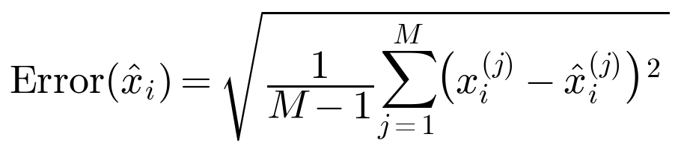
The errors of the predictions are assigned to the time they refer to. Unlike in assignments 6 and 8, the matrices P now depend on where the gaps occur, so they differ from run to run. Therefore the calculated error is also averaged over the runs:
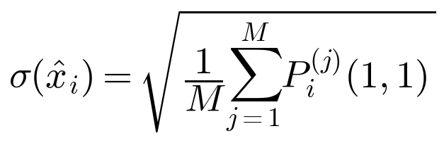
# true and calculated errors of the filtered estimate, the 1-step and the (m-1)-step ahead predictions over M runs (from assignment 6)
def run_experiment(p_gap, m_runs=M_RUNS):
shift = M_PRED - 1
sq_err_filt = np.zeros((m_runs, POINTS)) # (x_i - x_{i,i})^2
sq_err_pred1 = np.zeros((m_runs, POINTS)) # (x_i - x_{i,i-1})^2
sq_err_pred_m = np.full((m_runs, POINTS), np.nan) # (x_i - x_{i,i-m+1})^2
var_filt = np.zeros((m_runs, POINTS)) # P_{i,i}[0, 0]
var_pred1 = np.zeros((m_runs, POINTS)) # P_{i,i-1}[0, 0]
var_pred_m = np.full((m_runs, POINTS), np.nan) # P_{i,i-m+1}[0, 0]

for run in range(m_runs):
# new true trajectory and new measurements with new gaps in every run
true_traj, _ = generate_true_trajectory()
measurements = generate_measurements(true_traj, p_gap)
x_pred, p_pred, x_filt, p_filt, _ = kalman_filter(measurements, PHI, H, Q, R, X_0_0, P_0_0)
x_pred_m, p_pred_m = predict_ahead(x_filt, p_filt, PHI, Q)

sq_err_filt[run] = (true_traj - x_filt[:, 0, 0])**2
sq_err_pred1[run] = (true_traj - x_pred[:, 0, 0])**2
sq_err_pred_m[run, shift:] = (true_traj[shift:] - x_pred_m[:-shift, 0, 0])**2

var_filt[run] = p_filt[:, 0, 0]
var_pred1[run] = p_pred[:, 0, 0]
var_pred_m[run, shift:] = p_pred_m[:-shift, 0, 0]

# true errors: root of the sum over runs divided by (M - 1), as in assignment 6
true_err = [np.sqrt(np.sum(sq, axis=0) / (m_runs - 1)) for sq in (sq_err_filt, sq_err_pred1, sq_err_pred_m)]
# calculated errors: root of the mean of P over runs
calc_err = [np.sqrt(np.mean(var, axis=0)) for var in (var_filt, var_pred1, var_pred_m)]
return true_err, calc_err

ESTIMATES = [("Filtered Estimate $x_{i,i}$", "$\\sigma_{x_{i,i}}$"),
("1-Step Ahead Prediction $x_{i+1,i}$", "$\\sigma_{x_{i+1,i}}$"),
(f"{M_PRED - 1}-Step Ahead Prediction $x_{{i+{M_PRED - 1},i}}$", f"$\\sigma_{{x_{{i+{M_PRED - 1},i}}}}$")]

# a function to plot the true and calculated errors of the three estimates for one probability of gaps
def plot_true_vs_calc(true_err, calc_err, p_gap, start=2):
fig, axes = plt.subplots(3, 1, figsize=(12, 13))
for ax, true, calc, (name, calc_label) in zip(axes, true_err, calc_err, ESTIMATES):
ax.plot(steps[start:], true[start:], color="blue", linewidth=1.5, label=f"True error ({M_RUNS} runs)")
ax.plot(steps[start:], calc[start:], color="orange", linewidth=1.5, label=f"Calculated error {calc_label}")
ax.axhline(SIGMA_ETA, color="red", linestyle="--", linewidth=1, label="Measurement error $\\sigma_\\eta$")
ax.set_title(f"{name}: True and Calculated Errors, P = {p_gap}")
ax.set_xlabel("Time, s")
ax.set_ylabel("Estimation error, m")
ax.grid(True, color="black", linewidth=0.3)
ax.legend(frameon=True)
fig.tight_layout()
plt.show()

errors = {P_GAP: run_experiment(P_GAP)}
plot_true_vs_calc(*errors[P_GAP], P_GAP)

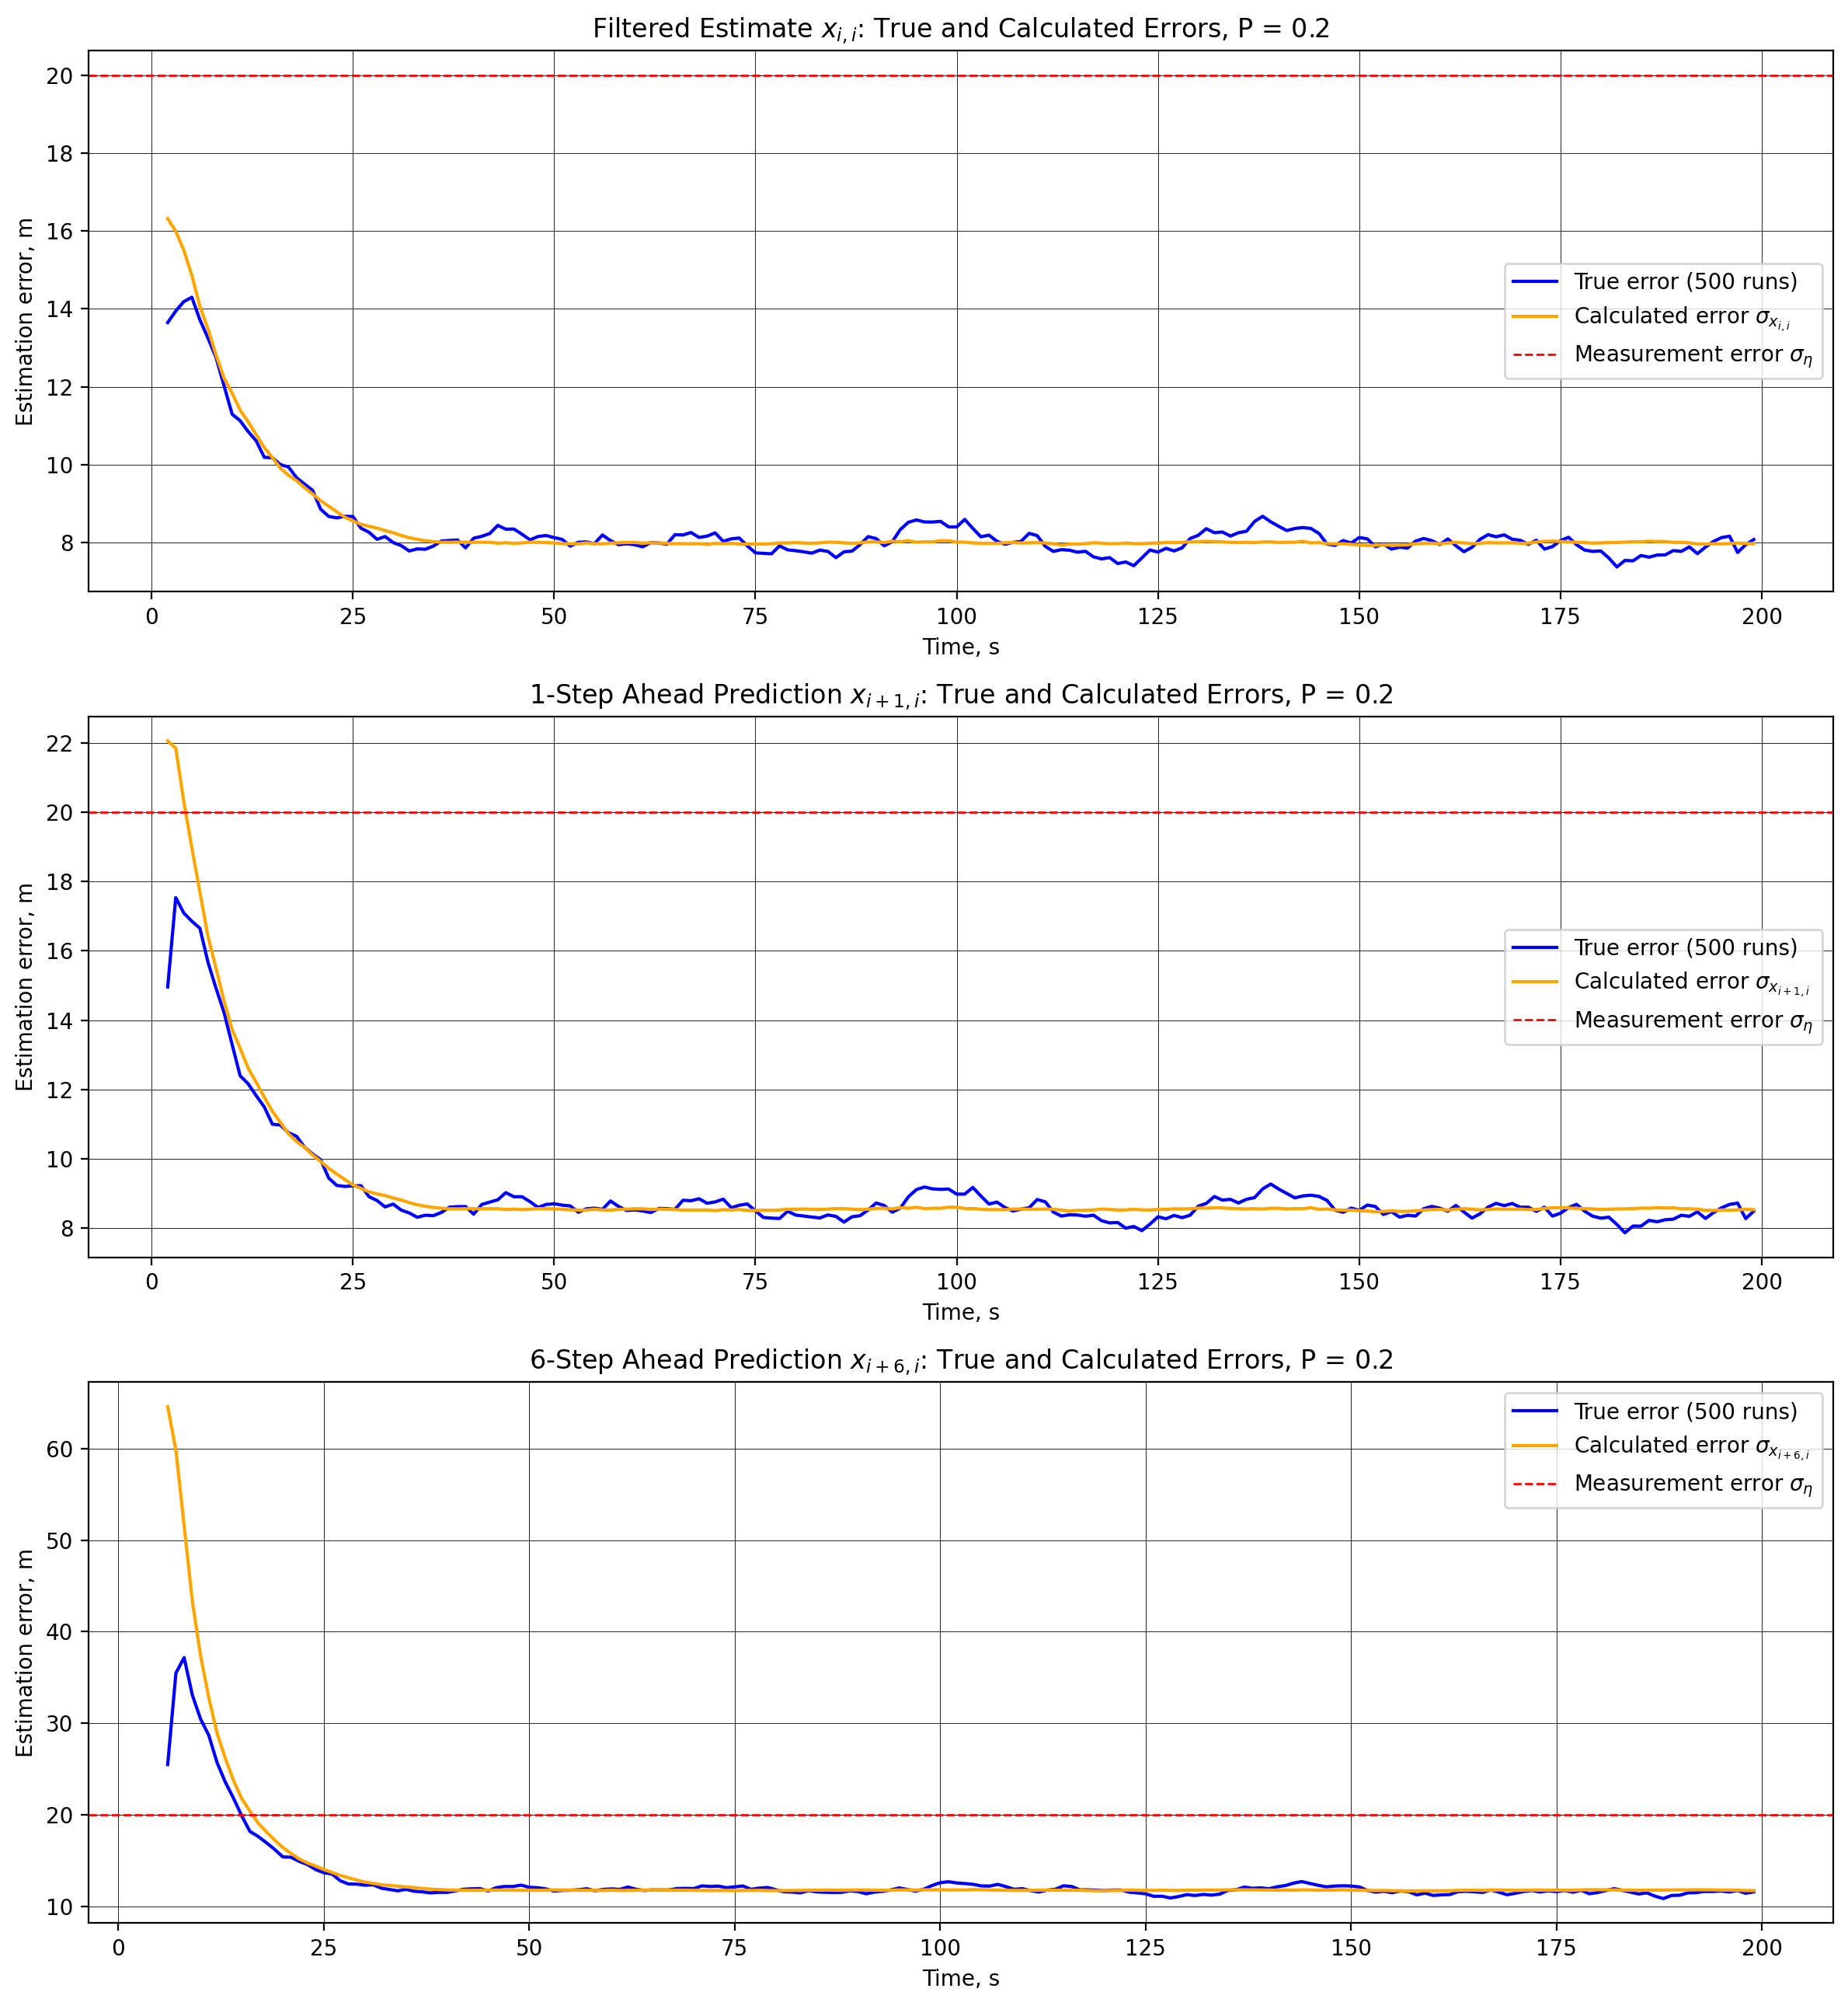
Figure 3 – True (500 runs) and calculated errors of the filtered estimate, the 1-step and the 6-step ahead predictions of the coordinate, P = 0.2.
The true and the calculated errors practically coincide: in the steady state they are 7.98 and 7.99 m for the filtered estimate, 8.53 and 8.54 m for the 1-step ahead prediction, and 11.74 and 11.78 m for the 6-step ahead prediction. The filter remains optimal with gaps, since its model and noise statistics are correct, and skipping the filtration step is exactly what the optimal filter does without a measurement. At the beginning the calculated errors are larger than the true ones (64.6 m against 37.2 m for the 6-step prediction), because P_{0,0} = diag(100, 100) is pessimistic compared with the real initial errors of X_{0,0} = [2, 0]^{T} (3 m and 1 m/s). In the steady state the filtered estimate is 2.51 times more accurate than a single measurement, and the 6-step ahead prediction is 1.70 times more accurate, but only after 15 s.
Comparison of the results for P = 0.3, 0.5 and 0.7
We repeat the single-run experiment on the same true trajectory with more frequent gaps (Figures 4–6).
# the same true trajectory as above, new measurements with more frequent gaps
for p_gap in P_GAPS_COMPARE:
measurements_p = generate_measurements(true_traj, p_gap)
_, _, x_filt_p, P_filt_p, _ = kalman_filter(measurements_p, PHI, H, Q, R, X_0_0, P_0_0)
x_pred_m_p, _ = predict_ahead(x_filt_p, P_filt_p, PHI, Q)
plot_filter_results(true_traj, measurements_p, x_filt_p[:, 0, 0], x_pred_m_p[:, 0, 0],
f"Kalman Filter with Measurement Gaps, P = {p_gap}: Coordinate")

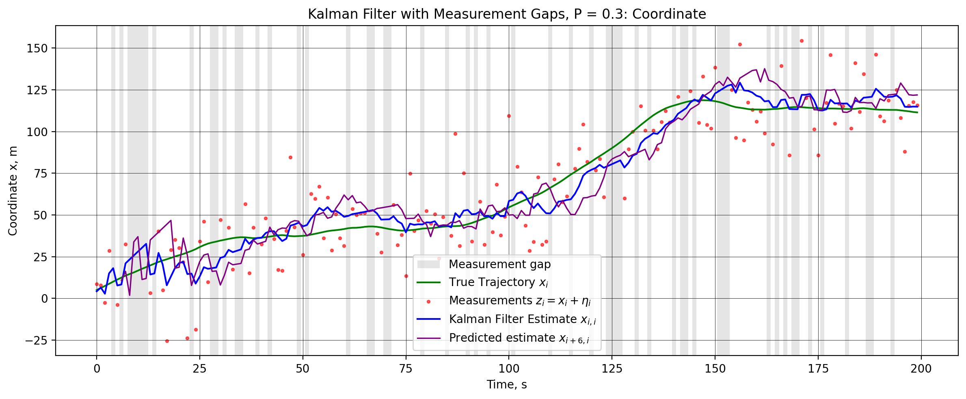
Figure 4 – Kalman filter estimate and 6-step ahead prediction of the coordinate, P = 0.3.
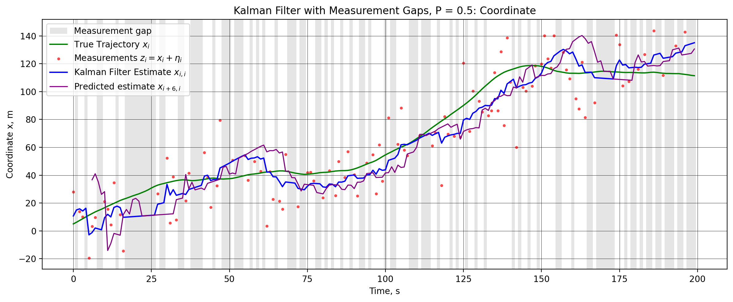
Figure 5 – Kalman filter estimate and 6-step ahead prediction of the coordinate, P = 0.5.
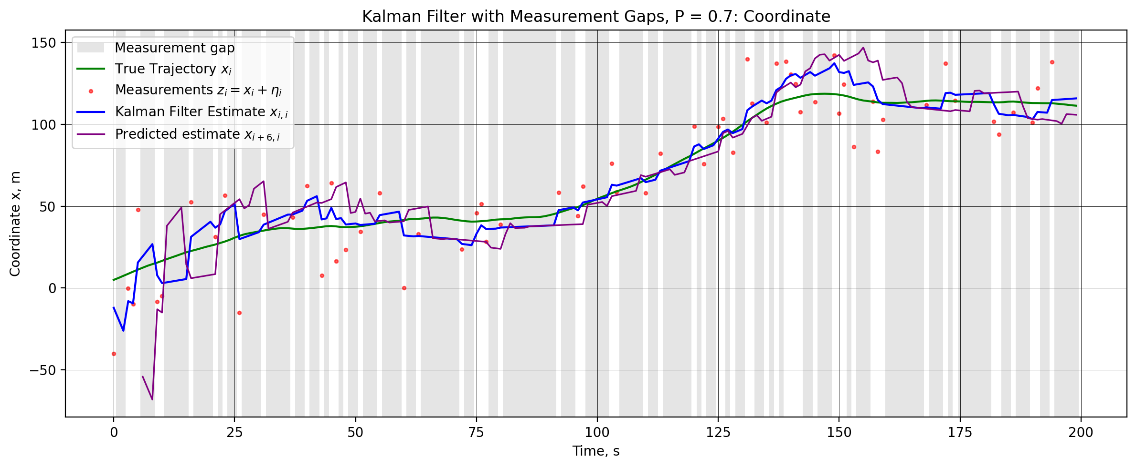
Figure 6 – Kalman filter estimate and 6-step ahead prediction of the coordinate, P = 0.7.
The fraction of missing measurements in these realizations is 28%, 47% and 68%, and the longest blackouts last 5, 10 and 11 s. With more gaps the filtered estimate becomes piecewise linear: it moves along straight lines during the blackouts and jumps when a measurement arrives. During long blackouts the estimate drifts away from the true trajectory: for P = 0.5, during the 10-s blackout at 17–26 s the estimate stays almost constant while the shuttle keeps moving, and the error reaches about 20 m. The 6-step ahead prediction becomes even less reliable, since it extrapolates an estimate that is itself an extrapolation.
Then we estimate the true and the calculated errors over 500 runs for each probability (Figures 7–9).
for p_gap in P_GAPS_COMPARE:
errors[p_gap] = run_experiment(p_gap)
plot_true_vs_calc(*errors[p_gap], p_gap)

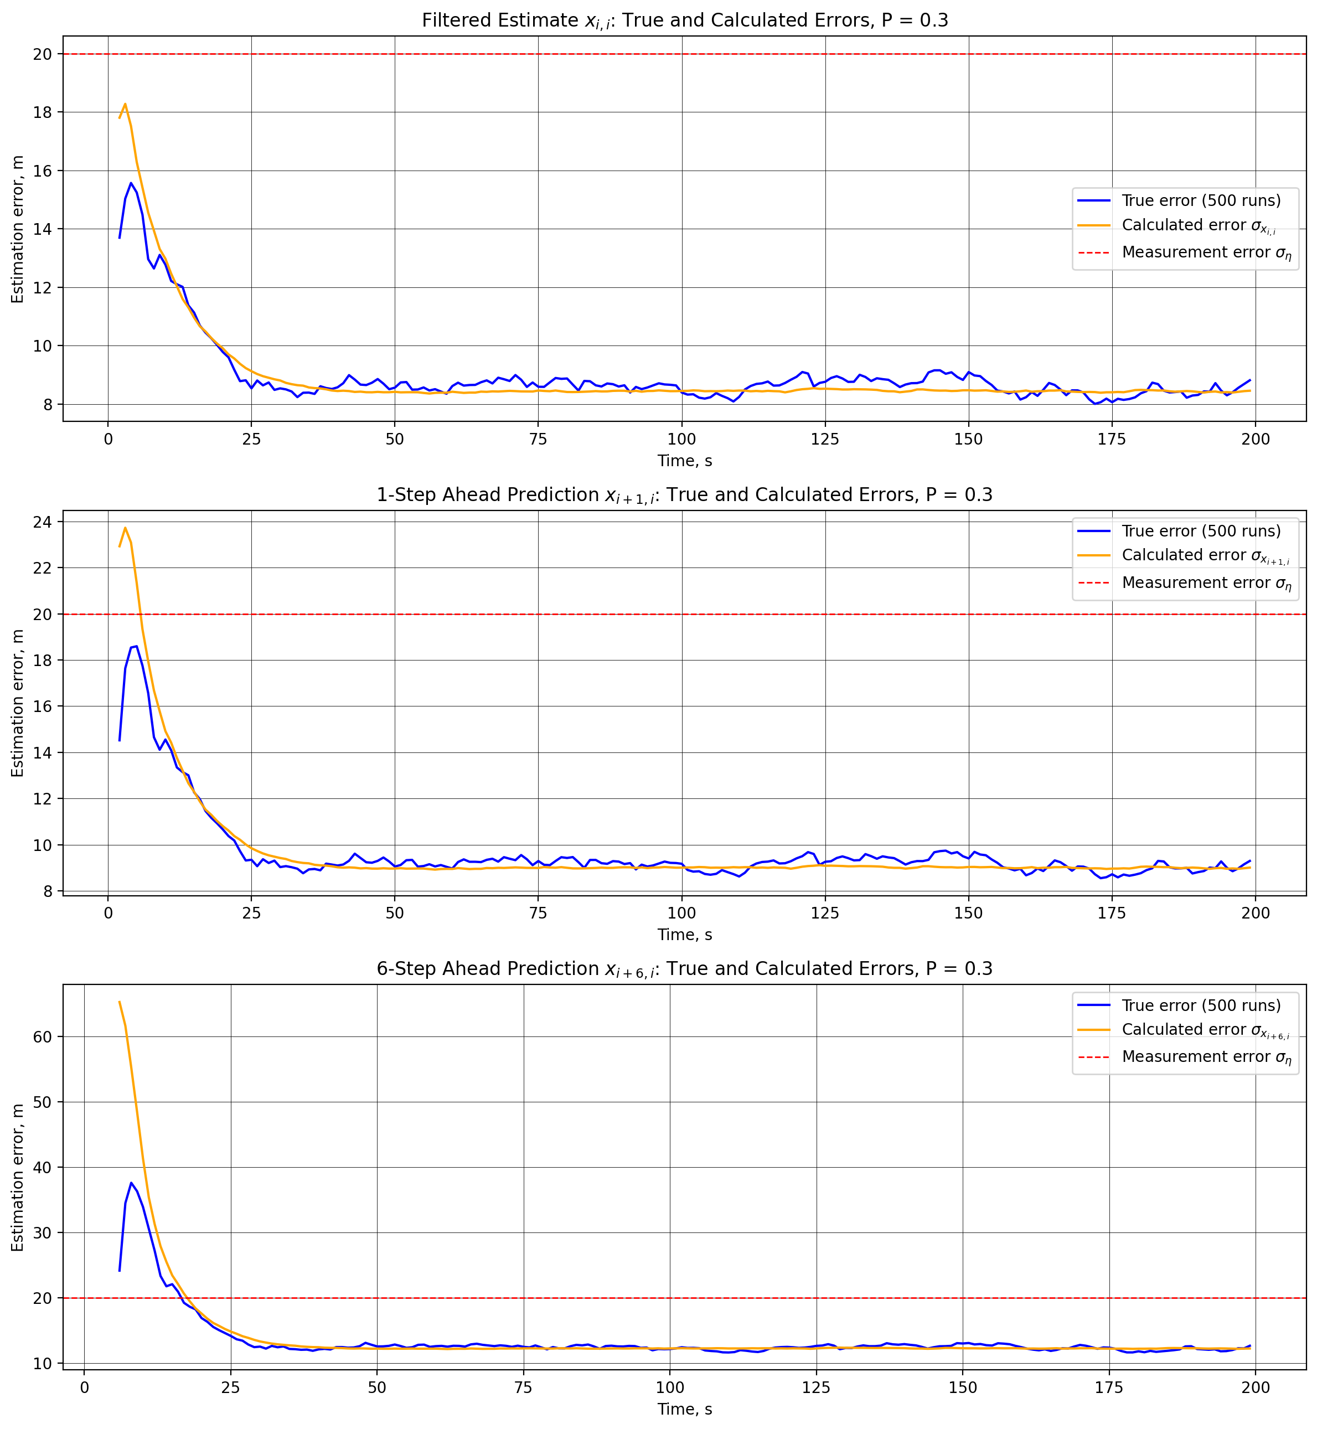
Figure 7 – True (500 runs) and calculated errors of the filtered estimate and the predictions, P = 0.3.
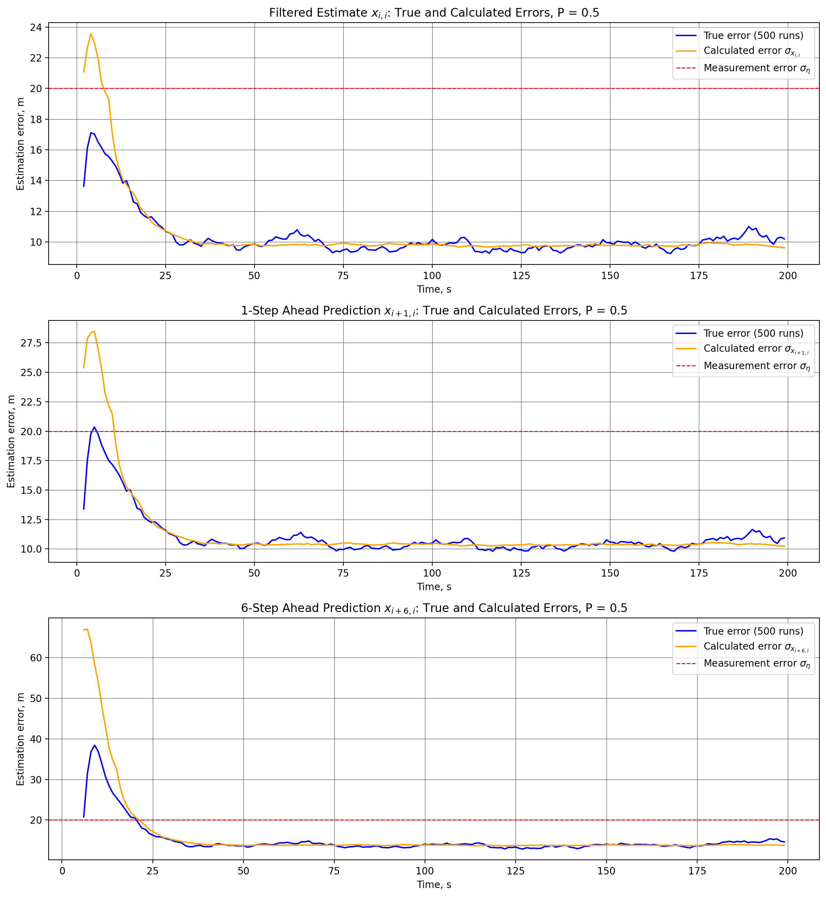
Figure 8 – True (500 runs) and calculated errors of the filtered estimate and the predictions, P = 0.5.
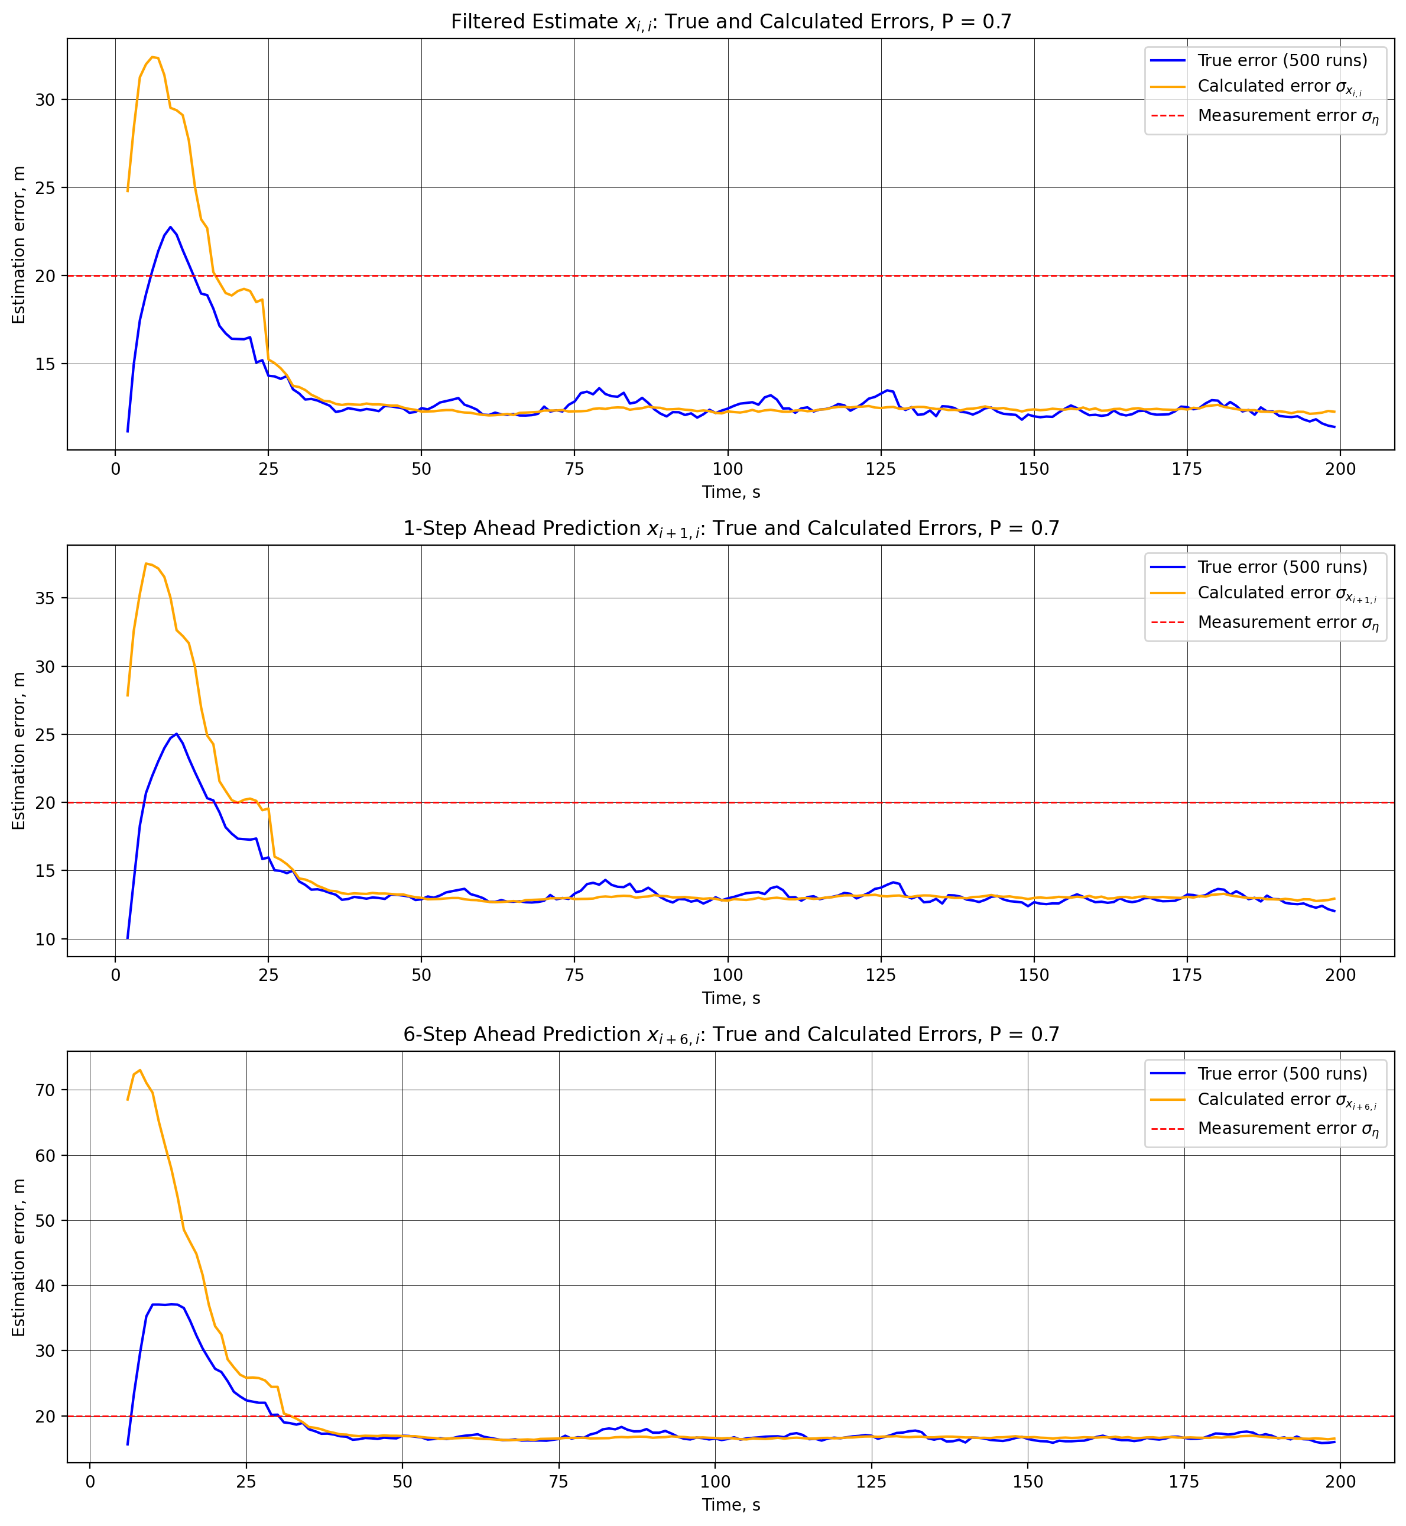
Figure 9 – True (500 runs) and calculated errors of the filtered estimate and the predictions, P = 0.7.
For all probabilities the calculated errors coincide with the true errors in the steady state, so the filter stays consistent even when 70% of the measurements are missing. The difference is in the transient: with fewer measurements the filter forgets the pessimistic P_{0,0} more slowly, and for P = 0.7 the calculated errors exceed the true ones during the first 25–30 s (the peak error of the 6-step prediction is 73.0 m calculated against 37.1 m true).
Finally, we compare the true errors for different probabilities of gaps (Figures 10–12) and summarize the steady-state values (Table 1).
# a function to plot several error curves on one figure (from assignment 8)
def plot_errors(curves, title, step_size=T, start=2, sigma_eta=None, ylabel="Estimation error, m", legend_outside=False):
# curves: list of (values, label, color)
steps = np.arange(len(curves[0][0]) * step_size, step = step_size)
fig, ax = plt.subplots(figsize=(12, 5))
for values, label, color in curves:
ax.plot(steps[start:], values[start:], color=color, linewidth=1.5, label=label)
if sigma_eta is not None:
ax.axhline(sigma_eta, color="red", linestyle="--", linewidth=1, label="Measurement error $\\sigma_\\eta$")
ax.set_title(title)
ax.set_xlabel("Time, s")
ax.set_ylabel(ylabel)
ax.grid(True, color="black", linewidth=0.3)
# many curves: the legend is placed to the right of the plot so that it does not cover them
if legend_outside:
ax.legend(frameon=True, loc="upper left", bbox_to_anchor=(1.01, 1))
else:
ax.legend(frameon=True)
fig.tight_layout()
plt.show()

# true errors of every estimate for all probabilities of gaps
colors = {0.2: "green", 0.3: "blue", 0.5: "purple", 0.7: "black"}
for j, (name, _) in enumerate(ESTIMATES):
plot_errors([(errors[p_gap][0][j], f"P = {p_gap}", colors[p_gap]) for p_gap in errors],
f"True Errors of the {name} for Different Probabilities of Gaps",
sigma_eta=SIGMA_ETA, legend_outside=True)

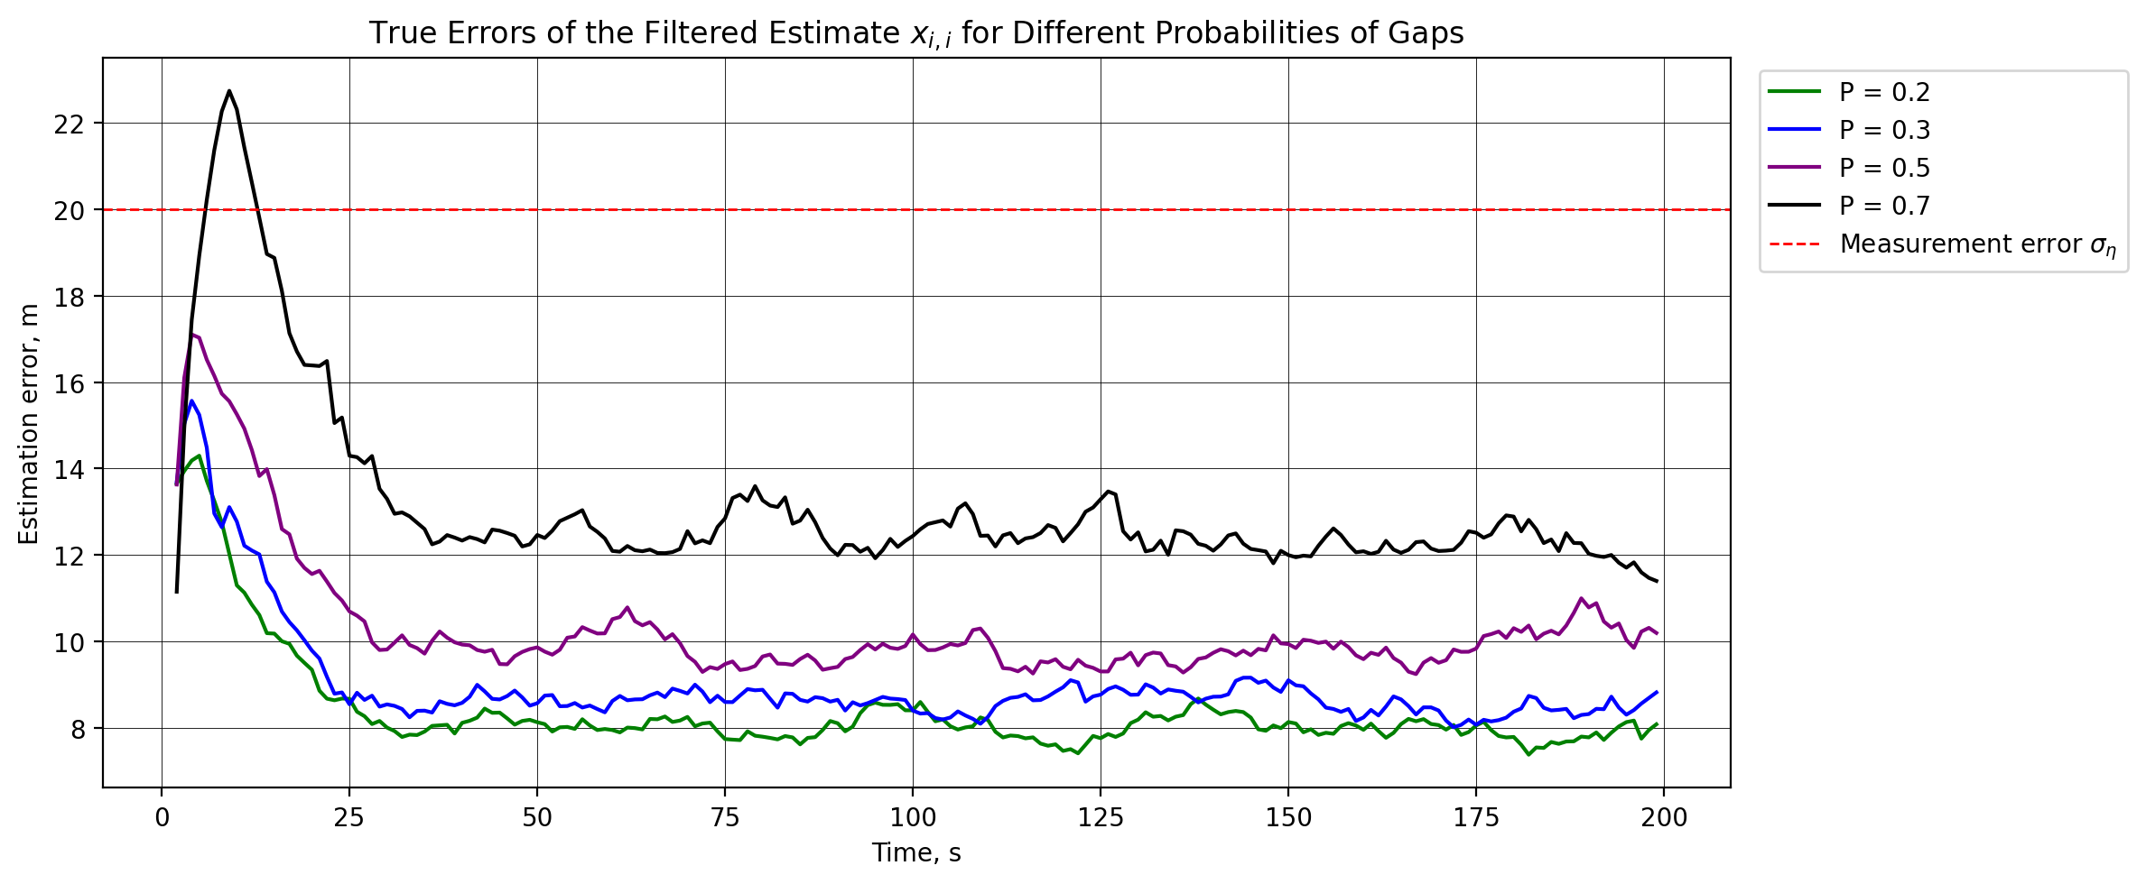
Figure 10 – True errors of the filtered estimate x_{i,i} for different probabilities of gaps.
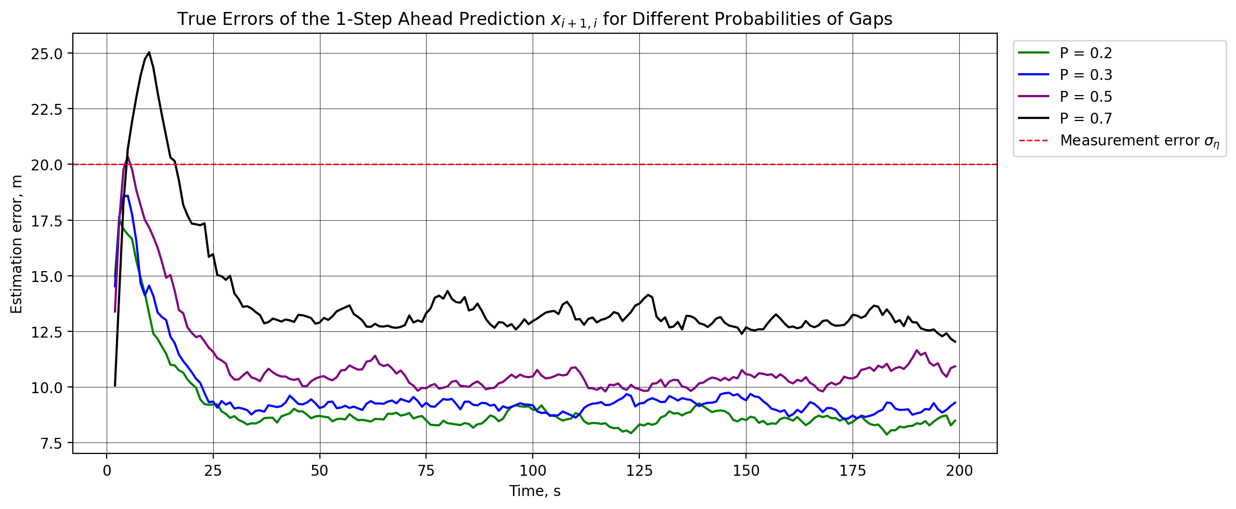
Figure 11 – True errors of the 1-step ahead prediction x_{i+1,i} for different probabilities of gaps.
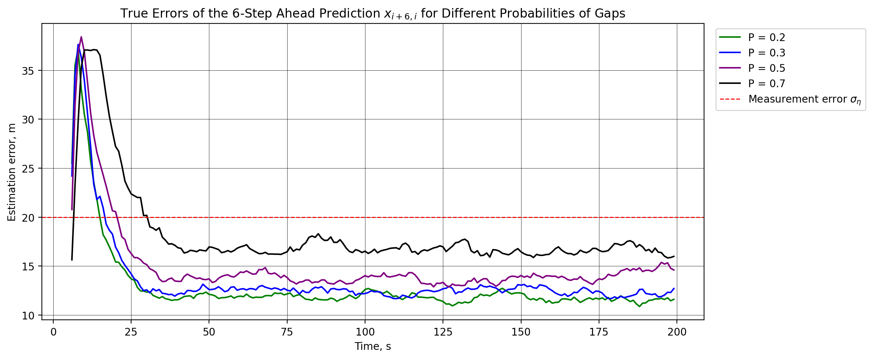
Figure 12 – True errors of the 6-step ahead prediction x_{i+6,i} for different probabilities of gaps.
# summary table of the steady-state errors: mean over the last 100 steps
names = ["filtered", "1-step", f"{M_PRED - 1}-step"]
print(f"{'P':<6}" + "".join(f"{name + ' true, m':>18}{name + ' calc, m':>18}" for name in names))
for p_gap, (true_err, calc_err) in errors.items():
print(f"{p_gap:<6}" + "".join(f"{np.mean(true[-100:]):>18.2f}{np.mean(calc[-100:]):>18.2f}"
for true, calc in zip(true_err, calc_err)))

Table 1 – Steady-state true and calculated errors of the coordinate (mean over the last 100 steps), m
P | Filtered estimate |  | 1-step ahead prediction |  | 6-step ahead prediction
P | true | calculated | true | calculated | true | calculated
0.2 | 7.98 | 7.99 | 8.53 | 8.54 | 11.74 | 11.78
0.3 | 8.58 | 8.46 | 9.13 | 9.02 | 12.37 | 12.30
0.5 | 9.84 | 9.77 | 10.43 | 10.36 | 13.86 | 13.77
0.7 | 12.36 | 12.39 | 13.00 | 13.03 | 16.62 | 16.66

The errors grow with the probability of gaps. The steady-state error of the filtered estimate increases from 7.98 m at P = 0.2 to 8.58, 9.84 and 12.36 m at P = 0.3, 0.5 and 0.7 (by 7%, 23% and 55%), and the error of the 6-step ahead prediction increases from 11.74 to 16.62 m. The growth is nonlinear: the largest loss of accuracy occurs between P = 0.5 and 0.7, when long blackouts become frequent. The initial transient also becomes longer: the true error of the 6-step prediction falls below σ_{η} after 15, 17, 21 and 31 s, and for P = 0.7 even the filtered estimate exceeds σ_{η} during the first 13 s. Still, in the steady state all estimates remain more accurate than a single measurement: for P = 0.7 the ratio σ_{η} / error is 1.62 for the filtered estimate and 1.20 for the 6-step ahead prediction.
Learning log
- A measurement gap is handled by skipping the filtration step: X_{i,i} = X_{i,i−1}, P_{i,i} = P_{i,i−1}. The filter then runs on the motion model alone, the estimate becomes a straight-line extrapolation, and P grows by Q at every step without a fix. The saw-tooth shape of σ(x_{i,i}) (Fig. 2) is exactly the real-time uncertainty that is needed to decide when the position of the shuttle is no longer reliable enough to plan a safe stop.
- A prediction m − 1 steps ahead is mathematically the same as a blackout of m − 1 steps: in both cases X is multiplied by Φ and Q is added to P at every step. This is why the 6-step error is 1.47 times larger than the filtered error at P = 0.2, but only 1.34 times at P = 0.7: with many gaps the filtered estimate is already an extrapolation most of the time.
- With gaps, P no longer depends only on the model: it depends on the random pattern of the gaps, though still not on the measured values. To compare the calculated and true errors over 500 runs we therefore averaged P over the runs as well. Then they coincide for every P (12.36 against 12.39 m at P = 0.7): missing data reduce the accuracy, but do not make the filter overconfident, because its model and noise statistics stay correct.
- The accuracy degrades gracefully but nonlinearly: when the share of missing fixes rises from 20% to 70%, the filtered error grows from 7.98 to 12.36 m, and most of this loss happens above P = 0.5, where blackouts of 10–11 s appeared in our realizations. Even at P = 0.7 every estimate is still more accurate than a single GNSS fix.
- The initial conditions matter more when measurements are scarce. The pessimistic P_{0,0} makes the calculated errors larger than the true ones during the first seconds, and at P = 0.7 this lasts about 30 s instead of 4–17 s at P = 0.2. For a safety-critical task an overestimated error at the start is acceptable, while an underestimated one would be dangerous. Fixing the seed and saving the trajectory to a file made all these comparisons reproducible for the whole team.

