To be able to run lighthouse report locally first it is needed to install addon for chrome.
Visit link: https://chromewebstore.google.com/detail/lighthouse/blipmdconlkpinefehnmjammfjpmpbjk
And add extension.
After lighthouse is set in chrome go to localhost:3000 and visit homepage.
To be able to run lighthouse locally we need to use DevTools Lighthouse by clicking right click on homepage, inspect.
Inside devtools follow those 3 steps in order:
1. Click on lighthouse to open lighthouse panel
2. Choose desktop version for report
3. Hit Analyze page load button to run analysis
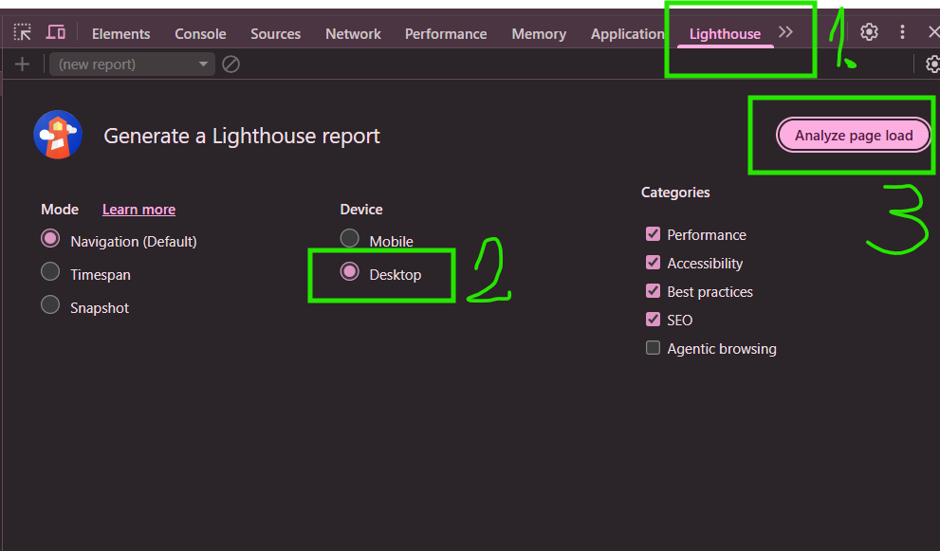
When analysis is done it will be displayed like this with base rates of performance tests, accessibility, best practices and SEO of website:
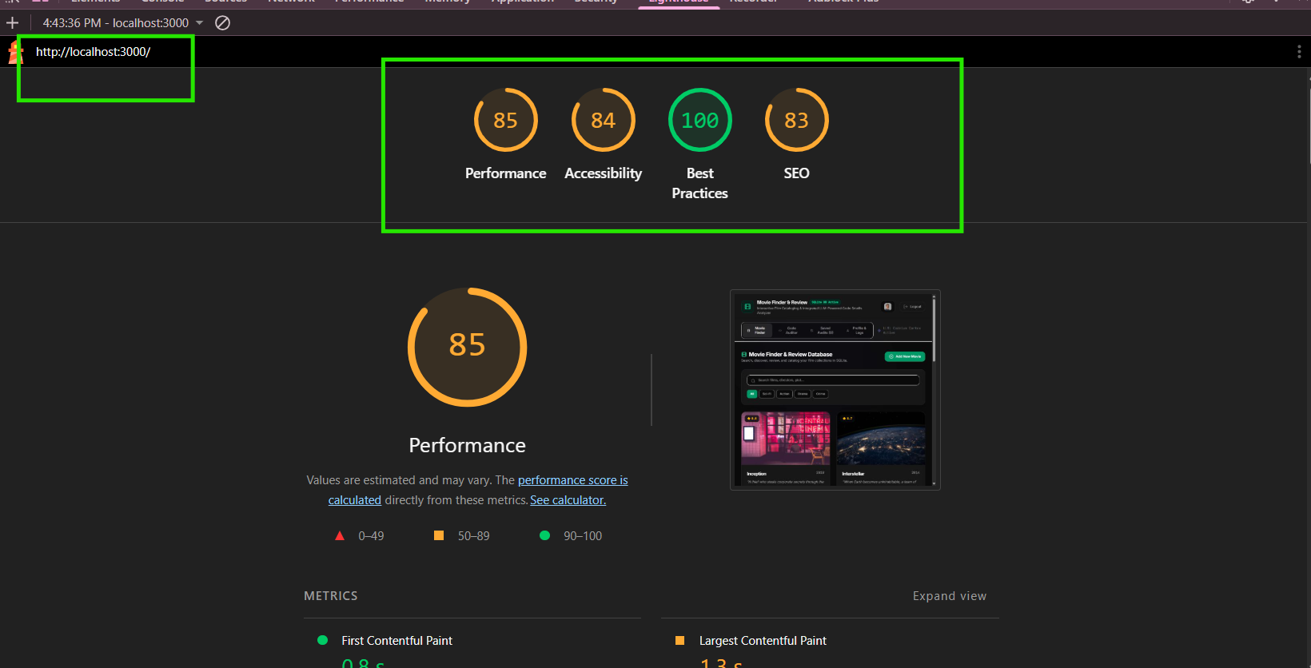

Below that there is diagnostics and insight with improvement points such as Reduce unused JavaScript where report marks part of code that is not used and could be cleaned up.
