Vladan Simic - Test Task 1 Manual QA Report
Target: https://test-qa.capslock.global/
Field | Value
Document purpose | Manual QA bug report for the recruitment assignment
Date tested | June 11, 2026
Tester | Vladan Simic
Primary browser | Google Chrome on Windows
Primary viewport | Desktop 1366 x 900
Evidence collected | Dynamic UI checks, network observation, client-side JavaScript review

Executive Summary
The lead funnel has several high-impact defects that can directly affect revenue operations. The most serious issue is that the user can reach the Thank you page after a nominally successful submission, while the observed network traffic only sends the ZIP step and not the completed lead details. The form also accepts invalid ZIP formats, allows unqualified property types to continue, and permits users to proceed without selecting required interest data.
Overall risk: the current funnel can create incomplete, invalid, or unqualified leads while still reporting a successful conversion to the user.

Scope
- In scope: multi-step form validation, top and bottom form behavior, lead qualification flow, successful redirect, and network behavior visible from the browser.
- In scope: validation rules listed in the assignment for required fields, ZIP, email, phone, and Thank you redirect.
- Out of scope: backend database verification, CRM ingestion, email/SMS delivery, internal analytics dashboards, and production monitoring systems.

Requirements Traceability
Requirement | Status | Observation | Related bugs
All fields are required | Fail | Interest selection is optional in practice | BUG-03
ZIP code must contain exactly 5 digits | Fail | ZIP+4 and Canadian postal code are accepted | BUG-01, BUG-02
Email must match a valid email pattern | Partial fail | Invalid email is blocked without clear inline error | BUG-09
Phone must contain exactly 10 digits | Fail | Validation/mask rules do not cleanly match the requirement | BUG-07, BUG-08
Successful submission redirects to Thank you page | Partial pass | Redirect works, but complete lead payload is not observed | BUG-06

Prioritized Bug Summary
ID | Severity | Priority | Area | Summary
BUG-01 | Critical | P1 | ZIP validation | ZIP+4 value is accepted although ZIP must contain exactly 5 digits
BUG-02 | Critical | P1 | ZIP validation | Canadian postal code is accepted in a US ZIP-only field
BUG-03 | Critical | P1 | Required fields | Interest selection is not required
BUG-04 | Critical | P1 | Lead qualification | Rental Property is accepted even though it should be blocked
BUG-05 | Critical | P1 | Lead qualification | Mobile Home is accepted even though it should be blocked
BUG-06 | Critical | P1 | Submission | Successful submit redirects to Thank you without sending complete lead data
BUG-07 | High | P2 | Phone validation | Phone validation does not match the 'exactly 10 digits' requirement
BUG-08 | High | P2 | Phone input | Phone mask blocks some 10-digit numeric values without explaining the rule
BUG-09 | High | P2 | Email validation UX | Invalid email shows no inline form validation message
BUG-10 | High | P2 | Duplicate form flow | Bottom form submission scrolls the user to the top form area

Detailed Bugs

BUG-01 - ZIP+4 value is accepted although ZIP must contain exactly 5 digits
Severity | Priority | Reproducibility | Area
Critical | P1 | 100% | ZIP validation

Bug description: On step 1 of the lead form, the ZIP field accepts a ZIP+4 value such as 12345-6789 and advances the user to step 2.
Steps to reproduce:
- Open https://test-qa.capslock.global/.
- Enter 12345-6789 in the ZIP Code field.
- Click Next.
Expected result: The value is rejected because the field must contain exactly 5 digits.
Actual result: The form accepts the value and posts stepNumber=1&zipCode=12345-6789 to /test-task/handle-form.
Business impact: Invalid location data can enter the funnel, harming lead routing, service area checks, analytics, and sales follow-up quality.
Evidence: Dynamic screenshot and network observation.
Evidence for BUG-01
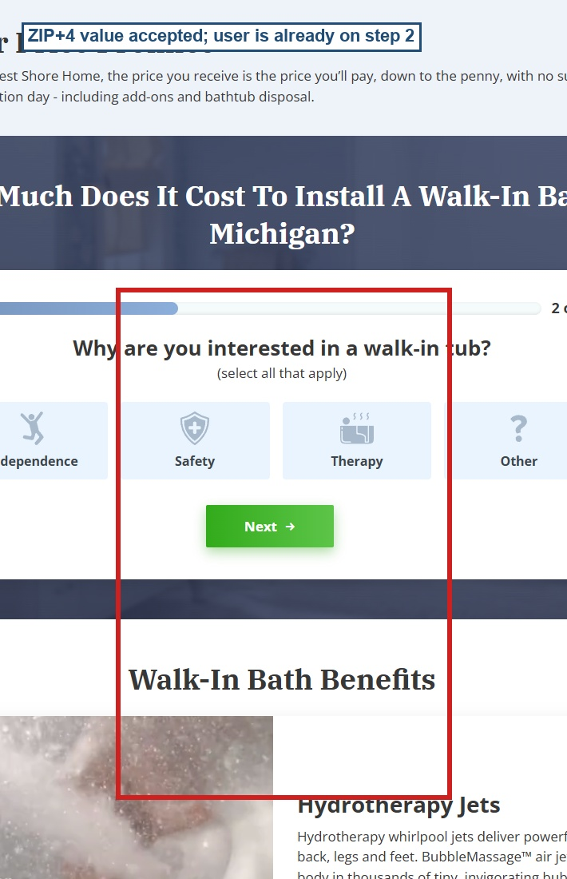

BUG-02 - Canadian postal code is accepted in a US ZIP-only field
Severity | Priority | Reproducibility | Area
Critical | P1 | 100% | ZIP validation

Bug description: The ZIP Code field accepts K1A 0B1 and advances to the next step even though the requirement says ZIP must contain exactly 5 digits.
Steps to reproduce:
- Open the page.
- Enter K1A 0B1 in the ZIP Code field.
- Click Next.
Expected result: The value is rejected because it is not exactly 5 digits.
Actual result: The form advances to step 2 and posts zipCode=K1A+0B1.
Business impact: Non-US or malformed location values can be treated as valid leads, creating wasted sales effort and unreliable market data.
Evidence: Dynamic screenshot and network observation.
Evidence for BUG-02
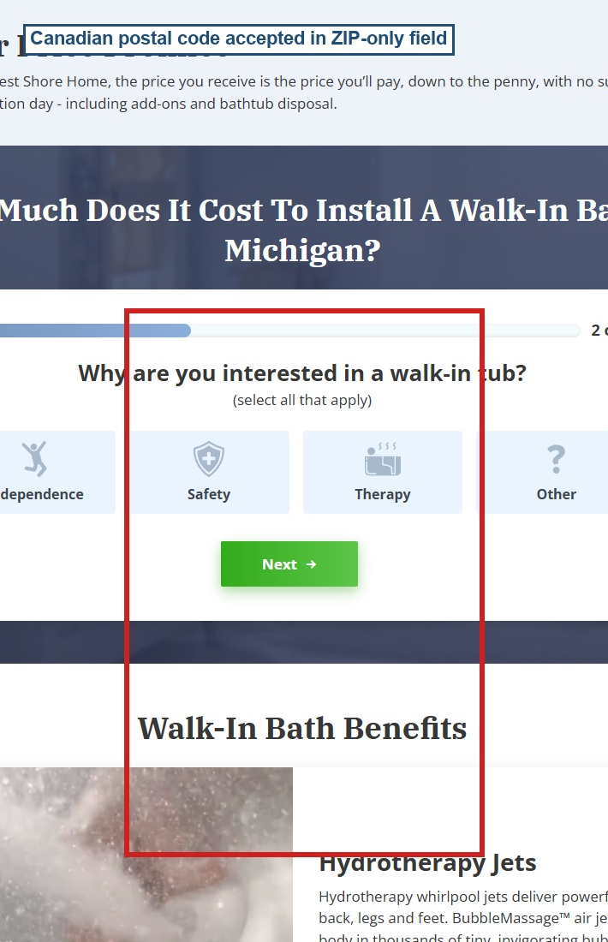

BUG-03 - Interest selection is not required
Severity | Priority | Reproducibility | Area
Critical | P1 | 100% | Required fields

Bug description: On step 2, the user can continue without selecting any option under 'Why are you interested in a walk-in tub?'.
Steps to reproduce:
- Enter a valid ZIP such as 90210.
- Leave Independence, Safety, Therapy, and Other unchecked.
- Click Next.
Expected result: The user remains on step 2 and sees a required-field validation message.
Actual result: The form advances to the property step with no error.
Business impact: Sales and marketing lose intent data needed to qualify and personalize the lead.
Evidence: Dynamic screenshot showing step 3 active while all interest checkboxes remain unchecked.
Evidence for BUG-03
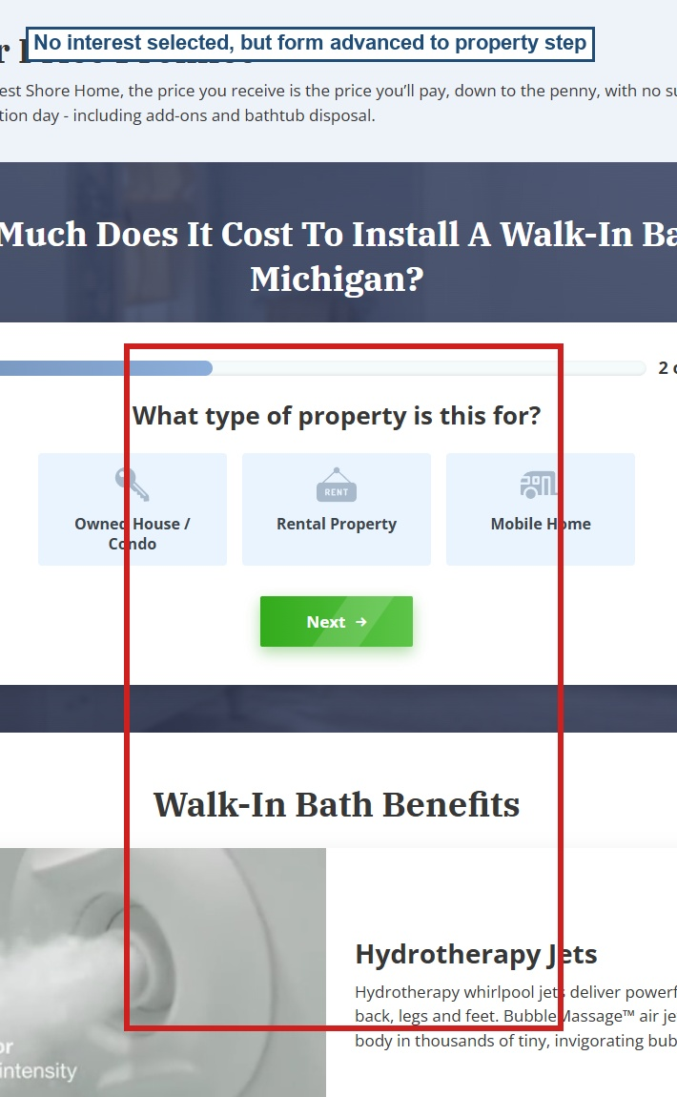

BUG-04 - Rental Property is accepted even though it should be blocked
Severity | Priority | Reproducibility | Area
Critical | P1 | 100% | Lead qualification

Bug description: The property step contains an ineligible-property message for rental/mobile homes, but selecting Rental Property advances the user to name/email collection.
Steps to reproduce:
- Enter ZIP 90210.
- Select Safety.
- Select Rental Property.
- Click Next.
Expected result: The user remains on the property step and sees the ineligible-property message.
Actual result: The form advances to the name/email step and continues collecting the lead.
Business impact: Unqualified leads enter the funnel, increasing cost per valid lead and wasting sales team time.
Evidence: Dynamic screenshot with Rental Property selected and step 4 active.
Evidence for BUG-04
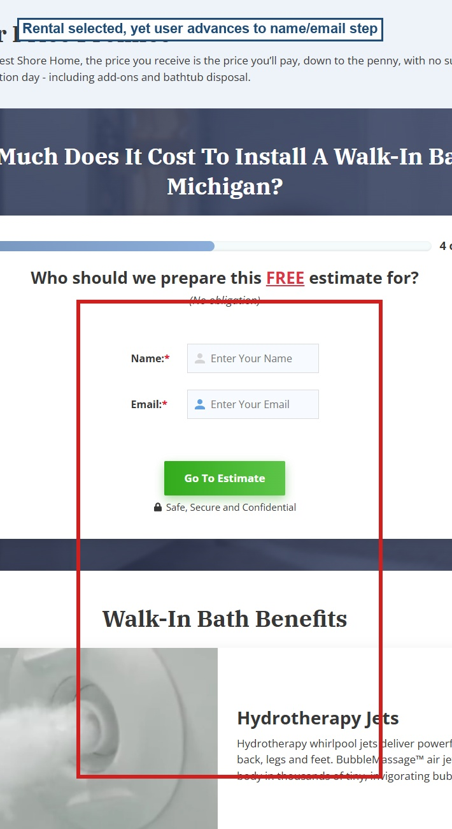

BUG-05 - Mobile Home is accepted even though it should be blocked
Severity | Priority | Reproducibility | Area
Critical | P1 | 100% | Lead qualification

Bug description: The Mobile Home option is configured as an ineligible value, but the user can still continue to the name/email step.
Steps to reproduce:
- Enter ZIP 90210.
- Select Safety.
- Select Mobile Home.
- Click Next.
Expected result: The user remains on the property step and sees the ineligible-property message.
Actual result: The form advances to the name/email step with Mobile Home selected.
Business impact: The system captures leads that the business explicitly says it cannot service.
Evidence: Dynamic screenshot and form state showing Mobile Home checked while step 4 is active.
Evidence for BUG-05
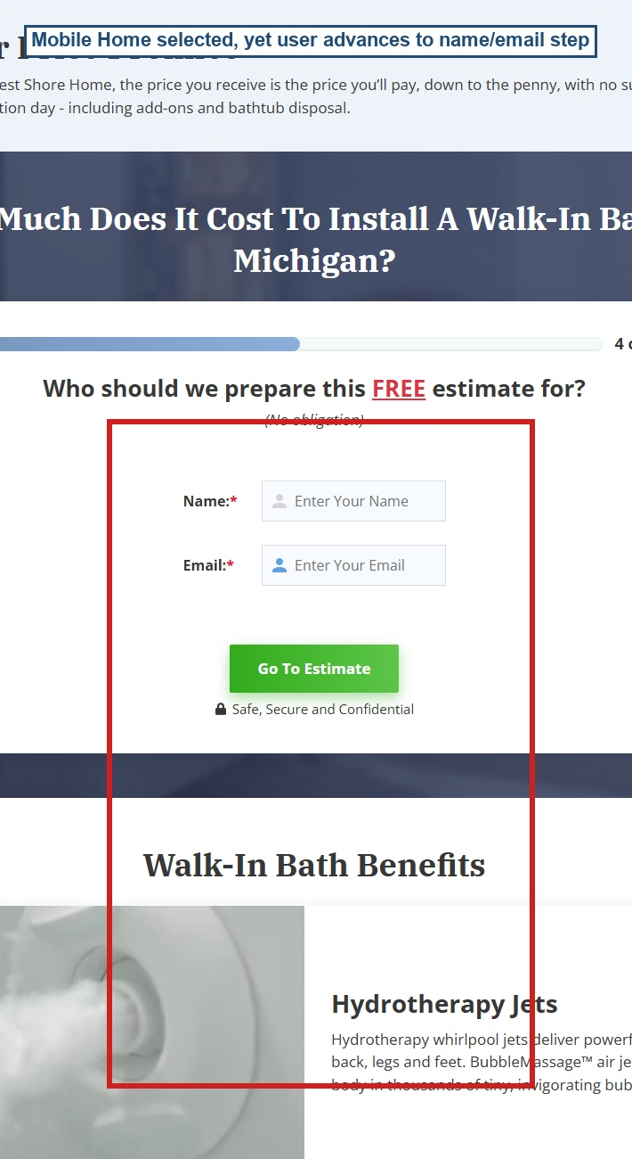

BUG-06 - Successful submit redirects to Thank you without sending complete lead data
Severity | Priority | Reproducibility | Area
Critical | P1 | 100% | Submission

Bug description: The user can complete the funnel and reach /thankyou, but observed network traffic contains only the ZIP step POST. No request containing name, email, phone, interest, or property was observed before redirect.
Steps to reproduce:
- Complete the form with ZIP 90210, Safety, Owned House / Condo, Test User, user@example.com, and 2345678901.
- Click Submit Your Request.
- Observe network traffic and final URL.
Expected result: The complete lead payload is submitted before the user is redirected to the Thank you page.
Actual result: The user is redirected to /thankyou, while the observed payload is only stepNumber=1&zipCode=90210.
Business impact: This is the highest business risk: the user sees a successful conversion, but the business may not receive actionable contact details.
Evidence: Network evidence table and Thank you screenshot.
Evidence for BUG-06
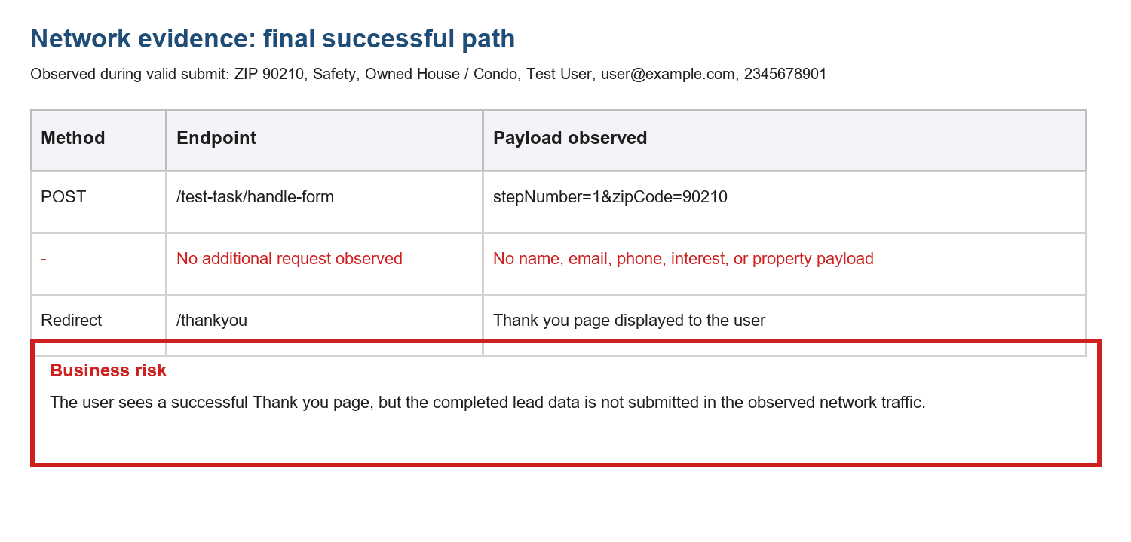
Additional evidence for BUG-06: Thank you page reached
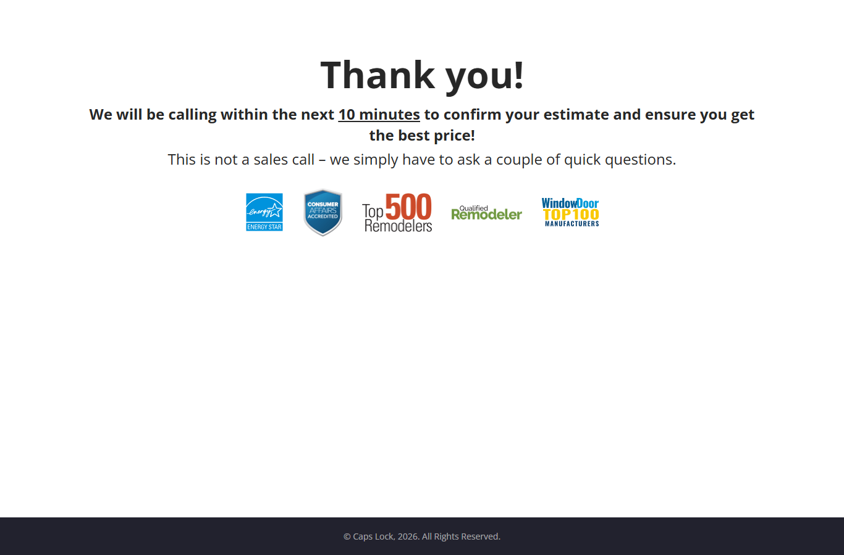

BUG-07 - Phone validation does not match the 'exactly 10 digits' requirement
Severity | Priority | Reproducibility | Area
High | P2 | 100% | Phone validation

Bug description: The JavaScript phone validator allows optional country code, separators, alphanumeric groups, and optional extensions. This is broader than the stated requirement.
Steps to reproduce:
- Review the phone validation rule in the client JavaScript.
- Compare it with the assignment requirement: phone number must contain exactly 10 digits.
Expected result: Validation accepts only 10 numeric digits after normalization.
Actual result: The implementation permits formats outside the stated rule.
Business impact: Lead phone values may be inconsistent across CRM, dialer, analytics, and deduplication systems.
Evidence: Implementation evidence: optional country code and extension handling in the phone regex.

BUG-08 - Phone mask blocks some 10-digit numeric values without explaining the rule
Severity | Priority | Reproducibility | Area
High | P2 | 100% | Phone input

Bug description: The phone mask uses X=[023456789] for the first digit, so a value starting with 1 cannot be entered normally, despite the assignment only stating 'exactly 10 digits'.
Steps to reproduce:
- Reach the phone step.
- Try to type 1234567890.
- Observe the masked input behavior.
Expected result: The UI rule is aligned with the stated requirement or clearly explains any additional phone-number restrictions.
Actual result: The UI silently imposes an extra first-digit restriction.
Business impact: Users with valid-looking 10-digit input may be blocked or confused; QA acceptance criteria become ambiguous.
Evidence: Implementation evidence: mask '(X99)999-9999' and X definition excludes 1.
Evidence for BUG-08
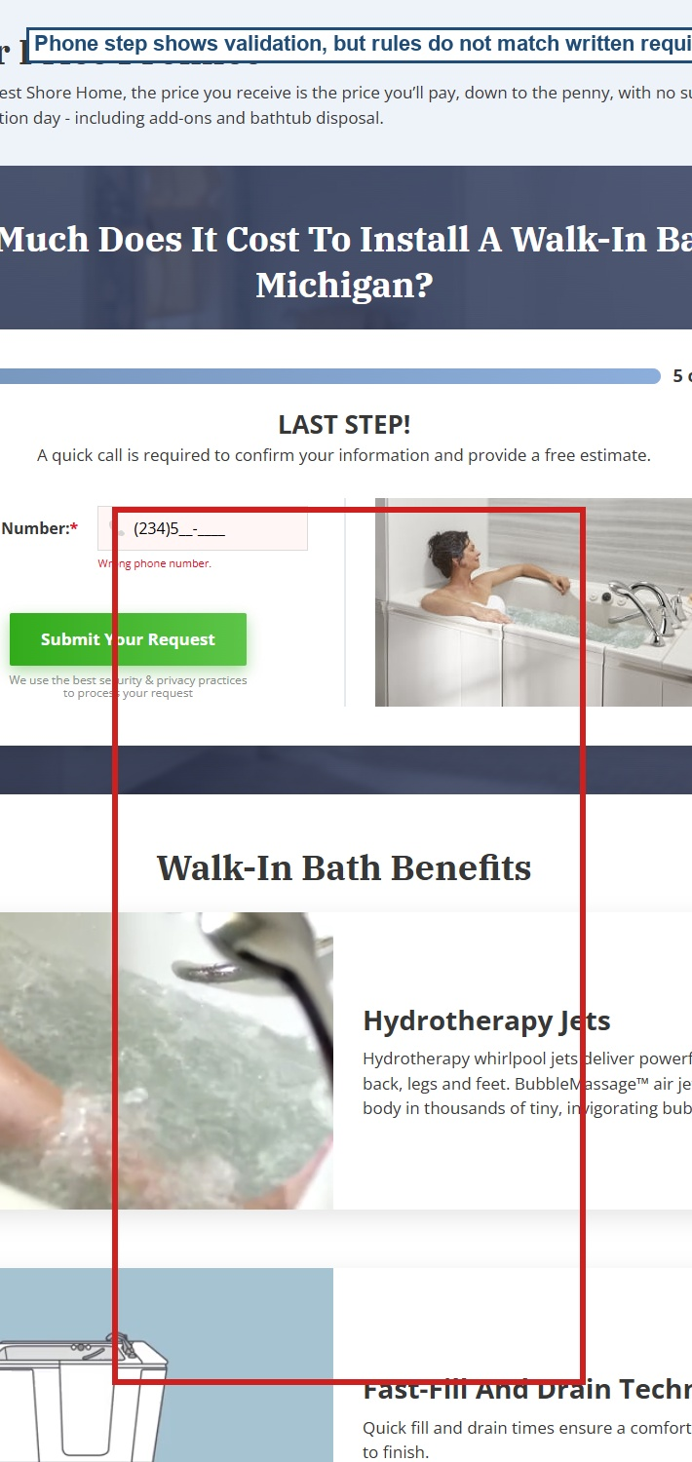

BUG-09 - Invalid email shows no inline form validation message
Severity | Priority | Reproducibility | Area
High | P2 | 100% | Email validation UX

Bug description: Entering bad-email keeps the user on the name/email step, but the form's inline error block remains empty.
Steps to reproduce:
- Enter ZIP 90210.
- Select Safety.
- Select Owned House / Condo.
- Enter Test User and bad-email.
- Click Go To Estimate.
Expected result: A clear inline email validation message is shown next to the email field.
Actual result: The user remains on the same step with no visible inline form error in the captured UI.
Business impact: Users may not understand why they cannot proceed, increasing abandonment at a high-intent step.
Evidence: Dynamic screenshot showing invalid email retained without an inline error.
Evidence for BUG-09
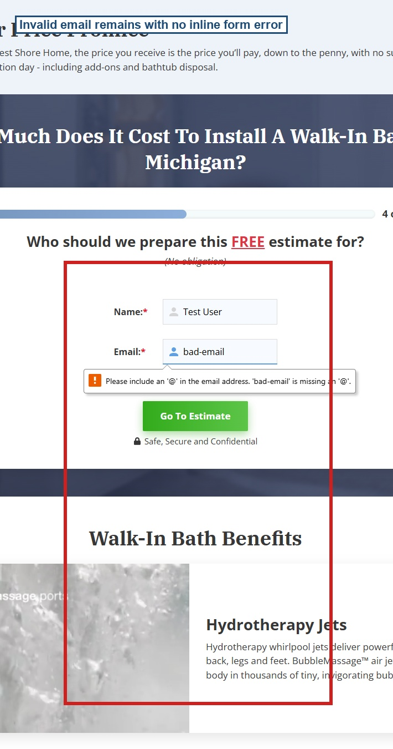

BUG-10 - Bottom form submission scrolls the user to the top form area
Severity | Priority | Reproducibility | Area
High | P2 | 100% | Duplicate form flow

Bug description: The page has two lead form instances. When the bottom form submits ZIP, the implementation scrolls the user to the top form container.
Steps to reproduce:
- Scroll to the bottom form.
- Enter ZIP 90210.
- Click Next.
Expected result: The user remains in the bottom form and continues the quiz there.
Actual result: The viewport jumps to the top form area, interrupting context.
Business impact: This can cause confusion, duplicate form state risk, and conversion loss on long landing pages.
Evidence: Dynamic screenshot and state data: before scrollY was 7070, after submit scrollY was 4388.
Evidence for BUG-10
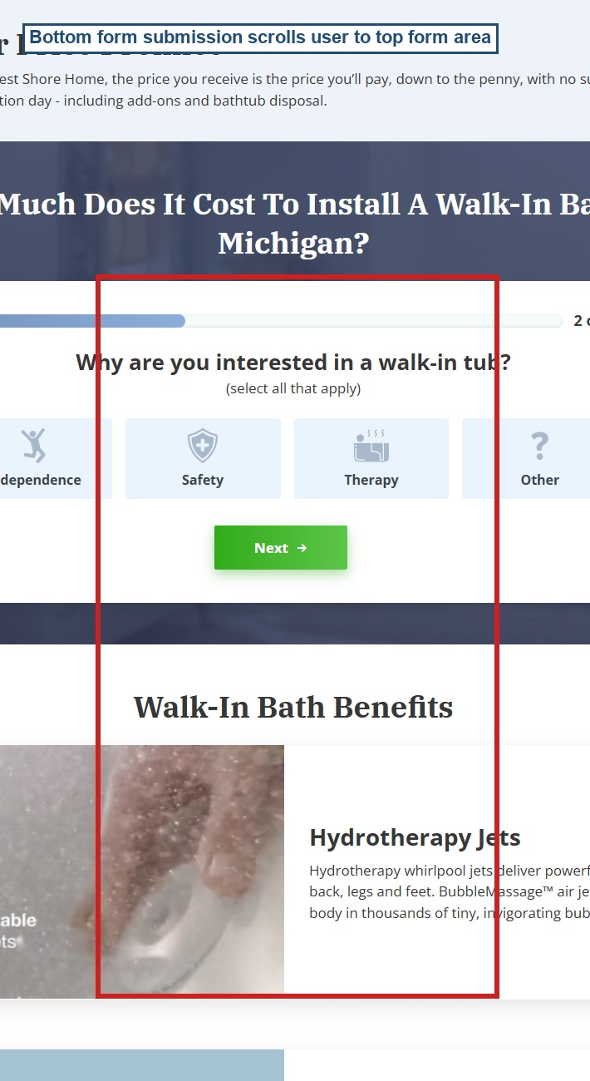

Boundary Test Matrix
Field | Test value | Expected | Observed
ZIP | empty | Reject | Rejected with 'Enter your ZIP code.'
ZIP | 1234 | Reject | Rejected as wrong ZIP
ZIP | 12345 | Accept | Accepted
ZIP | 123456 | Reject | Rejected as wrong ZIP
ZIP | 12345-6789 | Reject | Accepted - BUG-01
ZIP | K1A 0B1 | Reject | Accepted - BUG-02
ZIP | abcde | Reject | Rejected as wrong ZIP
Email | bad-email | Reject with clear message | No inline form message - BUG-09
Email | user@example.com | Accept | Accepted
Phone | 12345 | Reject | Rejected as wrong phone number
Phone | 2345678901 | Accept | Accepted and redirected
Phone | 1234567890 | Accept per written requirement | Input mask adds an undocumented first-digit restriction - BUG-08

Observed But Not Selected In Top 10
- Typo in visible copy: 'Michigian' appears instead of 'Michigan' in the form heading.
- A 404 console error appears during page load; this should be investigated but was lower priority than lead-data issues.
- Many form controls do not declare native required/pattern attributes, increasing reliance on custom JavaScript validation.
- The page duplicates the same funnel twice, which increases the risk of inconsistent state and scroll behavior.
- The sorry/out-of-area email path uses a separate email input and should be regression-tested once access to valid out-of-area data is confirmed.

Recommendations
- Enforce all validation rules on both client side and server side.
- Normalize ZIP and phone values before validation and storage; reject anything outside the stated acceptance criteria.
- Block ineligible property types before collecting contact details.
- Submit the complete lead payload before redirecting to the Thank you page.
- Add automated API or integration tests that verify the final submitted payload contains ZIP, interest, property, name, email, and phone.
- Use one shared form component/configuration for top and bottom forms to prevent divergent behavior.
- Add user-facing inline validation messages for every blocked field, including email.

Final Risk Summary
The highest-priority fixes are BUG-06, BUG-01/BUG-02, BUG-03, BUG-04, and BUG-05. Together, these issues mean that the business can lose complete contact information, accept invalid locations, and continue with leads that should be rejected. Fixing these first would most directly protect lead quality, sales efficiency, and conversion reporting.

