|  |  |  |  |
| --- | --- | --- | --- |
| Id | Description | Input(age) | Output |
| TC_SC_01 | Test case which will traverse all statements at least once. | 10 | Print "Munca interzisa!" |
| TC_BC_01 | Test case which will traverse ‘Yes’ brach from the first decision point. Also it will traverse ‘No’ braches from second and third decision points. | 5 | Print "Munca interzisa!" |
| TC_BC_02 | Test case which will traverse ‘Yes’ brach from the second decision point. Also it will traverse ‘No’ braches from first and third decision points. | 15 | Print "Munca permisa doar cu acordul parintilor cu o durata zilnica mai mica de 5 ore." |
| TC_BC_03 | Test case which will traverse ‘Yes’ brach from the third decision point. Also it will traverse ‘No’ braches from first and second decision points. | 17 | Print “Munca permisa cu o durata zilnica de pina la 7 ore.” |
| TC_MCC_01 | Test case which will test next possible outcomes for second decision point:  T T | 15 | Print "Munca permisa doar cu acordul parintilor cu o durata zilnica mai mica de 5 ore." |
| TC_MCC_02 | Test case which will test next possible outcomes for second decision point:  T F | 17 | Print “Munca permisa cu o durata zilnica de pina la 7 ore.” |
| TC_MCC_03 | Test case which will test next possible outcomes for second decision point:  F T | 5 | Print "Munca interzisa!" |
| TC_MCC_04 | Test case which will test next possible outcomes for third decision point:  T T | 17 | Print “Munca permisa cu o durata zilnica de pina la 7 ore.” |
| TC_MCC_05 | Test case which will test next possible outcomes for third decision point:  T F | 19 | Exit the program |
| TC_MCC_06 | Test case which will test next possible outcomes for third decision point:  F T | 14 | Print "Munca interzisa!" |

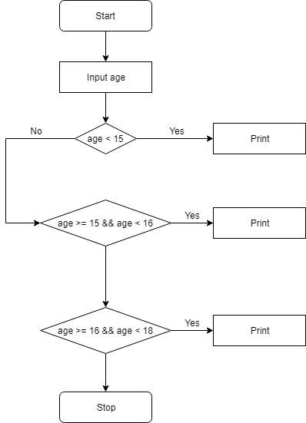

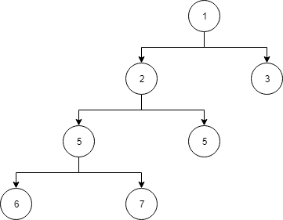

***C = E – N + 2 = 1***

*E –* the number of edges

*N –* the total number of nodes

**Specification:** inputs the age of an adolescent(integer) and return his/her work permission(strings).