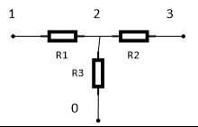

R = 14

W =

|  |  |  |  |
| --- | --- | --- | --- |
|  | 1 | 2 | 3 |
| 1 | 0.071 | -0.071 | 0 |
| 2 | -0.071 | 0.214 | -0.071 |
| 3 | 0 | -0.071 | 0.071 |