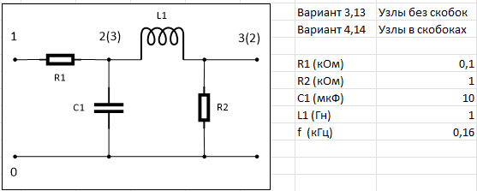

Вариант 14

W =

|  |  |  |  |  |
| --- | --- | --- | --- | --- |
|  | 1 | 2 | 3 | 4 |
| 1 | 10 | 0 | -10 | 0 |
| 2 | 0 | 1 | 0 | -1 |
| 3 | -10 | 0 | 10 + 10.053i | 1 |
| 4 | 0 | 1 | -1 | 0 + 1.005i |