AI-Powered Job Hunt Assistant
Final UML and System Diagrams with Explanations
This document presents the final design diagrams for the mobile application. The project is planned as a React Native phone app with an Express backend, PostgreSQL database, AI-powered document support, and job data integration. The diagrams below describe the system from three perspectives: user functionality, technical architecture, and data structure.

1. Use Case Diagram
The use case diagram shows the main actions that the user can perform in the application. It focuses on the functional side of the system and helps define what the app must support from the user's perspective.
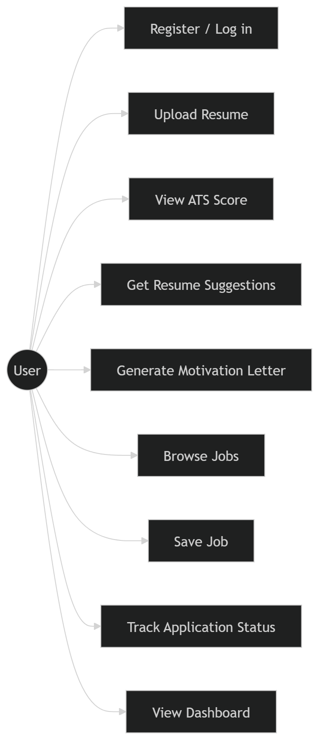
Figure: 1. Use Case Diagram
Explanation
- Register / Log in represents access control and user account management before protected features can be used.
- Upload Resume is one of the central actions because the application depends on the user's resume as the base input for analysis and personalization.
- View ATS Score and Get Resume Suggestions show how the app gives feedback on whether the resume is likely to pass applicant tracking systems.
- Generate Motivation Letter represents the AI-assisted feature that creates tailored application text from the user's resume and a selected job.
- Browse Jobs and Save Job support job discovery and allow the user to keep relevant opportunities for later action.
- Track Application Status and View Dashboard support organization and give the user a clear overview of progress across the job hunt process.

2. System Architecture Diagram
The system architecture diagram explains how the major technical components communicate with each other. It gives a high-level view of the mobile app, backend, database, and external services.
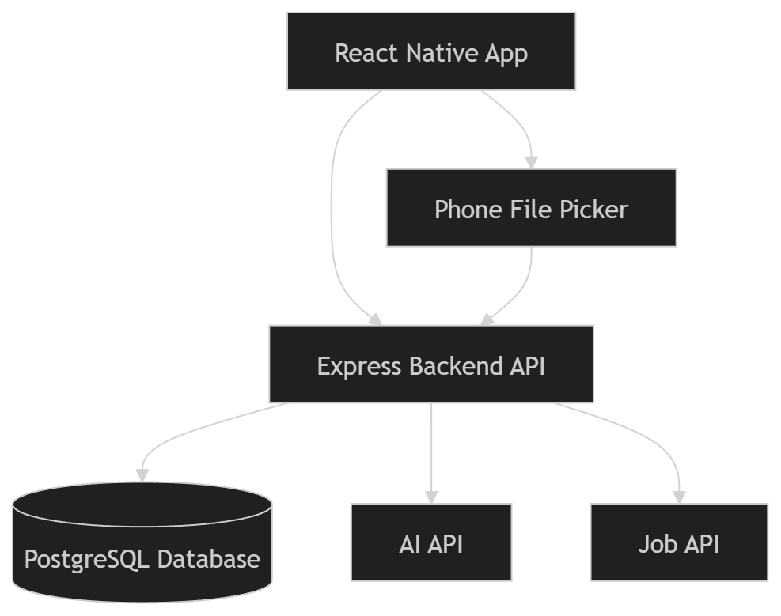
Figure: 2. System Architecture Diagram
Explanation
- The React Native App is the mobile client used by the user. It handles the interface, navigation, and communication with the backend API.
- The Phone File Picker is included because resume upload is a core part of the workflow and must interact with phone storage in a mobile-friendly way.
- The Express Backend API is the main processing layer. It receives requests from the app, validates data, applies business logic, and sends results back.
- The PostgreSQL Database stores persistent data such as users, resumes, applications, job information, and analysis results.
- The AI API is used for intelligent features such as generating motivation letters and providing resume improvement suggestions.
- The Job API supplies external job vacancy data so the application can display listings without relying on unauthorized scraping.

3. UML Class Diagram
The class diagram describes the main data entities in the system and the relationships between them. This is the most important diagram for backend planning because it guides database design and object relationships.
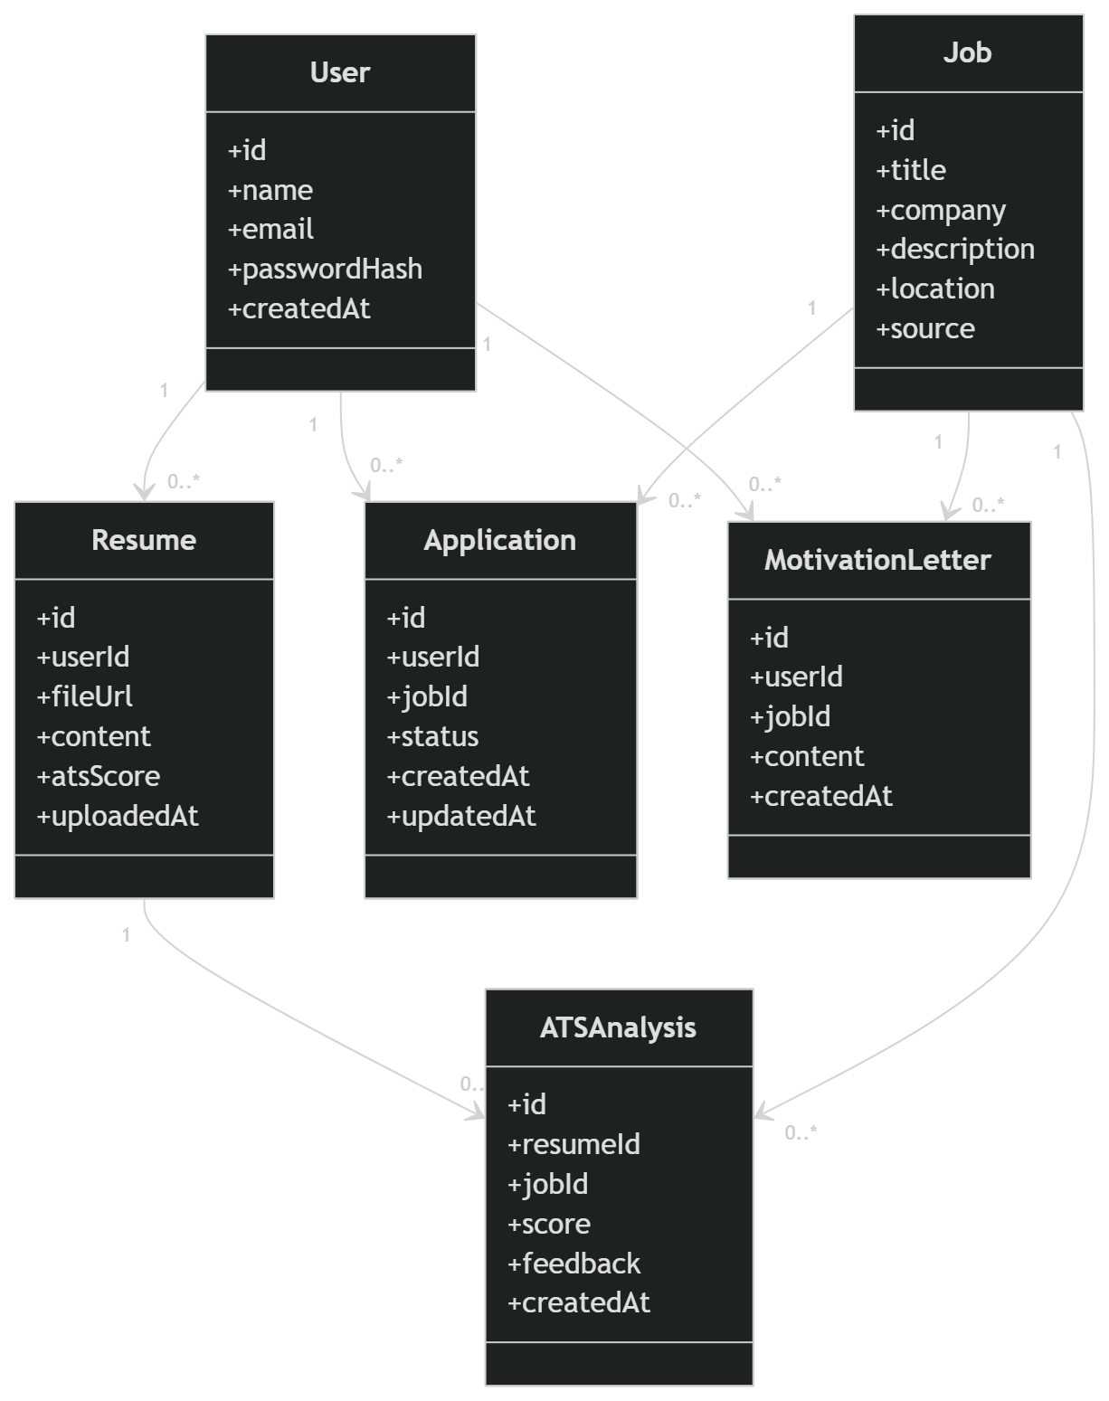
Figure: 3. UML Class Diagram
Explanation
- User stores the main account information for each person using the app.
- Resume belongs to a user and contains the uploaded file reference, extracted content, ATS score, and upload date.
- Job represents a vacancy that can be browsed, saved, analyzed, or used for an application.
- Application connects a user to a job and stores the current status, such as saved, applied, interview, or rejected.
- MotivationLetter stores AI-generated text that is tailored for a specific user and a specific job.
- ATSAnalysis stores the result of comparing one resume against one job description, including the score and generated feedback.
- The one-to-many relationships show that one user can have multiple resumes, applications, and motivation letters, while one job can be linked to multiple applications, letters, and analyses.

4. Design Summary
Together, these diagrams describe the system from complementary angles. The use case diagram defines what the user can do, the architecture diagram explains how the solution is technically structured, and the class diagram shows how the data model is organized. Using all three diagrams together creates a clear foundation for implementation, testing, and future documentation.

