Lab: Migrations and Django Admin
This document defines the problems for the in-class lab for the Python ORM course @ Software University.
Submit your solutions to the SoftUni Judge system.

For this lab, you are given an ORM project skeleton (you can download it from the current lesson's resources) with one model called "Product". That model consists of the fields: "name", "description", "price", "category", and "supplier".

Migrations
Note: The problem cannot be submitted in the Judge system.
Your task is to help us improve the model by making some changes to the code:
- First, we want you to migrate the model to the database.
- Next, we need to add a couple of records to the created database table. To help us, you need to open the caller.py file and execute the code on line 80.
- We just remembered that we need to put two more columns in the table:
  - created_on - a date and time field, that should be set to the current date and time when the object is first created and should not be editable.
  - last_edited_on - a date and time field, that should be set to the current date and time every time the object is saved and should not be editable.
Add the fields to the model and migrate the changes.
- We are willing to add one more record. Run only the code on line 82 in the caller.py file.
- Now, we come up with the idea to add the following field:
  - count - a positive integer field with a default value of 0 (zero).
We need you to refactor the code and migrate the changes to the database.
- We want to add a couple of records. Run only the code on line 84 in the caller.py file.
- We saw that it was a poor idea and now we want you to undo the changes from the previous task (reverse the last migration and remove the count field).
- Now, we have come to the opinion that making the fields "category" and "supplier" required (rather than optional) is beneficial. Make the changes to the code and migrate them to the database.
- For now, we think we are satisfied with the model.

Hint
Note: Before start solving the problem, set up the database.
First, we need to migrate the model to the database. We will use the terminal commands "python manage.py makemigrations" and "python manage.py migrate" successively.
Next, we will go to the caller.py file, and execute the code on line 80. If the products are added successfully to the database as record, we should see the following output on the console: 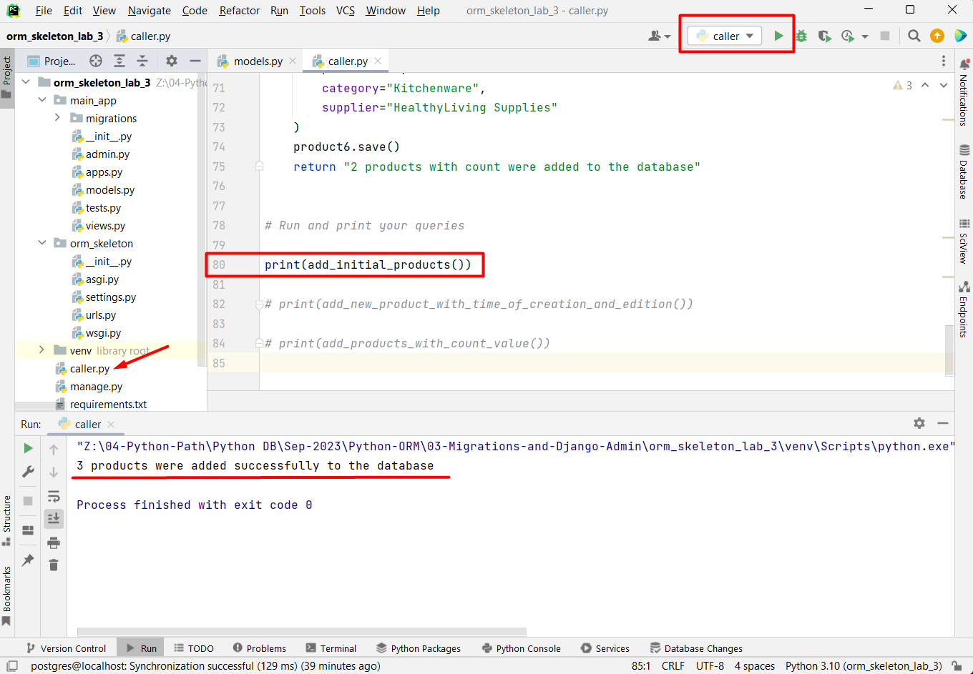
We can also check the table data, using the PyCharm Database tool: 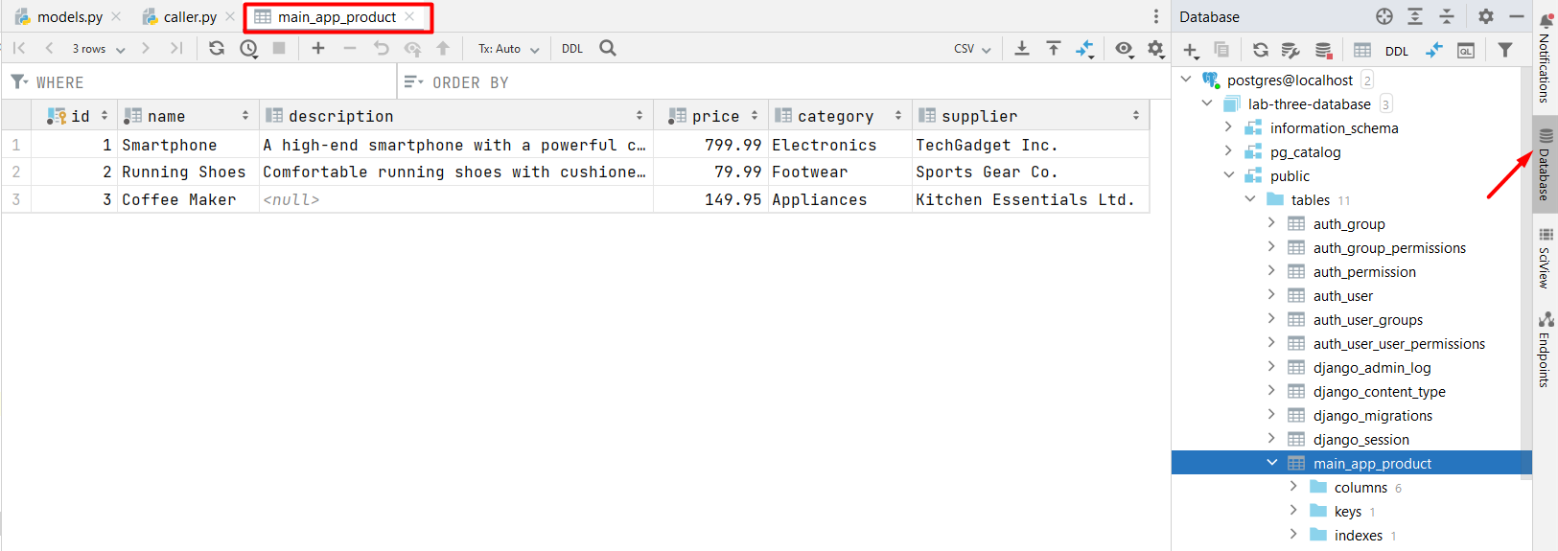
Now, our next task is to add two more fields to the model and migrate the changes. We can see that, when we try to make the migration files, Django raises an error. That is because the database needs something to populate existing rows. We have two options - we can provide a one-off value that will be set only on the already existing rows, or we can exit the operation and set a default value in the model fields: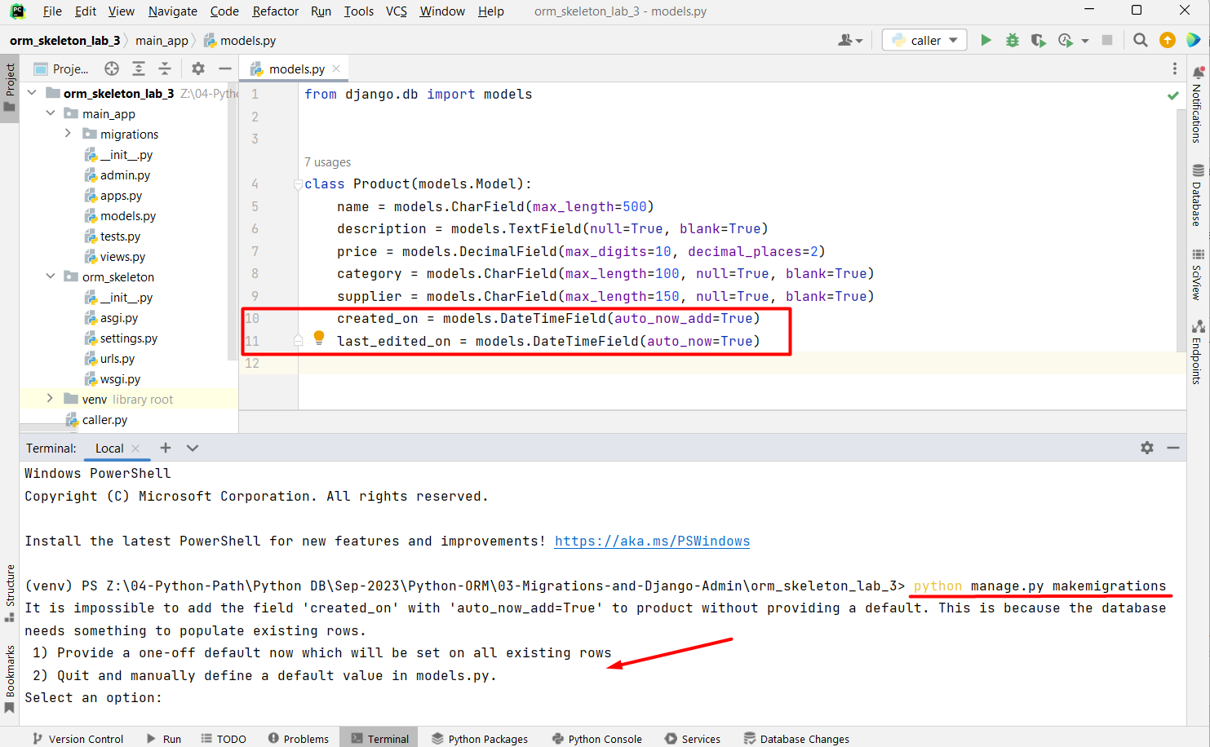
Let us choose option 1 for this example. We can enter a default value manually or we can choose to use the now() function provided by Django. Let us just set the default value to now() by pressing Enter:
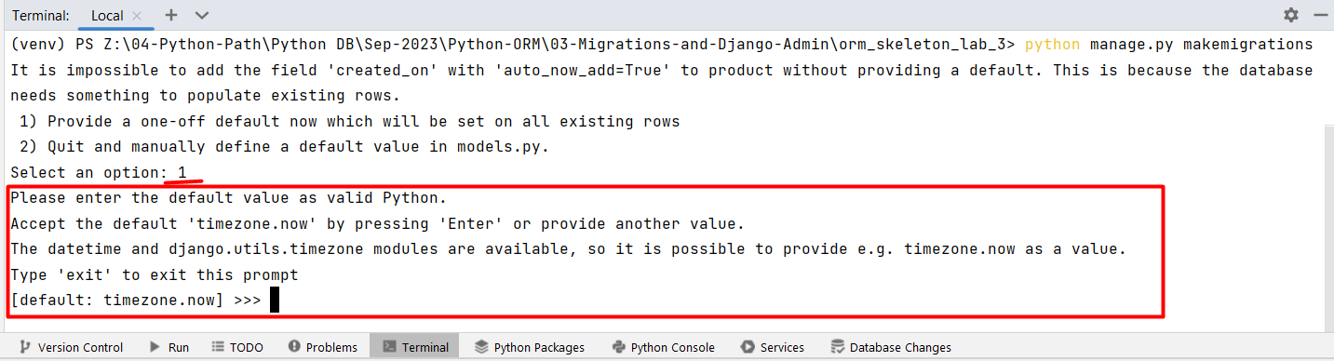
If we look at the migration file, we ca see the default value added:
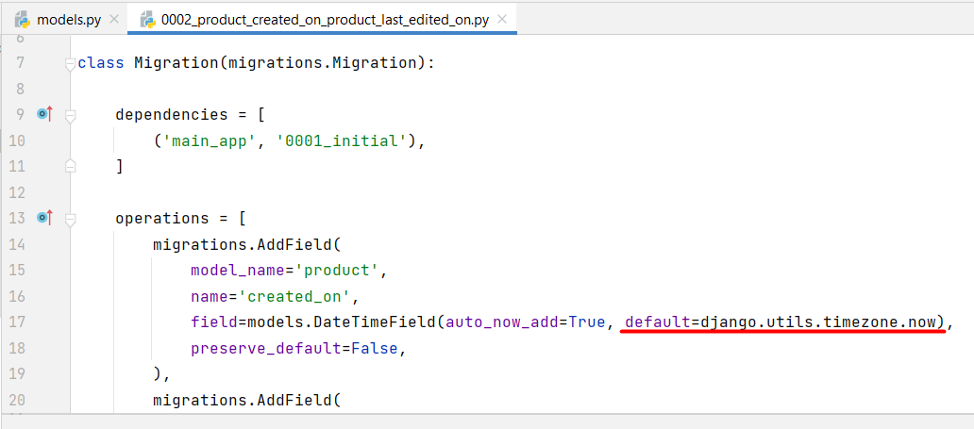
We can now easily migrate the changes to the database using the "python manage.py migrate" command.
Let us add one more record to the database using the code in the caller.py:
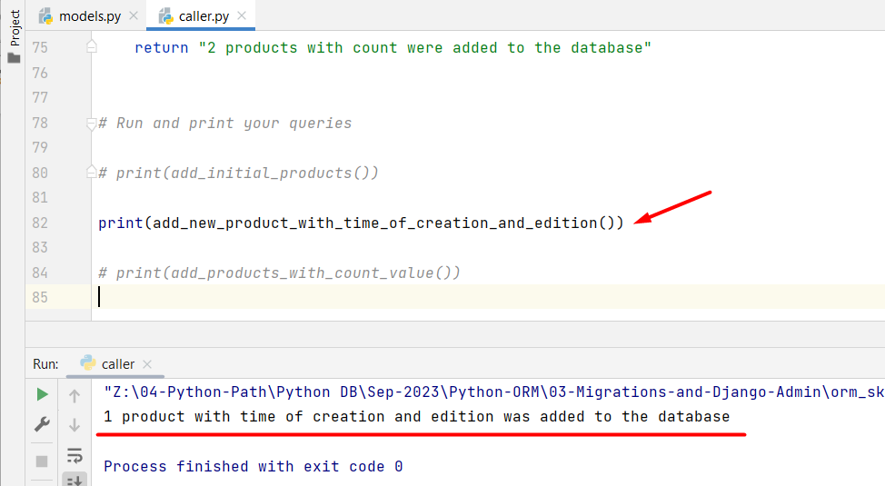
It is time to execute our next task. We need to add a new field called count: 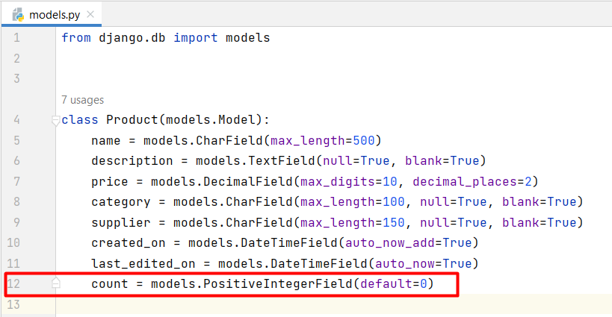
Migrate the changes to the database. Then, execute only the 84th line.
Unfortunatelly, we are given more work to do. Now, we need to undo our changes. First, let us reverse the last migration by using the command "python manage.py migrate main_app 0002":
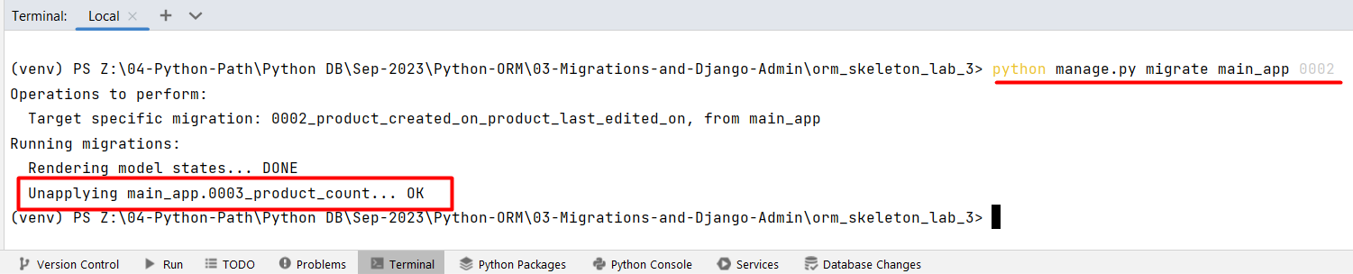
Next, we should delete the field "count", so that it will not be added to the table as a column anymore. And, finally, we do not need the migration file 0003, so we can delete it. If we do not delete it, the next time we migrate the changes, Django will execute the migration file again.
Finally, make the last changes to the model and migrate them.

Barcode System
Note: The problem cannot be submitted in the Judge system.
We've reconsidered it, and now we want to make some more changes to the "Product" model. Add a new unique integer field called "barcode" to the model. It will consist of the barcode of each product. For all already applied products in the database, we should add the barcode value - a random unique number from 100 000 000 to 999 999 999 both inclusive.

Hint
First, let us add the field "barcode" to the model:
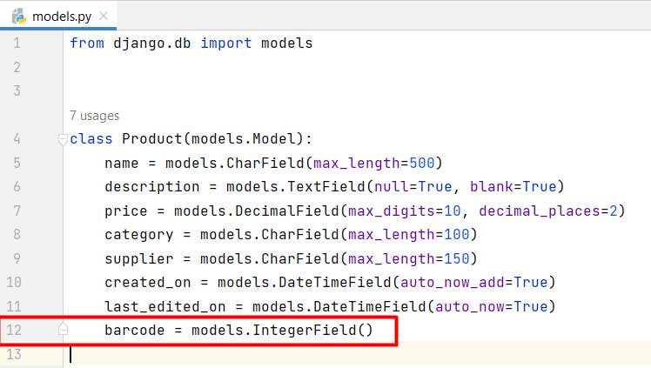
Next, let us migrate the changes to the database, and then on a separate migration file we can write our custom logic. First, we need to open the terminal and write the command "python manage.py makemigrations --empty main_app" to generate a new empty migration file. Then, we can populate the file. Note, that we can use random.sample(range, count) Python function to get only random unique values: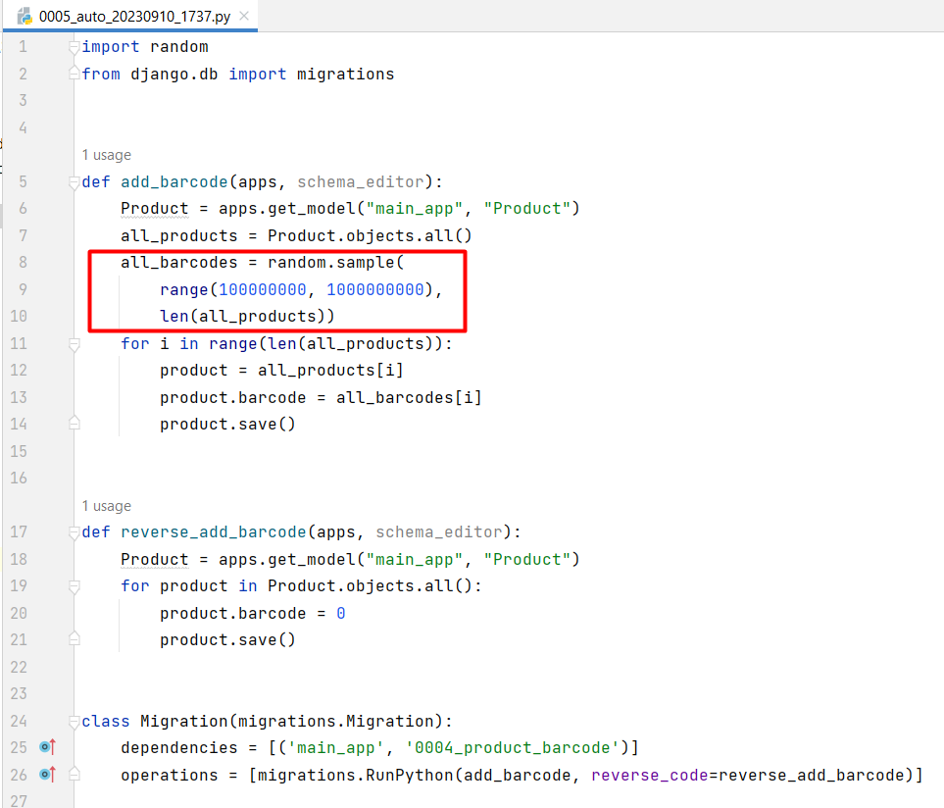

Register the Model
Register the model "Product" in the Django Admin site. Open the interface and create one record for each model. Familiarize yourself with the functionalities of the admin site. Submit your project to the Judge system.

Hint
First, let us open the admin.py file in the main_app and import the model "Product". Now, we have two ways of registering the model in the admin site. One way to register the model is by directly providing the model. We use this when we do not want to define any custom values and we are ok with the default admin interface: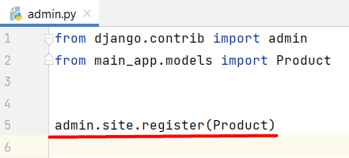
Second way - we can create a class that inherits from the ModelAdmin class to register our model: 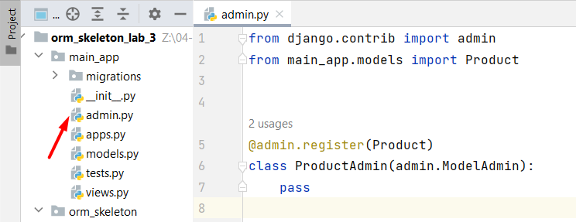
To work with the admin site, we need to create a superuser. We achieve it by executing the terminal command "python manage.py createsuperuser". Then, we need to pass the name and the password of the user.

Customize the Admin
Customize the interface of the registered model. In a ProductAdmin class add the following functionality:
- Display the fields "name", "category", "price", and "created_on" (in that order) in the admin panel.
- Enable searching for "name", "category", and "supplier" fields in the admin panel.
- Create filters for "category" and "supplier" fields in the admin panel.
- Control the layout of "Add" and "Change" pages by grouping related fields within different sections:
  - Group "General Information" with fields "name", "description", "price", "barcode".
  - Group "Categorization" with fields "category" and "supplier".
- Enable date-based drill-down navigation by the "created_on" field.

Hint
To include a date-based drill-down navigation by the field created_on, we should use the option date_hierarchy and set it to "created_on" value:
