Lab: Django Models Basics
This document defines the problems for the in-class lab for the Python ORM course @ Software University.
Submit your solutions to the SoftUni Judge system.

Employee Model
Note: the problem cannot be submitted to the Judge system.
In the main_app create a model called "Employee" which will contain information about each employee in a company. Each employee must have:
- name - a character field with a max length of 30 characters, containing the name of the employee.
- email_address - an email field, containing the employee's email address.
- photo - an URL field, containing the URL path to the employee image.
- birth_date - a date field, containing the birth date of the employee.
- works_full_time - a Boolean field that holds information about the type of employment. If the employee works full-time the field should be set to True, otherwise - it should be set to False.
- created_on - date and time field; the field should be set to the current date and time when the object is first created.

Hints
First, let us open the models.py file in the main_app Django application: 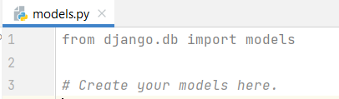
Then, we will create a class that will subclass the Model class from the django.db.models directory: 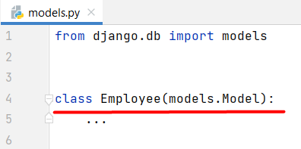
After that, we will write the fields of the model: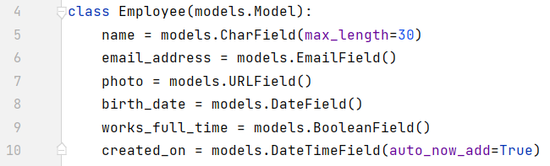

Department Model
Note: the problem cannot be submitted to the Judge system.
In the same main_app create a second model called "Department" containing information about each department in a company. Each department has:
- code
  - A character field with a max length of 4 characters.
  - Should be set to be the primary key.
  - Each code is unique.
  - It indicates the code of the department.
- name
  - A character field with a max length of 50 characters.
  - Each name should be unique.
  - It indicates the name of the department.
- employees_count
  - A positive integer field.
  - If no value is provided, it should be set to a default value of 1.
  - Its verbose name should be set to "Employees Count".
  - It indicates the predetermined number of employees that should work in that department.
- location
  - A character field with a max length of 20 characters.
  - Optional field.
  - Holds predefined choices of each city name: "Sofia", "Plovdiv", "Burgas", "Varna".
  - It indicates the department's location by city.
- last_edited_on
  - Date and time field.
  - It should be set to the current date and time every time the object is saved.
  - It should not be editable.

Migrate the Models
Migrate the created models named "Employee" and "Department" to the database. Check the created database tables using dbshell. Submit your project to the Judge system.

Hints
Open your terminal and run the following command to initiate the migration process: "python manage.py makemigrations". This command will generate migration files based on the changes in your models: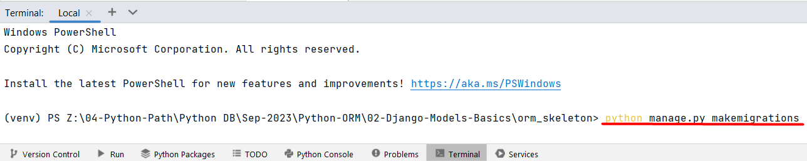

After generating the migration files, apply the migrations to the database using the following command: "python manage.py migrate". This command will create the database tables according to the model definitions: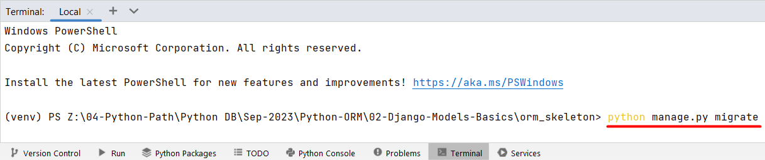
We can verify that the migration was successful by checking the database tables. We can use the dbshell.
Once we are confident that the migration was successful and the database tables are set up correctly, we will proceed to submit the project to the Judge system for evaluation.
First, we will archive the needed files and directories to a .zip file. Note that we need to archive the main_app, orm_skeleton, caller.py, manage.py, and requirements.txt:
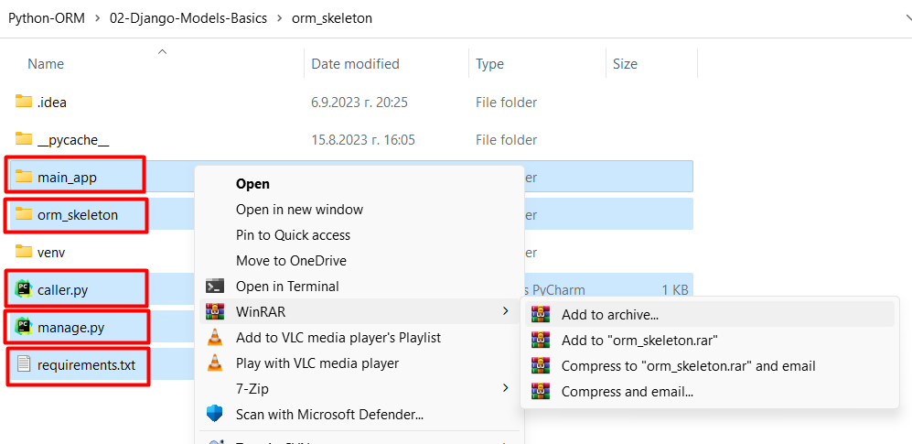
Do not change the names of the files and folders when you submit them in the Judge system!
Next, we will add the .zip file to the Judge system and click to submit the project: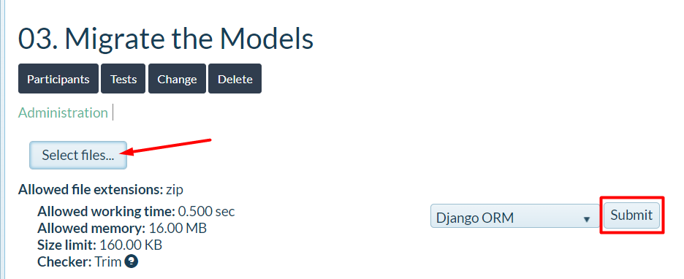

Project Model
Create a model called "Project" containing information about each project in a department and migrate it to the database. Each project has:
- name
  - A character field with a max length of 100 characters.
  - Each name should be unique.
  - It stores the name of the project.
- description
  - A text field.
  - Optional field.
  - It stores a detailed description of the project.
- budget
  - A decimal field.
  - Optional field.
  - It stores the project's budget with a maximum of 10 digits and 2 decimal places.
- duration_in_days
  - A positive integer field.
  - Optional field.
  - Its verbose name should be set to "Duration in Days".
  - It stores the number of days the project is expected to last.
- estimated_hours
  - A float field.
  - Optional field.
  - Its verbose name should be set to "Estimated Hours".
  - It stores the estimated hours required for the project.
- start_date
  - A date field.
  - Its verbose name should be set to "Start Date".
  - Optional field.
  - If no data is entered, by default it should be set to the current date when the object was first created.
  - It stores the project's start date.
- created_on
  - Date and time field.
  - It should be set to the current date and time when the object is first created.
  - It should not be editable.
- last_edited_on
  - Date and time field.
  - It should be set to the current date and time every time the object is saved.
  - It should not be editable.

Hints
To allow the start_date field to be set manually while also having a default value of today's date when no value is provided, we can use the default argument with the date.today function:
start_date = models.DateField(default=date.today)

