REPUBLIC OF GHANA
Ministry of Works and Housing
Ghana Revenue Authority

GHANA RENTAL MARKET
TAXATION SYSTEM
(GRMTS)
FUNCTIONAL SPECIFICATION DOCUMENT
Version 2.0
January 2025
CONFIDENTIAL

Document Control

Document Information
Document Title | Ghana Rental Market Taxation System - Functional Specification
Document Number | GRMTS-FS-2025-001
Version | 2.0
Status | Draft for Review
Classification | Confidential
Prepared By | GRMTS Project Team
Prepared For | Ghana Revenue Authority, Ministry of Works and Housing
Last Updated | January 29, 2025

Version History
Version | Date | Author | Changes
0.1 | Dec 1, 2024 | Requirements Team | Initial draft - requirements gathering
0.5 | Dec 15, 2024 | Requirements Team | Added business rules and workflows
1.0 | Jan 10, 2025 | Project Manager | First complete version for stakeholder review
1.5 | Jan 20, 2025 | Technical Lead | Incorporated stakeholder feedback
2.0 | Jan 29, 2025 | Project Team | Complete functional specification with UI specs

Document Approval
Role | Name | Signature | Date
Project Sponsor (GRA)
Project Sponsor (MWH)
Project Manager
Technical Lead
Business Analyst Lead

Distribution List
Name/Role | Organization | Distribution
Commissioner General | Ghana Revenue Authority | Electronic Copy
Deputy Commissioner (Domestic Tax) | Ghana Revenue Authority | Electronic Copy
Chief Director | Ministry of Works and Housing | Electronic Copy
Director of Housing | Ministry of Works and Housing | Electronic Copy
IT Director | Ghana Revenue Authority | Electronic Copy
Project Steering Committee | GRMTS Project | Electronic Copy
Development Team Lead | Implementation Vendor | Electronic Copy

Table of Contents

1. Executive Summary

1.1 Purpose of This Document
This Functional Specification Document (FSD) provides a comprehensive and detailed description of the Ghana Rental Market Taxation System (GRMTS). It serves as the primary reference for all stakeholders involved in the design, development, testing, deployment, and operation of the system. This document captures the complete functional requirements, business rules, user interface specifications, and system behaviors necessary to build a system that meets the needs of the Ghana Revenue Authority, Ministry of Works and Housing, landlords, tenants, and other stakeholders.
The intended audience for this document includes:
- Government stakeholders and policy makers who need to understand system capabilities
- Project managers and business analysts responsible for requirements management
- Software architects and developers who will implement the system
- Quality assurance teams who will validate the system against these specifications
- Training teams who will develop user documentation and training materials
- Operations teams who will support the system post-deployment

1.2 Problem Statement
Ghana's rental housing market faces several critical challenges that negatively impact both government revenue collection and tenant welfare:

1.2.1 Tax Evasion in the Rental Sector
The rental income tax compliance rate in Ghana is estimated at less than 15%. With approximately 90% of Ghanaians living in rental accommodations and an estimated 2.5 million rental contracts nationwide, the tax leakage represents a significant loss of government revenue. Conservative estimates suggest annual tax losses exceeding GHS 800 million from the residential rental sector alone.
Contributing factors to this tax evasion include:
- Lack of mandatory contract registration requirements
- Cash-based transactions that leave no audit trail
- Limited enforcement capacity at the district level
- No systematic method to identify landlords and their rental income
- Complex tax filing requirements that discourage voluntary compliance

1.2.2 Excessive Advance Rent Demands
Landlords in Ghana commonly require tenants to pay rent advances of 1-3 years upfront before occupancy. This practice creates severe financial hardship for tenants who must accumulate substantial sums before securing housing. A typical 2-bedroom apartment in Accra renting at GHS 2,000 per month with a 2-year advance requirement demands GHS 48,000 upfront - an amount that exceeds the annual income of many Ghanaian workers.
The consequences of excessive advance demands include:
- Reduced housing accessibility for low and middle-income families
- Increased informal lending at predatory interest rates
- Tenants trapped in substandard housing due to inability to save for moves
- Economic inefficiency as large sums remain locked in non-productive use
- Social inequality as housing access becomes wealth-dependent

1.2.3 Lack of Market Transparency
The absence of reliable rental market data creates information asymmetry that disadvantages tenants. Without access to comparable rental rates, tenants cannot effectively negotiate fair prices or identify overpriced properties. This opacity also hampers urban planning, policy formulation, and economic analysis of the housing sector.

1.2.4 Limited Tenant Protections
Current mechanisms for resolving landlord-tenant disputes are slow, expensive, and inaccessible to most tenants. The formal court system is overburdened, and many tenants are unaware of their legal rights. This power imbalance enables exploitation through arbitrary evictions, illegal fee collection, and poor property maintenance.

1.3 Proposed Solution
The Ghana Rental Market Taxation System (GRMTS) is a comprehensive digital platform designed to address these challenges through technology-enabled regulation, automated tax collection, and market transparency. The system will fundamentally transform how rental transactions are conducted in Ghana.

1.3.1 Core Solution Components
Mandatory Digital Contract Registration: All rental agreements must be registered through GRMTS to be legally valid and enforceable. Unregistered contracts will not be recognized by courts, police, or government agencies. This creates a powerful incentive for compliance while building a comprehensive database of rental activity.
Automatic Tax Withholding: When tenants make rent payments through the platform, the system automatically calculates and withholds the applicable withholding tax (8% for registered landlords, 15% for unregistered). Tax is remitted directly to GRA, eliminating the need for landlords to file separately and ensuring complete collection.
Advance Payment Limits: The system enforces maximum advance payment periods based on property type - 6 months for residential properties and 12-24 months for commercial properties. Contracts exceeding these limits cannot be registered, making them unenforceable.
Market Rent Database: Aggregated and anonymized rental data provides public access to fair market rent information by location and property type. This empowers tenants to negotiate effectively and helps landlords price competitively.
Digital Dispute Resolution: Built-in mechanisms for filing and resolving disputes provide accessible and affordable alternatives to court proceedings. Cases are assigned to qualified rent officers who can mediate and issue binding decisions.
Risk-Based Enforcement: Automated algorithms analyze data from multiple sources to identify potential violations and prioritize enforcement actions. Inspectors receive case assignments with risk scores and supporting evidence.

1.3.2 Key System Features
The GRMTS platform includes the following major features:
- Multi-channel access: Web portal, mobile application, and USSD for feature phones
- Identity verification through integration with National Identification Authority
- Property registration with ownership verification through Lands Commission
- Secure payment processing via Mobile Money (MTN, Vodafone, AirtelTigo) and bank transfer
- Automated tax certificate generation with QR code verification
- Real-time compliance monitoring dashboards for GRA officers
- Mobile-enabled inspector workflow with GPS tracking and evidence capture
- Anonymous tip reporting for suspected violations
- Comprehensive audit trail for all transactions and actions

1.4 Expected Benefits

1.4.1 Benefits for Government
Benefit Category | Description
Increased Tax Revenue | Projected 400% increase in rental income tax collection within 3 years through automatic withholding and expanded compliance base
Reduced Enforcement Costs | Risk-based targeting reduces wasted inspection resources by focusing on high-probability violations
Economic Data | Comprehensive rental market data supports urban planning, housing policy, and economic analysis
Formalization | Brings informal rental sector into regulated economy, enabling additional policy interventions
Reduced Corruption | Digital processes with audit trails reduce opportunities for corrupt practices in tax collection and enforcement

1.4.2 Benefits for Landlords
Benefit Category | Description
Simplified Compliance | Tax automatically withheld and remitted - no separate filing required for rental income
Tax Certificates | Automatic generation of withholding certificates for annual tax returns
Legal Protection | Registered contracts provide stronger legal standing in disputes and eviction proceedings
Tenant Verification | Access to tenant rental history and verification of identity
Payment Security | Digital payments reduce risks associated with cash handling

1.4.3 Benefits for Tenants
Benefit Category | Description
Reduced Advance Burden | Legal limits on advance payments reduce financial barriers to housing access
Price Transparency | Market rent data helps identify fair prices and strengthens negotiating position
Dispute Resolution | Accessible platform for filing complaints and resolving disputes without expensive litigation
Payment Records | Digital payment history serves as rental reference for future housing applications
Legal Protections | Registered contracts ensure tenant rights are documented and enforceable

1.5 Project Scope Summary
This functional specification covers the complete GRMTS platform including:
- User registration and identity verification for all user types
- Property registration and ownership verification
- Contract creation, tenant confirmation, and lifecycle management
- Payment processing with automatic tax withholding
- Tax certificate generation and verification
- Compliance monitoring and risk-based enforcement
- Inspector case management and field operations
- Dispute filing and resolution workflows
- Market rent data collection and public access
- USSD interface for feature phone users
- Administrative functions and system configuration
- Reporting and analytics for all stakeholder types

1.6 Success Metrics
The GRMTS project will be evaluated against the following key performance indicators:
Metric | Year 1 Target | Year 3 Target | Year 5 Target
Registered Landlords | 50,000 | 250,000 | 500,000
Registered Properties | 100,000 | 750,000 | 2,000,000
Active Contracts | 150,000 | 1,000,000 | 2,500,000
Tax Revenue (GHS millions) | 200 | 800 | 1,500
Contract Registration Rate | 30% | 70% | 90%
Digital Payment Rate | 80% | 95% | 99%
Dispute Resolution Time (days) | 45 | 30 | 21

2. Introduction

2.1 Background and Problem Statement
In Ghana, 90% of the population lives in rental premises. The rental market faces critical challenges that have persisted for decades:
- Landlords commonly require tenants to prepay rent for up to two years in advance, creating severe financial stress
- The rental market remains largely unregulated, leading to widespread tax evasion
- Unfair practices go unchecked due to lack of formal contract registration
- Government loses significant tax revenue from untracked rental income
- Tenants have limited legal recourse without formal contracts
- No centralized data exists for market analysis and policy decisions
Previous attempts to improve rental tax compliance through voluntary registration have yielded limited results. The GRMTS represents a paradigm shift from voluntary compliance to mandatory digital registration with automatic tax collection.

2.2 Solution Overview
The Ghana Rental Market Taxation System (GRMTS) is a centralized digital system for registering all rental contracts with the following key capabilities:
- Mandatory digital contract registration (unregistered contracts are legally invalid)
- Automatic 8% withholding tax on all rent payments
- Real-time monitoring and enforcement by GRA officers
- Market transparency through aggregated rent data
- Mobile app for landlords and tenants with Ghana Card verification
- Web portal for GRA officers, inspectors, and administrators
- Digital signature capture for contract authentication
- Mobile money payment integration (MTN, Vodafone, AirtelTigo)
- Ghana Card OCR scanning for identity verification
- Push notification support for real-time alerts

2.3 System Architecture Overview
GRMTS implements a strict platform separation architecture:

2.3.1 Mobile Application (React Native/Expo)
The mobile app is exclusively for Landlords and Tenants. It provides:
- User registration with Ghana Card verification and OTP
- Property registration and management (Landlords)
- Digital contract creation with ID scanning using OCR
- Digital signature capture for contracts
- Contract confirmation and signing (Tenants)
- Mobile money payment processing
- Payment history and receipt generation
- Tax certificate download (Landlords)
- Push notifications support

2.3.2 Web Portal (React)
The web portal is exclusively for GRA Officers, Inspectors, and Administrators. It provides:
- Role-based dashboard with analytics
- Contract monitoring and search
- Payment tracking and tax reports
- Compliance monitoring and scoring
- Inspector case management
- Penalty issuance (GRA Supervisor)
- Audit management
- Report generation and export
- User administration

2.3.3 Backend Services (Node.js/Express)
The backend provides RESTful APIs for both platforms:
- JWT-based authentication with role-based access control
- PostgreSQL database with Sequelize ORM
- Document scanning and OCR integration
- Payment gateway integration for mobile money
- Tax calculation engine (8% withholding)
- Push notification service via Expo

2.4 Legal and Regulatory Framework
The GRMTS operates within the following legal framework:

2.4.1 Primary Legislation
Rent Act, 1963 (Act 220): Governs landlord-tenant relationships, establishes tenant protections and landlord obligations.
Income Tax Act, 2015 (Act 896): Defines rental income as taxable and establishes the 8% withholding tax requirement on rent payments.
Revenue Administration Act, 2016 (Act 915): Provides GRA's administrative powers for tax collection and enforcement.
Data Protection Act, 2012 (Act 843): Governs personal data handling and privacy requirements.
Electronic Transactions Act, 2008 (Act 772): Provides legal validity for digital contracts and electronic signatures.

2.4.2 Tax Regulations
All rental payments processed through GRMTS are subject to 8% withholding tax at source:
- Tax is automatically calculated and deducted from every payment
- Tax is remitted directly to GRA
- Landlords receive tax certificates for their records
- Tax certificates can be downloaded from the mobile app

2.5 Stakeholder Analysis
The following stakeholders have significant interest in the GRMTS:
Stakeholder | Interest | Platform | Impact
Landlords | Simplified tax compliance, legal protection | Mobile App | High
Tenants | Fair rental terms, payment tracking | Mobile App | High
Ghana Revenue Authority | Tax collection, compliance monitoring | Web Portal | High
Ministry of Finance | Revenue increase, policy data | Reports | Medium
Rent Control Dept | Dispute resolution, monitoring | Web Portal | Medium
Mobile Money Providers | Transaction volume | Integration | Medium
NIA | Ghana Card verification services | Integration | Low

2.6 Document Conventions
This document uses the following conventions:
- SHALL: Indicates a mandatory requirement that must be implemented
- SHOULD: Indicates a recommended feature that is strongly encouraged
- MAY: Indicates an optional feature that can be implemented
- Requirement IDs follow the format: [MODULE]-[TYPE]-[NUMBER] (e.g., USR-FR-001)
- [Mobile]: Feature available on mobile app only (Landlord/Tenant)
- [Web]: Feature available on web portal only (GRA/Inspector/Admin)
- [Both]: Feature available on both platforms
- GHS refers to Ghanaian Cedis throughout this document

2.7 Glossary of Terms
Term | Definition
GRMTS | Ghana Rental Market Taxation System - the complete solution
GRA | Ghana Revenue Authority - primary tax collection agency
Ghana Card | National identification card issued by NIA, required for registration
TIN | Taxpayer Identification Number - unique tax identifier
Digital Address | Ghana Post GPS address format (XX-XXX-XXXX)
Withholding Tax | 8% tax deducted at source from all rental payments
OCR | Optical Character Recognition - extracts text from Ghana Card scans
OTP | One-Time Password - verification code sent via SMS
Mobile Money | Electronic payment via MTN MoMo, Vodafone Cash, or AirtelTigo Money
JWT | JSON Web Token - secure authentication mechanism
Expo | React Native development platform for mobile app

3. Scope and Objectives

3.1 Project Scope

3.1.1 In-Scope Features - Mobile Application
The following features are implemented in the React Native/Expo mobile application:
- User registration with Ghana Card verification and OTP
- Property registration and management (Landlords only)
- Digital contract creation with tenant ID scanning
- Ghana Card OCR data extraction with confidence scoring
- Manual correction support for OCR data
- Digital signature capture (full-screen signature pad)
- Contract confirmation workflow (Tenants)
- Mobile money payment integration (MTN, Vodafone, AirtelTigo)
- Payment history and receipt generation
- Tax certificate download (Landlords)
- Push notifications support
- Profile management

3.1.2 In-Scope Features - Web Portal
The following features are implemented in the React web portal:
- Role-restricted access (GRA/Inspector/Admin only)
- Dashboard with analytics and KPIs
- Property management views and search
- Contract monitoring and filtering
- Payment tracking and reporting
- Compliance reports and scoring
- Inspector case management
- Mobile app redirect notice for landlords/tenants attempting web login
- Data export capabilities (CSV, PDF)
- User administration (Admin only)

3.1.3 In-Scope Features - Backend Services
The following backend capabilities are implemented:
- RESTful API with JWT authentication
- PostgreSQL database with Sequelize ORM
- User management with role-based access control
- Property registration and management
- Contract creation and management
- Payment processing with automatic 8% tax calculation
- Document scanning and OCR integration
- Simulated external service integrations (NIA, GRA, Mobile Money)

3.1.4 Out-of-Scope Features
The following features are explicitly excluded from the current implementation:
- Direct bank account integration (mobile money only)
- International payment processing
- Property valuation services
- Legal case management for courts
- Integration with mortgage providers
- Multi-currency support (GHS only)
- Offline mode for mobile app
- USSD interface for feature phones
- Property listing marketplace
- Tenant credit scoring

3.2 Platform Access Matrix
GRMTS enforces strict platform separation to ensure appropriate access:
Role | Web Portal | Mobile App
LANDLORD | NOT ALLOWED | FULL ACCESS
TENANT | NOT ALLOWED | FULL ACCESS
GRA_OFFICER | FULL ACCESS | NOT AVAILABLE
GRA_SUPERVISOR | FULL ACCESS | NOT AVAILABLE
INSPECTOR | FULL ACCESS | NOT AVAILABLE
ADMIN | FULL ACCESS | NOT AVAILABLE
SYSTEM_ADMIN | FULL ACCESS | NOT AVAILABLE

3.3 Business Objectives
The GRMTS project aims to achieve the following measurable objectives:

3.3.1 Revenue Objectives
- Increase rental income tax collection through automatic 8% withholding
- Reduce tax leakage by making unregistered contracts legally invalid
- Provide transparent tax certificates for landlord compliance

3.3.2 Compliance Objectives
- Register all rental contracts digitally with both party signatures
- Process rent payments exclusively through the platform
- Achieve high tenant confirmation rate through mobile verification
- Enforce advance rent limits through system validation

3.3.3 Operational Objectives
- Maintain high system availability for business operations
- Process mobile money payments within 30 seconds
- Generate tax certificates automatically upon payment completion
- Enable GRA officers to monitor compliance in real-time

4. User Roles and Access Control

4.1 Role Overview
The GRMTS supports seven distinct user roles, strictly separated by platform:
Role Name | Platform | Primary Responsibilities
LANDLORD | Mobile | Register properties, create contracts, scan tenant IDs, sign contracts, view payments, download tax certificates
TENANT | Mobile | Confirm contracts, scan own ID, sign contracts, make mobile money payments, view payment history
GRA_OFFICER | Web | View all contracts and payments, view tax reports, monitor compliance, export reports, search users
GRA_SUPERVISOR | Web | All GRA_OFFICER permissions plus: issue penalties, manage audits, manage officers
INSPECTOR | Web | View assigned cases, update case status, upload evidence, submit inspection reports
ADMIN | Web | Full access to all system features, user management, system configuration
SYSTEM_ADMIN | Web | Full access including technical configuration and database management

4.2 Mobile App Roles

4.2.1 LANDLORD
Property owners who use the mobile app to manage their rental properties and contracts.
Registration Requirements:
- Valid Ghana Card number (verified through NIA integration)
- Active mobile phone number (for OTP verification)
- Email address
- Personal information (name, date of birth, gender)
- Digital address for correspondence

Permissions:
Permission | Description
register_property | Add new rental properties with details, photos, and digital address
create_contract | Create new rental contracts for registered properties
scan_tenant_id | Scan tenant's Ghana Card using camera with OCR extraction
sign_contract | Provide digital signature using signature pad
view_own_contracts | View all contracts for owned properties
view_own_payments | View payment history for own contracts
download_tax_certificate | Download 8% withholding tax certificates for tax filing
update_profile | Update personal profile and notification preferences

Landlord User Journey:
- 1. Download mobile app and register with Ghana Card
- 2. Complete OTP verification (via SMS)
- 3. Register rental property with digital address
- 4. Create contract by scanning tenant's Ghana Card
- 5. Review OCR-extracted data and add contract terms
- 6. Provide digital signature
- 7. Share confirmation code with tenant
- 8. Monitor payments and download tax certificates

4.2.2 TENANT
Individuals who rent properties and use the mobile app to confirm contracts and make payments.
Registration Requirements:
- Valid Ghana Card number (verified through NIA integration)
- Active mobile phone number (for OTP verification)
- Email address
- Personal information (name, date of birth, gender)

Permissions:
Permission | Description
confirm_contract | Review and confirm pending contracts using confirmation code
scan_own_id | Scan own Ghana Card for verification during contract confirmation
sign_contract | Provide digital signature to complete contract activation
make_payment | Process rent payments via MTN, Vodafone, or AirtelTigo mobile money
view_own_contracts | View contracts where user is the tenant
view_own_payments | View personal payment history and download receipts
update_profile | Update personal profile and notification preferences

Tenant User Journey:
- 1. Download mobile app and register with Ghana Card
- 2. Complete OTP verification (via SMS)
- 3. Receive confirmation code from landlord
- 4. Enter code to view pending contract details
- 5. Review contract terms and scan own Ghana Card
- 6. Provide digital signature to confirm contract
- 7. Make rent payments via mobile money
- 8. View payment history and download receipts

4.3 Web Portal Roles

4.3.1 GRA_OFFICER
Ghana Revenue Authority staff members who monitor rental contracts and tax compliance. This is a read-only role focused on monitoring and reporting.
Permissions:
Permission | Description
view_all_contracts | Search and view all registered contracts in the system
view_all_payments | View all payment transactions and history
view_tax_reports | Access tax collection reports and summaries
view_compliance_data | Monitor compliance metrics and statistics
export_reports | Export data to CSV/PDF formats for analysis
search_landlords | Search and view landlord profiles and properties
search_tenants | Search and view tenant profiles and contracts

4.3.2 GRA_SUPERVISOR
Senior GRA staff with elevated permissions for enforcement actions and audit management.
Additional Permissions (beyond GRA_OFFICER):
Permission | Description
issue_penalty | Assess and issue penalties for non-compliance violations
manage_audits | Create, assign, and manage audit cases for investigation
manage_officers | Manage GRA officer accounts and work assignments

4.3.3 INSPECTOR
Field officers who investigate compliance cases and conduct property inspections. Access is limited to assigned cases only.
Permissions:
Permission | Description
view_assigned_cases | View only inspection cases assigned to this inspector
update_case_status | Update status of assigned investigation cases
upload_evidence | Upload photos and documents as case evidence
submit_inspection_report | Submit formal inspection findings report
view_property_details | View property information for assigned cases only
view_contract_details | View contract details for assigned cases only

4.3.4 ADMIN / SYSTEM_ADMIN
Administrators with full system access. ADMIN handles user and operational management, while SYSTEM_ADMIN handles technical configuration.
Permissions (Wildcard *):
- All GRA_OFFICER permissions
- All GRA_SUPERVISOR permissions
- All INSPECTOR permissions
- User account management (create, modify, deactivate)
- System configuration and settings
- Audit log access and review
- Database management operations
- Integration configuration
- Reference data management

4.4 Role-Permission Matrix
Complete permission matrix showing all permissions by role:
Permission | Landlord | Tenant | GRA Off | GRA Sup | Inspector | Admin
Register Property | Yes | - | - | - | - | Yes
Create Contract | Yes | - | - | - | - | Yes
Confirm Contract | - | Yes | - | - | - | Yes
Scan Documents | Yes | Yes | - | - | - | -
Sign Contract | Yes | Yes | - | - | - | -
Make Payment | - | Yes | - | - | - | -
View All Contracts | - | - | Yes | Yes | - | Yes
View All Payments | - | - | Yes | Yes | - | Yes
Issue Penalties | - | - | - | Yes | - | Yes
Manage Cases | - | - | - | - | Yes | Yes
Export Reports | - | - | Yes | Yes | - | Yes
Tax Certificate | Yes | - | - | - | - | Yes
System Config | - | - | - | - | - | Yes

5. Functional Requirements
This section provides detailed functional requirements for each module of the GRMTS. Requirements are organized by functional area and include unique identifiers for traceability.
Requirement priorities are defined as:
- Must Have (M): Essential requirements that must be implemented for system launch
- Should Have (S): Important requirements that should be implemented if possible
- Could Have (C): Desirable requirements for future consideration
- Won't Have (W): Requirements explicitly excluded from current scope

5.1 User Management Module
The User Management Module handles all aspects of user registration, authentication, profile management, and access control. It integrates with external identity verification services to ensure user authenticity.

5.1.1 User Registration
The system shall support self-registration for external users (landlords and tenants) with identity verification through the National Identification Authority.
Functional Requirements - Registration:
Req ID | Requirement Description | Priority | Status
USR-FR-001 | System shall provide a registration form capturing: email, phone number, password, and role selection (Landlord/Tenant) | Must Have | Approved
USR-FR-002 | System shall validate email format and check for existing accounts with same email | Must Have | Approved
USR-FR-003 | System shall validate Ghana phone number format (10 digits starting with 0) | Must Have | Approved
USR-FR-004 | System shall enforce password complexity: minimum 8 characters, at least one uppercase, one lowercase, one number | Must Have | Approved
USR-FR-005 | System shall send OTP to provided phone number within 30 seconds of registration submission | Must Have | Approved
USR-FR-006 | System shall allow 3 OTP retry attempts before requiring new OTP generation | Must Have | Approved
USR-FR-007 | OTP shall expire after 10 minutes from generation | Must Have | Approved
USR-FR-008 | System shall collect Ghana Card number after phone verification | Must Have | Approved
USR-FR-009 | System shall verify Ghana Card with NIA and retrieve: full name, date of birth, gender, photo, address | Must Have | Approved
USR-FR-010 | System shall display NIA-retrieved information for user confirmation before account creation | Must Have | Approved
USR-FR-011 | System shall reject registration if Ghana Card is already associated with another account | Must Have | Approved
USR-FR-012 | For landlord registration, system shall prompt for TIN or offer to generate new TIN through GRA integration | Must Have | Approved
USR-FR-013 | System shall collect and verify TIN with GRA database | Should Have | Approved
USR-FR-014 | System shall collect bank account or mobile money number for landlord settlement | Must Have | Approved
USR-FR-015 | System shall send welcome SMS and email upon successful registration | Should Have | Approved
USR-FR-016 | Corporate registration shall require additional fields: company name, registration number, authorized representative details | Must Have | Approved
USR-FR-017 | Corporate registration shall require upload of: certificate of incorporation, board resolution, representative ID | Must Have | Approved
USR-FR-018 | Corporate accounts shall require manual verification before activation (within 48 hours) | Must Have | Approved

Registration Workflow:
Step 1: User accesses registration page and enters email, phone, and password
Step 2: System validates input and sends OTP to phone number
Step 3: User enters OTP received via SMS
Step 4: System verifies OTP and prompts for role selection
Step 5: User selects Landlord or Tenant role
Step 6: User enters Ghana Card number
Step 7: System verifies Ghana Card with NIA and displays retrieved information
Step 8: User confirms information is correct
Step 9: For Landlords: User enters TIN (or requests new TIN) and settlement account
Step 10: System creates account and sends confirmation

5.1.2 User Authentication
The system shall provide secure authentication mechanisms supporting multiple factors.
Functional Requirements - Authentication:
Req ID | Requirement Description | Priority | Status
USR-FR-020 | System shall authenticate users with email/phone and password | Must Have | Approved
USR-FR-021 | System shall lock account after 5 consecutive failed login attempts for 30 minutes | Must Have | Approved
USR-FR-022 | System shall support password reset via OTP sent to registered phone | Must Have | Approved
USR-FR-023 | System shall require current password for password change when logged in | Must Have | Approved
USR-FR-024 | System shall maintain session for 30 minutes of inactivity before automatic logout | Must Have | Approved
USR-FR-025 | System shall support 'Remember Me' option extending session to 30 days | Should Have | Approved
USR-FR-026 | System shall invalidate all sessions when password is changed | Must Have | Approved
USR-FR-027 | System shall log all authentication attempts with timestamp, IP address, and result | Must Have | Approved
USR-FR-028 | System shall support two-factor authentication via OTP for sensitive operations | Should Have | Approved
USR-FR-029 | System shall prevent concurrent sessions from different devices (optional setting) | Could Have | Approved
USR-FR-030 | System shall provide 'Forgot Password' flow with identity verification | Must Have | Approved

5.1.3 User Profile Management
Users shall be able to view and update their profile information subject to verification requirements.
Functional Requirements - Profile:
Req ID | Requirement Description | Priority | Status
USR-FR-040 | System shall display user profile with all registered information | Must Have | Approved
USR-FR-041 | System shall allow update of contact information (email, phone) with re-verification | Must Have | Approved
USR-FR-042 | System shall allow update of settlement account details with verification | Must Have | Approved
USR-FR-043 | System shall NOT allow modification of Ghana Card number (requires new registration) | Must Have | Approved
USR-FR-044 | System shall allow users to upload profile photo | Should Have | Approved
USR-FR-045 | System shall allow users to set notification preferences (SMS, email, push) | Must Have | Approved
USR-FR-046 | System shall allow users to set preferred language (English, Akan, Ewe, etc.) | Should Have | Approved
USR-FR-047 | System shall display compliance score for landlords | Must Have | Approved
USR-FR-048 | System shall display verification status badges (identity verified, TIN verified, etc.) | Should Have | Approved
USR-FR-049 | System shall allow landlords to add/remove settlement accounts | Must Have | Approved
USR-FR-050 | System shall maintain profile change history with timestamps | Must Have | Approved

5.1.4 Corporate Sub-User Management
Corporate accounts shall be able to create and manage sub-user accounts for property managers and staff.
Functional Requirements - Sub-Users:
Req ID | Requirement Description | Priority | Status
USR-FR-060 | Corporate primary user shall be able to create sub-user accounts | Must Have | Approved
USR-FR-061 | Sub-user creation shall require: name, email, phone, Ghana Card (optional) | Must Have | Approved
USR-FR-062 | System shall send invitation to sub-user with temporary password | Must Have | Approved
USR-FR-063 | Primary user shall be able to assign specific properties to sub-users | Must Have | Approved
USR-FR-064 | Primary user shall be able to set permission levels for sub-users | Must Have | Approved
USR-FR-065 | Sub-user permissions shall not exceed primary user permissions | Must Have | Approved
USR-FR-066 | Primary user shall be able to deactivate sub-user accounts | Must Have | Approved
USR-FR-067 | System shall log all actions taken by sub-users with user identification | Must Have | Approved
USR-FR-068 | Primary user shall be able to view activity log for all sub-users | Should Have | Approved
USR-FR-069 | Corporate accounts shall support up to 50 sub-users | Should Have | Approved
USR-FR-070 | Sub-users shall be able to reset their own passwords | Must Have | Approved

5.2 Property Management Module
The Property Management Module enables landlords to register their rental properties, upload documentation, and manage property availability. It integrates with external services for address validation and ownership verification.

5.2.1 Property Registration
Landlords shall register properties with comprehensive details to enable contract creation and compliance monitoring.
Functional Requirements - Property Registration:
Req ID | Requirement Description | Priority | Status
PRP-FR-001 | System shall require Ghana Post digital address for all properties | Must Have | Approved
PRP-FR-002 | System shall validate digital address format (XX-XXX-XXXX) | Must Have | Approved
PRP-FR-003 | System shall verify digital address with Ghana Post GPS service | Should Have | Approved
PRP-FR-004 | System shall require selection of property category (Residential/Commercial) | Must Have | Approved
PRP-FR-005 | System shall require selection of property type based on category | Must Have | Approved
PRP-FR-006 | For residential properties, system shall capture number of bedrooms (0-10+) | Must Have | Approved
PRP-FR-007 | For residential properties, system shall capture number of bathrooms (0-10+) | Must Have | Approved
PRP-FR-008 | System shall capture floor area in square meters (optional) | Should Have | Approved
PRP-FR-009 | System shall capture year built (optional) | Should Have | Approved
PRP-FR-010 | System shall capture furnishing status (Unfurnished/Semi-Furnished/Fully Furnished) | Must Have | Approved

Req ID | Requirement Description | Priority | Status
PRP-FR-011 | System shall capture amenities as multi-select (parking, security, generator, water tank, AC, etc.) | Should Have | Approved
PRP-FR-012 | System shall require at least one exterior photo of property | Must Have | Approved
PRP-FR-013 | System shall require at least one interior photo per bedroom | Should Have | Approved
PRP-FR-014 | Photo uploads shall support JPEG, PNG formats up to 10MB each | Must Have | Approved
PRP-FR-015 | System shall extract GPS coordinates from photo EXIF data when available | Should Have | Approved
PRP-FR-016 | System shall allow manual GPS coordinate entry if EXIF not available | Should Have | Approved
PRP-FR-017 | System shall require selection of ownership type (Freehold/Leasehold/Family/Estate/Corporate) | Must Have | Approved
PRP-FR-018 | System shall require upload of ownership documentation | Must Have | Approved
PRP-FR-019 | Ownership documents shall support PDF, JPEG, PNG formats up to 20MB | Must Have | Approved
PRP-FR-020 | System shall generate unique property code upon registration | Must Have | Approved

Req ID | Requirement Description | Priority | Status
PRP-FR-021 | Property code format shall be: [REGION]-[DISTRICT]-[DIGITAL_ADDRESS]-[SEQUENCE] | Must Have | Approved
PRP-FR-022 | System shall set initial property status to 'Pending Verification' | Must Have | Approved
PRP-FR-023 | System shall attempt ownership verification with Lands Commission integration | Should Have | Approved
PRP-FR-024 | System shall update status to 'Verified' upon successful ownership verification | Must Have | Approved
PRP-FR-025 | If automated verification fails, system shall queue for manual review | Must Have | Approved
PRP-FR-026 | Individual landlords shall be limited to 10 properties (enforced at registration) | Must Have | Approved
PRP-FR-027 | System shall notify landlord of property status changes via SMS and email | Should Have | Approved
PRP-FR-028 | System shall capture region and district from digital address lookup | Must Have | Approved
PRP-FR-029 | System shall allow optional neighborhood/area name entry | Should Have | Approved
PRP-FR-030 | System shall store full street address if provided | Should Have | Approved

Property Types - Residential:
Code | Type Name | Description
R-SR | Single Room | Single room in shared house, shared facilities
R-SC | Self-Contained | Single room with private bathroom and/or kitchen
R-CH | Chamber and Hall | Bedroom plus separate living room, may share facilities
R-1B | 1-Bedroom Apartment | Self-contained unit with one bedroom
R-2B | 2-Bedroom Apartment | Self-contained unit with two bedrooms
R-3B | 3-Bedroom Apartment | Self-contained unit with three bedrooms
R-4B | 4+ Bedroom Apartment | Self-contained unit with four or more bedrooms
R-HS | Standalone House | Detached house with private compound
R-VL | Villa/Mansion | Luxury detached property with extensive grounds
R-TH | Townhouse | Multi-story unit sharing walls with neighbors
R-CMP | Compound House | Multiple units within a shared compound

Property Types - Commercial:
Code | Type Name | Description
C-SHP | Shop/Retail | Retail space in commercial area or shopping center
C-OFF | Office Space | Office accommodation in commercial building
C-WHS | Warehouse | Storage and distribution facility
C-IND | Industrial | Manufacturing or industrial facility
C-RST | Restaurant/Food Service | Food service establishment premises
C-HTL | Hotel/Hospitality | Accommodation for hospitality business
C-MXD | Mixed Use | Combined residential and commercial use
C-LND | Land Only | Vacant land for commercial use

5.2.2 Property Modification
Landlords shall be able to update property information subject to restrictions.
Functional Requirements - Property Updates:
Req ID | Requirement Description | Priority | Status
PRP-FR-040 | System shall allow update of property amenities at any time | Must Have | Approved
PRP-FR-041 | System shall allow update of furnishing status at any time | Must Have | Approved
PRP-FR-042 | System shall allow addition of new photos at any time | Must Have | Approved
PRP-FR-043 | System shall allow removal of photos if minimum requirements still met | Should Have | Approved
PRP-FR-044 | System shall NOT allow change of digital address (requires new registration) | Must Have | Approved
PRP-FR-045 | System shall NOT allow change of property type if active contracts exist | Must Have | Approved
PRP-FR-046 | Change of ownership documentation shall trigger re-verification | Must Have | Approved
PRP-FR-047 | System shall maintain history of all property changes with timestamps | Must Have | Approved
PRP-FR-048 | System shall allow landlord to mark property as unavailable | Must Have | Approved
PRP-FR-049 | Marking property unavailable shall not affect active contracts | Must Have | Approved
PRP-FR-050 | System shall allow reactivation of unavailable properties | Must Have | Approved

5.2.3 Property Verification
The system shall verify property ownership and validity through automated and manual processes.
Functional Requirements - Verification:
Req ID | Requirement Description | Priority | Status
PRP-FR-060 | System shall attempt automated verification through Lands Commission API | Should Have | Approved
PRP-FR-061 | Automated verification shall check: property exists, owner name matches | Should Have | Approved
PRP-FR-062 | If automated verification succeeds, status shall change to Verified within 24 hours | Should Have | Approved
PRP-FR-063 | If automated verification fails, case shall be queued for manual review | Must Have | Approved
PRP-FR-064 | Manual verification queue shall be visible to District Officers | Must Have | Approved
PRP-FR-065 | District Officers shall be able to approve or reject pending properties | Must Have | Approved
PRP-FR-066 | Rejection shall require reason selection from predefined list | Must Have | Approved
PRP-FR-067 | Landlord shall be notified of verification outcome via SMS and email | Must Have | Approved
PRP-FR-068 | Rejected properties shall be able to be resubmitted with corrections | Must Have | Approved
PRP-FR-069 | Properties pending verification for >30 days shall trigger escalation | Should Have | Approved
PRP-FR-070 | Verified properties shall display verification badge in search results | Should Have | Approved

5.2.4 Multi-Unit Property Support
The system shall support registration of properties with multiple rentable units.
Functional Requirements - Multi-Unit:
Req ID | Requirement Description | Priority | Status
PRP-FR-080 | System shall allow marking a property as multi-unit during registration | Must Have | Approved
PRP-FR-081 | Multi-unit properties shall specify total number of units | Must Have | Approved
PRP-FR-082 | Each unit shall have a unique unit identifier (e.g., Apt 1, Unit A) | Must Have | Approved
PRP-FR-083 | Units may have different property types (e.g., mix of 1-bed and 2-bed) | Should Have | Approved
PRP-FR-084 | Contracts shall be created at unit level, not property level | Must Have | Approved
PRP-FR-085 | System shall track occupancy status per unit | Must Have | Approved
PRP-FR-086 | Property dashboard shall show unit-level occupancy summary | Should Have | Approved
PRP-FR-087 | Ownership verification shall apply to entire property, not individual units | Must Have | Approved
PRP-FR-088 | Each unit shall be able to have its own photos in addition to common areas | Should Have | Approved
PRP-FR-089 | Market rent data shall be calculated per unit type within multi-unit properties | Should Have | Approved

5.3 Contract Management Module
The Contract Management Module handles the complete lifecycle of rental contracts from creation through termination. It enforces business rules around advance payments and ensures tenant confirmation for contract validity.

5.3.1 Contract Creation
Landlords shall create contracts for their registered properties with specified terms and conditions.
Functional Requirements - Contract Creation:
Req ID | Requirement Description | Priority | Status
CTR-FR-001 | System shall allow landlords to create contracts for verified properties only | Must Have | Approved
CTR-FR-002 | System shall prevent contract creation for properties with active contracts (unless multi-unit) | Must Have | Approved
CTR-FR-003 | System shall require tenant identification: existing user OR phone number + Ghana Card | Must Have | Approved
CTR-FR-004 | If tenant not registered, system shall create pending tenant record | Must Have | Approved
CTR-FR-005 | System shall capture contract start date (cannot be more than 90 days in past) | Must Have | Approved
CTR-FR-006 | System shall capture contract end date (minimum 1 month, maximum 60 months from start) | Must Have | Approved
CTR-FR-007 | System shall calculate contract duration and display in months | Must Have | Approved
CTR-FR-008 | System shall capture monthly rent amount in GHS | Must Have | Approved
CTR-FR-009 | System shall enforce minimum rent of GHS 50 per month | Should Have | Approved
CTR-FR-010 | System shall capture number of advance months required | Must Have | Approved

Req ID | Requirement Description | Priority | Status
CTR-FR-011 | System shall enforce maximum advance months based on property type | Must Have | Approved
CTR-FR-012 | For residential properties: maximum 6 months advance | Must Have | Approved
CTR-FR-013 | For commercial shop/office/mixed: maximum 12 months advance | Must Have | Approved
CTR-FR-014 | For commercial warehouse/industrial: maximum 24 months advance | Must Have | Approved
CTR-FR-015 | System shall capture security deposit amount (optional) | Must Have | Approved
CTR-FR-016 | System shall enforce maximum security deposit of 3 months rent | Must Have | Approved
CTR-FR-017 | System shall capture service charge amount if applicable (optional) | Should Have | Approved
CTR-FR-018 | System shall allow selection of payment frequency (Monthly/Quarterly/Annually) | Should Have | Approved
CTR-FR-019 | System shall require upload of signed contract document (PDF or image) | Must Have | Approved
CTR-FR-020 | Contract document upload shall support up to 20MB file size | Must Have | Approved

Req ID | Requirement Description | Priority | Status
CTR-FR-021 | System shall display calculated total initial payment (advance + deposit + service) | Must Have | Approved
CTR-FR-022 | System shall display applicable tax rate and estimated tax amount | Must Have | Approved
CTR-FR-023 | System shall generate unique contract number upon creation | Must Have | Approved
CTR-FR-024 | Contract number format: CTR-[YEAR]-[SEQUENCE] | Must Have | Approved
CTR-FR-025 | System shall generate 6-digit OTP confirmation code for tenant | Must Have | Approved
CTR-FR-026 | System shall set contract status to PENDING_CONFIRMATION upon creation | Must Have | Approved
CTR-FR-027 | System shall send SMS to tenant with contract details and confirmation code | Must Have | Approved
CTR-FR-028 | System shall send email to tenant if email address available | Should Have | Approved
CTR-FR-029 | Confirmation code shall expire after 7 days | Must Have | Approved
CTR-FR-030 | System shall allow landlord to resend confirmation code (max 3 times) | Must Have | Approved

5.3.2 Tenant Confirmation
Tenants must confirm contracts for them to become active and legally valid.
Functional Requirements - Confirmation:
Req ID | Requirement Description | Priority | Status
CTR-FR-040 | System shall display pending contracts to tenant upon login | Must Have | Approved
CTR-FR-041 | System shall show complete contract details: property, landlord, terms, rent, deposit | Must Have | Approved
CTR-FR-042 | System shall display market rent comparison for property type and location | Should Have | Approved
CTR-FR-043 | System shall display warning if rent exceeds 90th percentile for area | Should Have | Approved
CTR-FR-044 | System shall allow tenant to view uploaded contract document | Must Have | Approved
CTR-FR-045 | Tenant shall enter confirmation code to confirm contract | Must Have | Approved
CTR-FR-046 | System shall verify confirmation code matches and is not expired | Must Have | Approved
CTR-FR-047 | Upon valid confirmation, contract status shall change to ACTIVE | Must Have | Approved
CTR-FR-048 | System shall record confirmation timestamp and tenant IP address | Must Have | Approved
CTR-FR-049 | System shall notify landlord of contract confirmation via SMS and email | Must Have | Approved
CTR-FR-050 | Tenant shall be able to object to contract instead of confirming | Must Have | Approved

Req ID | Requirement Description | Priority | Status
CTR-FR-051 | Objection shall require selection of reason from predefined list | Must Have | Approved
CTR-FR-052 | Objection reasons: Incorrect rent, Incorrect terms, Not my contract, Excess advance, Other | Must Have | Approved
CTR-FR-053 | Objection shall require comments describing the issue | Must Have | Approved
CTR-FR-054 | Upon objection, contract status shall change to DISPUTED | Must Have | Approved
CTR-FR-055 | System shall create dispute case automatically upon objection | Must Have | Approved
CTR-FR-056 | System shall notify landlord of objection with reason | Must Have | Approved
CTR-FR-057 | Contracts not confirmed within 7 days shall expire automatically | Must Have | Approved
CTR-FR-058 | Expired contracts shall change status to EXPIRED_UNCONFIRMED | Must Have | Approved
CTR-FR-059 | Landlord shall be notified when confirmation period expires | Must Have | Approved
CTR-FR-060 | Landlord may create new contract after expiry | Must Have | Approved

5.3.3 Contract Lifecycle Management
The system shall manage contracts through their complete lifecycle including renewal and termination.
Functional Requirements - Lifecycle:
Req ID | Requirement Description | Priority | Status
CTR-FR-070 | System shall send reminder 60 days before contract expiry | Should Have | Approved
CTR-FR-071 | System shall send reminder 30 days before contract expiry | Must Have | Approved
CTR-FR-072 | Landlord shall be able to initiate contract renewal | Must Have | Approved
CTR-FR-073 | Renewal shall create new contract linked to original | Must Have | Approved
CTR-FR-074 | Renewal shall pre-populate property and tenant from original contract | Should Have | Approved
CTR-FR-075 | Renewed contracts shall require tenant confirmation | Must Have | Approved
CTR-FR-076 | Either party shall be able to initiate termination with notice | Must Have | Approved
CTR-FR-077 | Termination shall require selection of reason from predefined list | Must Have | Approved
CTR-FR-078 | Termination shall require specification of termination date | Must Have | Approved
CTR-FR-079 | Minimum notice period for termination: 30 days | Must Have | Approved
CTR-FR-080 | Other party shall be notified of termination request | Must Have | Approved

Req ID | Requirement Description | Priority | Status
CTR-FR-081 | Contracts shall automatically change to EXPIRED status on end date | Must Have | Approved
CTR-FR-082 | System shall maintain complete contract history including all status changes | Must Have | Approved
CTR-FR-083 | System shall generate contract summary document with QR code | Should Have | Approved
CTR-FR-084 | QR code shall link to verification page showing contract status | Should Have | Approved
CTR-FR-085 | Third parties shall be able to verify contract status via QR code without login | Should Have | Approved
CTR-FR-086 | Contract modification after confirmation shall require agreement from both parties | Should Have | Approved
CTR-FR-087 | System shall track all contract modifications with before/after values | Must Have | Approved
CTR-FR-088 | Rent increases shall be limited to once per 12-month period | Should Have | Approved
CTR-FR-089 | Rent increases exceeding 20% shall trigger review flag | Should Have | Approved
CTR-FR-090 | System shall prevent deletion of contracts (soft delete only) | Must Have | Approved

Contract Status Flow:
DRAFT -> PENDING_CONFIRMATION -> ACTIVE -> EXPIRED
DRAFT -> PENDING_CONFIRMATION -> DISPUTED -> ACTIVE (if resolved) or CANCELLED
DRAFT -> PENDING_CONFIRMATION -> EXPIRED_UNCONFIRMED
ACTIVE -> TERMINATED (early termination by either party)
ACTIVE -> RENEWED (new contract created, original marked RENEWED)

5.4 Payment Processing Module
The Payment Processing Module enables tenants to make rent payments through the platform with automatic tax withholding and settlement to landlords. It integrates with multiple payment providers for broad accessibility.

5.4.1 Payment Initiation
Tenants shall be able to initiate payments for their active contracts through various channels.
Functional Requirements - Payment Initiation:
Req ID | Requirement Description | Priority | Status
PAY-FR-001 | System shall display active contracts with outstanding balances to tenant | Must Have | Approved
PAY-FR-002 | System shall show payment due date and days overdue if applicable | Must Have | Approved
PAY-FR-003 | System shall allow selection of contract for payment | Must Have | Approved
PAY-FR-004 | System shall pre-populate amount with monthly rent or outstanding balance | Should Have | Approved
PAY-FR-005 | System shall allow tenant to modify payment amount (minimum: 1 month rent) | Must Have | Approved
PAY-FR-006 | System shall allow payment of multiple months in single transaction | Should Have | Approved
PAY-FR-007 | System shall calculate payment breakdown: gross, tax (8%), net to landlord | Must Have | Approved
PAY-FR-008 | Tax calculation: flat 8% withholding tax on all rent payments | Must Have | Approved
PAY-FR-009 | Tax formula: tax_amount = gross_amount * 0.08 | Must Have | Approved
PAY-FR-010 | Net to landlord formula: net_amount = gross_amount - tax_amount | Must Have | Approved

Req ID | Requirement Description | Priority | Status
PAY-FR-011 | Platform fee: not applicable in current implementation | Should Have | Approved
PAY-FR-012 | System shall display clear breakdown before payment confirmation | Must Have | Approved
PAY-FR-013 | System shall show available payment methods to tenant | Must Have | Approved
PAY-FR-014 | Available methods: MTN Mobile Money, Vodafone Cash, AirtelTigo Money | Must Have | Approved
PAY-FR-015 | System shall remember tenant's preferred payment method | Should Have | Approved
PAY-FR-016 | System shall pre-populate phone number from user profile for mobile money | Should Have | Approved
PAY-FR-017 | Tenant shall confirm phone number before mobile money payment | Must Have | Approved
PAY-FR-018 | System shall generate unique payment reference for each transaction | Must Have | Approved
PAY-FR-019 | Payment reference format: PAY-[YEAR]-[SEQUENCE] | Must Have | Approved
PAY-FR-020 | System shall set initial payment status to PENDING | Must Have | Approved

5.4.2 Payment Processing
The system shall process payments through integrated payment providers with appropriate error handling.
Functional Requirements - Processing:
Req ID | Requirement Description | Priority | Status
PAY-FR-030 | System shall initiate payment request to selected payment provider | Must Have | Approved
PAY-FR-031 | For mobile money: provider shall prompt user on their phone to authorize | Must Have | Approved
PAY-FR-032 | System shall poll for payment status every 5 seconds | Should Have | Approved
PAY-FR-033 | System shall timeout payment after 5 minutes if not completed | Must Have | Approved
PAY-FR-034 | System shall display real-time status updates to user during processing | Should Have | Approved
PAY-FR-035 | Upon success, system shall update payment status to COMPLETED | Must Have | Approved
PAY-FR-036 | Upon failure, system shall update payment status to FAILED with reason | Must Have | Approved
PAY-FR-037 | System shall record provider reference number for reconciliation | Must Have | Approved
PAY-FR-038 | System shall record processing timestamps: initiated, completed/failed | Must Have | Approved
PAY-FR-039 | System shall handle partial payments (if supported by provider) | Should Have | Approved
PAY-FR-040 | System shall retry failed payments up to 3 times before final failure | Should Have | Approved

5.4.3 Payment Settlement
Successfully collected payments shall be settled to landlords after tax remittance.
Functional Requirements - Settlement:
Req ID | Requirement Description | Priority | Status
PAY-FR-050 | System shall calculate net settlement amount: gross - tax - platform fee | Must Have | Approved
PAY-FR-051 | System shall queue successful payments for settlement batch | Must Have | Approved
PAY-FR-052 | Settlement batches shall run twice daily (6:00 AM and 6:00 PM) | Should Have | Approved
PAY-FR-053 | System shall initiate settlement transfer to landlord's registered account | Must Have | Approved
PAY-FR-054 | Settlement shall be via mobile money or bank transfer based on landlord preference | Must Have | Approved
PAY-FR-055 | System shall record settlement status: PENDING, COMPLETED, FAILED | Must Have | Approved
PAY-FR-056 | System shall notify landlord via SMS when settlement is initiated | Must Have | Approved
PAY-FR-057 | System shall notify landlord via SMS when settlement is completed | Must Have | Approved
PAY-FR-058 | Failed settlements shall be retried in next batch | Must Have | Approved
PAY-FR-059 | Settlements failed 3 times shall be flagged for manual review | Must Have | Approved
PAY-FR-060 | System shall maintain complete audit trail of all settlements | Must Have | Approved

5.4.4 Payment Receipts
The system shall generate receipts for all completed payments.
Functional Requirements - Receipts:
Req ID | Requirement Description | Priority | Status
PAY-FR-070 | System shall generate digital receipt immediately upon successful payment | Must Have | Approved
PAY-FR-071 | Receipt shall include: date, amount breakdown, reference, property, parties | Must Have | Approved
PAY-FR-072 | Receipt shall include QR code for verification | Should Have | Approved
PAY-FR-073 | System shall send receipt via SMS (shortened URL) | Must Have | Approved
PAY-FR-074 | System shall send receipt via email if address available | Should Have | Approved
PAY-FR-075 | Tenants shall be able to download receipt as PDF from dashboard | Must Have | Approved
PAY-FR-076 | Landlords shall be able to view all receipts for their properties | Must Have | Approved
PAY-FR-077 | Third parties shall be able to verify receipt via QR code | Should Have | Approved
PAY-FR-078 | System shall maintain receipt history indefinitely | Must Have | Approved
PAY-FR-079 | Receipts shall be searchable by date, contract, amount | Should Have | Approved

5.4.5 Payment Error Handling
The system shall handle payment errors gracefully with appropriate user feedback.
Functional Requirements - Errors:
Req ID | Requirement Description | Priority | Status
PAY-FR-080 | System shall display user-friendly error messages for all failure scenarios | Must Have | Approved
PAY-FR-081 | Insufficient funds: 'Your account balance is insufficient. Please top up and try again.' | Must Have | Approved
PAY-FR-082 | Wrong PIN: 'Incorrect PIN entered. Please try again.' | Must Have | Approved
PAY-FR-083 | Timeout: 'Payment timed out. Please check your account and try again.' | Must Have | Approved
PAY-FR-084 | Provider unavailable: 'Payment service temporarily unavailable. Please try later.' | Must Have | Approved
PAY-FR-085 | System shall log all errors with full technical details for debugging | Must Have | Approved
PAY-FR-086 | System shall provide option to retry failed payments | Must Have | Approved
PAY-FR-087 | System shall provide option to try different payment method | Should Have | Approved
PAY-FR-088 | Failed payments shall not affect contract standing | Must Have | Approved
PAY-FR-089 | System shall prevent duplicate payments within 5 minutes for same contract | Must Have | Approved

5.5 Tax and Certificates Module
The Tax and Certificates Module manages automatic tax withholding, remittance to GRA, and generation of withholding certificates for landlords.

5.5.1 Tax Withholding
The system shall automatically calculate and withhold applicable taxes on all rent payments.
Functional Requirements - Withholding:
Req ID | Requirement Description | Priority | Status
TAX-FR-001 | System shall apply flat 8% withholding tax on all rent payments | Must Have | Approved
TAX-FR-002 | Tax is automatically calculated: tax_amount = gross_amount * 0.08 | Must Have | Approved
TAX-FR-003 | Tax is deducted at source before landlord receives funds | Must Have | Approved
TAX-FR-004 | Example: GHS 1,000 rent = GHS 80 tax, GHS 920 to landlord | Must Have | Approved
TAX-FR-005 | Tax rate is consistent regardless of landlord type or TIN status | Must Have | Approved
TAX-FR-006 | System shall display tax breakdown during payment flow | Must Have | Approved
TAX-FR-007 | Payment screen shall show: Gross Amount, Tax (8%), Net to Landlord | Must Have | Approved
TAX-FR-008 | System shall record tax amount for each payment transaction | Must Have | Approved
TAX-FR-009 | System shall maintain running total of tax withheld per landlord | Must Have | Approved
TAX-FR-010 | System shall maintain running total of tax withheld per contract | Must Have | Approved

5.5.2 Tax Certificate Generation
The system shall generate tax withholding certificates for landlords to use for tax filing.
Functional Requirements - Certificates:
Req ID | Requirement Description | Priority | Status
TAX-FR-020 | System shall generate monthly certificates by 5th business day of following month | Must Have | Approved
TAX-FR-021 | Monthly certificate shall show all payments and tax withheld during month | Must Have | Approved
TAX-FR-022 | System shall generate annual summary certificate by January 31st | Must Have | Approved
TAX-FR-023 | Annual certificate shall show totals by property for the tax year | Must Have | Approved
TAX-FR-024 | Certificate shall include unique certificate number | Must Have | Approved
TAX-FR-025 | Certificate number format: CERT-[YEAR]-[MONTH]-[SEQUENCE] | Must Have | Approved
TAX-FR-026 | Certificate shall include QR code linking to verification page | Must Have | Approved
TAX-FR-027 | Certificate shall include landlord TIN and name | Must Have | Approved
TAX-FR-028 | Certificate shall be downloadable as PDF | Must Have | Approved
TAX-FR-029 | System shall notify landlord when new certificate is available | Should Have | Approved
TAX-FR-030 | Landlord shall be able to request custom period certificate | Should Have | Approved

5.5.3 Certificate Verification
Third parties shall be able to verify certificate authenticity through a public portal.
Functional Requirements - Verification:
Req ID | Requirement Description | Priority | Status
TAX-FR-040 | System shall provide public verification portal (no login required) | Must Have | Approved
TAX-FR-041 | Verification by certificate number and landlord TIN | Must Have | Approved
TAX-FR-042 | Verification by QR code scan | Should Have | Approved
TAX-FR-043 | Verification result shall show: certificate validity, period, total tax withheld | Must Have | Approved
TAX-FR-044 | Verification shall not display detailed transaction data | Must Have | Approved
TAX-FR-045 | System shall log all verification attempts for audit | Should Have | Approved
TAX-FR-046 | Invalid certificate queries shall be flagged for review | Should Have | Approved
TAX-FR-047 | Verification portal shall be available 24/7 | Must Have | Approved

5.5.4 Tax Reporting to GRA
The system shall provide comprehensive tax reports to Ghana Revenue Authority.
Functional Requirements - GRA Reporting:
Req ID | Requirement Description | Priority | Status
TAX-FR-050 | System shall generate daily tax collection summary for GRA | Must Have | Approved
TAX-FR-051 | Daily report shall include: total collections, landlord count, transaction count | Must Have | Approved
TAX-FR-052 | System shall generate monthly detailed tax report by region and district | Must Have | Approved
TAX-FR-053 | System shall provide GRA dashboard showing real-time collection statistics | Must Have | Approved
TAX-FR-054 | GRA officers shall be able to drill down from summary to individual transactions | Must Have | Approved
TAX-FR-055 | System shall flag unusual patterns for GRA review | Should Have | Approved
TAX-FR-056 | System shall export data in GRA-specified formats | Must Have | Approved
TAX-FR-057 | System shall integrate with GRA tax administration system via API | Should Have | Approved

5.6 Compliance and Enforcement Module
The Compliance and Enforcement Module enables monitoring of rental market compliance, risk-based detection of violations, and management of inspection cases.

5.6.1 Compliance Scoring
The system shall calculate and maintain compliance scores for all landlords.
Functional Requirements - Compliance Score:
Req ID | Requirement Description | Priority | Status
ENF-FR-001 | System shall calculate compliance score (0-100) for each landlord | Must Have | Approved
ENF-FR-002 | Contract registration factor: 30% weight - % of properties with registered contracts | Must Have | Approved
ENF-FR-003 | Payment timeliness factor: 25% weight - % of payments received on time | Must Have | Approved
ENF-FR-004 | Tenant confirmation factor: 15% weight - % of contracts confirmed by tenants | Must Have | Approved
ENF-FR-005 | Document completeness factor: 10% weight - ownership docs verified | Must Have | Approved
ENF-FR-006 | Dispute history factor: 10% weight - deduction for lost disputes | Must Have | Approved
ENF-FR-007 | Inspection results factor: 10% weight - deduction for violations | Must Have | Approved
ENF-FR-008 | System shall recalculate score daily | Must Have | Approved
ENF-FR-009 | Score changes >10 points shall trigger alert to landlord | Should Have | Approved
ENF-FR-010 | Scores below 50 shall flag landlord as high risk | Must Have | Approved

5.6.2 Risk Detection
The system shall automatically identify potential violations through data analysis.
Functional Requirements - Risk Detection:
Req ID | Requirement Description | Priority | Status
ENF-FR-020 | System shall calculate risk score for each registered property | Must Have | Approved
ENF-FR-021 | Property registered but no contract >6 months: +25 risk points | Must Have | Approved
ENF-FR-022 | GSM presence detected but no contract: +20 risk points | Should Have | Approved
ENF-FR-023 | Utility consumption anomaly (high usage, no contract): +15 risk points | Should Have | Approved
ENF-FR-024 | Anonymous tip received: +15 risk points per tip | Must Have | Approved
ENF-FR-025 | Previous violations by landlord: +10 risk points | Must Have | Approved
ENF-FR-026 | Contract irregularities detected: +10 risk points | Should Have | Approved
ENF-FR-027 | Risk score >60 shall trigger automatic case creation | Must Have | Approved
ENF-FR-028 | System shall prioritize cases by risk score | Must Have | Approved
ENF-FR-029 | System shall exclude recently inspected properties (within 6 months) | Should Have | Approved

5.6.3 Anonymous Reporting
The system shall enable anonymous reporting of suspected violations.
Functional Requirements - Anonymous Tips:
Req ID | Requirement Description | Priority | Status
ENF-FR-030 | System shall provide anonymous tip reporting form (no login required) | Must Have | Approved
ENF-FR-031 | Tip form shall capture: location, description, evidence (optional) | Must Have | Approved
ENF-FR-032 | System shall attempt to match tip to registered property | Should Have | Approved
ENF-FR-033 | Unmatched tips shall be queued for manual location identification | Must Have | Approved
ENF-FR-034 | Tip submission shall return tracking number for status checks | Should Have | Approved
ENF-FR-035 | Reporter may provide contact for follow-up (optional, anonymity preserved) | Should Have | Approved
ENF-FR-036 | System shall prevent spam tips from same IP (max 5 per day) | Must Have | Approved
ENF-FR-037 | Tips matching same property shall be consolidated | Should Have | Approved

5.6.4 Inspection Case Management
District Officers and Inspectors shall manage field inspection cases through the system.
Functional Requirements - Case Management:
Req ID | Requirement Description | Priority | Status
ENF-FR-040 | System shall create cases automatically from risk detection | Must Have | Approved
ENF-FR-041 | District Officers shall be able to create cases manually | Must Have | Approved
ENF-FR-042 | Case shall include: property details, risk factors, evidence, history | Must Have | Approved
ENF-FR-043 | District Officer shall assign cases to inspectors | Must Have | Approved
ENF-FR-044 | Assignment shall consider inspector workload and location | Should Have | Approved
ENF-FR-045 | Inspector shall receive notification of new assignment | Must Have | Approved
ENF-FR-046 | Inspector shall schedule inspection date | Must Have | Approved
ENF-FR-047 | System shall notify property owner of scheduled inspection (optional) | Should Have | Approved
ENF-FR-048 | Inspector shall check in at location via GPS | Must Have | Approved
ENF-FR-049 | GPS check-in shall verify inspector is within 100m of property | Should Have | Approved
ENF-FR-050 | Inspector shall upload photos and evidence from mobile device | Must Have | Approved

Req ID | Requirement Description | Priority | Status
ENF-FR-051 | Inspector shall complete inspection report form | Must Have | Approved
ENF-FR-052 | Report form shall include structured findings and free-text notes | Must Have | Approved
ENF-FR-053 | Report shall capture: occupancy status, tenant interview results, violations found | Must Have | Approved
ENF-FR-054 | Inspector shall select outcome: Violation Confirmed, No Violation, Inconclusive | Must Have | Approved
ENF-FR-055 | For violations, inspector shall specify violation type and severity | Must Have | Approved
ENF-FR-056 | Completed report shall be submitted for supervisor review | Must Have | Approved
ENF-FR-057 | District Officer shall review and approve/reject inspection reports | Must Have | Approved
ENF-FR-058 | Approved violations shall trigger penalty assessment workflow | Must Have | Approved
ENF-FR-059 | Case shall be closed with final outcome recorded | Must Have | Approved
ENF-FR-060 | Closed cases shall update property and landlord risk profiles | Must Have | Approved

5.6.5 Penalty Assessment
The system shall support assessment and collection of penalties for violations.
Penalty Schedule:
Violation Type | First Offense | Second Offense | Third+ Offense
Unregistered Contract | 100% annual rent | 200% annual rent | 300% + prosecution
Excess Advance | 50% of excess | 100% of excess | 200% of excess
False Information | GHS 10,000 | GHS 50,000 | Prosecution
Cash Evasion | 100% amount | 200% amount | License revoke
Missing QR Display | GHS 5,000 | GHS 20,000 | Closure order

Req ID | Requirement Description | Priority | Status
ENF-FR-070 | System shall calculate penalty amount based on violation type and history | Must Have | Approved
ENF-FR-071 | GRA Officer shall approve penalty assessment before issuance | Must Have | Approved
ENF-FR-072 | System shall generate penalty notice with payment instructions | Must Have | Approved
ENF-FR-073 | System shall allow penalty payment through same payment channels | Must Have | Approved
ENF-FR-074 | Unpaid penalties shall accrue interest at 2% per month | Should Have | Approved
ENF-FR-075 | Penalties unpaid >90 days shall trigger escalation workflow | Must Have | Approved

5.7 Dispute Resolution Module
The Dispute Resolution Module provides mechanisms for landlords and tenants to file and resolve disputes through the platform.

5.7.1 Dispute Filing
Either party to a contract shall be able to file disputes for resolution.
Functional Requirements - Filing:
Req ID | Requirement Description | Priority | Status
DIS-FR-001 | System shall allow landlords and tenants to file disputes for their contracts | Must Have | Approved
DIS-FR-002 | Dispute filing shall require selection of dispute type | Must Have | Approved
DIS-FR-003 | Types: Contract Terms, Payment, Habitability, Eviction, Deposit Return, Rent Increase, Other | Must Have | Approved
DIS-FR-004 | Filing shall require detailed description of issue (minimum 50 characters) | Must Have | Approved
DIS-FR-005 | Filing shall allow upload of supporting evidence (documents, photos) | Must Have | Approved
DIS-FR-006 | Filing shall specify requested resolution | Should Have | Approved
DIS-FR-007 | System shall generate unique dispute number | Must Have | Approved
DIS-FR-008 | Dispute number format: DIS-[YEAR]-[SEQUENCE] | Must Have | Approved
DIS-FR-009 | System shall set initial status to FILED | Must Have | Approved
DIS-FR-010 | System shall notify other party of dispute filing | Must Have | Approved

5.7.2 Dispute Response
The responding party shall have opportunity to respond to disputes.
Functional Requirements - Response:
Req ID | Requirement Description | Priority | Status
DIS-FR-020 | Respondent shall have 7 days to submit response | Must Have | Approved
DIS-FR-021 | Response shall address each point raised in complaint | Should Have | Approved
DIS-FR-022 | Response shall allow upload of counter-evidence | Must Have | Approved
DIS-FR-023 | System shall change status to UNDER_REVIEW after response or after 7 days | Must Have | Approved
DIS-FR-024 | Original filer may submit reply to response (within 3 days) | Should Have | Approved
DIS-FR-025 | System shall limit rounds of response to 2 per party | Must Have | Approved

5.7.3 Dispute Resolution
Rent Officers shall review disputes and issue resolutions.
Functional Requirements - Resolution:
Req ID | Requirement Description | Priority | Status
DIS-FR-030 | System shall assign disputes to Rent Officers based on district | Must Have | Approved
DIS-FR-031 | Rent Officer shall review all submissions and evidence | Must Have | Approved
DIS-FR-032 | Rent Officer may request additional information from either party | Should Have | Approved
DIS-FR-033 | Rent Officer may schedule mediation session | Should Have | Approved
DIS-FR-034 | Rent Officer shall issue written resolution with reasoning | Must Have | Approved
DIS-FR-035 | Resolution may include: dismissed, awarded to complainant, awarded to respondent, compromise | Must Have | Approved
DIS-FR-036 | Resolution may include monetary award up to GHS 100,000 | Should Have | Approved
DIS-FR-037 | System shall notify both parties of resolution | Must Have | Approved
DIS-FR-038 | Either party may appeal resolution within 14 days | Must Have | Approved
DIS-FR-039 | Appeals shall be referred to senior Rent Officer or Rent Control Board | Should Have | Approved
DIS-FR-040 | System shall track dispute resolution time (target: 30 days) | Must Have | Approved

5.8 Market Rent Data Module
The Market Rent Data Module aggregates rental market information and provides public access to fair market rent data.

5.8.1 Data Aggregation
The system shall aggregate and analyze rental data from registered contracts.
Functional Requirements - Aggregation:
Req ID | Requirement Description | Priority | Status
MKT-FR-001 | System shall aggregate rent data from active contracts monthly | Must Have | Approved
MKT-FR-002 | Data shall be grouped by: region, district, neighborhood, property type, bedrooms | Must Have | Approved
MKT-FR-003 | System shall calculate: average, median, min, max, 10th/90th percentiles | Must Have | Approved
MKT-FR-004 | Minimum sample size of 5 contracts required for statistics display | Must Have | Approved
MKT-FR-005 | Data shall exclude outliers (rents >3 standard deviations from mean) | Should Have | Approved
MKT-FR-006 | System shall maintain 12 months of historical data for trends | Must Have | Approved
MKT-FR-007 | Data shall be anonymized - no individual property/landlord/tenant identification | Must Have | Approved

5.8.2 Market Rent Checker
The public shall have access to a tool for checking typical rental prices.
Functional Requirements - Rent Checker:
Req ID | Requirement Description | Priority | Status
MKT-FR-020 | System shall provide public Market Rent Checker (no login required) | Must Have | Approved
MKT-FR-021 | User shall select: region (required), district (required) | Must Have | Approved
MKT-FR-022 | User shall select: neighborhood (optional), property type (required) | Must Have | Approved
MKT-FR-023 | For residential, user shall select number of bedrooms | Must Have | Approved
MKT-FR-024 | System shall display: average rent, median rent, typical range | Must Have | Approved
MKT-FR-025 | System shall display sample size and data recency | Must Have | Approved
MKT-FR-026 | System shall display 12-month trend chart | Should Have | Approved
MKT-FR-027 | User may enter specific rent amount for comparison | Should Have | Approved
MKT-FR-028 | Comparison shall show percentile ranking of entered rent | Should Have | Approved
MKT-FR-029 | If insufficient data, system shall show nearest comparable area | Should Have | Approved

5.9 Notifications Module
The Notifications Module manages all system communications to users across multiple channels.

5.9.1 Notification Types
The system shall support the following notification categories:
Event | Description | SMS | Email
Registration Complete | Welcome message after account creation | Yes | Yes
Contract Created | Landlord notified of contract creation | Yes | Yes
Contract Pending | Tenant notified to confirm contract | Yes | Yes
Contract Confirmed | Both parties notified of active contract | Yes | Yes
Payment Received | Landlord notified of payment receipt | Yes | Yes
Payment Completed | Tenant confirmation of successful payment | Yes | Yes
Payment Due Reminder | Reminder 7 days before payment due | Yes | No
Payment Overdue | Alert for overdue payments | Yes | Yes
Contract Expiring | Reminder 30/60 days before expiry | Yes | Yes
Tax Certificate Ready | Monthly/annual certificate available | Yes | Yes
Dispute Filed | Party notified of dispute against them | Yes | Yes
Dispute Resolved | Resolution notification | Yes | Yes
Inspection Scheduled | Property inspection notice | Yes | Yes
Penalty Issued | Penalty assessment notification | Yes | Yes

Functional Requirements - Notifications:
Req ID | Requirement Description | Priority | Status
NOT-FR-001 | System shall send SMS notifications to registered phone number | Must Have | Approved
NOT-FR-002 | System shall send email notifications to registered email address | Should Have | Approved
NOT-FR-003 | System shall maintain in-app notification center | Must Have | Approved
NOT-FR-004 | Users shall be able to configure notification preferences by type | Should Have | Approved
NOT-FR-005 | SMS delivery shall be attempted within 60 seconds of event | Must Have | Approved
NOT-FR-006 | Failed SMS shall be retried up to 3 times over 1 hour | Should Have | Approved
NOT-FR-007 | System shall log all notification attempts and delivery status | Must Have | Approved
NOT-FR-008 | Notifications shall support English and local languages (Akan, Ewe) | Should Have | Approved
NOT-FR-009 | Critical notifications (payment, contract) shall not be opt-out | Must Have | Approved
NOT-FR-010 | Users shall be able to mark in-app notifications as read | Must Have | Approved

6. User Interface Specifications
This section provides detailed specifications for each screen in the GRMTS system. The system is strictly separated by platform: Mobile App (React Native/Expo) for Landlords and Tenants, Web Portal (React) for GRA Officers, Inspectors, and Administrators.

6.1 Platform Overview

6.1.1 Mobile Application (React Native/Expo)
The mobile app is exclusively for Landlords and Tenants. It is built using React Native with Expo platform.
Target Users: Landlords and Tenants only
Technology: React Native 0.73.x, Expo 50.x, React Navigation 6.x
State Management: Zustand 4.x
UI Components: react-native-paper 5.x

6.1.2 Web Portal (React)
The web portal is exclusively for GRA staff, Inspectors, and Administrators. Landlords and Tenants attempting to access the web portal are redirected to download the mobile app.
Target Users: GRA_OFFICER, GRA_SUPERVISOR, INSPECTOR, ADMIN, SYSTEM_ADMIN
Technology: React 18.x, Vite 5.x, TailwindCSS 3.x
State Management: Zustand 4.x
Charts: Recharts 2.x

6.2 Color Theme (Ghana Flag Colors)
The GRMTS color palette is based on the Ghana national flag colors:
Color Name | Hex Code | Usage
Primary (Ghana Green) | #006B3F | Primary buttons, headers, active states
Secondary (Ghana Gold) | #FCD116 | Highlights, warnings, accents
Accent (Ghana Red) | #CE1126 | Errors, alerts, destructive actions
Background | #F5F5F5 | Page backgrounds
Surface | #FFFFFF | Cards, modals, form backgrounds
Text | #1A1A1A | Primary text
Text Light | #999999 | Secondary text, placeholders
Success | #4CAF50 | Success messages, completed states
Warning | #FF9800 | Warning messages
Error | #F44336 | Error messages, validation errors

7. Mobile Application Screens
The following screens are implemented in the React Native/Expo mobile application for Landlords and Tenants.

7.1 Authentication Screens

7.1.1 Welcome Screen (MOB-AUTH-001)
Purpose: Initial app entry point with options to login or register
File: src/screens/auth/WelcomeScreen.tsx
Screen Elements:
- GRMTS Logo (centered, prominent)
- App tagline: 'Ghana Rental Market Taxation System'
- 'Login' button (Primary, full width)
- 'Register' button (Secondary, full width)
- Version number at bottom
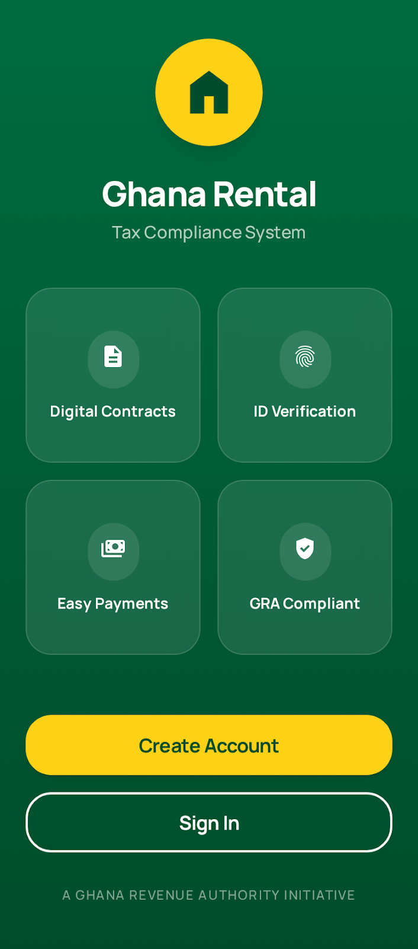
Figure: Welcome Screen - Mobile App Entry Point

7.1.2 Login Screen (MOB-AUTH-002)
Purpose: Authenticate existing users
File: src/screens/auth/LoginScreen.tsx
Field | Required | Type | Validation
Email | Yes | TextInput | Valid email format
Password | Yes | SecureTextEntry | Non-empty
Actions:
- Login button - validates and authenticates
- 'Forgot Password?' link
- 'Don't have an account? Register' link
On Success: Navigate to role-specific dashboard (Landlord or Tenant)
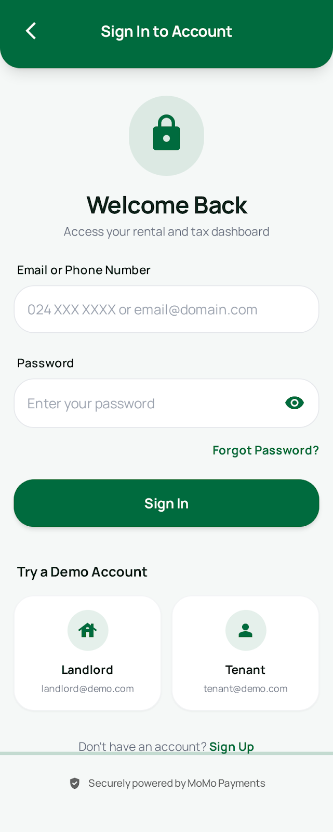
Figure: Login Screen - User Authentication

7.1.3 Registration Screen (MOB-AUTH-003)
Purpose: Create new user account
File: src/screens/auth/RegisterScreen.tsx
Field | Required | Type | Validation
Role | Yes | SegmentedControl | LANDLORD or TENANT
First Name | Yes | TextInput | Min 2 characters
Last Name | Yes | TextInput | Min 2 characters
Email | Yes | TextInput | Valid email, unique
Phone | Yes | TextInput | Ghana format (0XX XXX XXXX)
Ghana Card Number | Yes | TextInput | GHA-XXXXXXXXX-X format
Password | Yes | SecureTextEntry | Min 8 chars, complexity
Confirm Password | Yes | SecureTextEntry | Must match password
On Submit: Create user, send OTP to phone, navigate to verification screen

7.1.4 OTP Verification Screen (MOB-AUTH-004)
Purpose: Verify phone number with OTP code
File: src/screens/auth/VerifyOTPScreen.tsx
Field | Required | Type | Validation
OTP Code | Yes | 6-digit input | Must match code sent via SMS
Display Elements:
- Phone number (partially masked)
- 6 individual input boxes for OTP digits
- Countdown timer for resend (60 seconds)
- 'Resend Code' button (enabled after timer)
On Success: Navigate to dashboard
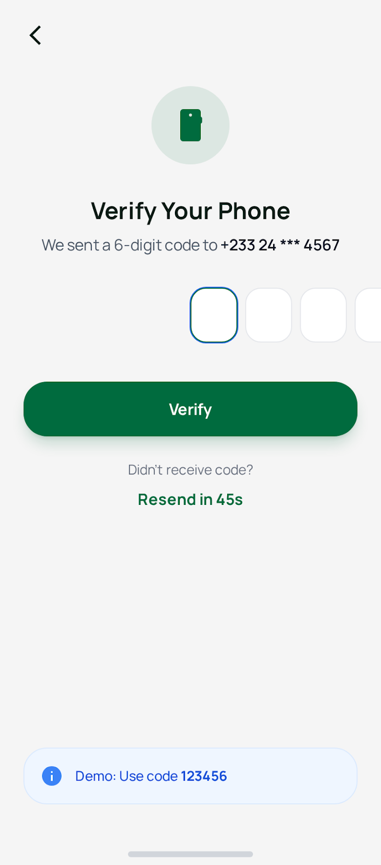
Figure: OTP Verification Screen - Phone Number Verification

7.2 Landlord Screens

7.2.1 Landlord Dashboard (MOB-LND-001)
Purpose: Overview of landlord's properties and contracts
File: src/screens/landlord/DashboardScreen.tsx
Summary Cards:
- Total Properties (count)
- Active Contracts (count)
- Total Revenue (GHS, current month)
- Tax Withheld (GHS, current month)

Quick Actions:
- 'Add Property' button
- 'Create Contract' button
- 'Download Tax Certificate' button

Recent Activity List:
- Recent payments received
- Contract status changes
- New tenant confirmations
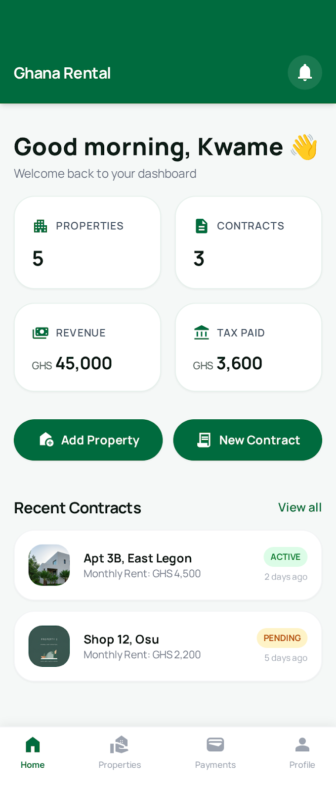
Figure: Landlord Dashboard - Properties and Revenue Overview

7.2.2 Properties List Screen (MOB-LND-002)
Purpose: View and manage registered properties
File: src/screens/landlord/PropertiesScreen.tsx
Screen Elements:
- Search bar (search by address or code)
- Filter chips (All, Verified, Pending, Available, Occupied)
- Property cards with photo, address, status, rent
- Floating '+' button to add new property
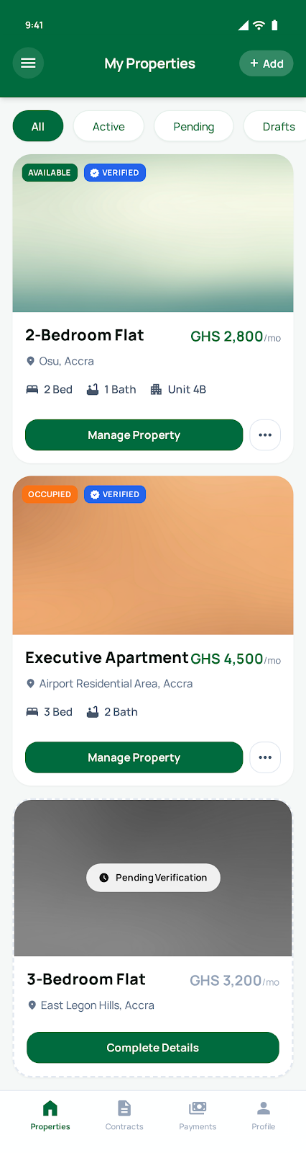
Figure: Properties List Screen - Registered Properties

7.2.3 Add Property Screen (MOB-LND-003)
Purpose: Register a new rental property
File: src/screens/landlord/AddPropertyScreen.tsx
Field | Required | Type | Validation
Digital Address | Yes | TextInput | XX-XXX-XXXX format
Region | Yes | Picker | Select from 16 regions
District | Yes | Picker | Filtered by region
Property Type | Yes | Picker | Apartment, House, etc.
Category | Yes | SegmentedControl | RESIDENTIAL or COMMERCIAL
Bedrooms | If residential | Stepper | 0-10+
Bathrooms | If residential | Stepper | 0-10+
Is Furnished | No | Switch | Yes/No
Photos | Yes | ImagePicker | Min 1, max 10 photos
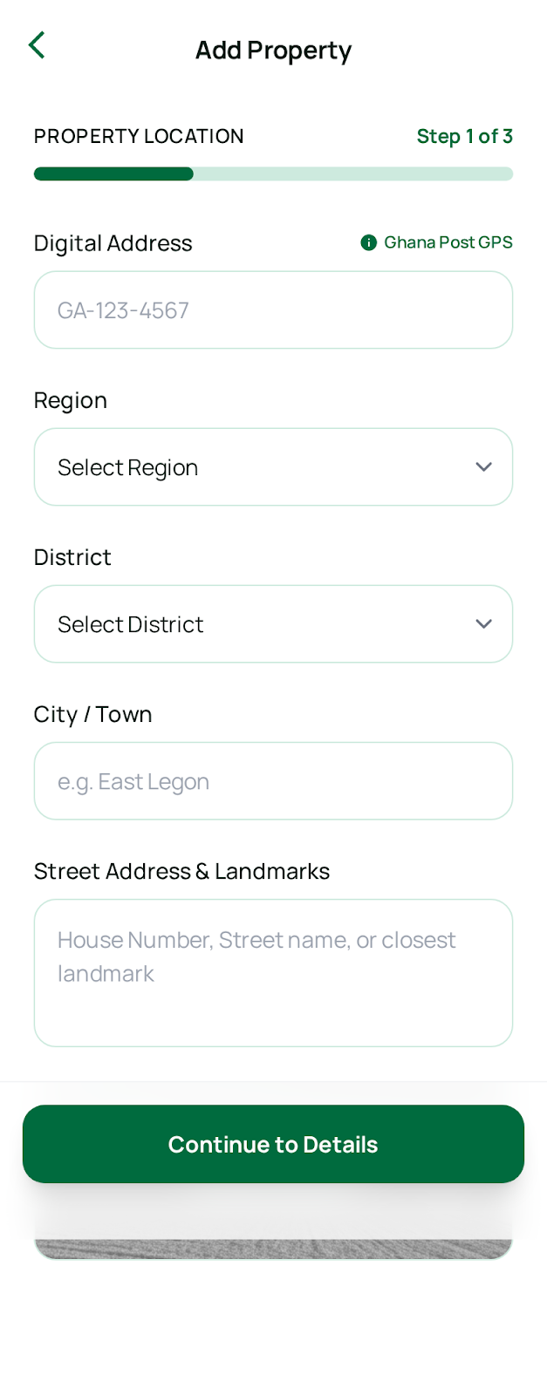
Figure: Add Property Screen - Property Registration Form

7.2.4 Create Contract Screen (MOB-LND-004)
Purpose: Create a new rental contract with ID scanning
File: src/screens/landlord/CreateContractScreen.tsx
Multi-step wizard with progress indicator:

Step 1: Select Property
- Picker to select from verified, available properties
- Shows property photo and address when selected

Step 2: Scan Tenant ID
- Button to open camera for Ghana Card scanning
- Uses expo-camera for image capture
- OCR extracts: Ghana Card Number, Name, Date of Birth, Gender
- Displays extracted data with confidence score
- Option to manually correct extracted data
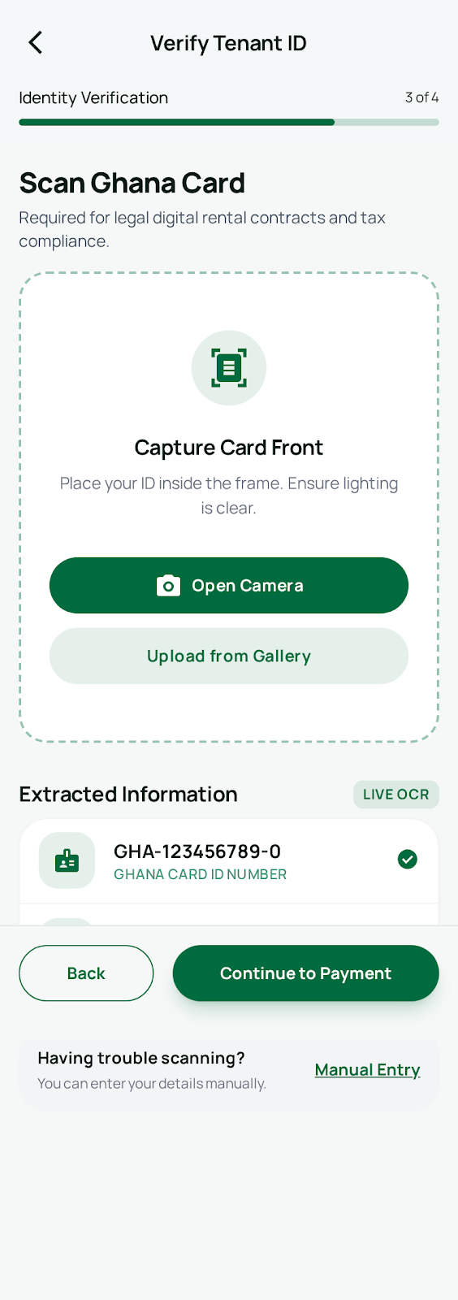
Figure: Scan Tenant ID - Ghana Card Verification
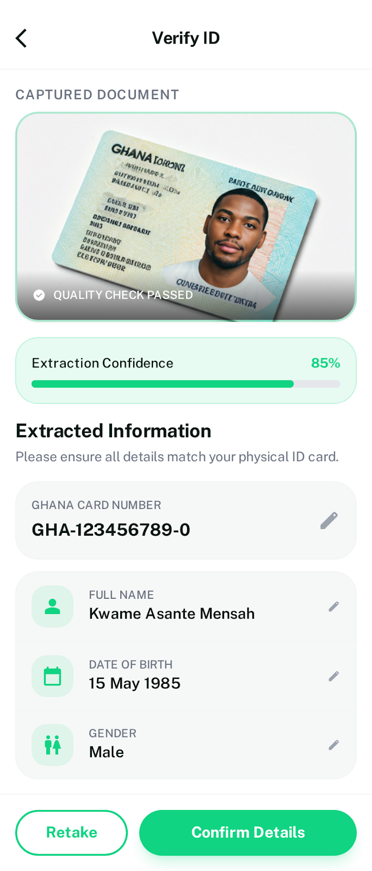
Figure: Verify Extracted Data - OCR Results Review

Step 3: Contract Terms
Field | Required | Type | Validation
Start Date | Yes | DatePicker | Today or future
End Date | Yes | DatePicker | After start date
Monthly Rent (GHS) | Yes | NumericInput | Min GHS 50
Advance Months | Yes | Stepper | 1-6 residential, 1-24 commercial
Security Deposit | No | NumericInput | Max 3x monthly rent
Service Charge | No | NumericInput | Any positive amount
Live Tax Calculation Display:
- Gross Amount: GHS X,XXX
- Tax (8%): GHS XXX
- Net to Landlord: GHS X,XXX

Step 4: Sign Contract
- Full-screen signature pad (react-native-signature-canvas)
- Clear and Redo buttons
- Signature saved as base64 image
- 'I agree to the terms' checkbox
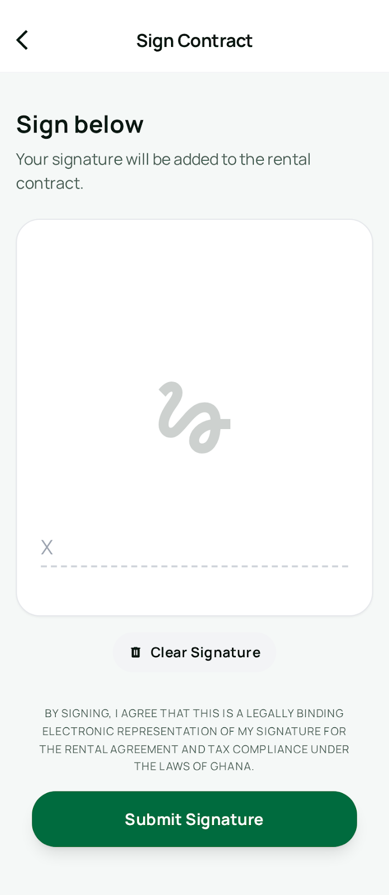
Figure: Digital Signature Pad - Contract Signing

Step 5: Confirmation
- Summary of all contract details
- Display 10-character confirmation code
- Instructions to share code with tenant
- 'Share Code' button (opens device share sheet)
- Code expires in 24 hours

7.3 Tenant Screens

7.3.1 Tenant Dashboard (MOB-TNT-001)
Purpose: Overview of tenant's contracts and payments
File: src/screens/tenant/DashboardScreen.tsx
Current Rental Card:
- Property photo and address
- Landlord name
- Monthly rent amount
- Next payment due date
- 'Pay Now' button

Pending Actions Alert:
- Contracts awaiting confirmation (prominent banner)
- 'View Pending Contract' button

Recent Payments List:
- Last 5 payments with amount, date, status
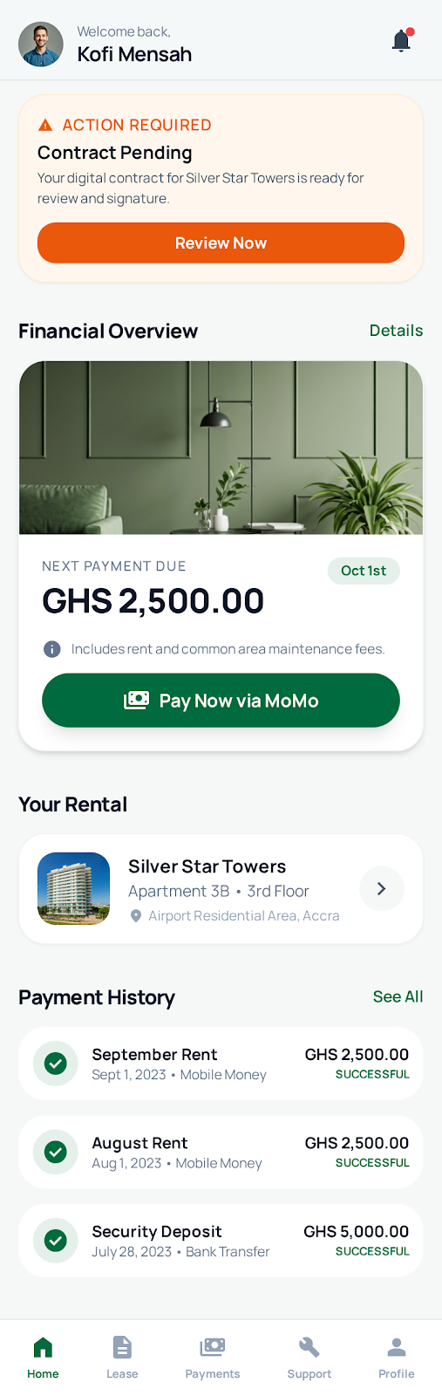
Figure: Tenant Dashboard - Contract and Payment Overview

7.3.2 Confirm Contract Screen (MOB-TNT-002)
Purpose: Review and confirm pending contract
File: src/screens/tenant/ConfirmContractScreen.tsx
Screen Flow:

Step 1: Enter Confirmation Code
Field | Required | Type | Validation
Confirmation Code | Yes | TextInput | 10-character code from landlord
On Submit: Fetch contract details if code is valid

Step 2: Review Contract Details
Display:
- Property information (address, type, features)
- Landlord information (name, contact)
- Contract terms (duration, rent, advance, deposit)
- Payment breakdown with 8% tax display
Actions: 'Accept' button, 'Decline' button

Step 3: Scan Own ID
- Camera opens to scan tenant's own Ghana Card
- OCR extracts and verifies identity
- Confirms Ghana Card matches registered user

Step 4: Sign Contract
- Full-screen signature pad
- Signature saved as base64 image
- 'I confirm this contract' checkbox

Step 5: Confirmation Success
- Success animation
- Contract now ACTIVE
- 'Make First Payment' button

7.4 Shared Mobile Screens

7.4.1 Document Scan Screen (MOB-SHR-001)
Purpose: Scan Ghana Card using device camera with OCR
File: src/screens/shared/ScanDocumentScreen.tsx
Screen Elements:
- Full-screen camera view (expo-camera)
- Rectangular overlay guide for card positioning
- 'Capture' button (centered bottom)
- 'Use Gallery' button (bottom left)
- Flash toggle (top right)

OCR Processing:
- Loading spinner during OCR processing
- Extracts Ghana Card data fields
- Displays confidence score (0-100%)

Extracted Data Interface:
Field | Format
ghanaCardNumber | GHA-XXXXXXXXX-X format
fullName | Complete name as on card
firstName | Parsed first name
lastName | Parsed last name
dateOfBirth | YYYY-MM-DD format
gender | M or F
nationality | e.g., GHANAIAN
confidence | 0-100 OCR confidence score

7.4.2 Digital Signature Screen (MOB-SHR-002)
Purpose: Capture digital signature for contracts
File: src/screens/shared/SignContractScreen.tsx
Screen Elements:
- Full-screen white signature canvas (react-native-signature-canvas)
- 'Clear' button (top left) - erases signature
- 'Done' button (top right) - saves signature
- Instructions text: 'Sign within the box below'

Signature Output:
- Base64-encoded PNG image
- Uploaded to server for storage
- Linked to contract record

7.4.3 Make Payment Screen (MOB-SHR-003)
Purpose: Process rent payment via mobile money
File: src/screens/shared/MakePaymentScreen.tsx
Payment Provider Selection:
- MTN Mobile Money (with logo)
- Vodafone Cash (with logo)
- AirtelTigo Money (with logo)

Field | Required | Type | Validation
Phone Number | Yes | TextInput | Ghana mobile format

Payment Breakdown Display:
- Gross Amount: GHS X,XXX.XX
- Withholding Tax (8%): GHS XXX.XX
- Net to Landlord: GHS X,XXX.XX

Payment Flow:
- 1. User selects provider and enters phone number
- 2. User taps 'Pay Now' button
- 3. Loading screen: 'Awaiting payment approval'
- 4. User receives prompt on mobile phone to authorize
- 5. User enters PIN on their phone (external)
- 6. Success screen with receipt details

Payment Status Values:
- PENDING - Payment initiated, awaiting authorization
- PROCESSING - Authorization received, processing
- COMPLETED - Payment successful
- FAILED - Payment failed (with reason)
- REFUNDED - Payment was refunded
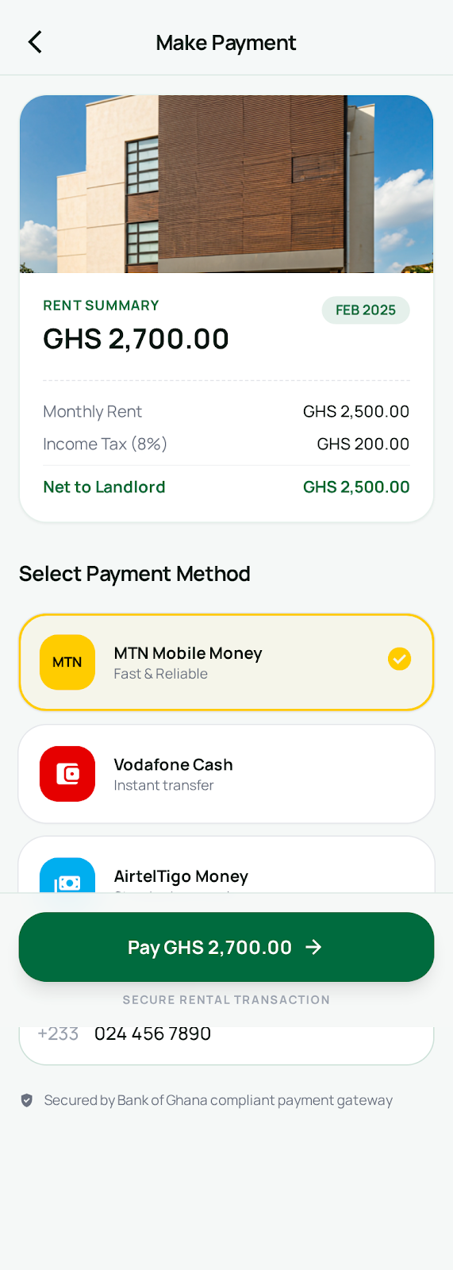
Figure: Make Payment Screen - Mobile Money Payment
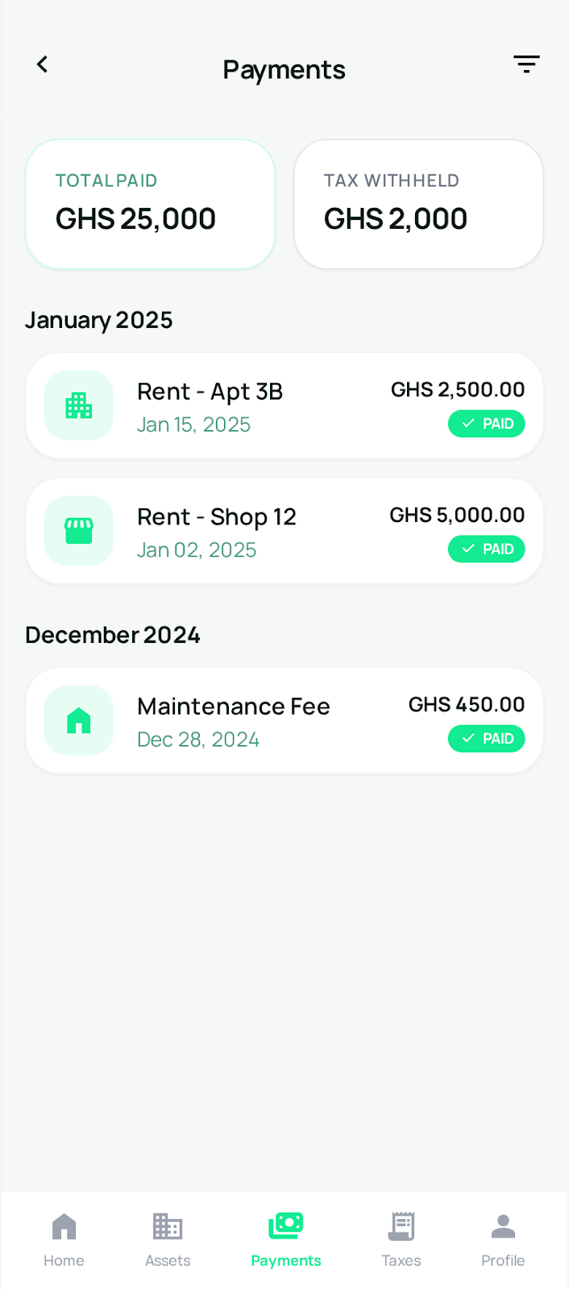
Figure: Payment History - Transaction Records
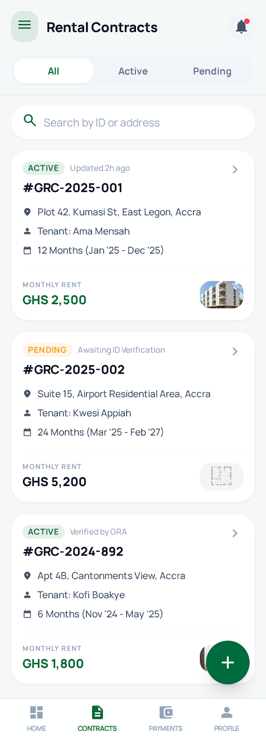
Figure: Rental Contracts List - Contract Management
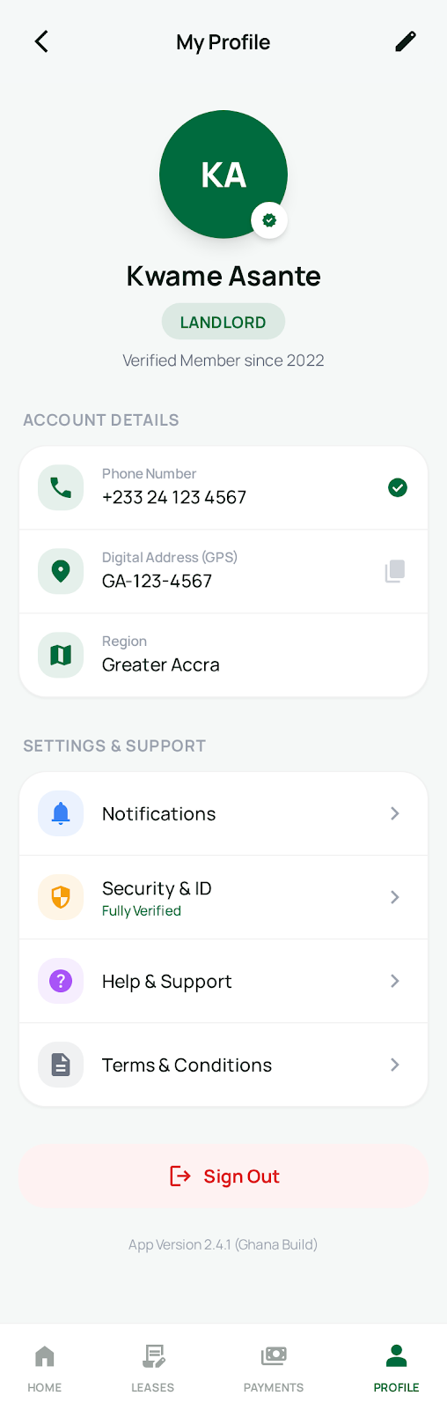
Figure: My Profile - User Profile Management

8. Web Portal Screens
The following screens are implemented in the React web portal for GRA Officers, Inspectors, and Administrators.

8.1 Access Restriction
When Landlords or Tenants attempt to login via the web portal, they receive a redirect message:
- Title: 'Mobile App Required'
- Message: 'Landlords and Tenants must use the GRMTS Mobile App'
- App Store and Play Store download links
- QR code for quick download
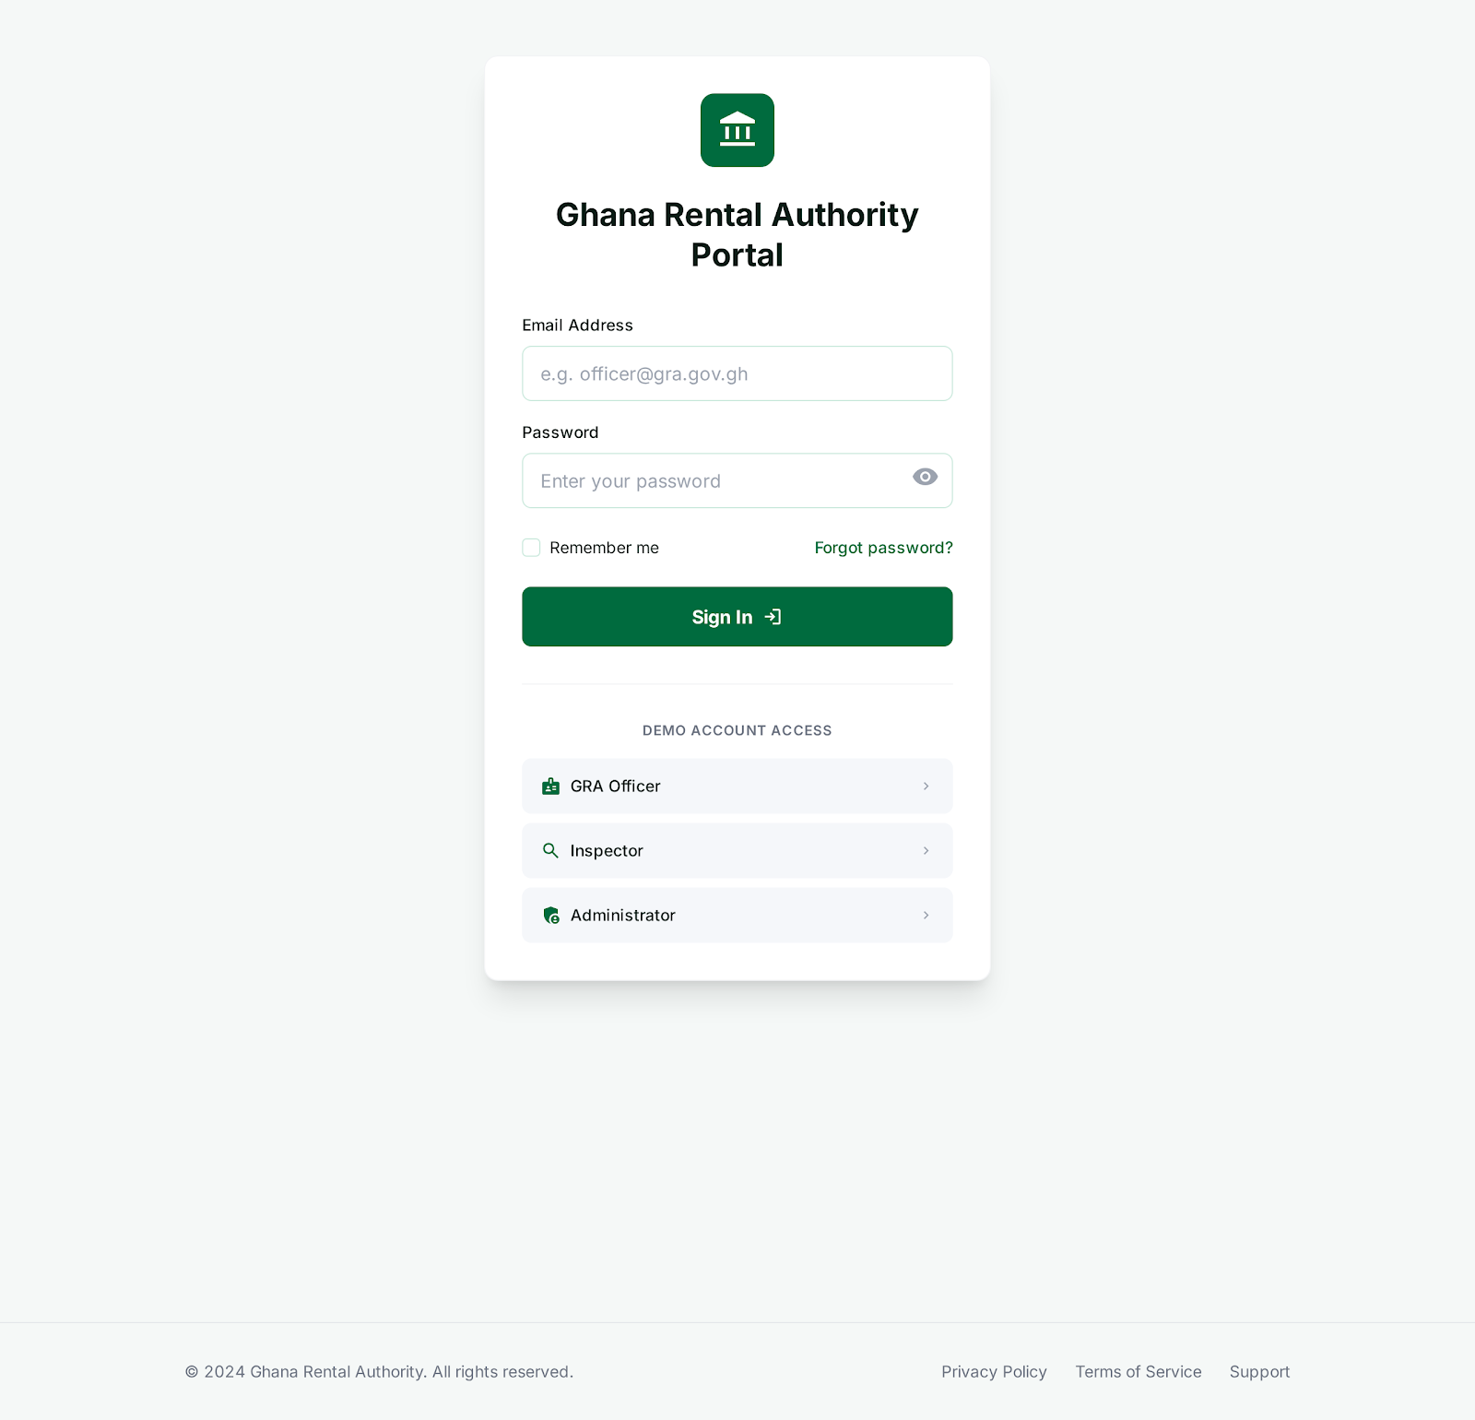
Figure: GRA Portal Login - Web Portal Access

8.2 GRA Officer Screens

8.2.1 GRA Dashboard (WEB-GRA-001)
Purpose: Overview of tax collection and compliance metrics
URL: /dashboard
KPI Cards:
- Total Tax Collected (this month) - GHS amount
- Active Contracts - count
- Registered Landlords - count
- Compliance Rate - percentage

Charts:
- Tax Collection Trend (Recharts line chart, 12 months)
- Contracts by Region (Recharts bar chart)
- Payment Method Distribution (Recharts pie chart)

Recent Activity Table:
- Recent payments with contract number, amount, tax withheld
- Sortable columns, pagination
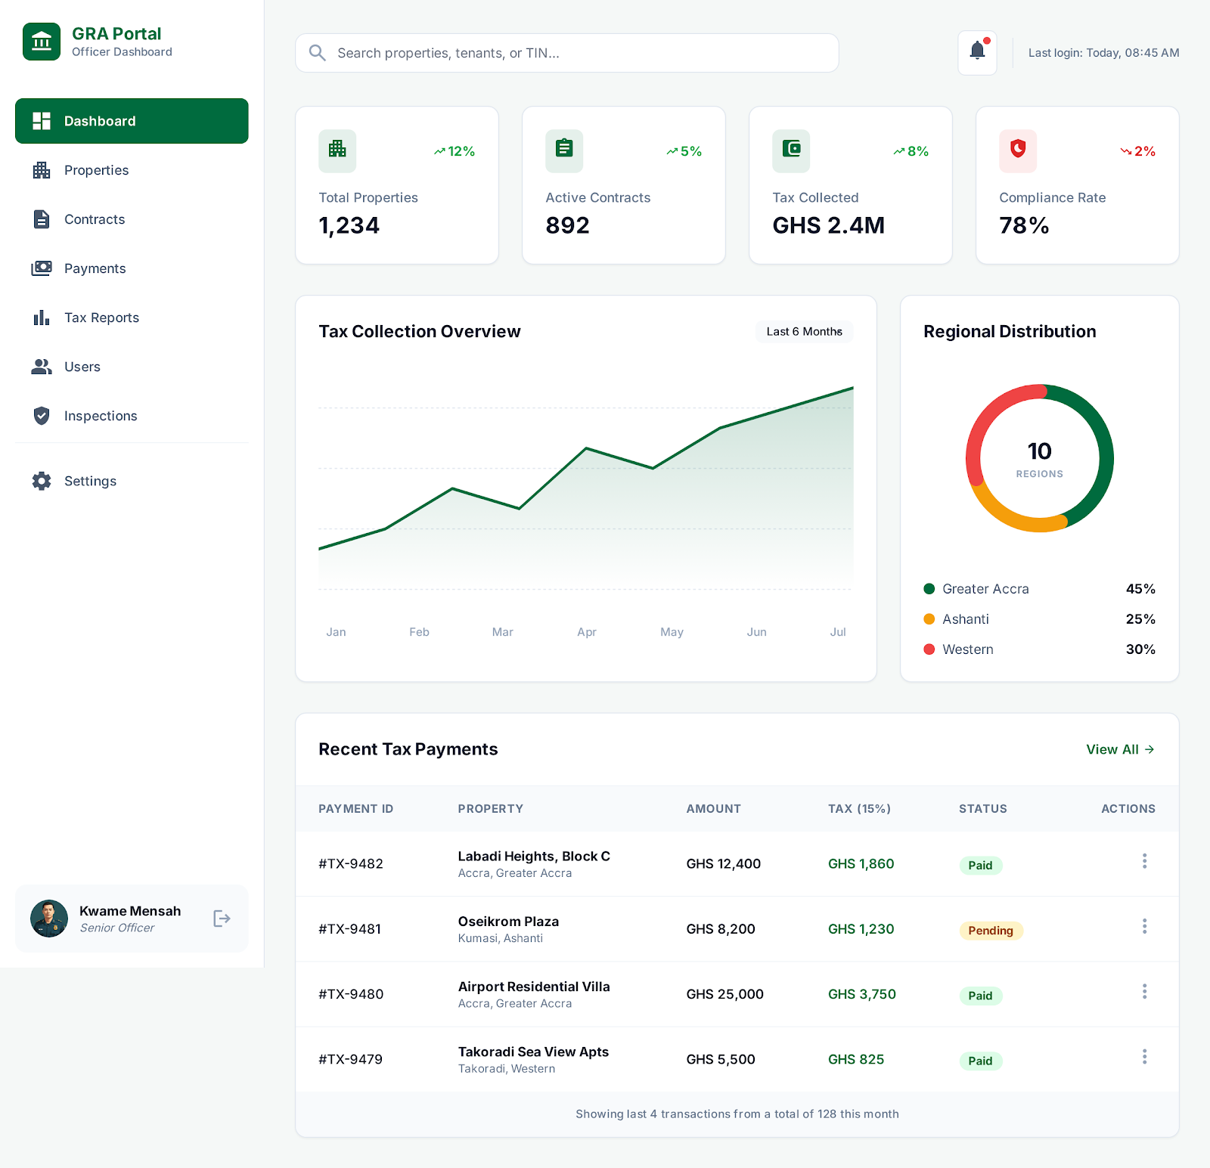
Figure: GRA Officer Dashboard - Tax Collection Overview

8.2.2 Contracts List (WEB-GRA-002)
Purpose: Search and view all registered contracts
URL: /contracts
Filters:
- Status: All, Active, Pending, Expired, Terminated
- Region: Dropdown of 16 regions
- Date Range: Start/End date pickers
- Search: Contract number, landlord name, property address

Table Columns:
- Contract Number, Landlord Name, Tenant Name, Property Address
- Monthly Rent, Start Date, End Date, Status
- Actions: View Details

Export Options:
- Export to CSV button
- Export to PDF button
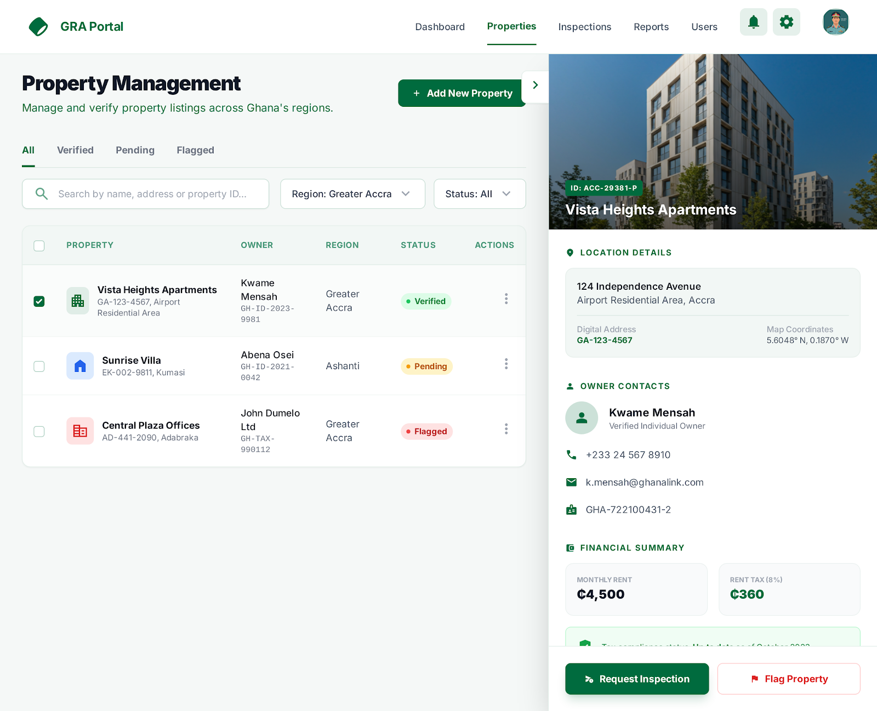
Figure: Property Management - Contract and Property Details

8.2.3 Tax Reports (WEB-GRA-003)
Purpose: Generate and view tax collection reports
URL: /reports/tax
Report Types:
- Daily Collection Summary
- Monthly Collection by Region
- Landlord Tax Withholding Details
- Year-to-Date Summary

Report Parameters:
- Period: Date range selection
- Region: Optional filter
- Format: View on screen or download PDF/CSV
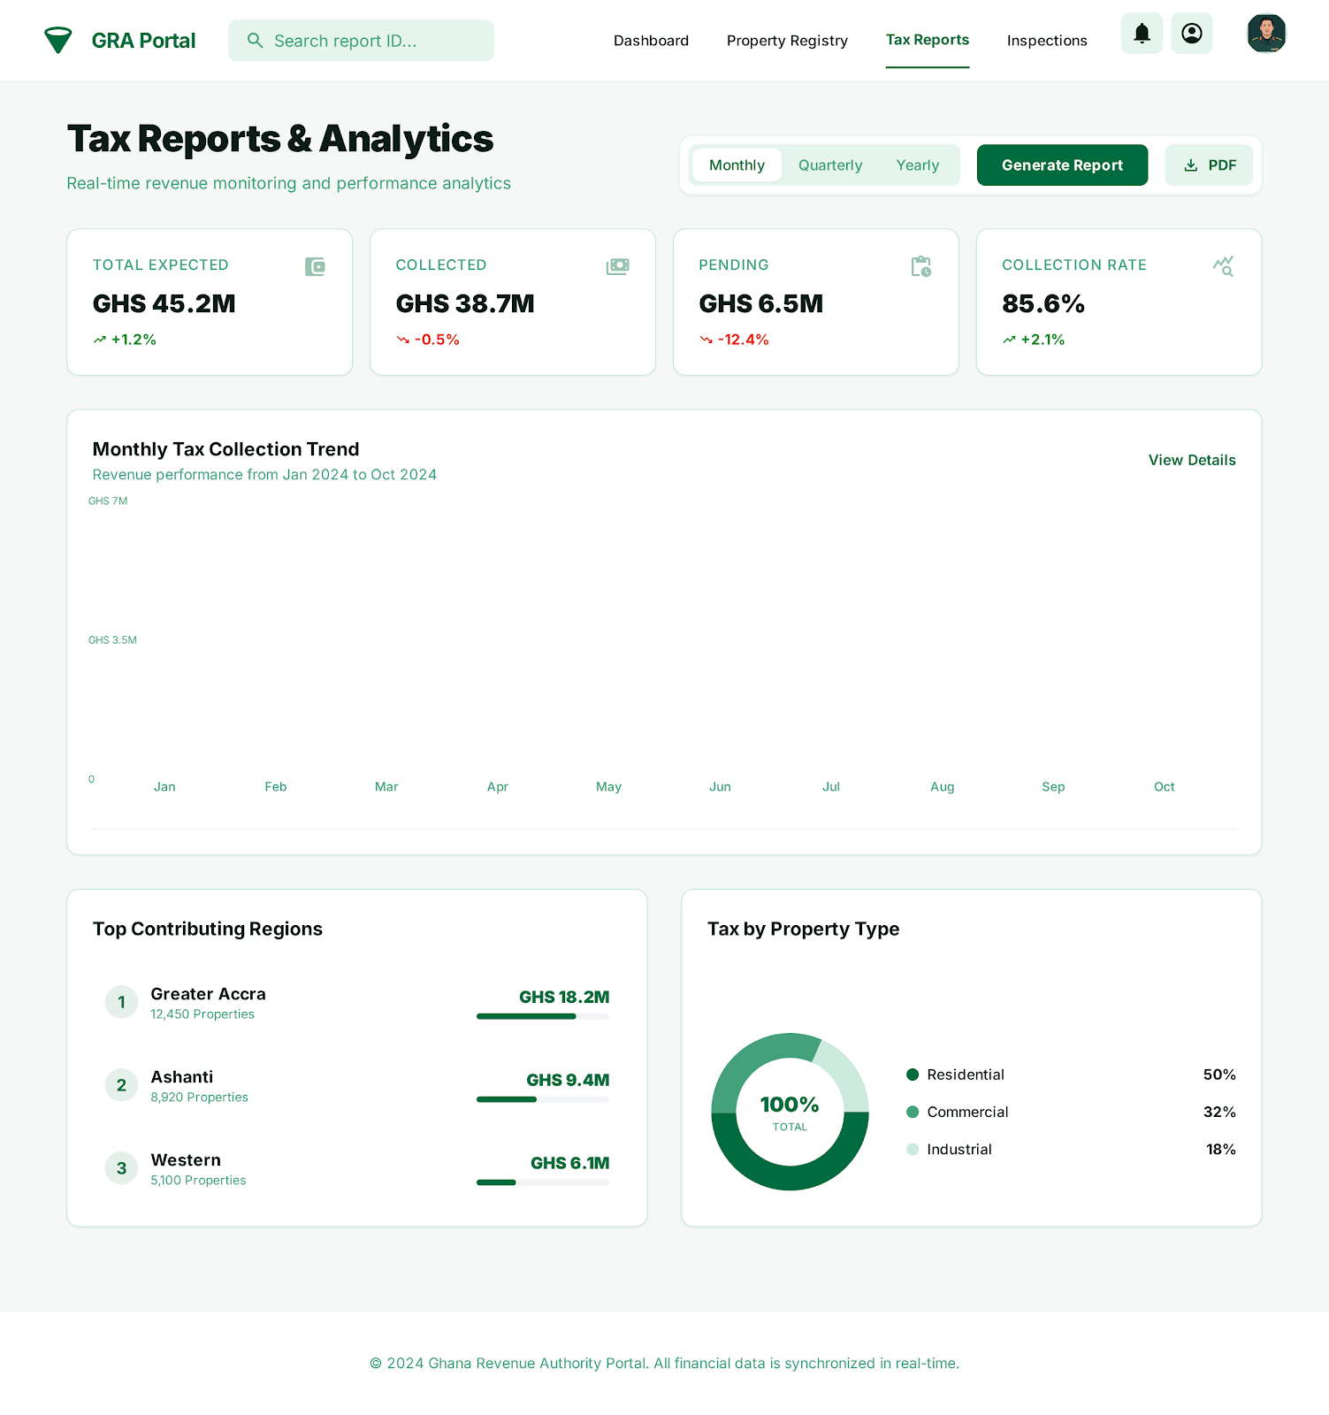
Figure: Tax Reports & Analytics - Revenue Analysis
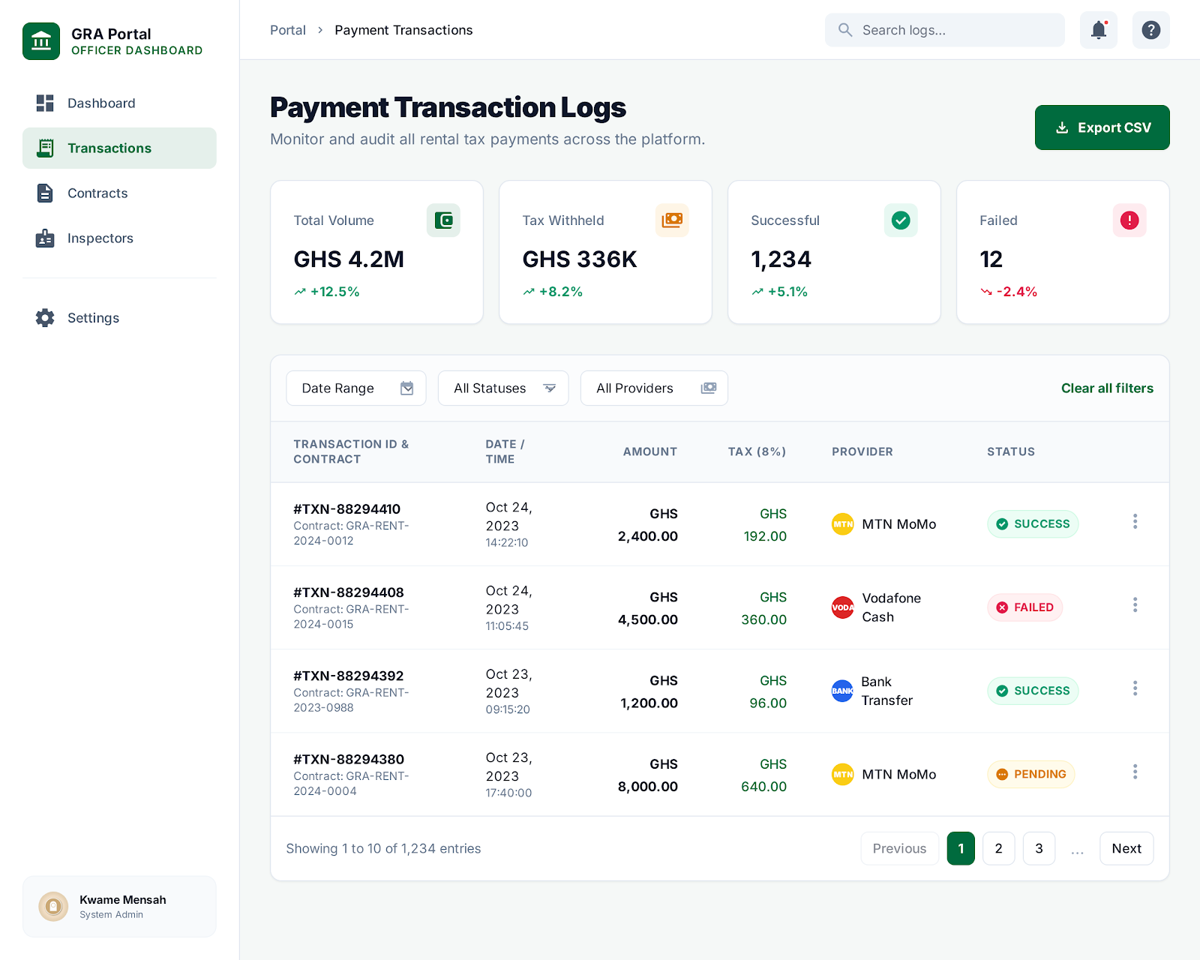
Figure: Payment Transaction Logs - Payment Records
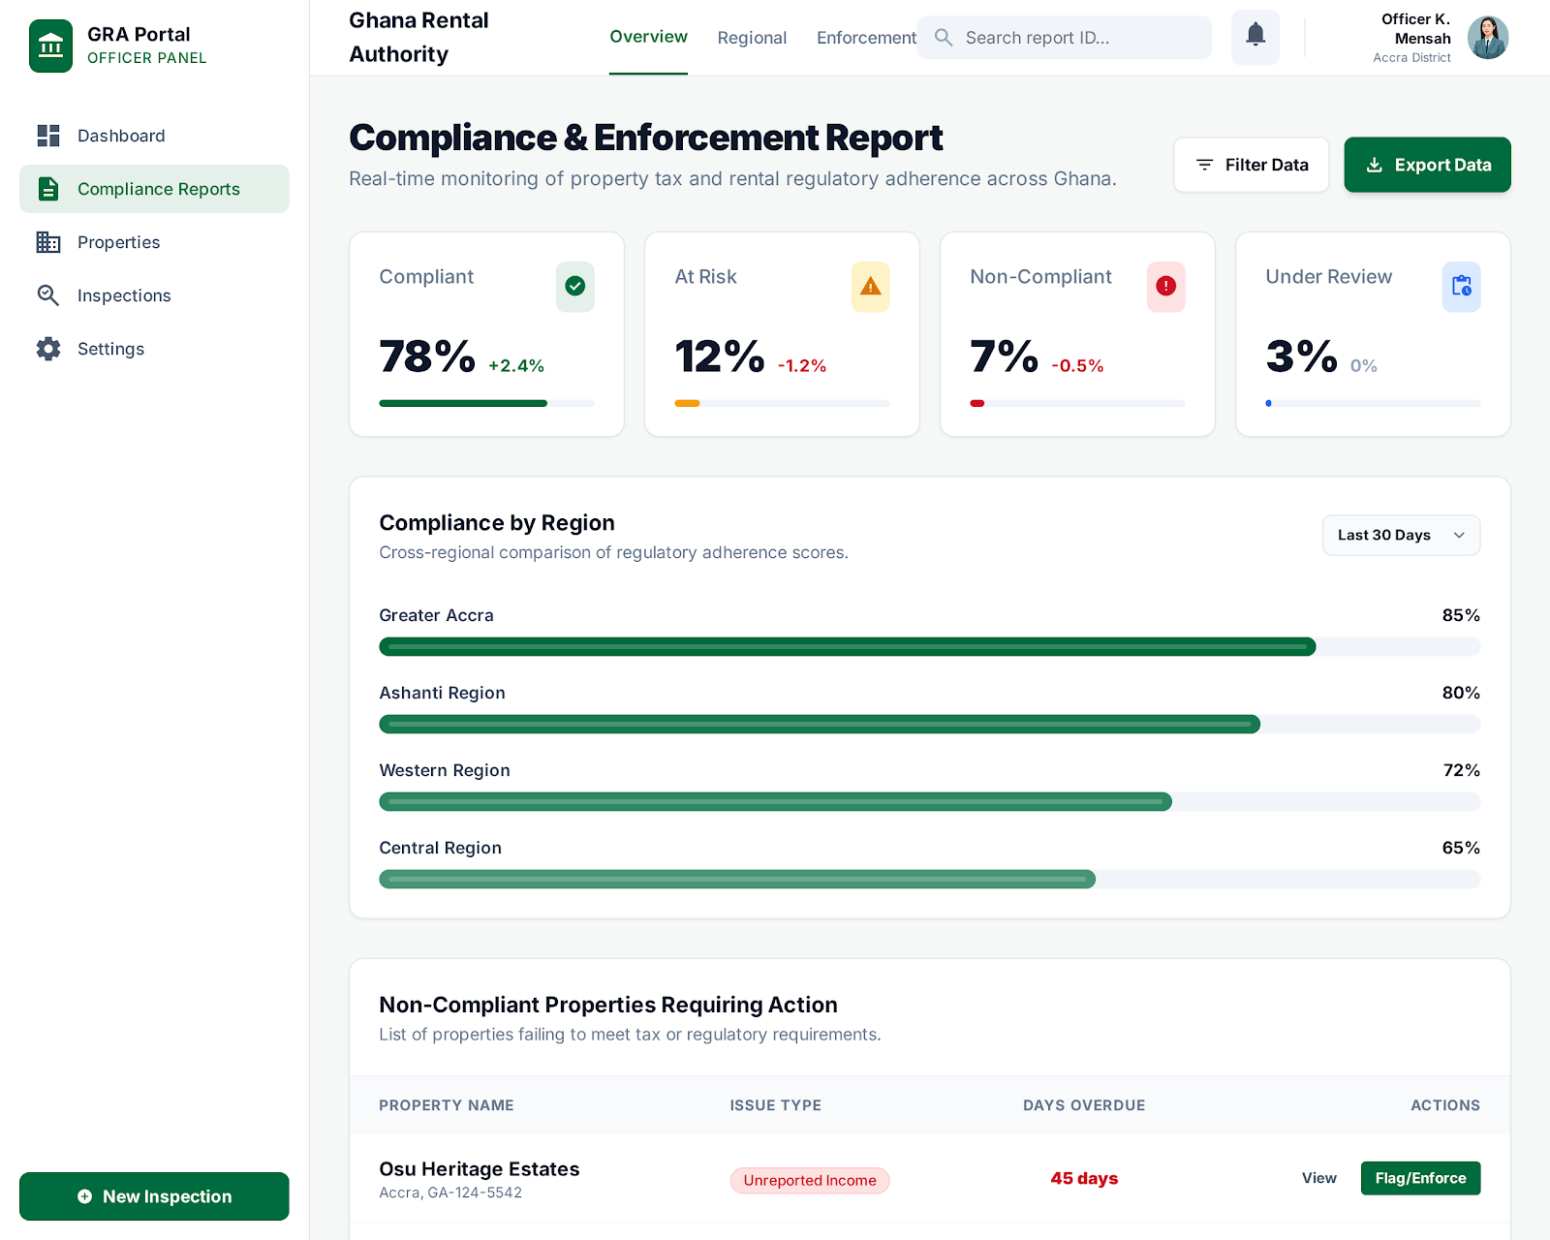
Figure: Compliance & Enforcement Report - Compliance Monitoring

8.3 Inspector Screens

8.3.1 Inspector Dashboard (WEB-INS-001)
Purpose: View and manage assigned inspection cases
URL: /inspections
Assigned Cases:
- List of cases assigned to logged-in inspector
- Case status: Pending, In Progress, Completed
- Due date, priority level

Case Actions:
- View Case Details
- Update Status
- Upload Evidence
- Submit Report
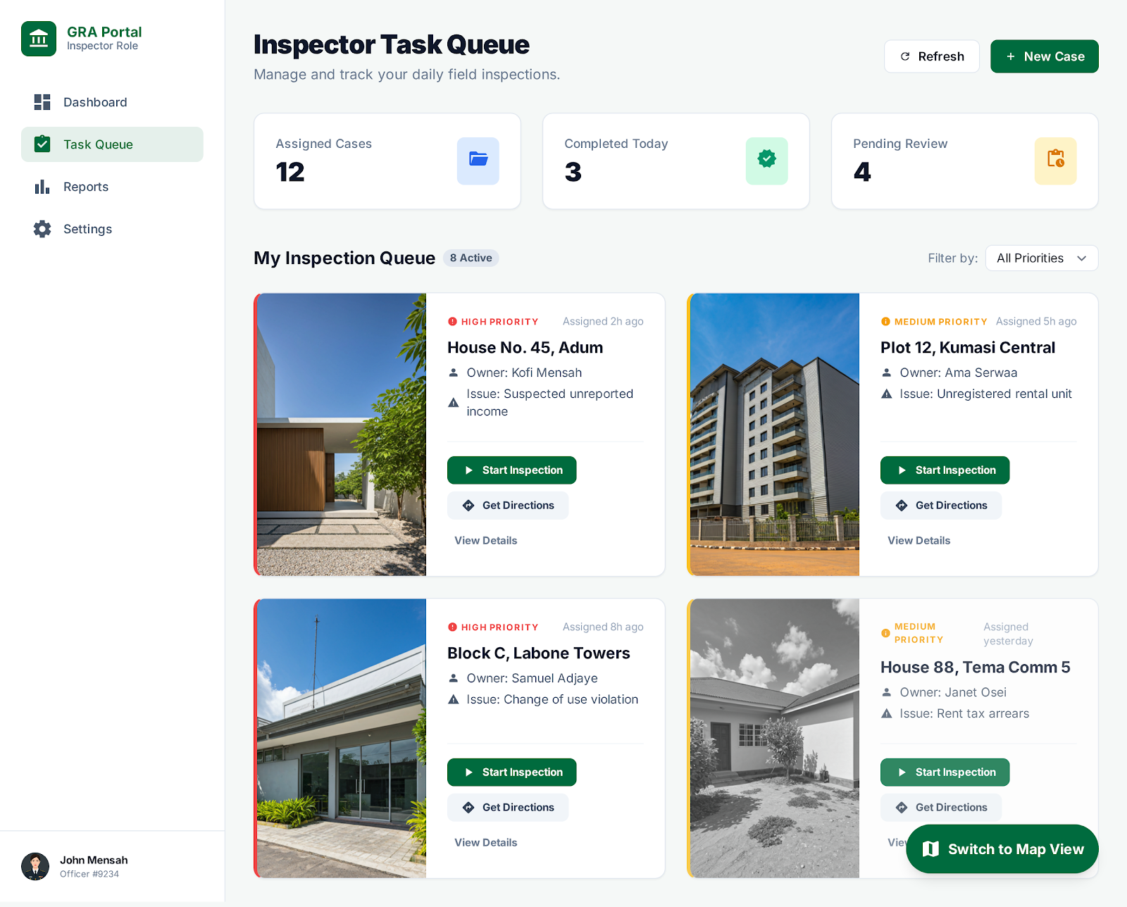
Figure: Inspector Task Queue - Assigned Cases

8.3.2 Case Details (WEB-INS-002)
Purpose: View and update specific inspection case
URL: /inspections/:id
Case Information:
- Property address and details
- Landlord and tenant information
- Contract details if applicable
- Case notes and history

Evidence Upload:
- Photo upload (drag-and-drop)
- Document upload (PDF, images)
- Evidence description field

Report Submission:
- Findings text area
- Recommendation dropdown
- Submit Report button

8.4 Admin Screens

8.4.1 User Management (WEB-ADM-001)
Purpose: Manage system user accounts
URL: /admin/users
User List:
- Search by name, email, phone
- Filter by role, status
- Table: Name, Email, Role, Status, Created Date

User Actions:
- View User Details
- Edit User (change role, status)
- Deactivate User
- Reset Password
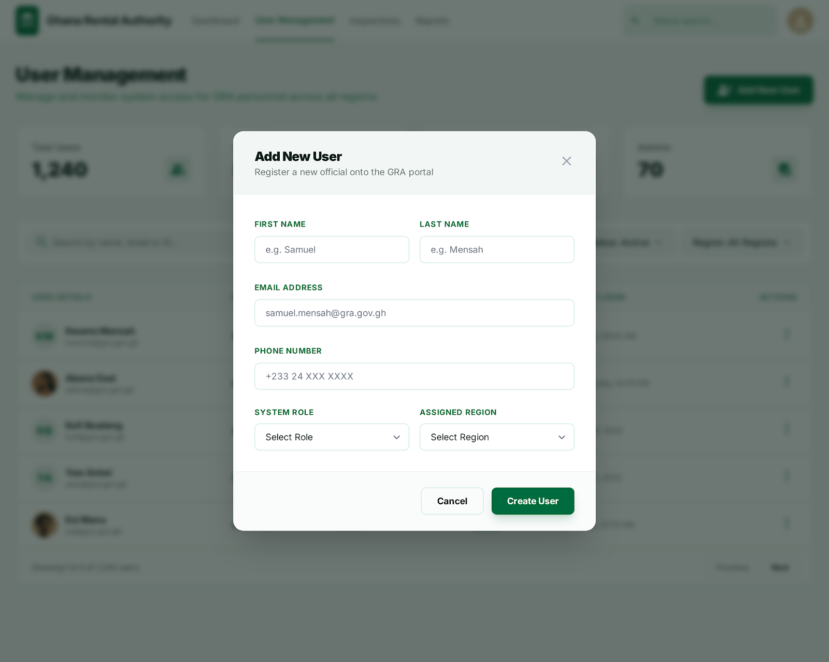
Figure: Admin User Management - User Administration

8.4.2 System Configuration (WEB-ADM-002)
Purpose: Configure system settings
URL: /admin/settings
Configuration Sections:
- Tax Settings (rate display - read only in current implementation)
- Notification Templates
- Reference Data (regions, property types)
- API Keys Management
- System Health Monitoring
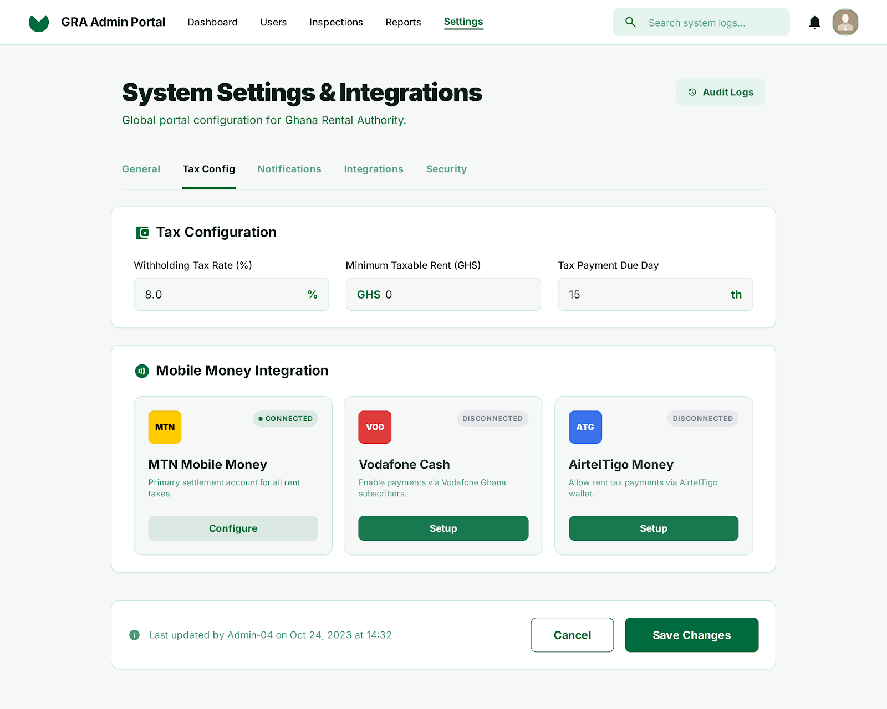
Figure: System Settings & Integrations - Configuration Panel

7. Business Rules
This section documents all business rules that govern system behavior. Rules are organized by functional area and include examples to illustrate application.

7.1 Contract Business Rules

7.1.1 Advance Payment Limits
Rule ID | Rule Description | Property Type | Limit
BR-CTR-001 | Maximum advance for single room | R-SR | 6 months
BR-CTR-002 | Maximum advance for self-contained | R-SC | 6 months
BR-CTR-003 | Maximum advance for apartments (1-4 bed) | R-1B to R-4B | 6 months
BR-CTR-004 | Maximum advance for houses/villas | R-HS, R-VL | 6 months
BR-CTR-005 | Maximum advance for shops | C-SHP | 12 months
BR-CTR-006 | Maximum advance for offices | C-OFF | 12 months
BR-CTR-007 | Maximum advance for warehouses | C-WHS | 24 months
BR-CTR-008 | Maximum advance for industrial | C-IND | 24 months
BR-CTR-009 | Maximum advance for mixed use | C-MXD | 12 months

Example Application:
Scenario: Landlord attempts to create a contract for a 2-bedroom apartment (R-2B) with 12 months advance.
Rule Applied: BR-CTR-003 limits R-2B to 6 months maximum.
System Response: Error message 'Advance payment of 12 months exceeds the maximum allowed (6 months) for this property type. Please reduce the advance period.'

7.1.2 Security Deposit Rules
Rule ID | Rule Description | Value
BR-CTR-010 | Maximum security deposit as multiple of monthly rent | 3 months
BR-CTR-011 | Security deposit must be refundable under agreed terms | Required
BR-CTR-012 | Security deposit is not subject to withholding tax | 0% tax

Example Calculation:
Monthly Rent: GHS 2,000
Maximum Security Deposit: GHS 2,000 x 3 = GHS 6,000
If landlord enters GHS 8,000, system displays: 'Security deposit of GHS 8,000 exceeds the maximum allowed (GHS 6,000 = 3 months rent).'

7.1.3 Contract Duration Rules
Rule ID | Rule Description | Value
BR-CTR-020 | Minimum contract duration | 1 month
BR-CTR-021 | Maximum contract duration | 60 months (5 years)
BR-CTR-022 | Contract start date cannot be more than X days in the past | 90 days
BR-CTR-023 | Tenant confirmation period | 7 days
BR-CTR-024 | Minimum termination notice period | 30 days

7.1.4 Contract Validation Rules
Rule ID | Rule Description
BR-CTR-030 | Contract cannot be created for unverified properties
BR-CTR-031 | Contract cannot be created for properties with existing active contracts (unless multi-unit)
BR-CTR-032 | Landlord cannot create contract with themselves as tenant
BR-CTR-033 | Contract end date must be after start date
BR-CTR-034 | Advance months cannot exceed contract duration
BR-CTR-035 | Monthly rent must be positive and at least GHS 50
BR-CTR-036 | Contract document must be uploaded before submission

7.2 Tax Calculation Rules

7.2.1 Withholding Tax Rate
GRMTS applies a flat 8% withholding tax on all rent payments processed through the system.
Rule ID | Rule Description | Value
BR-TAX-001 | Standard withholding tax rate on all rent payments | 8%
BR-TAX-002 | Tax is automatically calculated: tax_amount = gross_amount × 0.08 | Automatic
BR-TAX-003 | Tax is deducted at source before landlord receives funds | At source
BR-TAX-004 | Tax rate is consistent regardless of landlord type or TIN status | Universal
BR-TAX-005 | Tax is remitted directly to Ghana Revenue Authority | Direct remittance

7.2.2 Tax Certificate Rules
Rule ID | Rule Description | Value
BR-TAX-010 | Landlords can download tax certificates from mobile app | Available
BR-TAX-011 | Certificates show total tax withheld for filing purposes | PDF download
BR-TAX-012 | Certificates are generated per contract period | Per contract

Tax Calculation Example:
Payment Amount: GHS 1,000 (monthly rent)
Calculation:
- Gross Amount: GHS 1,000.00
- Tax Rate: 8% (BR-TAX-001)
- Tax Amount: GHS 1,000 × 0.08 = GHS 80.00
- Net to Landlord: GHS 1,000 - GHS 80 = GHS 920.00

Tax Display During Payment:
The payment screen clearly shows the breakdown:
- Gross Amount: GHS 1,000.00
- Tax (8%): GHS 80.00
- Net to Landlord: GHS 920.00

7.3 Payment Rules

7.3.1 Mobile Money Payment Rules
Rule ID | Rule Description | Value
BR-PAY-001 | Supported payment providers | MTN, Vodafone, AirtelTigo
BR-PAY-002 | User must enter mobile money phone number | Required
BR-PAY-003 | User authorizes payment on their mobile phone | External PIN entry
BR-PAY-004 | Payment confirmation received via callback | Webhook/polling

Payment Flow:
1. Tenant selects payment provider (MTN, Vodafone, or AirtelTigo)
2. Tenant enters mobile money phone number
3. Tenant taps 'Pay Now' button
4. System initiates payment request to provider
5. User receives prompt on their mobile phone
6. User enters PIN to authorize payment
7. Payment confirmation is received by the system
8. Receipt is generated and displayed

7.3.2 Payment Validation Rules
Rule ID | Rule Description
BR-PAY-010 | Payments can only be made for active contracts
BR-PAY-011 | Minimum payment amount is one month's rent
BR-PAY-012 | Duplicate payments for same period are blocked within 5 minutes
BR-PAY-013 | Payment timeout after 5 minutes of processing
BR-PAY-014 | Failed payments may be retried up to 3 times
BR-PAY-015 | Settlement batches run at 6:00 AM and 6:00 PM daily

7.4 Compliance and Enforcement Rules

7.4.1 Compliance Score Calculation
Rule ID | Factor | Weight | Max Impact
BR-CMP-001 | Contract registration rate (% of properties with registered contracts) | 30% | -30 points
BR-CMP-002 | Payment timeliness (% of payments received on/before due date) | 25% | -25 points
BR-CMP-003 | Tenant confirmation rate (% of contracts confirmed within 7 days) | 15% | -15 points
BR-CMP-004 | Document completeness (ownership verified) | 10% | -10 points
BR-CMP-005 | Dispute history (deduction per lost dispute) | 10% | -10 points
BR-CMP-006 | Inspection results (deduction per confirmed violation) | 10% | -10 points

Compliance Score Example:
Landlord Profile:
- 5 properties, 4 with registered contracts (80%) → Score impact: -6 points (30% × 20%)
- 90% payments on time → Score impact: -2.5 points (25% × 10%)
- 100% tenant confirmations → Score impact: 0 points
- All ownership docs verified → Score impact: 0 points
- 1 lost dispute → Score impact: -5 points
- No violations → Score impact: 0 points
Total Score: 100 - 6 - 2.5 - 0 - 0 - 5 - 0 = 86.5 (rounded to 87)

7.4.2 Risk Score Calculation
Rule ID | Risk Factor | Points
BR-RSK-001 | Property registered but no contracts for >6 months | +25
BR-RSK-002 | GSM presence detected but no registered contract | +20
BR-RSK-003 | Utility consumption anomaly (high usage, no contract) | +15
BR-RSK-004 | Anonymous tip received (per unique tip) | +15
BR-RSK-005 | Previous violations by landlord (per violation) | +10
BR-RSK-006 | Contract irregularities detected | +10
BR-RSK-007 | Threshold for automatic case creation | >60 points

8. Data Dictionary
This section defines all data entities, attributes, and relationships in the GRMTS database.

8.1 User Entity
Field Name | Data Type | Required | Description
id | UUID | Yes | Unique identifier (system generated)
email | VARCHAR(255) | Yes | Email address, unique constraint
phone | VARCHAR(20) | Yes | Phone number, unique constraint
password_hash | VARCHAR(255) | Yes | Bcrypt hashed password
role | ENUM | Yes | User role (LANDLORD_INDIVIDUAL, etc.)
first_name | VARCHAR(100) | Yes | First name from Ghana Card
last_name | VARCHAR(100) | Yes | Last name from Ghana Card
ghana_card_number | VARCHAR(20) | Yes | Ghana Card ID, unique, format GHA-XXXXXXXXX-X
tin_number | VARCHAR(20) | No | Taxpayer Identification Number
digital_address | VARCHAR(20) | No | Ghana Post digital address
region | VARCHAR(50) | No | Region of residence
district | VARCHAR(50) | No | District of residence
is_corporate | BOOLEAN | Yes | True if corporate account
company_name | VARCHAR(255) | If corporate | Registered company name
status | ENUM | Yes | PENDING, ACTIVE, SUSPENDED, BLACKLISTED
compliance_score | INTEGER | Yes | 0-100 compliance score (landlords)
created_at | TIMESTAMP | Yes | Account creation timestamp
updated_at | TIMESTAMP | Yes | Last update timestamp

8.2 Property Entity
Field Name | Data Type | Required | Description
id | UUID | Yes | Unique identifier
landlord_id | UUID (FK) | Yes | Reference to users table
property_code | VARCHAR(30) | Yes | Unique property code, system generated
digital_address | VARCHAR(20) | Yes | Ghana Post GPS address
region | VARCHAR(50) | Yes | Region (from digital address)
district | VARCHAR(50) | Yes | District (from digital address)
property_type | ENUM | Yes | R-SR, R-SC, R-1B, etc.
property_category | ENUM | Yes | RESIDENTIAL or COMMERCIAL
bedrooms | INTEGER | If residential | Number of bedrooms (0-10+)
bathrooms | INTEGER | No | Number of bathrooms
floor_area_sqm | DECIMAL(10,2) | No | Floor area in square meters
is_furnished | ENUM | Yes | UNFURNISHED, SEMI, FULLY
amenities | JSONB | No | Array of amenity codes
ownership_type | ENUM | Yes | FREEHOLD, LEASEHOLD, etc.
ownership_doc_url | TEXT | Yes | S3 URL to ownership document
photos | JSONB | Yes | Array of photo URLs
status | ENUM | Yes | PENDING, VERIFIED, SUSPENDED
is_available | BOOLEAN | Yes | Available for new contracts
created_at | TIMESTAMP | Yes | Registration timestamp

8.3 Contract Entity
Field Name | Data Type | Required | Description
id | UUID | Yes | Unique identifier
contract_number | VARCHAR(30) | Yes | Human-readable contract number
property_id | UUID (FK) | Yes | Reference to properties table
landlord_id | UUID (FK) | Yes | Reference to users table
tenant_id | UUID (FK) | Yes | Reference to users table
start_date | DATE | Yes | Contract start date
end_date | DATE | Yes | Contract end date
monthly_rent | DECIMAL(12,2) | Yes | Monthly rent in GHS
security_deposit | DECIMAL(12,2) | No | Security deposit in GHS
advance_months | INTEGER | Yes | Number of advance months
tax_rate | DECIMAL(5,4) | Yes | Applicable tax rate (0.08, 0.15, etc.)
total_tax_withheld | DECIMAL(12,2) | Yes | Running total of tax withheld
status | ENUM | Yes | DRAFT, PENDING, ACTIVE, EXPIRED, etc.
confirmation_code | VARCHAR(10) | Yes | 6-digit OTP for tenant confirmation
tenant_confirmed_at | TIMESTAMP | No | When tenant confirmed
created_at | TIMESTAMP | Yes | Contract creation timestamp

8.4 Payment Entity
Field Name | Data Type | Required | Description
id | UUID | Yes | Unique identifier
payment_reference | VARCHAR(30) | Yes | Human-readable payment reference
contract_id | UUID (FK) | Yes | Reference to contracts table
tenant_id | UUID (FK) | Yes | Paying tenant
landlord_id | UUID (FK) | Yes | Receiving landlord
gross_amount | DECIMAL(12,2) | Yes | Total payment before deductions
tax_amount | DECIMAL(12,2) | Yes | Tax withheld
platform_fee | DECIMAL(12,2) | Yes | Platform fee charged
net_amount | DECIMAL(12,2) | Yes | Amount to landlord
period_start | DATE | Yes | Start of covered period
period_end | DATE | Yes | End of covered period
payment_method | ENUM | Yes | MTN_MOMO, VODAFONE_CASH, etc.
provider_reference | VARCHAR(100) | No | Payment provider transaction ID
status | ENUM | Yes | PENDING, PROCESSING, COMPLETED, FAILED
initiated_at | TIMESTAMP | Yes | Payment initiation time
completed_at | TIMESTAMP | No | Payment completion time

9. Testing and Quality Assurance
This section defines the testing approach, test cases, and acceptance criteria for the GRMTS project.

9.1 Testing Strategy
The GRMTS will undergo comprehensive testing at multiple levels to ensure quality and reliability.

9.1.1 Testing Levels
Level | Scope | Responsibility
Unit Testing | Individual functions and methods | Development team
Integration Testing | API endpoints, database interactions | Development team
System Testing | End-to-end workflows | QA team
UAT | Business scenarios, user acceptance | Business stakeholders
Performance Testing | Load, stress, scalability | QA team
Security Testing | Vulnerability assessment, penetration testing | Security team

9.2 Test Cases

9.2.1 User Registration Test Cases
TC ID | Test Case | Expected Result | Priority
TC-REG-001 | Register with valid email, phone, password | OTP sent, proceed to verification | Critical
TC-REG-002 | Register with existing email | Error: Email already registered | Critical
TC-REG-003 | Register with existing phone | Error: Phone already registered | Critical
TC-REG-004 | Register with invalid email format | Error: Invalid email format | High
TC-REG-005 | Register with invalid phone format | Error: Invalid phone number | High
TC-REG-006 | Register with weak password | Error: Password does not meet requirements | High
TC-REG-007 | Verify phone with correct OTP | Proceed to role selection | Critical
TC-REG-008 | Verify phone with incorrect OTP (3 times) | Error: Invalid code, locked | High
TC-REG-009 | Verify phone with expired OTP | Error: Code expired, resend | High
TC-REG-010 | Verify Ghana Card with valid number | NIA data displayed for confirmation | Critical
TC-REG-011 | Verify Ghana Card already in use | Error: Ghana Card registered to another account | Critical
TC-REG-012 | Complete landlord registration | Account created, flat 8% tax rate applies | Critical
TC-REG-013 | Complete tenant registration | Account created, can confirm contracts | Critical

9.2.2 Contract Management Test Cases
TC ID | Test Case | Expected Result | Priority
TC-CTR-001 | Create contract with valid terms | Contract created, SMS sent to tenant | Critical
TC-CTR-002 | Create contract with excess advance (residential) | Error: Advance exceeds 6 months | Critical
TC-CTR-003 | Create contract with excess deposit | Error: Deposit exceeds 3 months | Critical
TC-CTR-004 | Create contract for unverified property | Error: Property not verified | High
TC-CTR-005 | Create contract for occupied property | Error: Property has active contract | High
TC-CTR-006 | Tenant confirms with valid OTP | Contract status changes to ACTIVE | Critical
TC-CTR-007 | Tenant confirms with expired OTP | Error: Confirmation code expired | High
TC-CTR-008 | Tenant objects to contract | Status changes to DISPUTED, case created | High
TC-CTR-009 | Contract expires without confirmation | Status changes to EXPIRED_UNCONFIRMED | High
TC-CTR-010 | Landlord initiates renewal | New contract created linked to original | Medium

9.2.3 Payment Processing Test Cases
TC ID | Test Case | Expected Result | Priority
TC-PAY-001 | Make payment via MTN MoMo | Payment completes, receipt generated | Critical
TC-PAY-002 | Make payment via Vodafone Cash | Payment completes, receipt generated | Critical
TC-PAY-003 | Make payment via AirtelTigo Money | Payment completes, receipt generated | Critical
TC-PAY-004 | Verify flat 8% tax calculation | Tax = Gross × 0.08 for all payments | Critical
TC-PAY-005 | Verify net amount to landlord | Net = Gross - Tax (Gross × 0.92) | Critical
TC-PAY-006 | Verify payment breakdown display | Shows Gross, Tax (8%), Net amounts | Critical
TC-PAY-007 | Payment fails - insufficient funds | Error message, retry option | High
TC-PAY-008 | Payment fails - timeout | Error message, status FAILED | High
TC-PAY-009 | Payment status tracking | PENDING -> PROCESSING -> COMPLETED | High
TC-PAY-010 | Tax certificate download | Landlord can download certificate from app | Critical

9.3 Requirements Traceability Matrix
The following matrix maps requirements to test cases and acceptance criteria:
Req ID | Requirement | Test Case(s) | Status
USR-FR-001 | Registration form with email, phone, password | TC-REG-001 to 006 | Pending
USR-FR-005 | OTP sent within 30 seconds | TC-REG-001, TC-REG-014 | Pending
USR-FR-009 | Ghana Card verification with NIA | TC-REG-010, TC-REG-011 | Pending
CTR-FR-011 | Enforce advance limits by property type | TC-CTR-002 | Pending
CTR-FR-016 | Enforce 3-month deposit maximum | TC-CTR-003 | Pending
CTR-FR-045 | Tenant confirmation via OTP | TC-CTR-006, TC-CTR-007 | Pending
PAY-FR-008 | Flat 8% tax on all payments | TC-PAY-004 | Pending
PAY-FR-009 | Tax calculation formula | TC-PAY-004, TC-PAY-005 | Pending
TAX-FR-028 | Tax certificate download | TC-PAY-010 | Pending

10. Security Requirements
This section defines the security requirements for protecting GRMTS data and systems.

10.1 Authentication and Access Control
Req ID | Security Requirement
SEC-001 | All passwords must be hashed using bcrypt with a cost factor of at least 12
SEC-002 | User sessions shall be managed using JWT tokens with 30-minute expiry
SEC-003 | Account lockout shall be enforced after 5 failed login attempts for 30 minutes
SEC-004 | All sensitive operations shall require OTP verification (two-factor authentication)
SEC-005 | Role-based access control shall be enforced for all API endpoints
SEC-006 | Password reset tokens shall expire after 15 minutes
SEC-007 | All authentication events shall be logged with timestamp, IP, and user agent

10.2 Data Protection
Req ID | Security Requirement
SEC-010 | All data in transit shall be encrypted using TLS 1.2 or higher
SEC-011 | All sensitive data at rest shall be encrypted using AES-256
SEC-012 | Personal data shall be handled in compliance with Ghana Data Protection Act
SEC-013 | Payment card data shall not be stored (use tokenization)
SEC-014 | Database backups shall be encrypted and stored in secure location
SEC-015 | Audit logs shall be tamper-proof and retained for minimum 7 years

10.3 Application Security
Req ID | Security Requirement
SEC-020 | All user input shall be validated and sanitized to prevent injection attacks
SEC-021 | Cross-Site Scripting (XSS) protection shall be implemented for all outputs
SEC-022 | Cross-Site Request Forgery (CSRF) tokens shall be required for state-changing operations
SEC-023 | API rate limiting shall be enforced (100 requests per minute per user)
SEC-024 | File uploads shall be scanned for malware before storage
SEC-025 | Content Security Policy headers shall be implemented
SEC-026 | Security headers shall include X-Frame-Options, X-Content-Type-Options

11. System Integration
This section describes the external system integrations required for GRMTS operation. Note: Current implementation uses simulated integrations.

11.1 Integration Overview
External System | Purpose | Integration Type
NIA (Ghana Card) | Identity verification | REST API - real-time verification
GRA | TIN verification, tax reporting | REST API - real-time and batch
Lands Commission | Property ownership verification | REST API - real-time query
Ghana Post GPS | Digital address validation | REST API - real-time validation
MTN Mobile Money | Payment processing | REST API - real-time transactions
Vodafone Cash | Payment processing | REST API - real-time transactions
AirtelTigo Money | Payment processing | REST API - real-time transactions
SMS Gateway | Notifications, OTP delivery | REST API - real-time messaging
ECG/GRIDCo | Utility consumption data | Batch file transfer - weekly
Ghana Water | Utility consumption data | Batch file transfer - weekly

11.2 API Specifications
All external API integrations shall follow these standards:
- Protocol: HTTPS only (TLS 1.2+)
- Authentication: OAuth 2.0 or API Key in header
- Format: JSON for request and response payloads
- Timeouts: 30 seconds for real-time, 5 minutes for batch
- Retry: 3 attempts with exponential backoff for transient failures
- Logging: All API calls logged with correlation IDs
- Circuit Breaker: Implemented for high-volume integrations

12. Appendices

Appendix A: Glossary
Term | Definition
Advance Rent | Rent paid in advance for future periods before occupancy
Digital Address | Ghana Post GPS location identifier (format: XX-XXX-XXXX)
Ghana Card | National identification card issued by NIA
GHS | Ghanaian Cedi, the national currency
GRA | Ghana Revenue Authority, responsible for tax collection
GRMTS | Ghana Rental Market Taxation System
Mobile Money | Electronic payment system via mobile phone
NIA | National Identification Authority
OTP | One-Time Password for verification
Security Deposit | Refundable amount held against property damage
Settlement | Transfer of funds to landlord after tax deduction
TIN | Taxpayer Identification Number
USSD | Unstructured Supplementary Service Data - for feature phones
Withholding Tax | Tax deducted at source before payment to landlord

Appendix B: Reference Documents
- Ghana Rent Act, 2020
- Income Tax Act, 2015 (Act 896)
- Ghana Revenue Authority Act, 2009 (Act 791)
- National Identification Authority Act, 2006 (Act 707)
- Electronic Transactions Act, 2008 (Act 772)
- Data Protection Act, 2012 (Act 843)
- Cybersecurity Act, 2020 (Act 1038)
- GRMTS Technical Specification Document v1.0

Appendix C: Approval Signatures
This document has been reviewed and approved by:

_____________________________ | _____________________________
Project Sponsor (GRA) | Date

_____________________________ | _____________________________
Project Sponsor (Ministry) | Date

_____________________________ | _____________________________
Project Manager | Date

--- END OF DOCUMENT ---

