**“Sign Up” page**

Non-registered users should have possibility create a new account on **Sign Up** page.

It can be accessed from Sign In page by **“Create an account”** link.

User should set

* Username (field),
* Email (field),
* Password(field),
* Confirm password (field),
* Role (**Seller or Buyer**) (dropdown list)

Role is required field

|  |  |  |  |  |
| --- | --- | --- | --- | --- |
|  | **Is Mandatory?** | **Allowed Symbols** | **Min length** | **Max Length** |
| **Username** | Yes | alphanumeric | 6 | 20 |
| **Email** | Yes | Email format | 1 | 50 |
| **Password** | Yes | any | 5 | 20 |
| **Confirm password** | Yes | any | 5 | 20 |

Validation should take place by click on **“Sign Me Up”** button

If validation failed that tooltip should appear next to problem field:

|  |  |
| --- | --- |
|  | **Error text** |
| **Incorrect number of symbols** | Please lengthen this text from < Min length> characters to < Max length> (you are currently using <> characters) |
| **If empty** | Please fill out this field |
| **Invalid email** | Please enter valid email |

User should confirm password by repeating it in “Confirm Password” field. If field is NOT specified or not match value in password field the following error should be displayed “Please specify value in Confirm Password field”

User cannot register new account if username/email exist. The following error should be displayed “User with such username exists”

**“Login” page**

User should have possibility to sign in using username or password.

System should validate entered information after user clicks on “**Sign Me In**” button.

If validation failed that tooltip should appear next to problem field:

|  |  |
| --- | --- |
|  | **Error text** |
| Non exist | Account with such username does not exist |
| Invalid password | Password is NOT valid. Please enter valid password |

There are should be two buttons on UI allowing to sign in using “Facebook” or “Google+” *(functionality is disabled for now - user should be just redirected to appropriate pages)*

**“Dashboard” page**

After signing in user should be redirected to **Dashboard** page.

Dashboard page should contain specified number of **Quick Access Cards.** Each user has predefined number of cards.

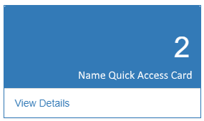

*Quick Access Cards*

Each card should have “View Details” link after clicking on which user would be redirected to appropriate view.

There are should be 3 cards for **administrator**:

* “Total # of users in the system” -> leads to “Users” page.
* “Total # of disabled users” -> leads to Users page and display only “disabled” users.
* “Total # of sellers without items” – without link

**Buyer/Premium_Buyer** user should have 3 cards:

* Total # of items in the system -> should lead to “Search” page,
* Total # of items with discount -> should lead to “Search” page with loaded product with discount,
* Total # of closed orders -> should lead to “Orders” page

**Seller** user should have 3 cards:

* Total # of items -> leads to “Goods” page,
* Total # of items with zero qty -> leads to “Goods” page with Quantity=0
* Total # of disabled items-> leads to “Goods” page with disabled product

**Buyer/Premium_Buyer**

User should have access to “Search” page where he can search for desired items and then add it to his own shopping cart.

*“Please enter valid search criteria to get results.”*  message should be displayed on page load.

User should be able to search by one of the listed criteria:

* Parent category
* Parent category + child category,
* Manufacturer,
* Name,
* Description,
* Min price,
* Max price,
* Discount,
* In store.

“Discount” and “Store” should have only True or False values. If no search criteria set then all available products should be displayed.

After clicking on [Search] button user should see list of active items in the right side of “Filter” panel. In case if no any result, system should display ”*No results*” message.

User should be able to change view by clicking on appropriate icon.



Also user can change currency in which price is displayed. (USD, EUR,GBP, BYN, RUR)

Items should be displayed in “card” view by default. On “card” view user can see only product name and price (if some discount then Actual price, Price without discount, Discount%).

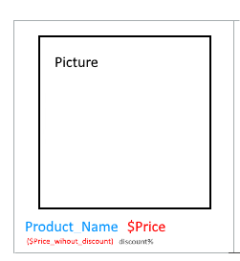

After changing view to list - detailed information of item should be displayed.

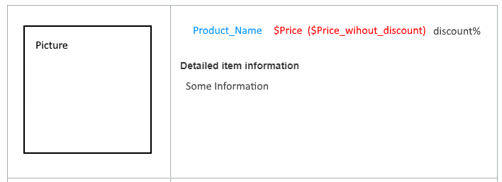

In case of large number of items - pagination should be displayed. There should be 10 items per page.



[Reset] button to reset filter state to default.

To add item to “Shopping Cart” user should hover mouse item over product image and click on **“+ Add to Cart**” link.

Number of items inthe **Cart** should be displayed in label for Cart navigation menu item.

**“Cart” page**

**Buyer/Premium_Buyer** can see list of items that he/she is going to buy. Shopping Cart item should be the same as on search page (same style and information).

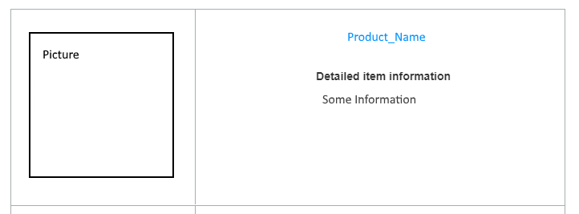

User can increase or reduce number of item using plus and minus  buttons.

For each product should be displayed “price per one item” and “price of item pack” (according to qty).

System should provide possibility of additional discount using a “coupons”. User can apply valid coupon code by entering it in appropriate field and clicking on [Apply coupon] button.

In case of incorrect or not valid coupon code user should be notified appropriately: **“Invalid coupon value.”** Max length 5 chars.

Subtotal field should display sum of all items*its qty.

Taxes **s**hould be 5% by default for all orders.

**Buyer** can set “Need shipping” to true and total price should be updated according his selection. Shipping by default= 30$

For **Premium_Buyer** user shipping should be free.

User is able remove item from shopping cart. Confirmation should appear “Are you sure you want to remove this item from cart?” and “Ok”, “Cancel” buttons.

User is able return to catalog using appropriate button (“Continue shopping”). All cart items and its state should stay remaining.

**Payment:**

To complete order user should fill in checkout information. All fields are required:

|  |  |
| --- | --- |
|  | **Validation** |
| Type of card | User can pay for items with Visa or MasterCard (type of card can be chosen by clicking on appropriate card image). Type of card should be also chosen automatically based on entered card Number |
| Credit Card Number | 15 numeric symbols |
| Card Holder | 5 to 26 charts |
| Expiration Date | Expiration Date cannot be in the past and should be at least two month in future. |
| CVC/CVV | 3 charts |

Validation should take place by click on **“Purchase”** button. If everything is correct then window with “**Complete”** text and “**Ok**” button should appear. After click on “Ok” button, “Orders” page should be opened.

If validation failed that tooltip should appear next to problem field:

|  |  |
| --- | --- |
|  | **Error text** |
| Incorrect number of symbols | Please lengthen this text from < Min length> characters to < Max length> (you are currently using <> characters) |
| If empty | Please fill out this field |
| Invalid card | Please use another card |

**“Orders” page**

Each **Buyer** user should have possibility to see completed orders.

Order details are displayed in expandable panel.

It should display the following information:

* Order date,
* Order Price,
* Order #,
* Category,
* Item,
* Quantity,
* Pack Price

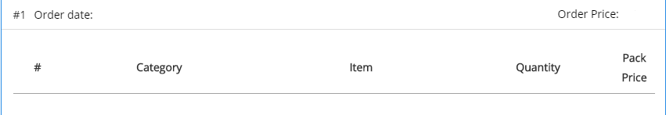

**Order Price** = total price of items including discounts and shipping.

**Pack price** = item quantity * item price including item discount.

User can go back to search clicking on appropriate button (**Go to Catalog**).

**Seller**

Users should manage existing items and add new items on **“Goods”** page.

Item card should contain detailed information about item, i.e. Name and Manufacturer, category, description, current qty, discount and price. Both price with discount and not should be displayed. Product image is displayed in the left side of card.



Seller user should see list of active and disabled items under ‘Add Catalog Item’ form. In case of large number of items - pagination should be displayed. Each page should contain 4 items.



‘**Add Catalog Item’**

To add new item user should fill in product information and click on [Save] button in ‘**Add Catalog Item’** form:

|  |  |  |  |  |  |
| --- | --- | --- | --- | --- | --- |
|  | **Is Mandatory?** | **Allowed Symbols** | **Min length** | **Max Length** | **Default value** |
| **Parent Category** | Yes | Available list of categories | NA | NA | Placeholder: *Parent Category* |
| **Child Category** | Yes | Available list of child categories based on selected parent category | NA | NA | Placeholder: *Child Category* |
| **Name** | Yes | Any | 3 | 20 | Placeholder: *Name* |
| **Manufacturer** | Yes | Any | 2 | 25 | Placeholder: *Manufacturer* |
| **Description** | No | Any | 0 | 50 | Placeholder: *Description* |
| **Price** | Yes | numeric symbols and “.” | 1 | 8 | Placeholder: *Price* |
| **Discount** | No | numeric symbols | 0 | 2 | Placeholder: *Discount %* |
| **Quantity** | Yes | numeric symbols | 1 | 4 | Placeholder: *Quantity* |
| **Product image** | No | Jpg, bmp, png >20mb | NA | NA | Placeholder: *Parent Category* |

Also user can select currency in which price is set upd. (USD, EUR, GBP, BYN, RUR).

There are should be available the following default parent and child categories. Alos user should have opportunely to create new categories (just type when create(only) a new product)

|  |  |
| --- | --- |
| **Parent Category** | **Child Category** |
| Electronic | Mobile phones, TV’s, Game Consoles |
| Clothes | T-shirts, Pants, Skirts |
| Auto | Cars, Tires |

Seller can set *“Discount”* in % (2 chars max). “Name” field can accept from 6 to 20 chars.

Validation should take place by click on **“Save”** button.

If validation failed that tooltip should appear next to problem field:

|  |  |
| --- | --- |
|  | **Error text** |
| Incorrect number of symbols | Please lengthen this text from < Min length> characters to < Max length> (you are currently using <> characters) |
| If empty | Please fill out this field |
| Invalid email | Please enter valid email |

User should be able reset form view using “**Reset**” button. Dropdown values should be set to default state.

**‘Edit Catalog Item’**

“Update item” popup should appear after clicking on [Edit] icon in the right top corner of the card on **“Goods”** page.

Seller can change all item information except image and category. Rule for mandatory fields is the same as on ‘Add Catalog Item’ form

Also item can be disabled via “Item On Shelf” toggle (temporarily removed, e.g. if supply is not expected in near future).

If item is disabled, appropriate note text should be displayed near title. Such items should be in the end of the list. If item is disabled - its quantity should be reset to 0.

**Help**

“**Help**” page should be available for each type of users (*administrator, seller, buyer, premium_buyer*).

Help information should be unique for each type of user: TBD

**Edit Profile**

Each user can edit own profile on “**Edit Profile”** page.

User should be able to change

* First Name
* Last Name
* Email
* Profile photo

User role field should be disabled to restrict user from changing it.

|  |  |  |  |  |
| --- | --- | --- | --- | --- |
|  | **Is Mandatory?** | **Allowed Symbols** | **Min length** | **Max Length** |
| **First Name** | No | Any | 7 | 20 |
| **Last Name** | No | Any | 7 | 20 |
| **Email** | Yes | Email format/ alpha numeric | 6 | 20 |
| **Profile Photo** | No | Jpg, bmp, png >20mb | NA | NA |

Validation should take place by click on **“Save”** button. If everything is correct then window with “**User profile was updated successfully**” text and “**Ok**” button should appear.

If validation failed that tooltip should appear next to problem field:

|  |  |
| --- | --- |
|  | **Error text** |
| Incorrect number of symbols | Please lengthen this text from < Min length> characters to < Max length> (you are currently using <> characters) |
| If empty | Please fill out this field |
| Invalid email | Please enter valid email |

User can cancel profile changes. If user wants to cancel confirmation dialog should appear with “**Cancel**”, “**OK**” buttons and “**Do you want cancel changes?**” text.

**Logout**

User should be able to logout from the application

After **Logout** user should be redirected to the “**Sign In”** page.

In case of closing application without signing out - session should be saved and user can continue work without entering credentials.