**[Skyrim-Inspired Menu](http://cssdeck.com/labs/skyrim-inspired-drop-down-menu" \t "_blank)**

[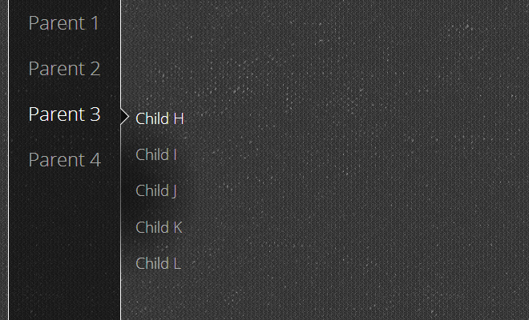](http://cssdeck.com/labs/skyrim-inspired-drop-down-menu)

<ul id="menu">

<li>

<a href="#">Parent 1</a>

<ul>

<li>

<a href="#">Child A</a>

</li>

<li>

<a href="#">Child B</a>

</li>

<li>

<a href="#">Child C</a>

</li>

</ul>

<li>

<li>

<a href="#">Parent 2</a>

<ul>

<li>

<a href="#">Child D</a>

</li>

<li>

<a href="#">Child E</a>

</li>

<li>

<a href="#">Child F</a>

</li>

<li>

<a href="#">Child G</a>

</li>

</ul>

<li>

<li>

<a href="#">Parent 3</a>

<ul>

<li>

<a href="#">Child H</a>

</li>

<li>

<a href="#">Child I</a>

</li>

<li>

<a href="#">Child J</a>

</li>

<li>

<a href="#">Child K</a>

</li>

<li>

<a href="#">Child L</a>

</li>

</ul>

<li>

<li>

<a href="#">Parent 4</a>

<ul>

<li>

<a href="#">Child M</a>

</li>

<li>

<a href="#">Child N</a>

</li>

<li>

<a href="#">Child O</a>

</li>

<li>

<a href="#">Child P</a>

</li>

<li>

<a href="#">Child Q</a>

</li>

<li>

<a href="#">Child R</a>

</li>

</ul>

<li>

</ul>

/\*\*

\* Skyrim-inspired Menu

\*/

@import url(http://fonts.googleapis.com/css?family=Open+Sans:400,300);

html {

background: #333 url(http://subtlepatterns.com/patterns/tex2res4.png) 0 0 repeat;

min-height: 100%;

font-family: "Open Sans", sans-serif;

font-weight: 300;

color: #FFF;

}

body, html {

height: 100%;

margin: 0;

padding: 0;

}

a {

color: rgba(255, 255, 255, 0.6);

text-decoration: none;

}

a:hover, li:hover > a {

color: #FFF;

}

ul {

list-style-type: none;

margin: 0;

padding: 0;

}

li {

margin: 0;

padding: 0;

}

#menu {

border-left: 1px solid #FFF;

border-right: 1px solid #FFF;

background: rgba(0, 0, 0, 0.5);

float: left;

font-size: 1.5em;

min-height: 100%;

margin-left: 1em;

}

#menu li {

position: relative;

z-index: 1;

}

#menu li a {

display: block;

padding: 0.5em 1em;

white-space: nowrap;

}

#menu li ul {

position: absolute;

overflow: hidden;

display: none;

left: 100%;

top: 0.5em;

float: none;

background-image: -moz-radial-gradient(0 50%, ellipse farthest-side, rgba(0,0,0,0.6) 0%, rgba(0,0,0,0.5) 33%, rgba(0,0,0,0) 100%);

background-image: -webkit-radial-gradient(0 50%, ellipse farthest-side, rgba(0,0,0,0.6) 0%, rgba(0,0,0,0.5) 33%, rgba(0,0,0,0) 100%);

background-image: radial-gradient(0 50%, ellipse farthest-side, rgba(0,0,0,0.6) 0%, rgba(0,0,0,0.5) 33%, rgba(0,0,0,0) 100%);

}

#menu li:hover ul {

display: block;

}

#menu li ul a {

position: relative;

font-size: 0.8em;

}

#menu li ul a:hover:before {

content: "";

display: block;

width: 1em;

height: 1em;

background: rgba(0,0,0,0.75);

border: 1px solid #FFF;

position: absolute;

top: 0.5em;

left: -0.75em;

-moz-transform: rotate(45deg);

-webkit-transform: rotate(45deg);

transform: rotate(45deg);

}