Meteorological System

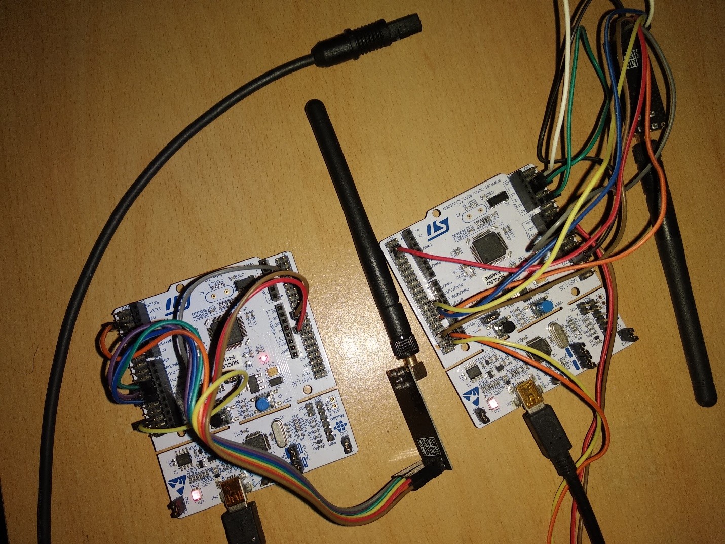

|  |  |  |  |
| --- | --- | --- | --- |
| Revision | Date | Name | Comments |
| 1.0 | 22/12/2020 | Vladimir Trushin | First Revision |

The Weather Station is integrated by following sensors:

1. Air temperature
2. Relative humidity
3. ADC

The Weather Station implemented using two boards of the Cortex-M4.

|  |  |  |
| --- | --- | --- |
| Sensors | Quantity | Type |
| Air temperature | 1 | I2C |
| Relative humidity | 1 | I2C |
| ADC | 1 | Digital |

|  |  |
| --- | --- |
| Resources of microcontroller | Quantity |
| UART | 2 |
| I2C | 1 |
| SPI | 2 |
| DAC | 1 |
| ADC | 1 |
| RTC | 1 |
| TIMER | 1 |

Communication between computer and microcontroller provides by UART.

The communication has two option:

1. Main microcontroller to slave microcontroller by NRF24L01+ and slave to PC by UART.
2. Main microcontroller to PC by UART.

**Block diagram**

PC

Android

ADC

DAC

Sensor

Sensor

I2C

I2C

SPI

SPI

NRF

NRF

PC

PC

UART

UART

Cortex-M4 main

Cortex-M4 slave

TCP/IP - TCP

C++ application

Python application

**Communication protocols:**

|  |  |  |  |  |  |  |  |  |  |  |  |
| --- | --- | --- | --- | --- | --- | --- | --- | --- | --- | --- | --- |
| 4 bytes | 4 bytes | 4 bytes | 1 byte | 1 byte | 1 byte | 1 byte | 1 byte | 1 byte | 1 byte | 4 bytes | 4 bytes |
| Relative humidity | Air temperature | ADC | Year | Month | Day | Week day | Hour | Minute | Seconds | Prob time | Average |

Wireless communication with NRF24L01+ can be 1 kilometer.

**Software on PC:**

Implemented a base GUI Python 3 application on PC.

**Probe time:** the period time which changes the last update.

**Average:** number of probe-data during the period of time.

**Humidity:** percent of humidity.

**Temperature:** value in Celsius.

**ADC Voltage:** value in Volt.

**Change time and date:** must be a two-digit number for each part.

year: month:day:week day: hour: minute: seconds

for example: 20:12:22:3:16:32:30

**Change time and average:** seconds:average

1 <= seconds <= 1200 3 <= average <= seconds * 1000

**Change port:** can change the port.

1. NRF24 – main to slave and slave to PC.
2. UART – main to PC

**Software on Android:**

Implemented a base GUI C++ (QT) application on Android.

**Probe time:** the period time which changes the last update.

**Average:** number of probe-data during the period of time.

**Humidity:** percent of humidity.

**Temperature:** value in Celsius.

**ADC Voltage:** value in Volt.

**T and D (Change time and date):** must be a two-digit number for each part.

year: month:day:week day: hour: minute: seconds

for example: 20:12:22:3:16:32:30

**T and A (Change time and average):** seconds:average

1 <= seconds <= 1200 3 <= average <= seconds * 1000

**IP and P (Enter IP and Port to connect):** ip:port

for example: 192.168.1.12:12345