Project report
Fine-Tuning Mistral-7B on Steam Game Reviews Using LoRA
Vladimir Hristovski 110640555

Introduction
Full fine tuning of generative models is expensive and time consuming. A way to adapt a model to a specific task with low demand on hardware and time is to use a technique called LoRA. LoRA is short for Low Rank Adaptation and is a parameter-efficient fine-tuning technique that adapts large or small pre-trained models, like LLMs or diffusion models, by adding small, trainable low-rank matrices to frozen layers. In this project I will be answering the question “Can a LoRA fine-tuned model achieve comparable difference to the same model without any tuning?”
Originally the project idea was to train the base model TinyLlama 1.1B using LoRA, but instead I decided to use the model Mistral 7B. I used Steam game reviews dataset from 2021to train the model and I used ROUGE scores to evaluate the models. The motivation that led me to work on this project was my ambition towards gaming as well as the curiosity of how much more efficient training can be.

Dataset
The dataset used for this project is Steam game reviews dataset from 2021 from Kaggle. The original dataset was 8 GB but after cleaning the dataset only focusing on games that have 5 or more helpful reviews in English, which narrowed down the dataset to only 315 games, reducing its size to 600 KB. The final dataset was formatted in a csv file with the following columns: app_name, input, output. It was tokenized using the Mistral tokenizer and labels were created by copying input_ids for causal language modeling. The test-train split was 10/90.

Methodology and Experimental Setup
The methodology used for this project was to get a clean, training ready dataset, evaluate the base model, train the base model, evaluate the trained model and compare the scores. After the data was ready the base model was loaded using 4-bit quantization via BitsAndBytes to reduce memory usage and was evaluated using ROUGE scores. Then Low Rank Adaptation was configured with these parameters: rank (r) = 16, alpha = 32, target modules = q_proj, v_proj, dropout = 0.05. Training was done using the Hugging Face trainer with the following configuration: Batch size = 1, Gradient accumulation = 8, Learning rate = 2e-4, Epochs = 3, Optimizer = paged_adamw_32bit, Mixed precision (fp16) = enabled. After this process the trained model was evaluated.
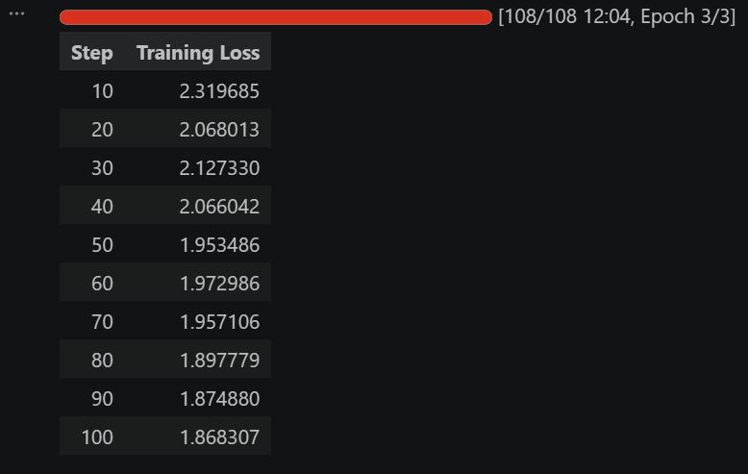

Results and Conclusion
Model | ROUGE-1 | ROUGE-2 | ROUGE-L | ROUGE-Lsum
Base Mistral 7B | 0.234 | 0.056 | 0.134 | 0.165
LoRA Mistral | 0.262 | 0.076 | 0.164 | 0.180

Comparing the results we can see that LoRA did improve the model for the specified task. Rouge 1 score difference: 0.029, Rouge 2 score difference: 0.019. From these results we can conclude that the model was better able to generate outputs that align with the reference texts after task-specific adaptation. Although the score differences are moderate they are meaningful since the model was adapted in a shorter time period.

Ethical considerations and AI usage disclosure
The AI tools that aided me for this project was the model Mistral 7B for evaluating a testing on. The other model used was for guidance and it was ChatGPT. I prompted it to give me a bullet point guide workflow for the project and assistance with importing relevant Python modules and properly utilizing them for training and testing. This project has no ethical issues in terms of bias, fairness, or misuse.

