**Web Page** - One document of information of a web site. Usually in HTML. May have CSS, JavaScript, Images and other...

**Web Site** - Collection of web pages having web resources. It has navigation between pages. Hosted on at least one server.

**World Wide Web** - Collection of all sites.

**Web App** - Next level. High interactivity. AJAX, Silverlight, Flash... Broken into tiers. Each tier has a role.

**WEB 1.0** - Professional authors who put content. Expensive. Users = consumers.

**WEB 2.0** - Users generate content. Anyone can publish. It has rich Internet applications. Social web. High content variety. Users are authors too.

**WEB 3.0** - Computer generated information. Semantic web. AI. Personalization. Mobility.

**Semantic Web** - Can be read an categorized by computers. Search engines are faster. Hard to be implemented.

**AI**- Google Suggest, Google Translate

**Personalization** - Sites show different content for different users.

**Trident-Based Web Browsers** - Internet Explorer, Netscape, Maxton

**Gecko-Based Web Browsers** - Firefox, Netscape, Sea Monkey

**Webkit-Based Web Browsers**- Chrome, Safari, Maxton

**Presto-Based Web Browsers** - Opera

**User Agent String** - Identify browser version, layout engine, OS

Windows NT 6.2 = Windows 8

Windows NT 6.1 = Windows 7

Windows NT 6.0 = Windows Vista and Server 2008

Windows NT 5.2 = Windows 2003 Server ans XP x64

Windows NT 5.1 = Windows XP

Windows NT 5.0 = Windows 2000

Windows NT 4.0 = Windows NT

WOW64 = Win32 on Windows 64

x64 - 64 bit application on Windows 64

**Servers** - Database Server, File Server, Mail Server, Print Server, VPS Server

**Hardware Server** - Controlled by OS. Handles web requests. Redirected to APS.NET, PHP and other server-side programming languages.

Apache - 60.31% Of all servers

IIS - 19,34% (MS)

nginx - 7,65% (Igor Syslov)

GWS - 5,09% (Google)

lighttpd - 0,60%

**Client-Server Architecture:**

-server - machine(s) providing web apps or services to client. Cloud, PHP, ASP.NET

-client - software with UI to access services. Web Browsers, HTML5

**3-Tier Architecture:**

- Front End - client (UI)

- Middle Tier (Business Layer) - server software core system logic

- Backend - database, cloud

**ORM** - Object Relational Database. Virtually maps tables in database.

**SOA**- Service-oriented architecture - Create service - Register service - Secure service - Manage service - Virtualize service - Integrate service

**IDE Coding Tools** - Visual Studio, Web Developer, Web Matrix, Eclipse, Aptana, Webstorm, Dream Weaver

**Lite Coding Tools**- Gedit, Notepad++

**Browser Tools**- Firebug, Webinspector, F12, Inspect, Console

**Drawing Tools** - Photoshop, Fireworks, Gimp, Paint.NET

**Source Control**- TFS, GIT, SVN

**DOM** - Document Object Model - defines logical structure of documents

**OSI Model** - Application Layer, Presentation Layer, Session Layer, Transport Layer, Network Layer, Datalink Layer, Physical Layer

**<pre> tag** - preformatted text

**<dl>** - definition list

**<dt>**- data title

**<dd>** - data description

**<caption>** with <table> - description of the table

**HTML**- Hypertext Markup Language

**tag** - smallest piece in HTML

**attribute** - property of a tag

**element**- combination of opening, closing tag and attributes

**<head>** - markup is not visible for the user in the head

**<b>** - bold

**<i>** - italic

**<sup>** - superscript

**<sub>**- subscript

**<strong>** - stronger text

**<em>** - emphasized text

**<blockquote>** - quoted text

**<del>** - deleted text

**<br />** - new line

**<a href="..."> </a>** - hyperlink

**<img src="..." alt="..." />** - image

**<h1> - <h6>** - headings

**<p>** - paragraph

**<div>** - rectangular block element. Used with styles

**<span>** - inline element. Used with styles

**<ol>**- ordered list(1, A, a, I, i)

**<ul>**- unordered list (circle, disc, square)

**Block elements** - <div> <p> <h1> <ul> <dl> <ol>

**Inline elements** - <span> <a> <em> <img>

**HTML 5 tags:**

**<nav>** - navigation. Used with links, lists...

**<header>**- header of a section, site

**<footer>** - footer of a section, site

**<section>** - section of a website

**<article>** - part of a section

**<aside>** - content not directly with the site. Ads for example

**<hgroup>**- header of a section

**<figure>**- self-contained flow content

**<figcaption>** - optional caption for figure

**<video> <audio>** - media

**<track>** - subtitles for video

**<mark>** - highlighted text

**<progress>** - progress bar

**<meter>** - measurement

**<time>**- date or time

**<bdi>** - isolated text

**<wbr>** - line-break opportunity

**<canvas>** - dynamic content

**<datalist>** - set of predefined options (can be hided or shown)

**<keygen>** - key generator

**<output>**- output of a calculation

**<meta>**- meta tag

**&** - to insert symbol. For example &amp shows ampersand

**<!-- ... -->** - comment

**<div title="...">** - gives tooltip on the div

**<code>** - gives you code

**<cite>**- citedd text (цитиран текст)

**<big>** - bigger font

**<small>** - smaller font

**<table>** - table start

**<tr>**- table row

**<td>** - table data

**<colgroup>** - groups columns

**<col>** - used for <colgroup>

**cellspacing**- space between cells

**cellpadding** - margins of cells

**colspan** - merges columns

**rowspan** - merges rows

**<hr>** - horizontal line

**taborder, tabindex** - for TAB key

**External CSS file** - <link rel=stylesheet type="text/css" href = "..."></link>

**<form method="...">** - how to send data

**<form action="...">** - where to send data

**<input type="text" />** - textbox

**<input type="reset" />** - reset button for the form

**<textarea>** - multiline textbox

**<input type="password" />** - *-textbox

**<input type="submit" />** - submit button

**<input type="image" />**- gets coordinates from image

**<input type="button" />** - with javasctipt

**<input type="checkbox" />**- checkbox

**<input type="radio" name="..." />** - radio buttons group by "name"

**<select><option value="..." selected="selected"></option></selected>** - dropdown menu

**<select multiple="multiple"></select>** - multiple choice menu

**<input type="hidden" />**- hidden data not seen by user

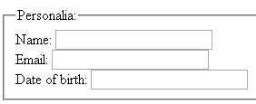**<label for="example">**- gives shortcut for "example"

**<fieldset>** - groups data in form

**<legend>** - caption for the fieldset

**<input type="range">**- spinbox (does not work in Firefox)

**<input type="number">** - slider (does not work in Firefox)

**<input type="email" />** - email pattern

**<input type="url" />**- URL pattern

**<input type="tel" />** - brings telephone keypad

**<iframe>** - shows one web site in another

**HTML is used for content, not layout. Presents information in a meaningful manner. Defines headers paragraphs, textboxes. Does not define colors, size, positions.**

**Semantic HTML is easier to read by developers. Easier to render by browsers. Easier for search engines.**

**<details> + <summary>** - accordion like widget

**To show new content on older browsers - HTML5Shiv and Modernizr.**

**<dfn>** - definition <p><dfn>HTML</dfn> is the standard markup language for creating web pages.</p>

**<kbd>** - user input

**<menu>** - list of commands

**<object>**- external resource

**<optgroup>** - list of option elements with a common label

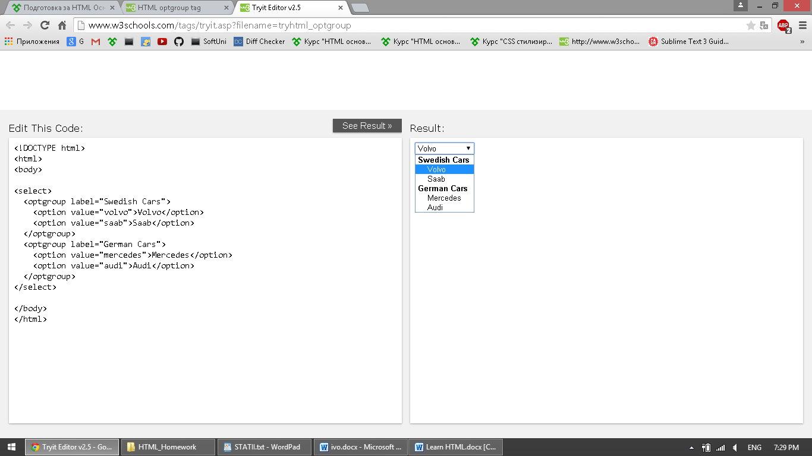**<param>** - parameters for plugins. Invoked by object element.

**<s>**- no longer acurate element

**<samp>**- sample output

**<source>** - to show alternative media