# THE BEST GREENHOUSE MONITORING PROGRAM

By Vlad & Emile

To start monitoring the greenhouse,

you simply start the Python script named SendingInfo2.py.

Then enter the wanted thresholds (Temperature and Moisture).

Let the magic happen and your plants grow like no tomorrow!

## GPIO

**Led_pin = 24**

**Fan_gpio_pin = 25**

**Pump_gpio_pin = 4**

**With (GPIO.BCM) mode**

## ADC Channels

Channel 0: Light sensor

Channel 1: Humidity

## How to setup email/thresholds

Both the thresholds and the email configuration will be set when starting the program.

The program requires an App password to send emails. Here is how to get it (for google users):

Login the email you want to send emails from, then:

1. Go to your Google Account.
2. Select Security.
3. Under "Signing in to Google," select App Passwords. You may need to sign in again.
4. If you don’t have this option, it might be because:
   * 2-Step Verification is not set up for your account.
   * 2-Step Verification is only set up for security keys.
   * Your account is through work, school, or other organization.
   * You’ve turned on Advanced Protection for your account.
5. At the bottom, choose Select app and choose the app you using and then Select device and choose the device you’re using and then Generate.
6. Follow the instructions to enter the App Password. The App Password is the 16-character code in the yellow bar on your device.
7. Tap Done.

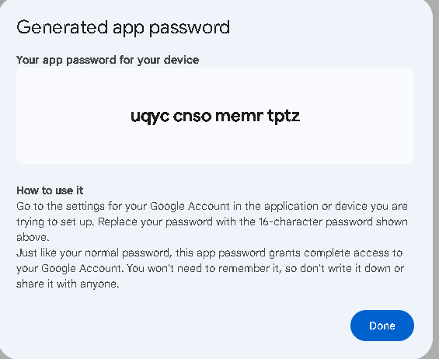

Insert the App Password into the command prompt and voila!

## TBEL DATA CONVERTER CODE

// decode payload to JSON

var data = decodeToJson(payload);

// Result object with device attributes/telemetry data

var topicParts = metadata.topic.split("/");

var deviceType = topicParts[0];

var deviceName = topicParts[1];

var result = {

deviceName: deviceName,

deviceType: deviceType,

attributes: {

state: data.val0,

},

telemetry: {

temperature: data.val1,

light: data.val2,

moisture: data.val0

}

};

/** Helper functions 'decodeToString' and 'decodeToJson' are already built-in **/

return result;

## Alarms

To change the alarms threshold, we need to update the alarm in the ThingsBoard page.

First, got to device profiles and click on your device:

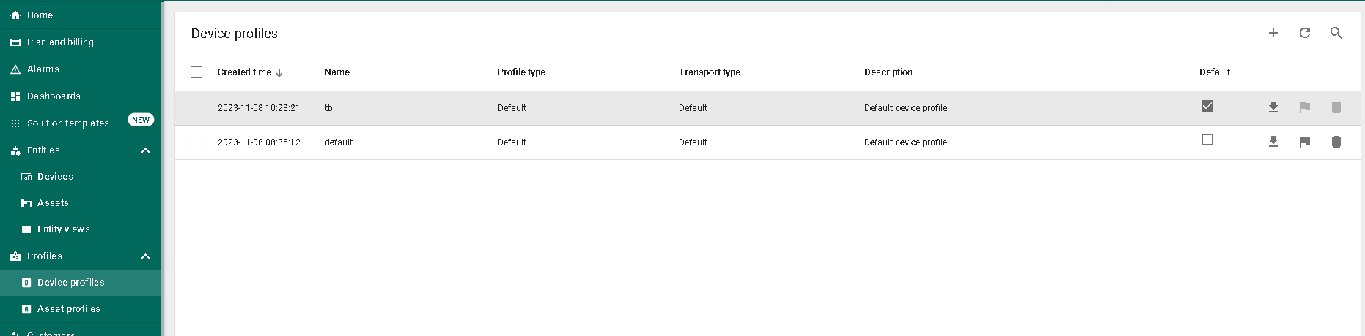



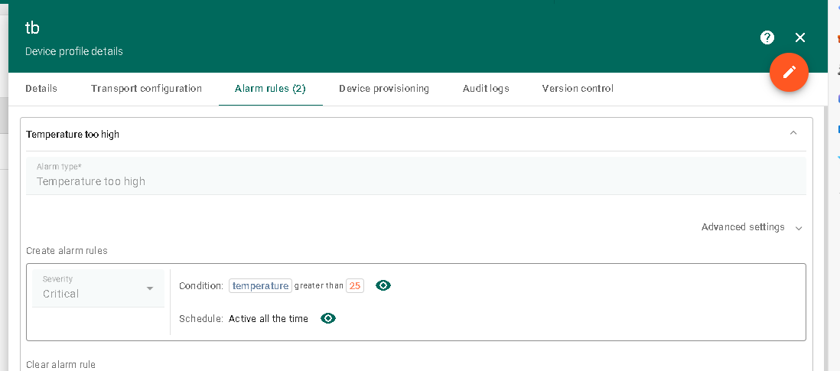Then go to Alarm rules, and click on the edit button



Then click on the pencil after the condition:

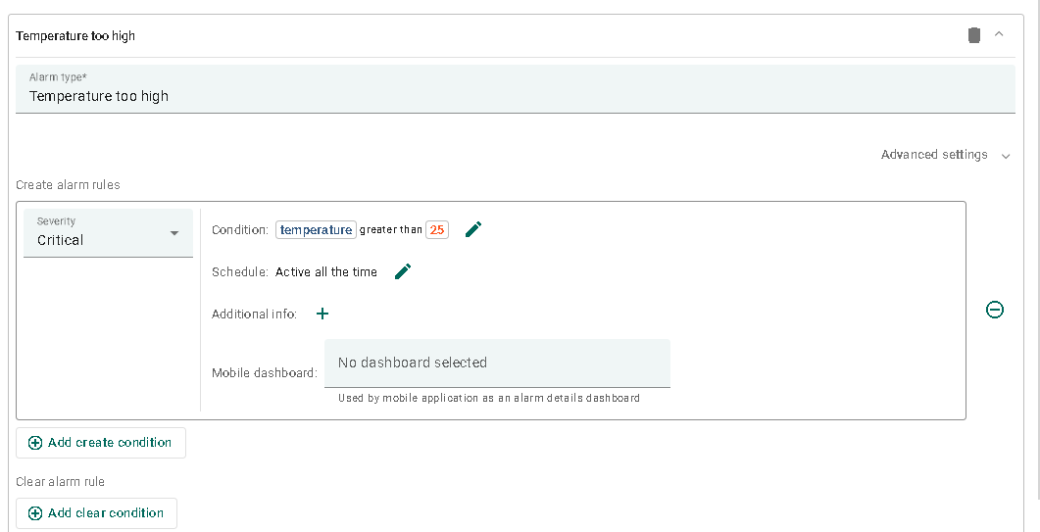



Then edit the key filter.



Change the value to the threshold you want to use then click on update!

