1.

select B.ticket_no, B.flight_id, B.boarding_no, B.seat_no, flights.flight_id

from boarding_passes B

INNER JOIN flights

ON B.flight_id = flights.flight_id and B.seat_no = '15F'

ORDER BY flights.flight_id DESC

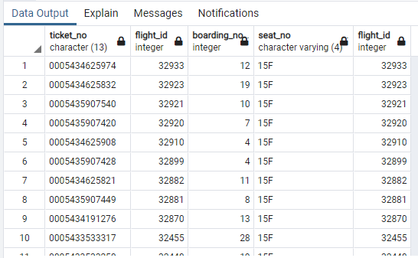

2.

select *

from flights

where status != 'Scheduled' and status != 'Arrived'

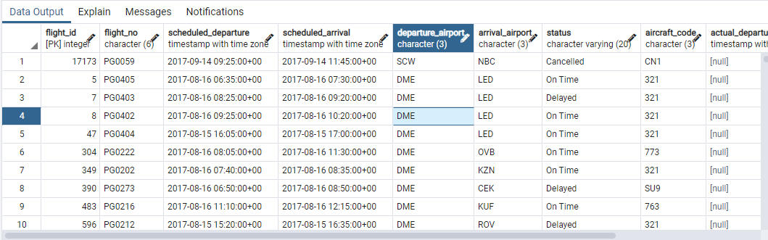

3.

select count(aircraft_code)

from aircrafts_data

where range between 3000 and 5650

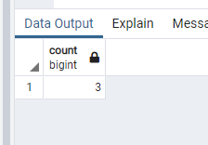

4.

select timezone

from airports_data

group by timezone

order by timezone asc

limit 5;

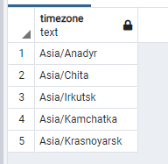

5.

select boarding_passes.seat_no, aircrafts_data.aircraft_code

from seats S

INNER JOIN boarding_passes

ON S.seat_no = boarding_passes.seat_no

INNER JOIN aircrafts_data

ON S.aircraft_code = aircrafts_data.aircraft_code AND aircrafts_data.aircraft_code = '320'

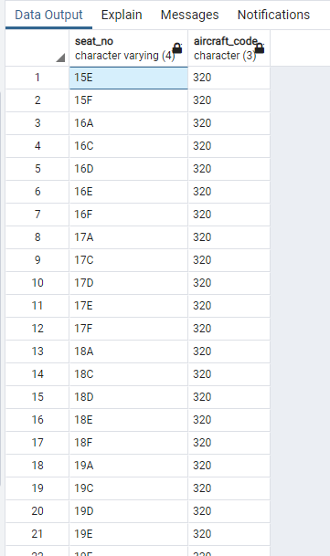

6.

select avg(amount)

from ticket_flights

where fare_conditions = 'Business'

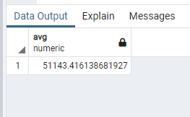

7.

select timezone,

CASE

WHEN count(timezone) <= 3 THEN '4'

ELSE count(timezone)

END

from airports_data

group by timezone

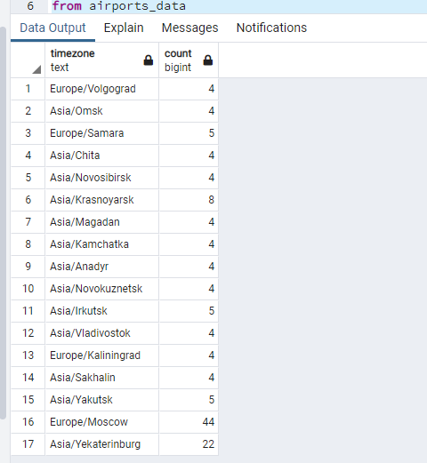

8.

select fare_conditions, amount

from ticket_flights

group by fare_conditions, amount

HAVING amount =(select min(amount)

from ticket_flights

where fare_conditions = 'Business')

