1.

select

B.boarding_no,

B.seat_no,

flights.aircraft_code

from boarding_passes B

INNER JOIN flights ON B.flight_id = flights.flight_id and B.seat_no = '15F'

ORDER BY flights.aircraft_code DESC

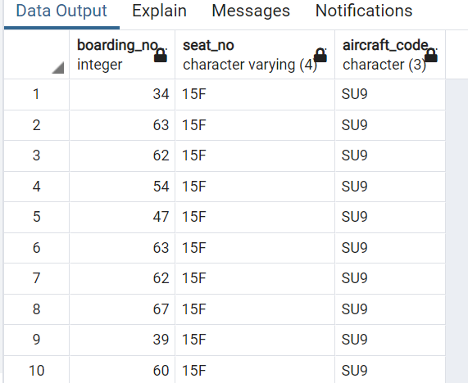

2.

select *

from flights

where status not in('Scheduled', 'Arrived')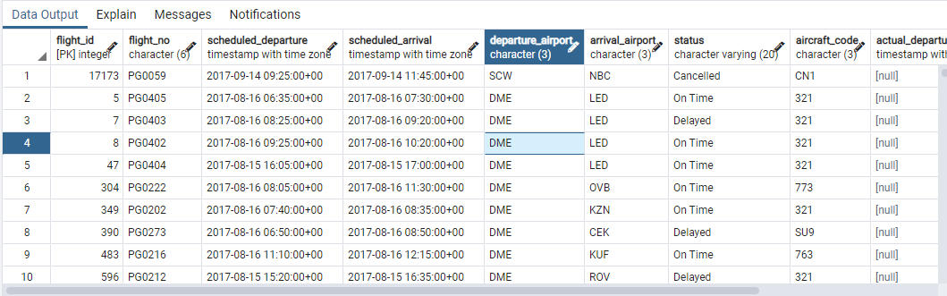

3.

select count(aircraft_code)

from aircrafts_data

where range between 3000 and 5650

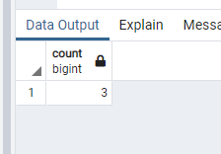

4.

select distinct timezone

from airports_data

order by timezone

limit 5;

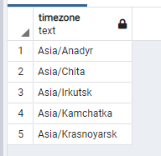

5.

select

s.seat_no,

ad.aircraft_code

from

seats s

inner join aircrafts_data ad on s.aircraft_code = ad.aircraft_code

where

ad.aircraft_code = '320'

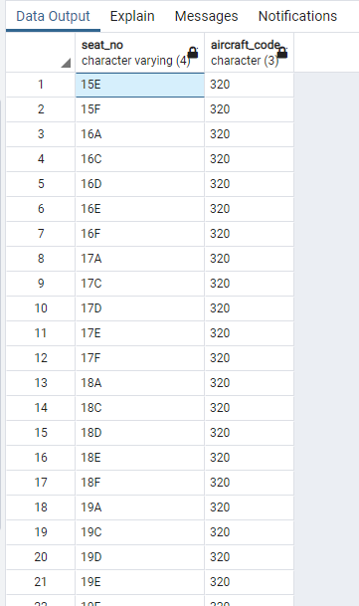

6.

select avg(amount)

from ticket_flights

where fare_conditions = 'Business'

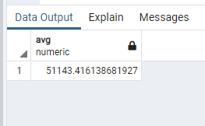

7.

select

timezone,

count(airport_code) cnt_ap

from airports_data

group by timezone

having count(airport_code) > 3

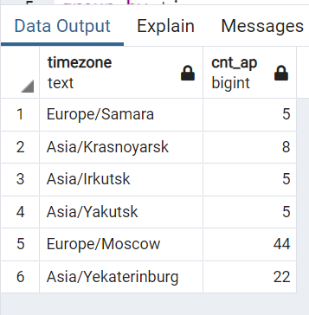

8.

select fare_conditions, amount

from ticket_flights

group by fare_conditions, amount

HAVING amount =(select min(amount)

from ticket_flights

where fare_conditions = 'Business')

