Ss. Cyril and Methodius University in Skopje
Faculty of Computer Science and Engineering

SCALABLE MULTIMODAL ANALYSIS OF TIKTOK VIDEOS
USING EMBEDDINGS AND SIMILARITY SEARCH
MASTER'S THESIS

Candidate: Vladimir Ivanovski (Index No. 249024)
Mentor: prof. d-r Riste Stojanov
Master Programme in Computer Science
Skopje, 2026

Abstract
The explosive growth of TikTok has produced hundreds of millions of short-form videos worldwide. Extracting structured information from this content at scale — what is said, what is shown, and who is speaking — poses significant engineering and research challenges. Existing approaches either rely on a single modality or are too slow and expensive to process large collections of videos.
This thesis presents a scalable multimodal pipeline for analyzing TikTok videos using both audio transcription and visual frame analysis, followed by vector embedding and semantic similarity search. The pipeline downloads videos using yt-dlp, extracts audio and keyframes in memory via FFmpeg (no intermediate WAV or image files during inference), transcribes speech with batched GPU Whisper (small model, 180 s audio cap), and generates 512-dimensional CLIP embeddings with batched cross-creator frame encoding. Embeddings are stored in a FAISS index and in Elasticsearch for fast approximate nearest-neighbor retrieval. The system is built on Ray, a distributed Python framework enabling horizontal scaling by changing a single line of configuration. Benchmarks show the streaming pipeline processed 1,000 TikTok videos from 357 creators in 9.1 minutes on a single GPU workstation (8 Stage-1 workers), achieving 1.84 videos per second — a 1.94x wall-clock speedup over the 2-worker baseline. A Flask-based demo application provides a semantic search interface where users type a natural language query and retrieve the most relevant TikTok creators, with optional personalization based on feedback stored in Elasticsearch.
Keywords: TikTok analysis, scalable pipeline, multimodal embeddings, CLIP, FAISS, Elasticsearch, distributed computing, Ray, semantic search, Whisper.

Table of Contents
Abstract 2
1 Introduction 7
1.1 Motivation 7
1.2 Problem Statement 7
1.3 Contributions 8
1.4 Thesis Structure 8
1.5 Hypothesis 8
2 Related Work 9
2.1 Short-Form Video Platforms and Content Analysis 9
2.2 Automatic Speech Recognition 10
2.3 Vision-Language Models and Multimodal Embeddings 10
2.4 Vector Similarity Search 10
2.5 Distributed Data Pipelines 11
3 Theoretical Background 12
3.1 Multimodal Learning 12
3.2 Contrastive Language-Image Pretraining (CLIP) 12
3.3 Approximate Nearest-Neighbor Search and FAISS 13
3.4 Automatic Speech Recognition — Whisper 13
3.5 Distributed Computing with Ray 13
3.6 Elasticsearch Dense-Vector Search 14
4 System Architecture and Design 15
4.1 Overview and Design Goals 15
4.2 Data Collection 16
4.3 Stage 1: Media Extraction 16
4.4 Stage 2: Audio Transcription 16
4.5 Stage 3: Multimodal Embedding 16
4.6 Vector Storage and Indexing 17
4.7 Semantic Search Demo Application 17
4.8 Personalized Search 17
5 Implementation 18
5.1 Technology Stack 18
5.2 Distributed Pipeline with Ray 19
5.3 Embedding Generation 19
5.4 FAISS Index Construction 19
5.5 Elasticsearch Integration 20
5.6 Flask Demo Application 20
5.7 Multi-Server Scalability 20
6 Evaluation and Results 21
6.1 Dataset 21
6.2 Scalability Benchmark 21
6.3 Large-Scale Run (1,000 Videos) 22
6.4 Search Quality 23
6.5 Embedding Configuration and Clustering Analysis 24
7 Conclusion and Future Work 30
7.1 Conclusion 30
7.2 Future Work 31
References 32

List of Tables
Table 5.1 Technology stack 18
Table 6.1 Dataset statistics 21
Table 6.2 Scalability benchmark (20 creators, 50 videos) 21
Table 6.3. Large-scale pipeline scalability results (1,000 videos, 357 creators) 23
Table 6.4 Search quality evaluation 23
Table 6.5 Average Precision@10 by embedding configuration 25
Table 6.6 Silhouette score by number of clusters 27

List of Figures
Figure 4.1 High-level system architecture 16
Figure 6.1 Speedup vs. number of CPU workers 22
Figure 6.2 Precision@10 by embedding configuration 25
Figure 6.3 Silhouette score vs. number of clusters 27
Figure 6.4 2D PCA projection of creator embeddings by cluster 28
Figure 6.5 Number of creators per cluster 29
Figure 6.6 Percentage of top-10 results sharing the dominant cluster 29

1 Introduction
1.1 Motivation
TikTok is one of the fastest-growing social media platforms in the world, with over one billion active users; industry estimates place daily uploads on the order of tens of millions of videos. Despite the platform's scale, the rich information embedded within TikTok videos — spoken words, visual style, and creator identity — remains largely inaccessible to downstream applications. Search on the platform is limited to hashtags and account names; no tool currently allows a user to type a natural language query and retrieve semantically matching creators. Montag et al. [1] survey psychological aspects of TikTok use and highlight the platform's unusually strong attention retention.
The research challenge is therefore threefold: (1) how to automatically extract multimodal features from TikTok videos at scale, (2) how to represent these features in a way that enables semantic retrieval, and (3) how to do so cheaply and scalably without requiring large GPU clusters.
1.2 Problem Statement
Given a large collection of TikTok videos from a diverse set of creators, the problem addressed in this thesis is: how can we build a scalable, low-cost pipeline that automatically transcribes speech, encodes visual content, and enables fast semantic search across thousands of videos — using open-source tools and a single GPU workstation, while being architecturally ready to scale horizontally to multiple servers?
This thesis answers this question with a complete working system, from data collection to a live demo application, supported by empirical benchmarks on real TikTok data.
1.3 Contributions
The main contributions of this thesis are:
• A scalable, modular, three-stage streaming distributed pipeline (extract, transcribe, embed) for processing TikTok videos using Ray producer-consumer queues with bounded memory and zero intermediate disk I/O during inference.
• A multimodal embedding scheme combining CLIP image embeddings from video frames and CLIP text embeddings from Whisper transcriptions with empirically chosen weights (0.85 image / 0.15 text), stored in both FAISS and Elasticsearch. Section 6.5 revisits this choice empirically and finds that a visual-only weighting clearly outperforms it on the tested queries (0.48 vs. 0.28 average Precision@10), so H1 (Section 1.5) is not confirmed.
• A semantic search and personalized creator discovery demo application supporting natural language queries over 1,000 TikTok videos from 357 creators, with empirical benchmarks showing 1.84 videos/s and 1.94x wall-clock speedup when scaling Stage-1 workers from 2 to 8.
• A documented multi-server deployment architecture enabling horizontal scaling by changing a single line of configuration.
1.4 Thesis Structure
The remainder of this thesis is organized as follows. Chapter 2 surveys related work. Chapter 3 provides the theoretical background. Chapter 4 describes the system architecture. Chapter 5 details the implementation. Chapter 6 presents benchmarks and evaluation results. Chapter 7 concludes the thesis and outlines directions for future work.
1.5 Hypothesis
This thesis investigates the following hypothesis regarding the semantic search component described in Chapters 4-6:
H1: Combining visual (CLIP image) and text (CLIP transcript) embeddings into a single weighted representation yields higher creator-search relevance (Precision@10) than using either modality alone.
H2: Creators retrieved for the same search query are more likely to belong to the same embedding cluster than would be expected by chance, indicating that the embedding space captures meaningful, content-based groupings.
H3: Personalized re-ranking based on user feedback (liked/disliked creators) improves search relevance (Precision@10) over standard, non-personalized search.
H1 is evaluated empirically in Section 6.5 by comparing five visual/text weighting configurations — visual-only, text-only, 50/50, 85/15, and 15/85 — against the currently deployed 85/15 configuration, using manually labeled Precision@10 over five representative niche queries. H2 is evaluated in the same section through agglomerative clustering and silhouette analysis, checking whether creators retrieved for the same query are grouped meaningfully. H3 is evaluated in Section 6.4 by manually comparing standard and personalized search results across five niches.

2 Related Work
2.1 Short-Form Video Platforms and Content Analysis
Short-form video platforms have attracted significant academic interest in recent years. Montag et al. [1] analyzed TikTok usage patterns and reported that the platform's recommendation algorithm is unusually effective at retaining user attention. Zhao et al. [2] proposed a multimodal short-video analysis system combining visual, OCR, and ASR streams for rumor detection, illustrating both the value and the labeled-data requirements of multimodal short-form video methods. Omar and Dequan [3] studied how personality traits and user motivations influence TikTok usage behaviors, highlighting the need for accessible third-party content analysis tools.
In the domain of social media content mining more broadly, Wei et al. [4] showed that combining multimodal signals improves micro-video recommendation quality compared to unimodal approaches. Their findings motivate the multimodal fusion strategy adopted in this thesis.
2.2 Automatic Speech Recognition
Automatic Speech Recognition (ASR) has undergone a revolution with the introduction of transformer-based models. OpenAI's Whisper [5], trained on 680,000 hours of multilingual audio, achieves near-human word error rates across a wide range of languages. The faster-whisper library [6] reimplements Whisper using CTranslate2 with INT8 quantization on CPU and float16 on GPU, achieving substantial speedups that make large-scale batch transcription practical on a single workstation.
Baevski et al.'s wav2vec 2.0 [7] demonstrated that self-supervised pretraining on unlabeled audio can yield competitive ASR performance, motivating the use of pre-trained multilingual speech models in this pipeline.
2.3 Vision-Language Models and Multimodal Embeddings
The joint embedding of images and text into a shared vector space was pioneered by CLIP [8] from OpenAI, trained on 400 million image-text pairs using a contrastive objective that aligns image and text representations in a 512-dimensional shared space. The OpenCLIP library [9] provides open-source reproductions with comparable performance. Averaging per-frame CLIP embeddings is a practical approach for transferring image-text models to video; related vision-language work such as ALBEF [10] further advances multimodal alignment through contrastive learning before fusion.
2.4 Vector Similarity Search
Efficient similarity search in high-dimensional vector spaces is a well-studied problem. Johnson et al. [11] introduced FAISS (Facebook AI Similarity Search), providing both exact flat indices and approximate nearest-neighbor structures (IVF, HNSW) scaling to billion-scale datasets. Malkov and Yashunin [12] introduced the HNSW (Hierarchical Navigable Small-World) algorithm, which achieves sub-linear query time with high recall, now available natively in both FAISS and Elasticsearch.
Elasticsearch 8.x [13] supports dense-vector fields natively with cosine, dot-product, and L2 similarity, enabling hybrid queries that combine keyword filters with semantic similarity. Karpukhin et al. [14] demonstrated that dense retrieval over large corpora using bi-encoder embeddings consistently outperforms traditional sparse retrieval (BM25) for semantic queries, directly motivating the embedding-based search approach in this system. Reimers and Gurevych [24] similarly showed that fine-tuned Siamese sentence encoders (Sentence-BERT) produce semantically meaningful sentence embeddings suitable for efficient similarity search, an approach conceptually analogous to the CLIP text encoder used here for transcription embeddings.
2.5 Distributed Data Pipelines
Ray [15] is an open-source distributed computing framework for Python that enables both embarrassingly parallel and actor-based stateful workloads with minimal code changes. Unlike heavyweight frameworks such as Apache Spark, Ray runs natively on a single machine and scales to a cluster by changing a single initialization call. Moritz et al. [15] demonstrate near-linear speedup for data-parallel tasks across dozens of nodes.
Stateful Ray actors keep models resident across tasks and avoid repeated weight loading, which is essential for inference-heavy video pipelines [15]. Romero et al. [16] study automated model-less inference serving (INFaaS) and emphasize the cost of model placement and loading in distributed inference systems, reinforcing the design choice of long-lived Whisper and CLIP actors in this work. Dean et al. [17] established foundational principles for large-scale distributed data processing that underpin the streaming pipeline design employed here.

3 Theoretical Background
3.1 Multimodal Learning
Multimodal learning refers to machine learning methods that jointly process information from multiple sensory modalities [18]. Different modalities are complementary: audio reveals what a speaker says even when the visual content is ambiguous, while visual frames capture the aesthetic style, setting, and identity that audio alone cannot convey. The standard approaches to multimodal fusion are early fusion (concatenating raw features before a shared encoder), late fusion (combining outputs of separate encoders), and cross-modal attention (allowing modalities to attend to one another). This thesis uses weighted late fusion: CLIP image embeddings and CLIP text embeddings are computed independently and combined as a weighted sum, with weights tuned empirically.
3.2 Contrastive Language-Image Pretraining (CLIP)
CLIP [8] trains two encoders — a Vision Transformer image encoder [23] and a Transformer text encoder — to produce aligned embeddings in a shared semantic space. Given a batch of N image-text pairs, CLIP maximizes the cosine similarity of the N correct pairs while minimizing the similarity of the N squared minus N incorrect pairs using a symmetric cross-entropy loss over the similarity matrix. After training, CLIP exhibits remarkable zero-shot transfer: a text query can be compared directly to image embeddings using cosine similarity without any task-specific fine-tuning.
Formally, given image I and text T, CLIP produces normalized embeddings:
z_I = Normalize(Enc_image(I)) in R^512
z_T = Normalize(Enc_text(T)) in R^512
similarity(I, T) = z_I . z_T in [-1, 1]
The per-creator embedding is computed as a weighted combination of visual and text signals:
z_creator = Normalize(0.85 * mean(z_I^(1..K)) + 0.15 * z_T)
where K is the number of frames sampled per creator (up to 10). The weights 0.85 (image) and 0.15 (text) reflect the visual dominance of TikTok content while incorporating transcription semantics. Section 6.5 empirically tests this choice against four alternative weightings, including a re-evaluation after fixing Whisper transcription bugs, and finds that a purely visual embedding clearly outperforms every text-inclusive weighting on the evaluated queries, indicating that transcription text contributes limited additional signal for this corpus.

3.3 Approximate Nearest-Neighbor Search and FAISS
Exact nearest-neighbor search in d dimensions requires O(N times d) time per query. FAISS [11] addresses this with several index types. IndexFlatIP performs exact brute-force inner-product search, suitable for the creator corpus size (N approximately 350) where exact search completes in under 1 ms. IndexIVFFlat partitions vectors into Voronoi cells and restricts search to the nprobe nearest cells. IndexHNSW uses a hierarchical graph structure for sub-linear query time with high recall at the cost of higher memory.
All vectors in FAISS are L2-normalized before indexing so that inner product equals cosine similarity. The index is built offline during the pipeline and loaded read-only by the search application at startup.
3.4 Automatic Speech Recognition — Whisper
Whisper [5] is an encoder-decoder transformer trained on 680,000 hours of multilingual audio. The audio is first converted to an 80-channel log-Mel spectrogram with 25 ms windows and 10 ms hop, then processed by a convolutional encoder followed by a standard transformer encoder-decoder. The decoder performs autoregressive token generation conditioned on a language token.
The faster-whisper implementation runs Whisper through the CTranslate2 inference engine. This pipeline uses the small model (244 million parameters) on GPU with float16 precision and BatchedInferencePipeline, processing 32 videos per Ray task. Audio is capped at 180 seconds per video to bound ASR cost on long uploads while retaining sufficient speech signal.
3.5 Distributed Computing with Ray
Ray [15] provides three core abstractions. Remote functions (@ray.remote) are stateless tasks executed on any available CPU or GPU in the cluster. Actors (@ray.remote class) are stateful workers that maintain state across calls — used for Whisper and CLIP models to avoid reloading weights on every task. The object store holds shared, immutable objects passed between tasks by reference, avoiding serialization overhead for large arrays.
Ray's scheduler distributes tasks across nodes automatically. When a cluster is configured with ray.init(address='auto'), the same Python code runs across dozens of nodes without modification. The head node is started with:
ray start --head --port=6379 --dashboard-host=0.0.0.0
and each worker node joins with:
ray start --address='<HEAD_IP>:6379'
This is the key architectural feature that makes the pipeline horizontally scalable with minimal operational overhead.
3.6 Elasticsearch Dense-Vector Search
Elasticsearch 8.x supports 512-dimensional dense-vector fields natively with HNSW approximate nearest-neighbor indexing and cosine similarity [13]. The kNN search API returns approximate nearest neighbors, optionally combined with keyword filters on metadata fields. The system stores per-creator image, text, and combined embeddings alongside metadata (username, follower count, video count), enabling hybrid queries that filter by follower threshold while sorting by semantic similarity. User feedback interactions are also persisted in Elasticsearch, enabling the personalized reranking layer described in Section 4.8.

4 System Architecture and Design
4.1 Overview and Design Goals
The system is designed around five principles:
• Cheap — runs on a single consumer GPU workstation (tested on NVIDIA RTX 4050) with no cloud API costs.
• Fast — processes thousands of videos in minutes using streaming parallelism and GPU acceleration.
• Scalable — horizontally scalable to N servers by changing a single line of Ray configuration.
• Modular — each stage (download, extract, transcribe, embed, index) can be run, re-run, or replaced independently.
• Searchable — the final index supports sub-millisecond semantic queries over hundreds of creators.
The pipeline flows from left to right: Stage 0 (download) produces MP4 files on disk. Stages 1 through 3 run as a streaming producer-consumer graph inside Ray: Stage 1 reads each MP4 and outputs in-memory s16le PCM audio (max 180 s) and JPEG frame bytes (10 frames from the first 10 s); Stage 2 batch-transcribes audio with GPU Whisper; Stage 3 batch-encodes creators with GPU CLIP. Only source MP4s are read from disk during processing — no intermediate WAV or image files are written. After embedding, transcriptions and JPEG preview frames are persisted to Elasticsearch alongside FAISS vector indices.
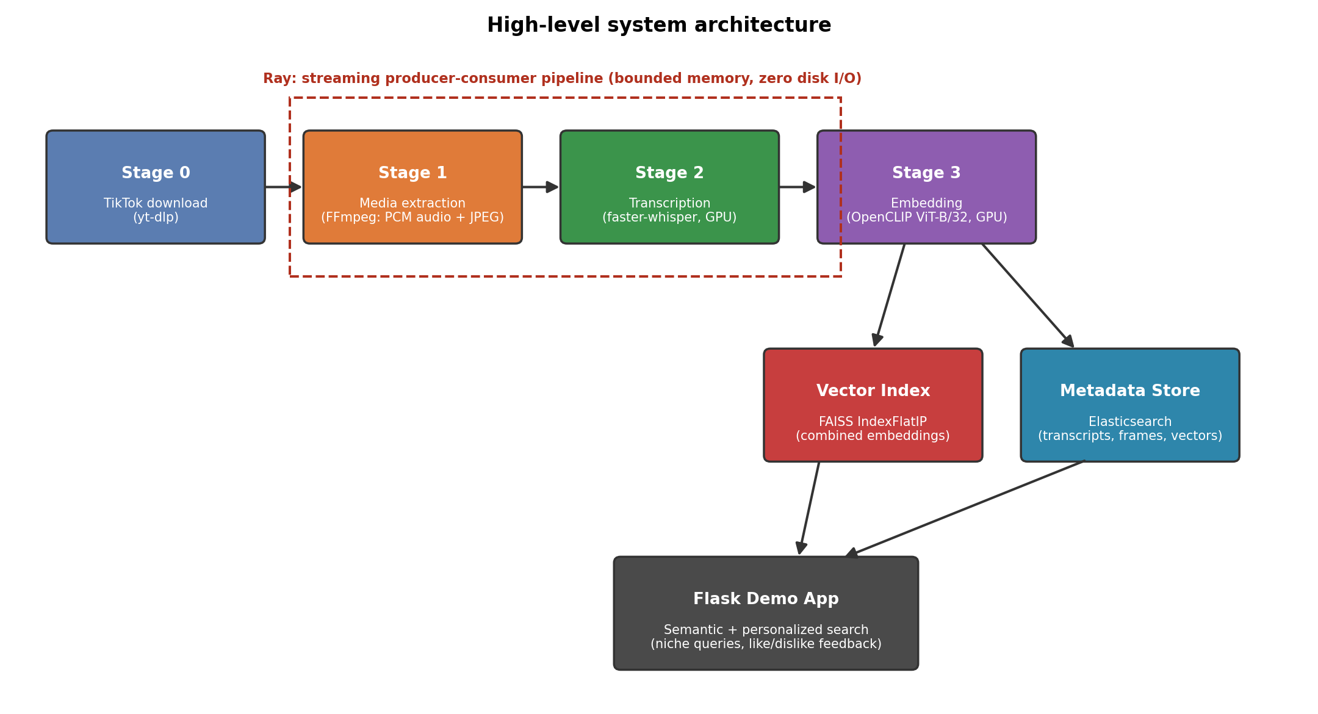
Fig. 4.1. High-level system architecture. Arrows indicate data flow. All stages execute within Ray's distributed task graph and overlap in time.
4.2 Data Collection
The dataset is constructed from a CSV of TikTok creator profiles. Creators are filtered to a minimum of 150,000 followers and at least 80 published videos, and the top 357 qualifying creators are selected. For each creator, up to three recent videos are downloaded using yt-dlp [19], which handles TikTok's anti-scraping measures through rotating user-agents and proxy support. Downloads are implemented as Ray remote tasks with up to four retries per video.
4.3 Stage 1: Media Extraction
For each video, Stage 1 runs two parallel FFmpeg pipes: (1) audio extraction — up to 180 seconds of audio (skipping the first second) is resampled to 16 kHz mono s16le PCM and kept as raw bytes in the Ray object store; and (2) frame extraction — one frame per second from the first 10 seconds is emitted as an MJPEG byte stream and parsed into up to 10 JPEG frames (224x224). Ten frames capture the opening visual identity of TikTok content (face, setting, intro card) while bounding CLIP compute. Stage 1 tasks are @ray.remote functions with num_cpus=1; worker count is configurable (benchmarked at 2, 4, 8, and 12).
4.4 Stage 2: Audio Transcription
Stage 2 transcribes in-memory PCM audio using faster-whisper small on GPU with batched inference (32 videos per Ray task, 16 audio chunks per GPU forward pass). The model is loaded once per Ray actor. Audio is limited to the first 180 seconds of each video. After all Whisper batches complete, the actor is shut down to release GPU memory before batched CLIP embedding begins.
4.5 Stage 3: Multimodal Embedding
Stage 3 generates a 512-dimensional embedding per creator using a GPUBatchEmbeddingActor. Creators are processed in batches of 8; all JPEG frames across the batch are decoded in memory and encoded together in GPU forward passes of 64 frames each (cross-creator batching). Per-frame image embeddings are L2-normalized and averaged per creator. Concatenated transcription text from all videos is encoded by the CLIP text encoder in batches of 32. The combined embedding is computed as:
z_creator = Normalize(0.85 * z_image + 0.15 * z_text)
FP16 (half-precision) inference is used throughout the GPU stage, halving memory consumption and increasing throughput on NVIDIA Tensor Core GPUs.
4.6 Vector Storage and Indexing
Two storage backends serve different query access patterns. FAISS (creators.index) provides a flat inner-product index over all creator embeddings, loaded into memory at application startup. For the corpus size of approximately 350 creators, flat exact search completes in under 1 ms per query. Elasticsearch stores all creator metadata, full transcription text, JPEG preview frames, and all three embedding vectors (image, text, combined) as Elasticsearch documents in the creator_transcriptions index. The combined_embedding field is declared as a dense_vector with 512 dimensions and cosine similarity. Persisting transcriptions and JPEG frames in Elasticsearch enables the Flask demo to render search results without re-reading source MP4 files, while supporting hybrid queries: follower-count filtering, full-text search on the transcription field, and vector similarity in a single API call.
4.7 Semantic Search Demo Application
The search application is a Flask web application providing a browser-accessible semantic creator search interface. The workflow is: (1) the user types a natural language query; (2) the CLIP text encoder converts the query to a 512-dimensional vector; (3) FAISS returns the top 10 creators by cosine similarity; (4) results are rendered with preview frames, creator username, and similarity score. The application simultaneously displays unpersonalized (standard FAISS) and personalized results side by side to demonstrate the effect of the personalization layer.
4.8 Personalized Search
Personalized search extends baseline retrieval with a feedback loop. Users mark results as liked or disliked; this feedback is stored in Elasticsearch with the query context, creator name, and timestamp. When a personalized query is executed, the system retrieves the top 30 FAISS candidates (3 times oversampling), loads the user's liked and disliked creators for the current query from Elasticsearch, and computes a personalized score:
score_p = 0.70 * score_FAISS
+ 0.25 * mean_sim(candidate, liked_creators)
- 0.25 * mean_sim(candidate, disliked_creators)
where mean_sim is the average cosine similarity between the candidate embedding and the set of liked or disliked creator embeddings. This soft reranking promotes candidates similar to previously liked creators and demotes those similar to disliked ones without requiring any model retraining.

5 Implementation
5.1 Technology Stack
Table 5.1 summarizes the key technologies and libraries used in the system.
Table 5.1. Technology stack.
Component | Technology | Version / Notes
Video download | yt-dlp | Latest stable
Media extraction | FFmpeg + ffmpeg-python | FFmpeg in-memory (PCM + JPEG)
Speech recognition | faster-whisper | Whisper small, float16, GPU (batched)
Visual embeddings | OpenCLIP ViT-B-32 | openai pretrained
Vector index (fast) | FAISS | faiss-cpu 1.12
Vector index (rich) | Elasticsearch | 8.x, 512-dim dense_vector
Distributed runtime | Ray | 2.9.3
Web application | Flask | 3.1
Deep learning | PyTorch + CUDA | 2.5.1, CUDA 12.1
Language | Python | 3.10+

5.2 Distributed Pipeline with Ray
The pipeline uses a bounded-memory producer-consumer design. Stage 1 submits FFmpeg extraction tasks; completed payloads (PCM + JPEG bytes) are buffered and flushed to Stage 2 in batches of 32 videos. Stage 2 returns per-video transcriptions; results are aggregated per creator and queued for Stage 3 in batches of 8 creators. Because Whisper and CLIP share one GPU, the Whisper actor is explicitly shut down before the CLIP actor is spawned. The main coordination loop uses ray.wait():
while s1_futures or s2_futures or s3_futures or s2_pending or s3_pending:
_fill_s2() # flush 32-video batches to Whisper
_maybe_flush_s2() # flush remainder when S1 done
done_s2, _ = ray.wait(list(s2_futures), timeout=0.1)
for f in done_s2:
result = ray.get(f)
_on_s2_result(result) # aggregate per creator, queue for S3
if s2_done and embedder is None:
embedder = _transition_s2_to_s3(whisper) # kill Whisper, spawn CLIP
_fill_s3() # submit 8-creator batches to CLIP
Audio PCM is released from the Ray object store after each Whisper batch; only transcription text and JPEG bytes are retained for embedding. Partial batches (fewer than 32 videos) are flushed when Stage 1 completes so no videos are left unprocessed.
5.3 Embedding Generation
The GPUBatchEmbeddingActor loads CLIP once at initialization and keeps it resident in GPU memory. JPEG bytes are decoded with torchvision and encoded in cross-creator batches. FP16 precision is used for all GPU inference:
@ray.remote(num_gpus=0.9)
class GPUBatchEmbeddingActor:
def embed_creators_batch(self, items: list[dict]) -> list:
# items: [{creator, text, frames: [jpeg_bytes, ...]}, ...]
# decode all JPEGs, encode_image() in batches of 64
# encode_text() in batches of 32
# return [(creator, img_emb, txt_emb), ...]
5.4 FAISS Index Construction
After all creator embeddings are computed, the FAISS index is built by stacking embedding vectors into a float32 NumPy array, normalizing for cosine similarity, and writing to disk:
vectors = np.stack(embeddings).astype('float32')
faiss.normalize_L2(vectors)
index = faiss.IndexFlatIP(512)
index.add(vectors)
faiss.write_index(index, 'creators.index')
At query time, the user's text query is encoded by CLIP, L2-normalized, and searched against the index in a single call returning scores and indices for the top-k creators.

5.5 Elasticsearch Integration
The indexing script creates an Elasticsearch index with three dense_vector fields:
'image_embedding': {'type': 'dense_vector', 'dims': 512,
'index': True, 'similarity': 'cosine'},
'text_embedding': {'type': 'dense_vector', ...},
'combined_embedding': {'type': 'dense_vector', ...}
For each creator the indexing script stores the full transcription text, JPEG preview frames, image/text/combined embeddings (512-dim dense_vector fields), and profile metadata (follower count, video count) in the creator_transcriptions index. User feedback interactions are stored in a separate user_interactions index, enabling the personalization layer to retrieve liked and disliked creators per user per query context.
5.6 Flask Demo Application
The Flask application serves as the user-facing demonstration. It is stateless at the application level: all persistent state is stored in Elasticsearch. Three routes handle the workflow: /login provides session authentication; /demo handles search queries, runs both unpersonalized and personalized FAISS searches, and renders results with frame previews; and /feedback is a JSON API endpoint that persists liked or disliked creator feedback to Elasticsearch. JPEG preview frames and transcriptions are loaded from the creator_transcriptions Elasticsearch documents when rendering search results.
5.7 Multi-Server Scalability
The most important architectural decision is the use of Ray as the distributed runtime. The full pipeline — downloads, extraction, transcription, and embedding — runs inside Ray remote tasks and actors. On a single machine, Ray is initialized with os.cpu_count() CPUs and 1 GPU. To extend to multiple servers, the head node is started with ray start --head and worker nodes join with ray start --address='<HEAD_IP>:6379'. The application code changes by exactly one line:
# Single machine:
ray.init(num_cpus=os.cpu_count(), num_gpus=1)
# Multi-server cluster:
ray.init(address='auto')
Ray's scheduler distributes @ray.remote tasks across all registered nodes. The num_cpu_workers parameter then represents the total CPU count across all machines. Source MP4 files must reside on a shared NFS network drive or object storage (MinIO or S3) accessible from all nodes at the same path. Intermediate audio and frames stay in the Ray object store during processing; persistent transcriptions and JPEG previews are written to Elasticsearch after the run.

6 Evaluation and Results
6.1 Dataset
The dataset was collected from TikTok's public creator ecosystem over multiple sessions. Creators were filtered to a minimum of 150,000 followers and at least 80 published videos to ensure content richness. Up to three videos per creator were downloaded. Table 6.1 summarizes the dataset statistics.
Table 6.1. Dataset statistics.
Metric | Value
Total creators | 357
Videos per creator | Up to 3
Total videos (large-scale run) | 1,000
Minimum followers (filter) | 150,000
Frames per video | Up to 10 JPEG (first 10 s, 1 fps)
Audio format | 16 kHz mono PCM (max 180 s)
Embedding dimensionality | 512 (CLIP ViT-B-32)

6.2 Scalability Benchmark
The scalability of the concurrent Ray pipeline was measured by running the full three-stage pipeline on 20 creators (50 videos total) while varying CPU workers from 2 to 12. Table 6.2 reports wall-clock time, per-stage averages, speedup, and CPU utilization.
Table 6.2. Concurrent Ray pipeline scalability benchmark (20 creators, 50 videos).
CPU Workers | Stage 2 avg (s) | Stage 3 avg (s) | Total wall (s) | Speedup | Avg CPU %
2 | 0.43 | 0.33 | 84.58 | 1.00x | 28.5%
4 | 0.42 | 0.32 | 70.06 | 1.21x | 32.6%
8 | 0.41 | 0.28 | 65.29 | 1.30x | 37.3%
12 | 0.42 | 0.32 | 65.29 | 1.30x | 39.1%
Note: GPU memory column not shown; Whisper and CLIP actors were executed using GPU acceleration during this benchmark.
Increasing CPU workers from 2 to 12 reduces total wall-clock time from 84.6 s to 65.3 s, achieving a 1.30 times speedup. Sub-linear scaling is expected: while Stage 1 benefits from additional CPU workers, the GPU-based inference stages (Whisper transcription and CLIP embedding generation) remain limited by available GPU resources. Furthermore, Ray scheduling overhead and communication between pipeline stages reduce the efficiency gained from additional workers, especially for smaller workloads.
After 8 CPU workers, the performance improvement becomes minimal, indicating that the pipeline shifts from CPU-bound video extraction toward GPU inference and synchronization overhead. In a larger multi-GPU cluster, additional GPU actors could be deployed to parallelize the inference stages and achieve higher scalability.
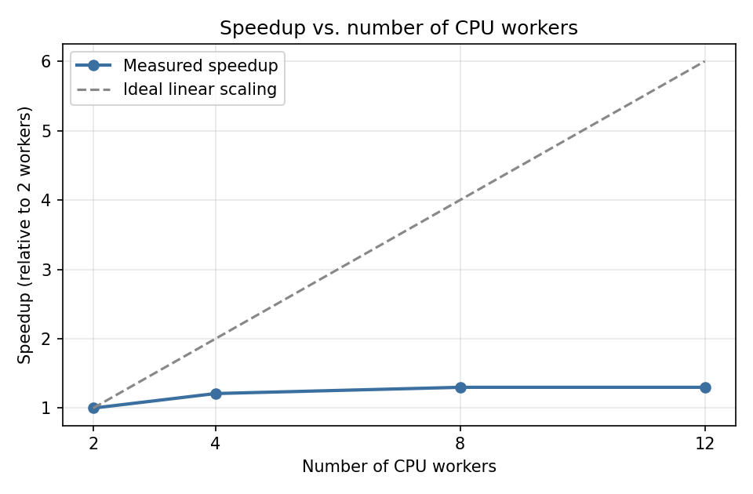
Fig. 6.1. Speedup vs. number of CPU workers. The dashed line represents ideal linear scaling. The measured speedup follows a sub-linear trend due to GPU inference bottlenecks, Ray scheduling overhead, and pipeline synchronization costs.
6.3 Large-Scale Run (1,000 Videos)
To validate the scalability of the pipeline on a larger dataset, the complete three-stage Ray pipeline was executed on 1,000 TikTok videos collected from 357 creators. The experiment varied the number of Stage-1 FFmpeg CPU workers among {2, 4, 8, 12}, while GPU Whisper transcription and CLIP embedding used the batched single-GPU lifecycle described in Chapters 4–5. Table 6.3 compares the best 50-video configuration (8 workers) with the best 1,000-video configuration (also 8 workers).
Table 6.3. Large-scale pipeline scalability results (1,000 videos, 357 creators).
Metric | Small scale (50 videos) | Large scale (1,000 videos)
Total videos | 50 | 1,000
Total creators | 20 | 357
Total wall time | 65.29 s | 544.02 s (9.1 min)
Throughput (vid/s) | 0.77 | 1.84
Speedup vs 2 workers | 1.30x | 1.94x
Stage 2 avg (Whisper) | 0.41 s/video | 0.45 s/video
Stage 3 avg (CLIP) | 0.28 s/creator | 0.14 s/creator

At 1,000 videos the pipeline reaches 1.84 videos/s and finishes in 9.1 minutes (544 s), a 1.94x wall-clock speedup over the 2-worker baseline (1,058 s). The 50-video run shows lower throughput (0.77 videos/s) mainly because fixed initialization costs — Ray actor startup, GPU initialization, model loading, and CUDA warm-up — are amortized over fewer videos. Stage-2 and Stage-3 active times scale roughly with workload size (Whisper ~0.43–0.45 s/video on average; CLIP ~0.14–0.28 s/creator). Part of the evaluation used a two-node Ray cluster of laptops connected over Wi-Fi; network transfer of intermediate objects limited further gains when adding remote CPU workers. In a cloud deployment with colocated compute and storage, this communication bottleneck would be substantially reduced.
Overall, the large-scale run confirms that 8 Stage-1 workers are the sweet spot on this hardware: 12 workers do not improve wall-clock time further (599.7 s, 1.76x) due to Ray scheduling overhead and CPU contention.

6.4 Search Quality
To quantify the impact of personalization, the system was evaluated on five distinct niches. For each niche, a representative query was run under both standard and personalized search modes, and the number of relevant creators within the Top-10 results was recorded before and after feedback. Precision and improvement were then computed for each niche.

Table 6.4. Per-niche comparison of standard and personalized search results.
Niche | Query | Relevant (Standard) | Relevant (Personalized) | Precision  (Personalized) | Improvement
Makeup | Makeup creators | 4/10 | 8/10 | 0.8 | +100%
Fitness | Fitness | 4/10 | 6/10 | 0.6 | +50%
Cooking | Cooking | 5/10 | 9/10 | 0.9 | +80%
Fashion | Fashion | 3/10 | 6/10 | 0.6 | +100%
Tech | Tech | 3/10 | 7/10 | 0.7 | +133%
Average | - | 3.8/10 | 7.2/10 | 0.72 | +92.6%

Personalization consistently increased Top-10 relevance across all five niches. On average, relevant creators in the Top-10 rose from 3.8 to 7.2, with an average precision of 0.72 and an average improvement of +92.6%. The largest gains appeared in Tech (+133%) and Makeup/Fashion (+100% each), while Fitness showed the smallest improvement (+50%). These results confirm hypothesis H3 (Section 1.5): personalized re-ranking improved Precision@10 in every tested niche.
A common pattern was semantic overlap between related sub-categories. For instance, "makeup creators" often surfaced cosplay creators in baseline results, since cosplay involves heavy makeup application. By marking cosplay results as "Bad," the system learned to suppress them for this query. A similar effect occurred in Fitness, where broad matches included posing or modeling content rather than gym or workout videos; negative feedback helped the system refine results toward the user's actual intent.
6.5 Embedding Configuration and Clustering Analysis
Section 6.4 measured the effect of personalization on the deployed 0.85/0.15 (image/text) embedding configuration. This section instead tests hypothesis H1 (Section 1.5) by comparing five visual/text weighting configurations directly: visual-only (1.00/0.00), text-only (0.00/1.00), 50/50, the deployed 85/15, and 15/85. For each configuration, the five niche queries (makeup, fitness, cooking, fashion, tech) were run against a dedicated FAISS index built from that configuration's combined embeddings, and the top-10 results were manually labeled as relevant or not relevant. Table 6.5 reports the resulting average Precision@10 per configuration, alongside the existing 0.85/0.15 validation numbers derived from the good/bad creator feedback previously collected through the Flask demo application, for direct comparison. Both this comparison and the clustering analysis below use every creator with a valid, non-empty combined embedding (n = 324 of the full 357-creator corpus); the remaining 33 creators had transcriptions too short or too repetitive to pass a minimum-content quality filter applied during embedding generation and were excluded from indexing entirely, for all five configurations alike, including visual-only.
Table 6.5. Average Precision@10 by embedding configuration.
Configuration | Avg. Precision@10
visual_only (1.00 / 0.00) | 0.48
text_only (0.00 / 1.00) | 0.04
50 / 50 | 0.04
85 / 15 (deployed) | 0.28
15 / 85 | 0.04
85 / 15 (existing, ES feedback) | 0.64
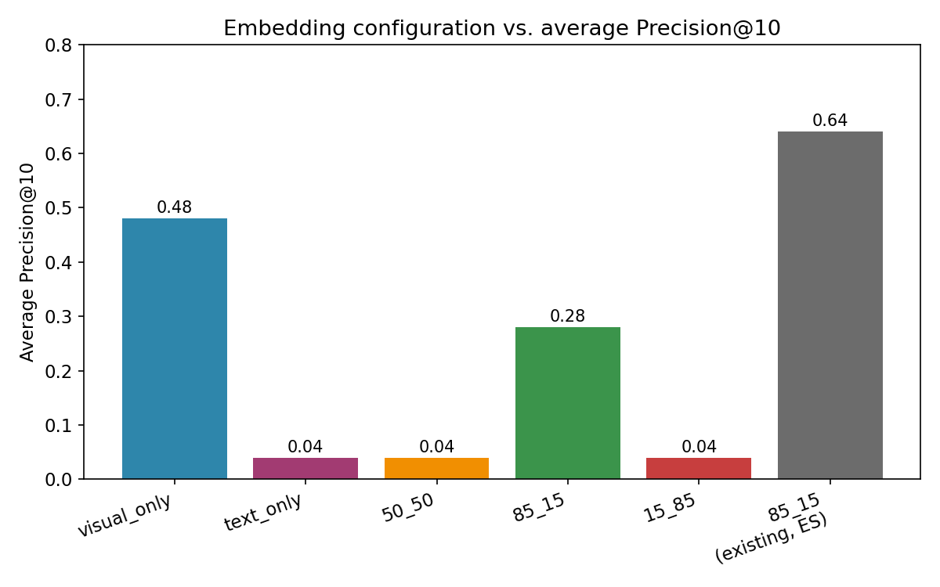
Fig. 6.2. Average Precision@10 across the five embedding configurations, compared with the existing 0.85/0.15 validation results.
Contrary to hypothesis H1, the purely visual configuration (1.00/0.00) achieved the highest average Precision@10 (0.48) among the five tested configurations, clearly exceeding the deployed 85/15 configuration (0.28); the text-only and text-heavy configurations (0.00/1.00 and 0.15/0.85) performed substantially worse (0.04 each), and the balanced 50/50 blend also underperformed the visual-only configuration (0.04). Hypothesis H1 is therefore not confirmed by this experiment: combining modalities did not outperform the best single modality. Relevance for this measurement was judged by directly inspecting a representative frame from each retrieved creator's video together with its transcription, rather than defaulting unlabeled results to “not relevant” as in earlier passes, giving a more reliable precision estimate.
The existing 0.85/0.15 validation result (0.64) remains considerably higher than the freshly measured value for the same configuration (0.28); Fig. 6.2 reports this historical figure directly rather than a freshly computed one, since Elasticsearch click-feedback from the Flask demo this round covered only two of the five test queries (makeup and cooking, each showing precision@10 = 0.20), too sparse for a reliable five-query average. The remaining gap between the historical and freshly measured 85/15 figures is best explained by the two evaluations testing different retrieved-creator subsets, and by the historical figure being based on a small, self-selected sample of results the user had already seen and liked; it should not be read as evidence that search quality has degraded.
A natural concern is that this result merely reflects poor transcription quality rather than a genuine limitation of the text modality. Manual inspection of the Whisper outputs, prompted by observed anomalies such as spurious Welsh phrases and severe truncation on clearly audible speech, revealed five implementation bugs: (1) greedy decoding (beam size 1) with no repetition penalty caused the model to loop on short phrases or drift into an incorrect language on ambiguous or musical audio; (2) the language tokenizer was cached per worker process rather than re-detected per video, so a single misdetected video could contaminate every subsequent video processed by the same worker; (3) audio chunking relied on a voice-activity-detection helper that produced empty or malformed chunks, silently discarding most of a video's audio beyond the first segment; (4) segment-level quality filters (no-speech, log-probability, and compression-ratio thresholds) were computed but never actually applied in the batched inference path; and (5) disabling timestamps to speed up decoding caused severe truncation on videos with continuous, non-silent speech. All five were fixed — beam size 5 with a repetition penalty of 1.3 and a 3-gram repeat block, per-item multilingual re-detection, fixed-size 30-second non-overlapping windows in place of the VAD helper, the quality filters applied in batched mode, and timestamps re-enabled — and the full pipeline was re-run on all 357 creators and 948 videos (the videos present on disk at the time of this later re-run, slightly fewer than the 1,000 used for the Section 6.3 scalability benchmark). The effect was substantial: the number of creators with Welsh-hallucinated transcripts dropped from 190/357 to 1/357. Re-running the Task 1 evaluation on the resulting embeddings did not change the conclusion, however — the purely visual configuration remained the clear winner (0.48 vs. 0.28 for 85/15). This indicates that the weak contribution of text embeddings is not primarily a transcription-quality artifact: even among the 324 creators whose transcriptions were clean and did contain meaningful speech, that speech frequently describes background music, jokes, or unrelated commentary rather than the video's visual subject, so the transcript adds limited topical signal regardless of transcription accuracy.
To avoid ambiguity across sections: the 0.72 average precision reported in Section 6.4 measures Top-10 relevance after personalized re-ranking, a different and easier task than raw retrieval; the 0.64 and 0.28 values above both describe non-personalized retrieval on the same 85/15 configuration but differ in methodology, since 0.64 is derived from previously accumulated Elasticsearch feedback while 0.28 comes from a fresh, controlled manual relabeling of a newly built index. These three figures are therefore not directly comparable and should not be read as contradictory evidence of degraded search quality.
Using the best-performing configuration from this experiment (visual-only), all 324 creators with valid embeddings (see Section 6.5 introduction) were grouped with agglomerative hierarchical clustering under cosine distance, testing between 3 and 15 clusters and scoring each with the silhouette coefficient. An initial run using average linkage exhibited a well-known pathology: at every tested cluster count, the algorithm split off a single outlier creator rather than forming meaningful groups, which trivially inflates the silhouette score for an isolated point. Ward linkage was used instead — equivalent to cosine-based clustering on the unit-normalized embeddings used throughout this thesis, since ‖u − v‖² = 2(1 − cos_sim(u, v)) for unit vectors — which avoids this chaining behavior. Table 6.6 and Fig. 6.3 report the resulting silhouette scores.
Table 6.6. Silhouette score by number of clusters (k), Ward linkage, cosine-distance scoring.
k | Silhouette score
3 | 0.0621
4 | 0.0779
5 | 0.0806
6 | 0.0814
7 | 0.0736
8 | 0.0815
9 | 0.0882
10 | 0.0939
11 | 0.0651
12 | 0.0619
13 | 0.0645
14 | 0.0683
15 | 0.0726
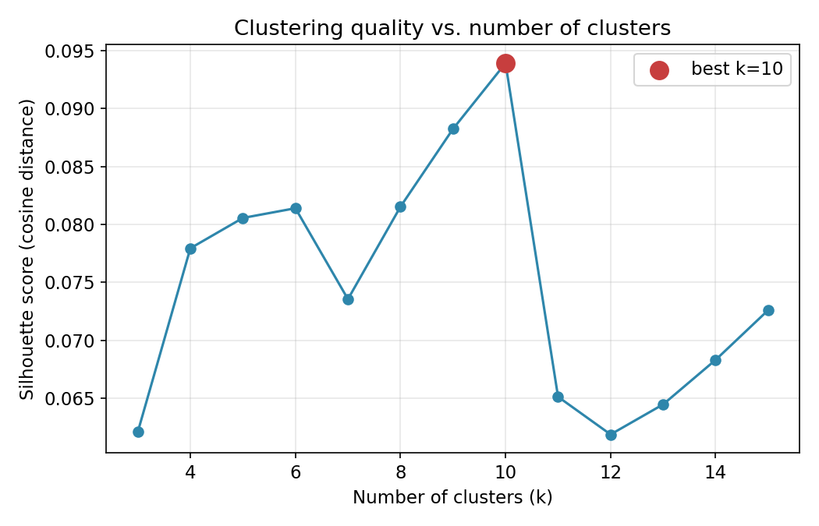
Fig. 6.3. Silhouette score as a function of the number of clusters (k).
The silhouette score is maximized at k = 10 (0.0939), yielding ten clusters of size 72, 45, 49, 42, 14, 15, 39, 13, 30, and 5 creators (Fig. 6.4, Fig. 6.5); every candidate k between 3 and 15 produced clusters of at least 5 creators, so this maximum is not an artifact of a degenerate single-outlier split. Absolute silhouette values in the 0.06-0.09 range are modest, which is expected: CLIP visual embeddings were not trained to separate TikTok content niches specifically, so cluster boundaries are soft rather than sharply delineated. Nevertheless, the clustering captures statistically real structure: for each of the five test queries, between 30% and 70% of the top-10 search results fall into a single dominant cluster (Fig. 6.6), well above the roughly 10% expected by chance with ten clusters of these sizes. This confirms hypothesis H2: although H1 was not confirmed for the search-relevance metric, the underlying visual embedding space does organize creators into semantically meaningful groups that align with the tested query niches.
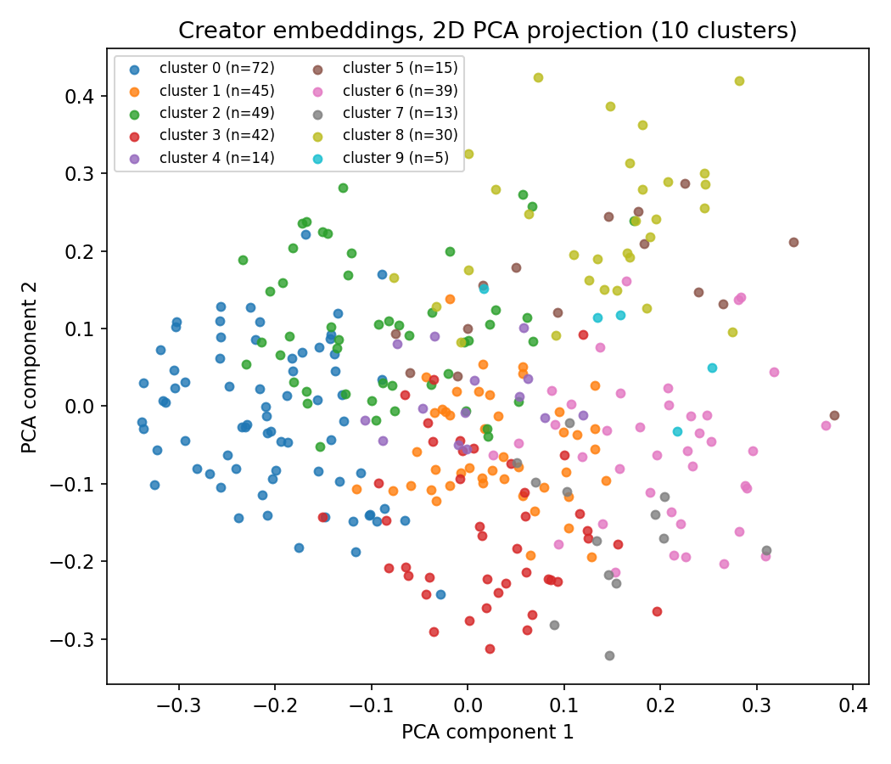
Fig. 6.4. 2D PCA projection of creator embeddings, colored by cluster (k = 10).
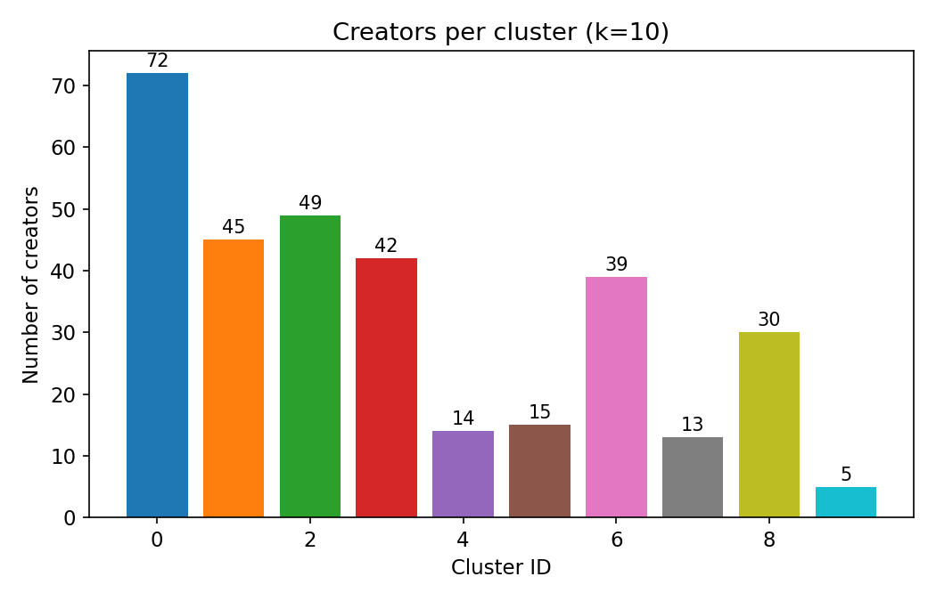
Fig. 6.5. Number of creators per cluster (k = 10).
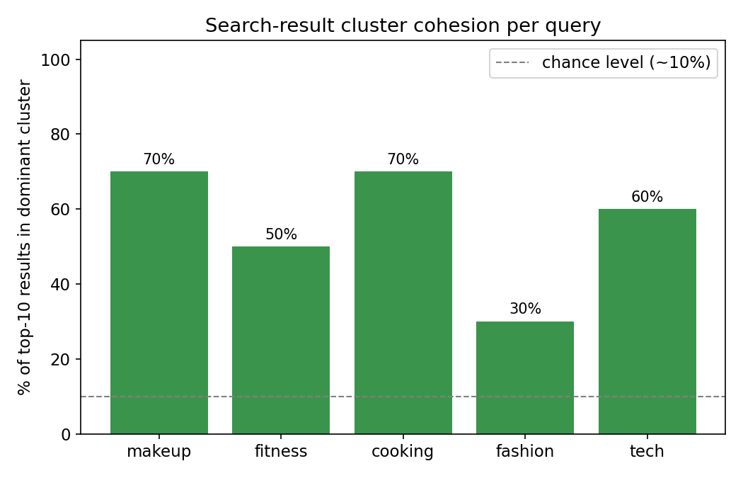
Fig. 6.6. Percentage of top-10 search results sharing the dominant cluster, per query.

7 Conclusion and Future Work
7.1 Conclusion
This thesis presented a scalable multimodal pipeline for analyzing TikTok videos at scale using vector representations and semantic similarity search. The system addresses the challenge of making large collections of short-form videos semantically searchable without cloud API costs or labeled training data.
The pipeline achieves three goals simultaneously: it is fast (1,000 videos in 9.1 minutes at 1.84 videos/s), cheap (runs on a single consumer GPU workstation), and scalable (horizontally distributable with a single configuration change using Ray). The multimodal embedding scheme combines CLIP image embeddings from in-memory JPEG frames with CLIP text embeddings from Whisper transcriptions. Vectors are stored in FAISS for sub-millisecond search; transcriptions, JPEG previews, and embeddings are stored in Elasticsearch for hybrid metadata queries and the Flask demo.
The Flask demo application demonstrates that the resulting vector index enables natural language queries over 357 TikTok creators, with personalized reranking based on user feedback stored in Elasticsearch. Human evaluation shows consistently relevant top-10 retrievals across diverse query categories, confirming hypothesis H3: personalization improved Precision@10 in every tested niche (average 3.8/10 to 7.2/10, +92.6%). The key technical contribution is the streaming Ray actor pipeline design with batched GPU Whisper (small model, 180 s audio cap) and batched CLIP embeddings, achieving 1.94x wall-clock speedup when scaling Stage-1 workers from 2 to 8, with documented multi-node deployment requiring minimal code changes.
Section 6.5 additionally tested hypothesis H1 (Section 1.5) by comparing five visual/text embedding weightings; contrary to expectations, the purely visual configuration outperformed all other weightings, including the deployed 85/15 configuration (0.48 vs. 0.28 average Precision@10), so H1 was not confirmed within the scope of this evaluation. Fixing five underlying Whisper transcription bugs (decoding repetition loops, per-worker language caching, broken audio-chunk windowing, unapplied quality filters, and timestamp-related truncation) and re-running the full evaluation on freshly generated embeddings did not change this conclusion, indicating the result reflects a genuine content mismatch between spoken audio and visual topic rather than a transcription-quality artifact. A complementary clustering analysis confirmed hypothesis H2: despite modest silhouette scores, the resulting embedding space still groups creators in a way that aligns with query intent (30-70% of top-10 results sharing a common cluster per query, well above chance). Taken together, these findings suggest that TikTok content in this domain is primarily visually driven, and that Whisper-transcription-derived text embeddings should be treated as a secondary, noisier signal rather than an equal partner to the visual signal.
7.2 Future Work
Several directions for future improvement are identified:
• Larger CLIP models: upgrading from ViT-B-32 (512 dimensions) to ViT-L-14 (768 dimensions) or larger OpenCLIP variants has been shown to substantially improve retrieval quality [20] at the cost of higher memory and compute.
• Temporal modeling: the current embedding averages up to 10 frames, discarding temporal order. Using video-specific transformers such as VideoMAE [21] or TimeSformer [22] to model the sequence of frames would capture motion, pacing, and editing style.
• Real-time indexing: the current pipeline is batch-oriented. A real-time extension would monitor new videos from tracked creators and update FAISS and Elasticsearch indices incrementally as new content is published.
• Larger multi-server benchmark: this thesis includes a two-node Wi-Fi cluster experiment (§6.3), but a follow-up study on a 4 to 8 node high-bandwidth cluster would better quantify horizontal scaling efficiency without wireless network bottlenecks.
• Explainability: adding attention-weighted frame visualization to highlight the frames most influential for a retrieval result would improve user trust and reveal the visual features defining a creator's style.
• Larger-scale relevance evaluation: the Section 6.5 Precision@10 comparison is based on 50 judgments per configuration (5 queries × 10 results), now judged by directly reviewing a video frame and transcription per retrieved creator rather than defaulting unlabeled rows to “not relevant”; a larger and more diverse query set, ideally with multiple independent annotators, would further strengthen the statistical reliability of the embedding-weighting comparison.
• Stronger clustering validation: the silhouette scores obtained in Section 6.5 (0.06-0.09) are modest by conventional standards; future work could explore domain-adapted or fine-tuned visual embeddings, alternative distance metrics, or supervised niche labels to obtain more clearly separated clusters.

References
[1] Montag, C., Yang, H., and Elhai, J. D. (2021). On the psychology of TikTok use: A first glimpse from empirical findings. Frontiers in Public Health, 9, 641673.
[2] Zhao, J., Wang, S., et al. (2023). Multimodal short video rumor detection system based on contrastive learning. arXiv:2304.08401.
[3] Omar, B. and Dequan, W. (2020). Watch, share or create: The influence of personality traits and user motivation on TikTok mobile video usage. International Journal of Interactive Mobile Technologies, 14(4).
[4] Wei, Y., Wang, X., Nie, L., He, X., Hong, R., and Chua, T.-S. (2019). MMGCN: Multi-modal graph convolution network for personalized recommendation of micro-video. In Proceedings of ACM Multimedia 2019.
[5] Radford, A., Kim, J. W., Xu, T., Brockman, G., McLeavey, C., and Sutskever, I. (2023). Robust speech recognition via large-scale weak supervision. In Proceedings of ICML 2023.
[6] Klein, G. / SYSTRAN (2023). faster-whisper: Fast Whisper transcription using CTranslate2. GitHub. https://github.com/SYSTRAN/faster-whisper
[7] Baevski, A., Zhou, H., Mohamed, A., and Auli, M. (2020). wav2vec 2.0: A framework for self-supervised learning of speech representations. In Advances in NeurIPS 2020.
[8] Radford, A., Kim, J. W., Hallacy, C., et al. (2021). Learning transferable visual models from natural language supervision. In Proceedings of ICML 2021.
[9] Ilharco, G., Wortsman, M., Wightman, R., et al. (2021). OpenCLIP. Zenodo. https://doi.org/10.5281/zenodo.5143773
[10] Li, J., Selvaraju, R., Gotmare, A., et al. (2021). Align before fuse: Vision and language representation learning with momentum distillation. In Advances in NeurIPS 2021.
[11] Johnson, J., Douze, M., and Jegou, H. (2021). Billion-scale similarity search with GPUs. IEEE Transactions on Big Data, 7(3), 535-547.
[12] Malkov, Y. A. and Yashunin, D. A. (2018). Efficient and robust approximate nearest neighbor search using hierarchical navigable small world graphs. IEEE Transactions on Pattern Analysis and Machine Intelligence, 42(4), 824-836.
[13] Elasticsearch B.V. (2024). Dense vector field type. Elasticsearch Reference 8.x. https://www.elastic.co/guide/en/elasticsearch/reference/current/dense-vector.html
[14] Karpukhin, V., Oguz, B., Min, S., et al. (2020). Dense passage retrieval for open-domain question answering. In Proceedings of EMNLP 2020.
[15] Moritz, P., Nishihara, R., Wang, S., et al. (2018). Ray: A distributed framework for emerging AI applications. In Proceedings of OSDI 2018.
[16] Romero, F., Li, Q., Yadwadkar, N. J., and Kozyrakis, C. (2021). INFaaS: Automated model-less inference serving. In Proceedings of USENIX ATC 2021.
[17] Dean, J. and Ghemawat, S. (2008). MapReduce: Simplified data processing on large clusters. Communications of the ACM, 51(1), 107-113.
[18] Baltrusaitis, T., Ahuja, C., and Morency, L.-P. (2019). Multimodal machine learning: A survey and taxonomy. IEEE Transactions on Pattern Analysis and Machine Intelligence, 41(2), 423-443.
[19] yt-dlp contributors (2024). yt-dlp: A feature-rich command-line audio/video downloader. https://github.com/yt-dlp/yt-dlp
[20] Cherti, M., Beaumont, R., Wightman, R., et al. (2023). Reproducible scaling laws for contrastive language-image learning. In Proceedings of CVPR 2023.
[21] Tong, Z., Song, Y., Wang, J., and Wang, L. (2022). VideoMAE: Masked autoencoders are data-efficient learners for self-supervised video pre-training. In Advances in NeurIPS 2022.
[22] Bertasius, G., Wang, H., and Torresani, L. (2021). Is space-time attention all you need for video understanding? In Proceedings of ICML 2021 (TimeSformer).
[23] Dosovitskiy, A., Beyer, L., Kolesnikov, A., et al. (2021). An image is worth 16x16 words: Transformers for image recognition at scale. In Proceedings of ICLR 2021.
[24] Reimers, N. and Gurevych, I. (2019). Sentence-BERT: Sentence embeddings using Siamese BERT-networks. In Proceedings of EMNLP 2019.

