To launch the application you will may need to add libraries in the build path from the “/lib” folder. The application is launched by simple compilation of the main Java class “App.java”.

Once the app is running the following message will pop up in the console:

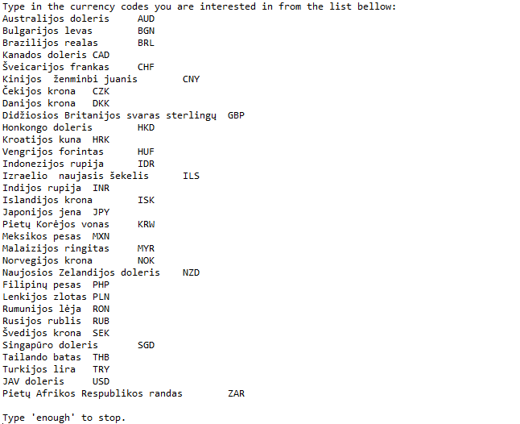

Then you should type in one by one the currency codes and then type in word “enough” to stop. When this done the following dates input request will pop up (with input example):

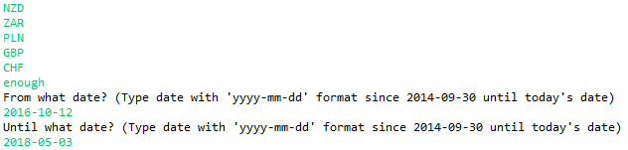

After entering dates, the program will do its job with subsequent output (example):

