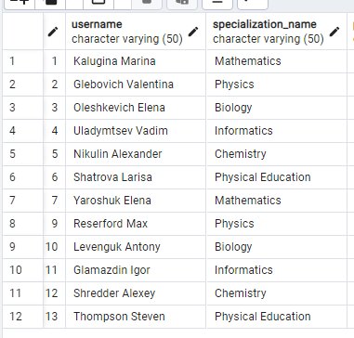

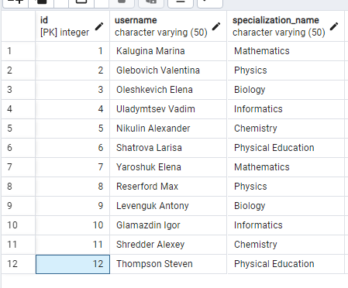

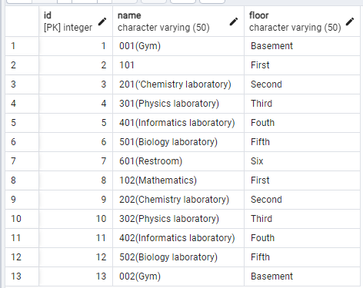

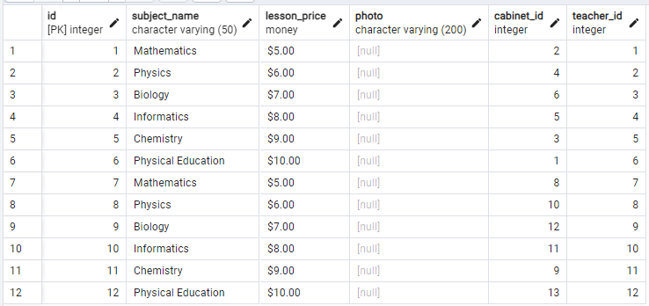

1:1,2,4,6

2: 3, 5, 6

|  |  |  |  |  |  |
| --- | --- | --- | --- | --- | --- |
|  | Monday | Tuesday | Wednesday | Thursday | Friday |
| 9:00 | 1Math | 3Biol | 1Math | 3Biol | 1Math |
| 10:00 | 2Phys | 4Infor | 2Phys | 4Infor | 2phys |
| 11:00 | 6PE |  |  |  |  |
|  |  |  |  |  |  |
|  |  |  |  |  |  |

2Group

|  |  |  |  |  |  |
| --- | --- | --- | --- | --- | --- |
|  | Monday | Tuesday | Wednesday | Thursday | Friday |
| 9:00 |  | 3biol |  | 3Biol |  |
| 10:00 |  | 5Chemistry |  | 5Chemistry |  |
| 11:00 | 6PE |  |  |  |  |

3Group

|  |  |  |  |  |  |
| --- | --- | --- | --- | --- | --- |
|  | Monday | Tuesday | Wednesday | Thursday | Friday |
| 9:00 | 8Phys | 10Informatics | 8Phys | 10Informatics | 8Phys |
| 10:00 | 7Math | 9Biol | 7Math | 9Biol | 7Math |
| 11:00 | 12PE | 11Chemisty | 10Informatics | 11Chemistry | 12PE |

