1.AlienEncountersRUSBYLYAJKA



1. AmericanDAD!

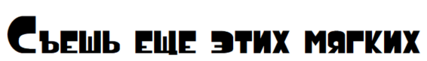

3.Astrocyr-lat

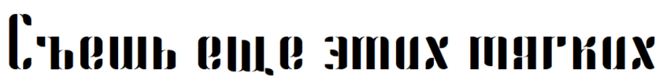

4.CaesarDressingCyrillic

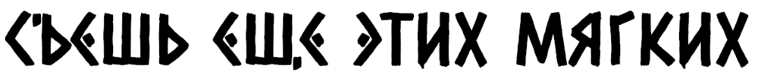

5.Carbon2



6.CARbonedFONTBYLYAJKA



7.CCHellshockRUSBYLYAJKA

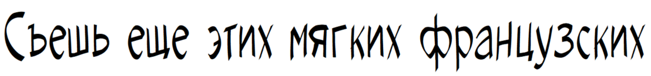

8.ColdNightforAlligators



9.Dr.PoGothicRu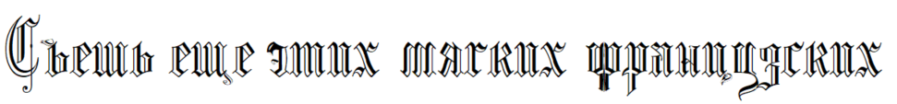

10.EchoRevival



11.Facon-BoldItalic



12.File-Bold



13.FuturesporeCyrillic



14.Gasrux



15.HappySpratCyrillic2



16.HoneyScriptCYR-Light

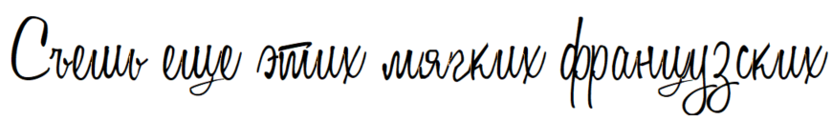

17.KashimaRUSbyCop



18.Mak-Bold



19.mr_DopestyleG



20.mr_HangingLettersG



21.mr_KindlyJasmineG



22.mr_ReaverockG



23.NekomancerATH0.3



24.NoNaMeClassic



25.Remains



26.Roadshow



27.RobotronDotMatrix



28.SPSLSten-Plain



29.StreamsterRUSBYLYAJKA

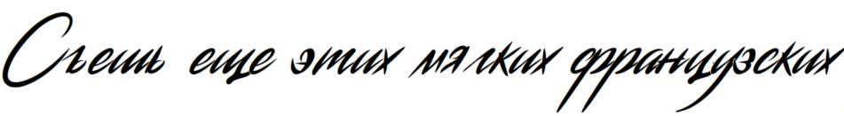

30.TheVoiceFont



31.ThisNight



32.TrixiePro-Heavy



33.UmbraTL



34.UnicephalonCyrillic



35.void-bold



36.AmericanCaptainCyrillic



37.Amethyst



38.AndesNormal



39.AndroidKG



40.AOTYPEcyr-lat



41.Architectural-Regular

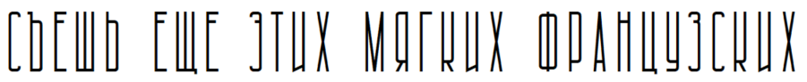

42.BlackStarFJNTBYLYAJKA



43.Bodoni



44.BroadwayEngravedRUSBYLYAJKA



45.byboryaaa



46.Cinzel-Bold



47.Cinzel-Regular



48.d_DueDate



49.EFNZepsutaMaszyna



50.EnglishRose



51.Fabryka4FMedium



52.HellenicWideJF-Regular



53.Kinkie



54.L&CHairlineHQ



55.Lato-Regular



56.MariageAntD



57.MasterCardDi



58.MerkurCyrillic



59.MightMakesRightBB



60.Monoton-Regular



61.mr_ApexMk3-ExtraLight



62.mr_ApexMk3-Medium



63.mr_ArenqG



64.mr_BelladonaStencilG



65.mr_PotraLightG-Light



66.MysteryDiItalic



67.NationalyzeALP



68.OpenSans



69.P22ArtsAndCrafts



70.PostmodernOne



71.Roboto-Regular



72.RodeoKoncev-Regular

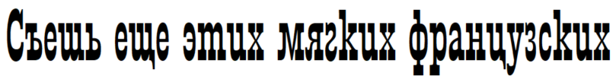

73.SpaceAgeCyrillic-Regular



74.TannenbergFett



75.Thintel



76.Zelek-Bold

