**AT, IN, ON – PREPOSITIONS OF TIME**

Use *at* with *times of day*, including mealtimes, bedtime, etc.

**at** 3 o’clock

***at*** 10.30 am

***at*** noon

***at*** dinnertime

***at*** bedtime

***at*** sunrise

***at*** sunset

***at*** the moment

Use *in* with *months, seasons, years, decades, centuries and long periods* **of time in general**

**in** May

***in*** the summer

***in*** 1990

***in*** the 1990s

***in*** the 20th century

***in*** the Ice Age

***in*** the past/future

Use *on* followed by **days and dates**

**on** Sunday

***on*** Tuesday mornings

***on*** 6 March

***on*** 25 December 2010

***on*** Christmas Day

***on*** Independence Day

***on*** my birthday

***on*** New Year’s Eve

Also, use *at* in the following **common *expressions***

***at****the weekend: I don’t usually work****at****the weekend.*

***at****Christmas/Easter: I stay with my family****at****Christmas.*

***at****the same time****:****We finished the test****at****the same time.*

***at****present/****at****the moment****:****He’s not home****at****present. Try later.*

***Parts*** of the ***day***

***in****the morning*

***in****the afternoon*

***in****the evening*

***but***

***at****night*

***last, next, every and this***

When we say **last, next, every, this** we ***do not use at, in, on***.

*I went to London* ***last*** *June. (NOT in last June)*

*He’s coming back* ***next*** *Tuesday. (NOT on next Tuesday)*

*I go home* ***every*** *Easter. (NOT at every Easter)*

*We’ll call you* ***this*** *evening. (NOT in this evening)*

***in five minutes / in a few days / in six weeks / in two years etc.***

*Hurry! The train leaves* ***in five minutes***

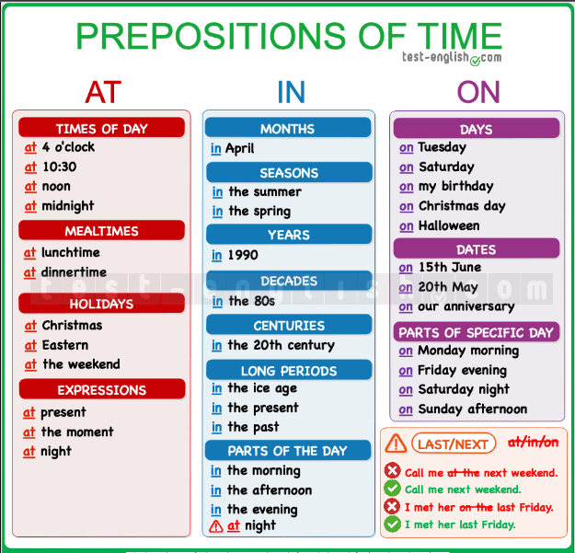*Bye! I'll see you* ***in a few days***

**AT, IN, ON – PREPOSITIONS OF PLACE**

**AT**

***at a point***

*We use* ***at*** *to refer to a point near something:*

*Can you see that car at the traffic light? (===The car is at a point near the traffic light)*

*Who is that man at the door? (===The man is at a point near the door)*

***at the top of/at the bottom of/at the end of***

*We use* ***at*** *in the expressions at the top of, at the bottom of and at the end of:*

*She is at the top of the stairs.*

*Please, sign at the bottom of the page.*

*The new café is at the end of the street.*

***Group activities***

*We use* ***at*** *to refer to group activities like parties, concerts, and other events:*

*We were at the cinema.*

*I didn’t see you at Jackie’s party.*

*We met at a concert.*

***at + school/university/college***

*We normally use* ***at*** *with school, university and college:*

*He is at school every morning until 12.*

*I’m studying at Oxford University.*

***be at home/work***

*We say be* ***at home/at work*** *(without the):*

*She’s at home. (NOT at the home)*

*I’ll be at work all morning. (NOT at the work)*

***at the shop***

*We use* ***at*** *to refer to shops, restaurants, cafés, etc.:*

*I’m at the bakery.*

*If you are at the chemist’s, can you buy some aspirins?*

**IN**

***in a 3D space***

*We use* ***in*** *to refer to a position inside of a* ***three dimensional space****:*

*The book is in the bag.*

*She is waiting in the classroom.*

***in a space with limits***

*We also use* ***in*** *for areas that* ***have limits or boundaries****, like continents, countries, cities, regions, etc.:*

*We are in France.*

*I love the houses in the Alps.*

***in a car***

*We use* ***in*** *for* ***cars*** *and* ***van:***

*They are in the car*

***in the water***

*We also use* ***in*** *when something is* ***in the water****: in the sea, in the river, in the swimming pool, etc.:*

*The kids have fun in the swimming pool*

***in a picture, in a book***

*We also use* ***in*** *for things that are* ***printed*** *in books, pictures, documents, etc.:*

*Who’s that woman in the picture?*

*Does it say anything about the concert in the newspaper?*

**ON**

***on a surface***

*We use* ***on*** *to refer to a position on a* ***surface:***

*The book is on the table*

***on the first/second/... floor***

*We use* ***on*** *to refer to* ***floors*** *in a* ***building:***

*The office is on the third floor*

***on the right/left***

*We use* ***on*** *in the* ***expressions******on the right*** *and* ***on the left:***

*The office is on the third floor on the left*

***on the bus/train/plane***

*We use* ***on*** *when we are using* ***public transport****: on the bus, on a train, on a plane, etc.:*

*She’s on the bus right now*

***on TV/the radio/the Internet/a website***

*We use* ***on*** *when we read, see or learn something on the* ***media****:*

*I saw it on TV last night*

**SUMMARY CHART**

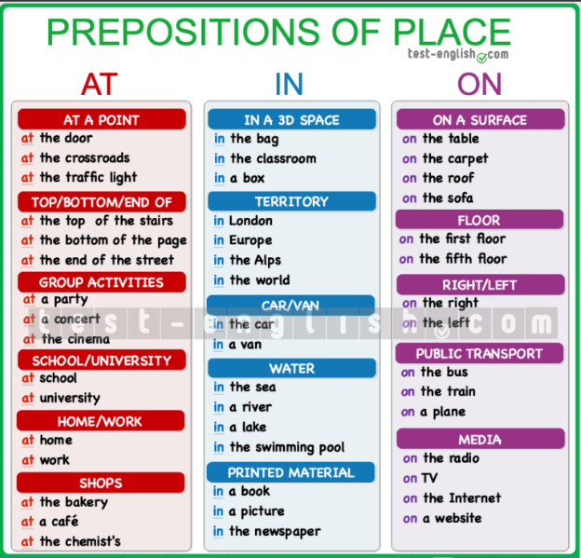

**PREPOSITIONS OF PLACE (OTHER)**

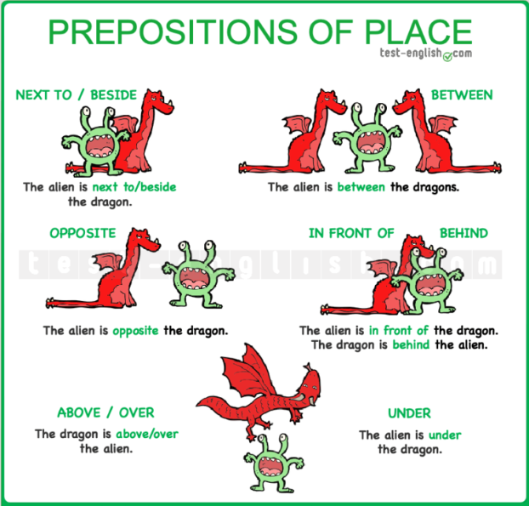***Summary chart***

***next to / beside***

*We had a picnic next to/beside the river.*

*Come and sit next to/beside me.*

***between***

*I live in a small town between Liverpool and Manchester.*

*She is sleeping between her mum and dad.*

***in front of***

*John sits in front of me in class.*

*You are always in front of the mirror.*

***behind***

*She is hiding behind the curtains.*

*We hang our coats behind the door.*

***opposite***

*I live opposite the supermarket (===on the other side of the road)*

*I am sitting opposite him (===facing him)*

***under***

*The cat is hiding under the bed.*

*Why are your shoes under the table?*

*I’m wearing a white shirt under the jersey.*

***above / over***

*Above and over mean ‘at or to a higher position’. Over is more common.*

*She lives in an apartment above/over the grocery store.*

*There is a shelf above/over the sink.*

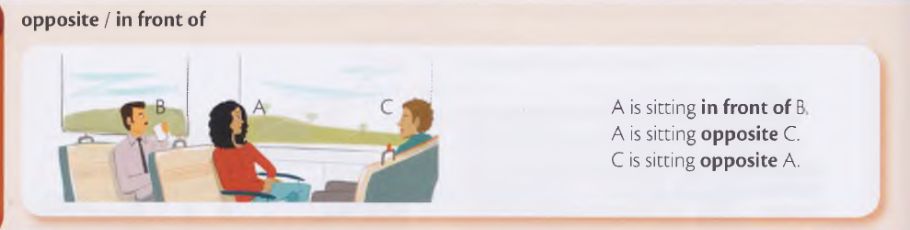***opposite VS in front of***

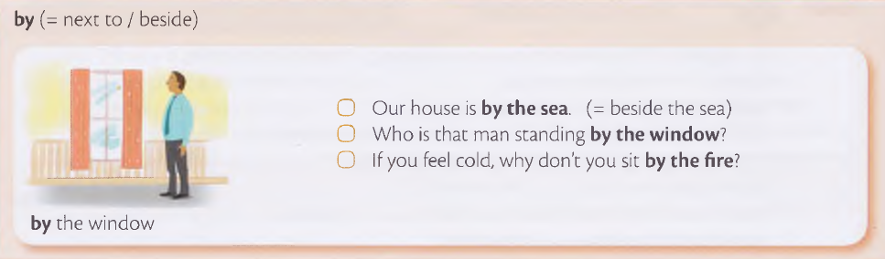***by (=== next to / beside)***

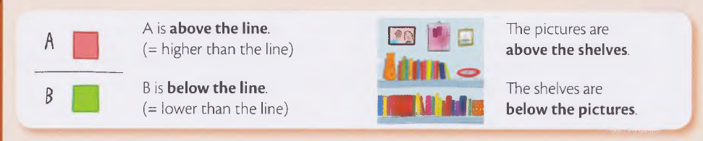***above and below***