**IT’S + ADJECTIVE + TO + INFINITIVE**

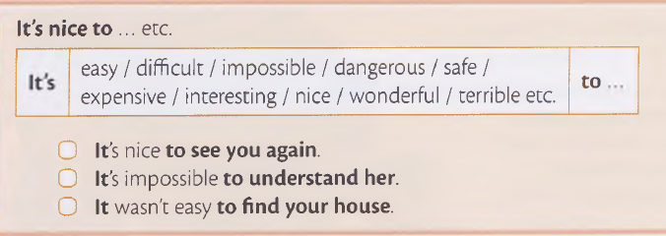*We use it’s + adjective + to + infinitive.*