ФЕДЕРАЛЬНОЕ ГОСУДАРСТВЕННОЕ ОБРАЗОВАТЕЛЬНОЕ УЧРЕЖДЕНИЕ ВЫСШЕГО ОБРАЗОВАНИЯ

МОСКОВСКИЙ АВИАЦИОННЫЙ ИНСТИТУТ

(НАЦИОНАЛЬНЫЙ ИССЛЕДОВАТЕЛЬСКИЙ УНИВЕРСИТЕТ)

**ОТЧЕТ**

**О ВЫПОЛНЕНИИ ЛАБОРАТОРНОЙ РАБОТЫ №2**

**ПО ДИСЦИПЛИНЕ**

**«ОСНОВЫ КОМПЬЮТЕРНОГО МОДЕЛИРОВАНИЯ ДИНАМИЧЕСКИХ СИСТЕМ»**

**ВАРИАНТ ЗАДАНИЯ №25**

Выполнил студент группы М8О-206Б-23

Сергеев В. С._____________________________

подпись, дата

Проверил и принял

Ст. преп. каф. 802 Волков Е.В._____________________________

подпись, дата

с оценкой _____________________________

Москва, 2024**Вариант №25**

**Задание:**

Реализовать анимацию движения механической системы.

**Механическая система:**

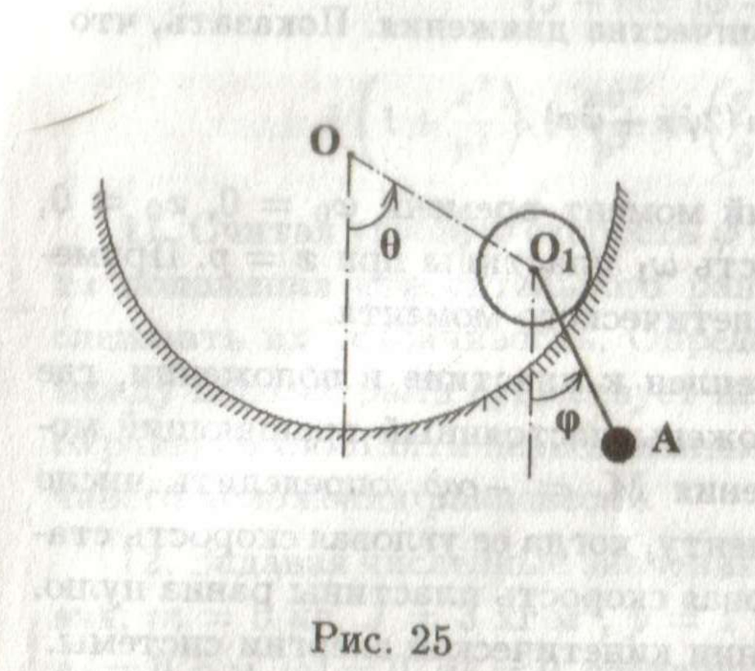

**Текст программы**

Текст программы в приложении №1.

**Результат работы программы:**

|  |  |
| --- | --- |
|  |  |
|  |  |
|  |  |

**Вывод:**

В ходе выполнения лабораторной работы была написана программа на языка Python, для симуляции и визуализации движения системы тел в соответствии с заданными законами движения.

**Приложение №1**

import numpy as np

from matplotlib import use, pyplot as plt

from matplotlib.animation import FuncAnimation

class Wheel:

"""Class for displaying a wheel."""

def __init__(self, radius, position, phase=0, spokes_count=2, precision=360,

tire_color='black', spokes_color='gray', tire_width=5, spokes_width=2):

self.spokes_count = spokes_count

self.radius = radius

self.spoke_functions = (

(lambda x, phase, number:

np.array([

x + self.radius * np.cos(phase + np.pi / self.spokes_count * number),

x - self.radius * np.cos(phase + np.pi / self.spokes_count * number)

])

),

(lambda y, phase, number:

np.array([

y + self.radius * np.sin(phase + np.pi / self.spokes_count * number),

y - self.radius * np.sin(phase + np.pi / self.spokes_count * number)

])

)

)

self.spokes = []

for i in range(self.spokes_count):

self.spokes.append(region.plot(

self.spoke_functions[0](position[0], phase, i),

self.spoke_functions[1](position[1], phase, i),

color=spokes_color, lw=spokes_width

)[0])

angles = np.linspace(0, 2 * np.pi, precision + 1)

self.tire_values = self.radius * np.cos(angles), self.radius * np.sin(angles)

self.tire, = region.plot(self.tire_values[0] + position[0], self.tire_values[1] + position[1],

color=tire_color, lw=tire_width)

def update(self, position, phase):

for i in range(self.spokes_count):

self.spokes[i].set_data(

self.spoke_functions[0](position[0], phase, i),

self.spoke_functions[1](position[1], phase, i)

)

self.tire.set_data(self.tire_values[0] + position[0], self.tire_values[1] + position[1])

def return_plot(self):

return *self.spokes, self.tire,

class Pendulum:

"""Class for displaying a pendulum."""

def __init__(self, weight_radius, suspension_position, weight_position, precision=360,

color='red', line_width=2):

angles = np.linspace(0, 2 * np.pi, precision + 1)

self.weight_values = weight_radius * np.cos(angles), weight_radius * np.sin(angles)

self.weight, = region.plot(

self.weight_values[0] + weight_position[0],

self.weight_values[1] + weight_position[1],

color=color, lw=line_width

)

self.rod, = region.plot(

np.array([suspension_position[0], weight_position[0]]),

np.array([suspension_position[1], weight_position[1]]),

color=color, lw=line_width

)

def update(self, weight_position, suspension_position):

self.weight.set_data(

self.weight_values[0] + weight_position[0],

self.weight_values[1] + weight_position[1]

)

self.rod.set_data(

np.array([suspension_position[0], weight_position[0]]),

np.array([suspension_position[1], weight_position[1]]),

)

def return_plot(self):

return self.weight, self.rod,

class Cord:

"""Class for displaying a cord."""

def __init__(self, start, end, color='gray', line_style='--', line_width=1):

self.plot, = region.plot(

np.array([start[0], end[0]]),

np.array([start[1], end[1]]),

color=color, linestyle=line_style, lw=line_width

)

def update(self, start, end):

self.plot.set_data([start[0], end[0]], [start[1], end[1]])

def return_plot(self):

return self.plot,

def make_concave_platform(radius, position, precision=180, color='blue'):

"""Function for displaying a concave platform."""

angles = np.linspace(-np.pi, 0, precision)

plot_values = (

np.concatenate((

[-1.5 * radius, -radius], radius * np.cos(angles), [radius, 1.5 * radius]

)) + position[0],

np.concatenate((

[0, 0], radius * np.sin(angles), [0, 0]

)) + position[1]

)

region.plot(

plot_values[0], plot_values[1],

color=color, lw=2

)

region.fill_between(

plot_values[0],

plot_values[1],

np.full(precision + 4, - 2 * radius),

alpha=.4, color=color

)

if __name__ == '__main__':

# --- Simulation settings ---

platform_position = (0, 0) # Position of concave platform

platform_radius = 5 # Radius of concave platform

wheel_radius = 2 # Radius of wheel

wheel_frequency = .8 # Oscillation frequency of wheel

pendulum_length = 6 # Length of pendulum rod

pendulum_frequency = 1.6 # Oscillation frequency of pendulum

MAX_TIME = 30 # Maximum simulation time

STEPS = 1000 # Count of time points

FPS = 60 # Frames per second

# --- Calculations ---

time_points = np.linspace(0, MAX_TIME, STEPS)

# Angles of the wheel's deviation from the vertical

wheel_angles = np.pi * (np.sin(wheel_frequency * time_points) - 1) / 2

# Wheel locations at each time point

wheel_positions = (

platform_position[0] + platform_radius * np.cos(wheel_angles),

platform_position[1] + platform_radius * np.sin(wheel_angles)

)

gear_ratio = -(platform_radius / wheel_radius)

# Phases of rotation of the wheel

wheel_phases = wheel_angles * gear_ratio

# Angles of the pendulum's deviation from the vertical

pendulum_angles = np.pi * (np.sin(pendulum_frequency * time_points) - 1) / 2

# Pendulum locations at each time point

pendulum_positions = (

wheel_positions[0] + pendulum_length * np.cos(pendulum_angles),

wheel_positions[1] + pendulum_length * np.sin(pendulum_angles)

)

# --- Rendering ---

use('QtAgg')

window = plt.figure(facecolor='#bbbbbb')

region = window.add_subplot(1, 1, 1)

region.set_title("Вариант 25, Сергеев Владимир")

x_axis_limit = 1.5 * np.max(np.array([np.max(np.abs(pendulum_positions[0])), np.max(np.abs(wheel_positions[0]))]))

y_axis_limit = 1.5 * np.max(np.array([np.max(np.abs(pendulum_positions[1])), np.max(np.abs(wheel_positions[1]))]))

region.set_xlim(-x_axis_limit, x_axis_limit)

region.set_ylim(-y_axis_limit, y_axis_limit)

# We will set the value to "image" in order to comply with the established limits and avoid distortions.

region.axis('image')

make_concave_platform(platform_radius + wheel_radius, platform_position, precision=180)

wheel = Wheel(wheel_radius, (0, 0), 0, spokes_count=3, precision=36, spokes_color='#6e6e6e')

cord = Cord(platform_position, (0, 0)) # Cord from the platform position to a wheel position

pendulum = Pendulum(1.25, (0, 0), (0, 0), precision=36)

plt.xlabel('x')

plt.ylabel('y')

def animate(i):

wheel.update((wheel_positions[0][i], wheel_positions[1][i]), wheel_phases[i])

cord.update(platform_position, (wheel_positions[0][i], wheel_positions[1][i]))

pendulum.update((pendulum_positions[0][i], pendulum_positions[1][i]),

(wheel_positions[0][i], wheel_positions[1][i]))

return *wheel.return_plot(), *cord.return_plot(), *pendulum.return_plot()

ani = FuncAnimation(window, animate, frames=STEPS, interval=round(1000 / FPS), repeat=False, blit=True)

plt.show()

print("Симуляция успешно завершена.")