Kang Light Air Cargo (KLAC), aging fleet renewal

Report

Date:

*Case: You have been appointed Project Manager to a light aircraft cargo carrier, Kang Light Air Cargo (KLAC), who are looking to re-new their aging fleet of aircraft with 10 single engine planes and 6 twin engine planes. The management have asked you for an informal report into the planning and implications of the renewal.*

*You will find the Guidance Notes below and The Project Schedule below gives you all the information you need to complete the task successfully.*

Section 1: Introduction

This report is a formal report into the planning and implication of Kang Light Air Cargo (KLAC), who are seeking to renew their aging fleet of aircraft. The flight company intends to have 10 single engine planes and another 6 twin engine planes. The company has realized the aging in their fleet of aircraft and hopes that the renewal will lead to improvements and betterment of the company and business. This report details the project schedule (as concerns the renewal) and provides the useful information required in the successful completion of the renewal task. It further advices the management of the principles and project planning processes. **According to** Wiefling 2008, project management is the art and science of organizing project components, be it a new product or undergoing improvements, or new service launch. Wiefling 2008 emphasize that project management is not and should not be considered part of regular business operations. According to Wiefling 2008, project management is created once and so momentary and should be specific to the project for which it is created. Brown and Vessey 2003 state that project management is essential to a project since it is among the essential delivery systems for efficient development of a project. This report also provides manual analysis of using CPA methodology and concludes by giving the merits of using computerized modelling packages in this renewal task and process.

*Section 2: Advises the management of the Principles of Projects and Project Planning.*

As a project manager for this project, I would advise the management and those involved in the process and planning as follows;

1. Time, objectives and goal setting are essential part of this renewal process. We all need to understand the objectives of Kang Light Air Cargo (KLAC), its core value and prioritize the goals and help in making great use of the scheduled duration. All the members who are taking part in this task are therefore required to review the company objectives and operating process. Goal fulfilment can be achieved when all stakeholders understand the set of activities that define the project success and process.
2. It is also important to understand the resources remaining and the specific needs of the company. This can be money related, time or manpower. The project management planning team should detail all the related costs as this will assist in determining the rough estimates of the needed resources and budget.
3. The process should be done in phases with the process review in between. Every procedure or step before, during and on completion should be documented and reviewed. This provide a solid report and record that one can refer and verify during the process. It will also record the failures and challenges propping up in every stage. All the reports should be accessible to the entire team.
4. It is advised that the members make use of various applications and programs for instance project planning software to capture the project and its tasks on a computer and the progress of the tasks. The schedule analysis will help determine and make sequence of activities that are to be closely monitored to avoid cost overruns.
5. The team members in the renewal process should be taken through the entire process before it starts. This ensures that they fully understand the system and conversant with its processes, requirements and expectations.
6. In determining the information and things to include in the planning stage, the project planner has to define what is to be accomplished in a particular project and, the actual cost of the project and available resources. The planner has also to determine the actual effort consumed by the project in comparison to what the organization can attain and the deficiencies if any. The planner has also to consider the number of change that has been made in respect to the requirements of the project as used in developing a project.

Section 3: Manual analysis of this project using CPA methodology

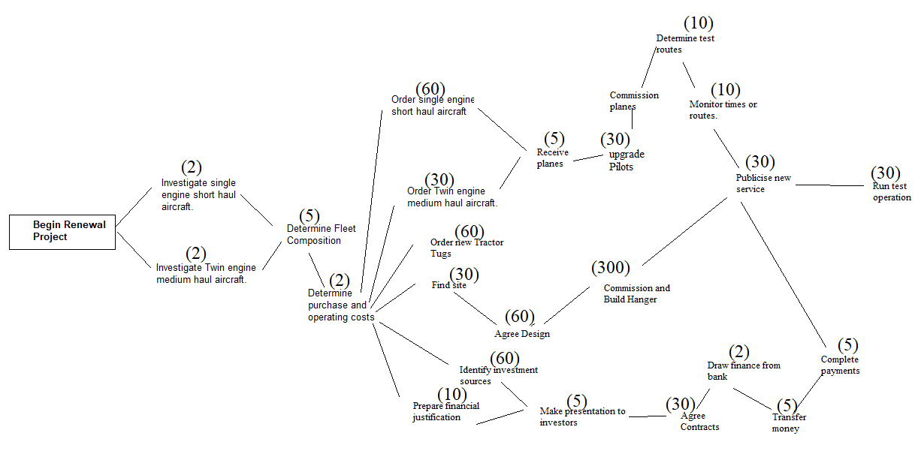The critical path is the line that has the longest duration of activities. A delay in any of the activities in the critical path will cause a delay in the entire process and project.

The critical path in this case is;

|  |  |
| --- | --- |
|  | *Begin Renewal Project* |
| *11, 12* | Investigate single/twin engine short haul aircraft. (2 days) |
| *13* | Determine Fleet Composition (5 days) |
| *14* | Determine purchase and operating costs (2 days) |
| *31* | Find site (30 days) |
| *32* | Agree Design (60 days) |
| *33* | Commission and Build Hanger (300 days) |
| *81* | Publicise new service (30 days) |
| *82* | Run test operation (30 days) |

The estimated time for the entire project, suppose everything run as planned will be 459 days.

Section 4: Using project planning software (Open Project or MS Project), capture the project and its tasks on a computer. Then model the project for efficiency using appropriate software.

The project planning software have various advantages to other methods for instance project planning software help to decrease the risks associated with cost analysis. It also helps give better estimation and duration of the entire project. This project can be modelled better using MS Project as this would encourage careful assessments of the project need in each set of activities. MS Project would further spot the actions that are considered slack or “float” and this could therefore transfer some resources hence better resource allocations. It is through the software that the managers of this project will be provided with essential overview of complex tasks. The project plan also details the tasks and assigned members. This enables the management of the company to monitor the progress and manage the users with ease.

Section 5: A brief conclusion giving the advantages of using computer packages for modelling and any resource implications you see fit.

Computer packages help in the designing, creating and evaluating complex systems. These packages are essential in understand and evaluating “what if” case scenarios. The packages can model an actual system and this is important when changes are hard to implement, involving high costs or seem unrealistic. Among the advantages include:

1. The computerized method can be used to reduce the time taken to edit a project. It is a method of faster investigation of the effects a change can bring to a project and the effects of such changes in many years or long duration.
2. It can be used to understand process that are complex and otherwise difficult to study and understand.
3. The packages can be used in engineering and product design in investigating the impacts of alteration without producing a physical prototype.
4. It can be used in investigating scenarios that would be dangerous in real life.
5. It is expected that through the computerised method, all the project stakeholders will be able to monitor the progress of the project. All the components, process, scheduled tasks and related costs can be accessed by all the members making if efficient.
6. The modelling using computerized methods will be cost effective.
7. Lowery and Gwen 1994 state that project planning helps in tailoring of a project to match the available resources and manpower. It is through a project planning that the project to be developed can be defined based on provided information and resources. These also contribute to planning importance. In product development, Lowery and Gwen 1994 note that project planning helps in defining elements of data to be employed and thus ensuring the integrity of the data meaning. Project planning also helps in establishing the amount of data required as well as defining timeframe of the project to be developed.

Computer packages are essential as they act as a guide in controlling the entire project’s success or failure. They are essential in providing flexible and consistent ways of carrying out activities in the project. Every project development stage objectives are clearly explained in the corresponding deliverables. According to the analysis, project planning is essential as it is through it that various project weaknesses and areas to adjust can be identified.

Appendices: As you deem appropriate

|  |  |  |  |  |  |  |  |  |  |  |  |  |  |  |  |
| --- | --- | --- | --- | --- | --- | --- | --- | --- | --- | --- | --- | --- | --- | --- | --- |
| The Project Schedule Workpack-age or Task ID | Workpackage or Task Description | | Duration  (Days) | | | Precedent (s) | | Resource  Name  (If blank then not resource constrained) | | | Resource Quantities (Use 1 unless otherwise noted) | | | | Comments |
| 1 | | Begin Renewal Project | | | | | 0 | | | | | - | | | |
| 10 | | | | Scoping of new Aircraft | | | | | | 1 | | | | | |
| 11 | | Investigate single engine short haul aircraft. | | | 2 | | | | 1 | | | | Planner, Buyer | | |
| 12 | | Investigate Twin engine medium haul aircraft. | | | 2 | | | | 1 | | | | Planner, Buyer | | |
| 13 | | Determine Fleet Composition | | 5 | | | 11, 12 | | | Planner | | | | 2 | |
| 14 | | Determine purchase and operating costs | | 2 | | | 13 | | | Planner | | | | 2 | |
| 20 | | | | Order Aircraft | | | | | | 10 | | | | | |
| 21 | | Order single engine short haul aircraft. | | | 60 | | | | 10 | | | | Buyer | | |
| 22 | | Order Twin engine medium haul aircraft. | | | 30 | | | | 10 | | | | Buyer | | |
| 23 | | Order new Tractor Tugs | | | 60 | | | | 10 | | | | Buyer | | |
| 30 | | | | Design and Build Hanger | | | | | | 10 | | | | | |
| 31 | | Find site | | 30 | | | 10 | | | Planner | | | | 2 | |
| 32 | | Agree Design | | | 60 | | | | 31 | | | | Planner | | |
| 33 | | Commission and Build Hanger | | | | | 300 | | | | | 32 | | | |
| 40 | | | | Raise Finance | | | | | | 10 | | | | | |
| 41 | | Identify investment sources | | | 60 | | | | 10 | | | | Finance director | | |
| 42 | | Prepare financial justification | | | 10 | | | | 10 | | | | Operations Director | | |
| 43 | | Make presentation to investors | | | 5 | | | | 41,42 | | | | Finance Director | | |
| 44 | | Agree Contracts | | | 30 | | | | 43 | | | | Finance Director | | |
| 45 | | Transfer money | | | | | 5 | | | | | 44 | | | |
| 50 | | | | Receive and commission planes | | | | | | 20 | | | | | |
| 51 | Receive planes | | 5 | | | 20 | | Pilot | | | See Comments | | | | Need 1 pilot per aircraft |
| 52 | Upgrade pilots | | 30 | | | 51 | | Trainer | | | See Comments | | | | Need 1 trainer per pilot |
| 53 | Commission planes | | 5 | | | 52 | | Mechanics | | | See Comments | | | | Need 2 mechanics per aircraft |
| 60 | | | | Release Finance for equipment | | | | | | 40 | | | | | |
| 61 | | Draw finance from bank | | | | | 2 | | | | | 40 | | | |
| 62 | | Complete payments | | | 5 | | | | 61 | | | | Buyer | | |

Reference

Brown, C., and I. Vessey, (2003) "Managing the Next Wave of Enterprise Systems:

Leveraging Lessons from ERP," MIS Quarterly Executive, 2(1), 2003.

Wiefling, K., 2008. What is Project Management? Written on January 24, 2008 published on

http://www.mpug.com/education/what-is-project-management/ Retrieved on 18th,

Oct, 2013.