Fishermen on duty
“Fishermen on Duty highlights the daily life, responsibilities, and challenges of those who make their living from the waters. Being "on duty" for fishermen means more than casting nets or lines – it involves early mornings, navigating unpredictable seas or rivers, respecting nature’s balance, and ensuring that their catch supports both their families and local communities. It is a role that blends tradition, skill, and endurance, reminding us that fishermen are not only providers of food but also guardians of marine resources..
Fishermen on Duty — guardians of the waters and providers of the shore, where duty meets the deep, casting nets to sustain lives while protecting tradition and feeding tomorrow. Help them do their job by making the app work.

Entities and Enums
There are two main entities in the system:

Fisherman
This represents the fisherman who is registered on the platform. Fishermen will log in, catch fishes, and sell it to the other fishermen and edit their profile data.
- id: Unique identifier for each Fisherman (UUID)
- username: The Fisherman's username (String, unique, not null)
- password: The Fisherman's password (String, not null) - must be hashed
- nickname: The fisherman’s nickname (not null)
- imageUrl: URL of the fisherman's image(String)
- experience: The fisherman’s experience (enum Experience* one of these: BEGINNER, INTERMEDIATE, EXPERT, not null)
- cash: fisherman’s money (int, not null, every cash value should be associated with experience level:
BEGINNER – 100,
INTERMEDIATE – 200,
EXPERT - 300
- createdOn: When the fisherman registered (LocalDateTime, not null)
- updatedOn: When the fisherman's information was last updated (LocalDateTime, not null)
- fishes: List of fishes the fisherman has caught or/and bought (List<Fish>)

Fish
This represents a Fish that a fisherman can catch or buy. Each Fish has various attributes:.
- id: Unique identifier for each Fish (UUID)
- species: The species of the Fish (e.g., "Salmon", "Tuna") (String, not null)
- weight: The weight of the Fish (int)
- type: The type of the Fish (String, there are only two types: ORNAMENTAL or EATABLE not null)
- imageURL: The image of the Fish (String, not null)
- price: Price of the fish (int, not null)
- owner: The fisherman who caught/bought the fish (Fisherman)

*Experience: BEGINNER - 100, INTERMEDIATE - 200, EXPERT - 300
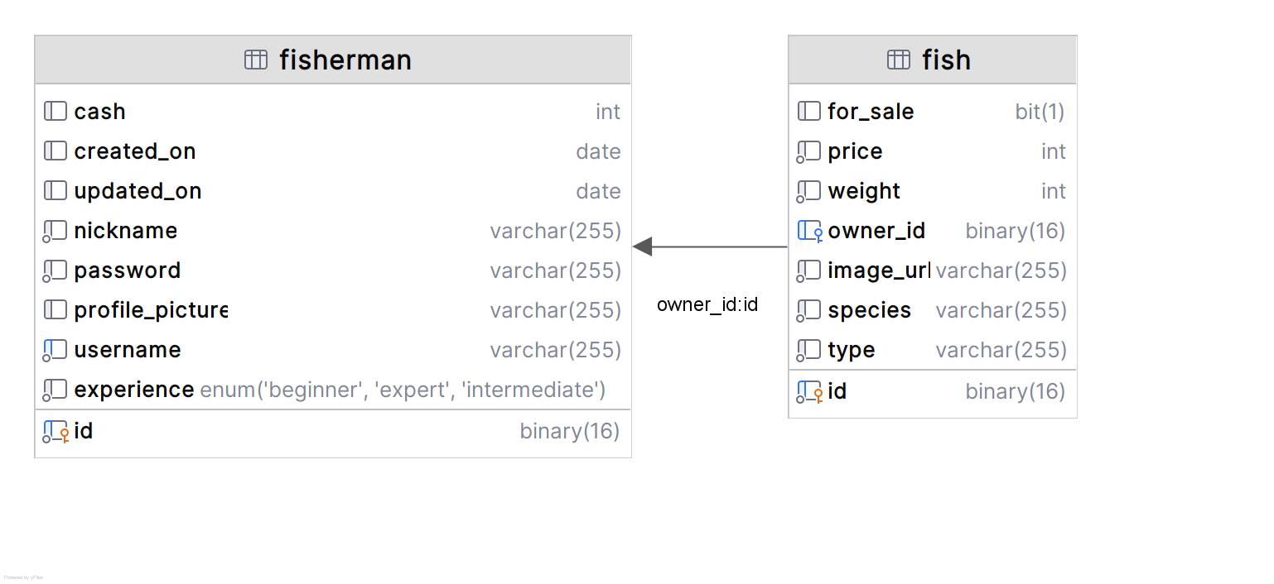

Configuration Properties
In the project skeleton, you are provided with a fishes.yaml file containing the details of all available fishes.
Additionally, you are given an empty FishsProperties.java class. Your task is to complete this class to read the fishes.yaml file at application startup and map its content. The loaded data must be accessible across the application in runtime, allowing fishermen to catch/bought fishes.

Business Constraints & Error Handling
You must enforce every business rule described in this document. If a user attempts an action that violates a business constraint, throw a custom Java runtime exception (e.g., only unique usernames). The WhiteLabel Error Page is acceptable for the exam.
For pages with form validation – Login, Register and Edit Profile forms, you must validate user input according to the listed constraints in the description. If invalid input is given upon form submit, you should re-render the same form and display the field error messages in the provided HTML. Do not use custom error messages, just use the message that is already provided in the HTML file.
On the login and register pages there are a Back to Home button that you should make to navigate the user to the Index page.

Functionalities

Index Page
View: index.html
Requirements:
- Implement a GET handler that serves the index.html view as the application’s landing page (See Figure 1 below).
- On this view, there are two main navigation links/buttons:
  - Register - navigates the user to the Register page
  - Login - navigates the user to the Login page
Figure 1: Default index view, landing page.
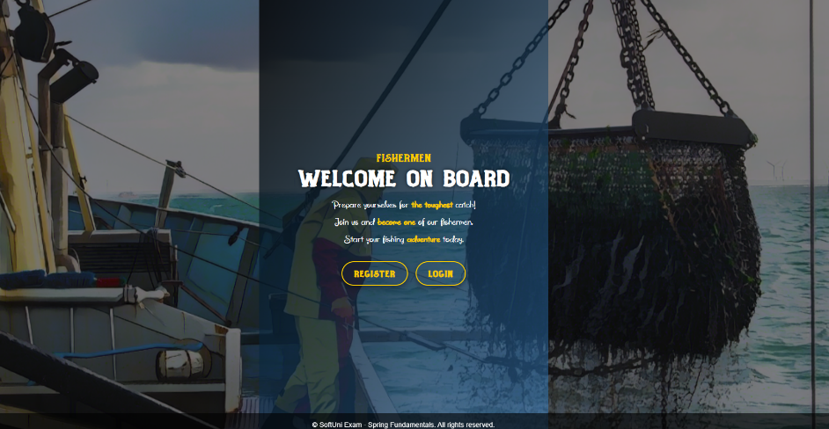

Register Page
View: register.html
Requirements:
- Implement a GET handler that serves the register.html view (See Figure 1 below).
- Implement a POST handler that creates a new Fisherman profile with the submitted form data.
  - Store the password hashed
  - Upon successful registration, the fisherman must automatically receive cash according to it's experience level
- Validate the form input, on DTO field validation error, show the same page with the error message provided in the HTML file - the orange messages, under the form input field (See Figure 2 below).
- Form validation constraints:
  - Username - length [4 - 20] characters, not empty/blank text
  - Password – at least 4 characters, not empty/blank text
  - Nickname - - length [4 - 20] characters, not empty/blank text
  - Experience - must be valid Experience enum value, not null
- On successful registration: navigates the user to the Login page.
Figure 1: Registration page, default view
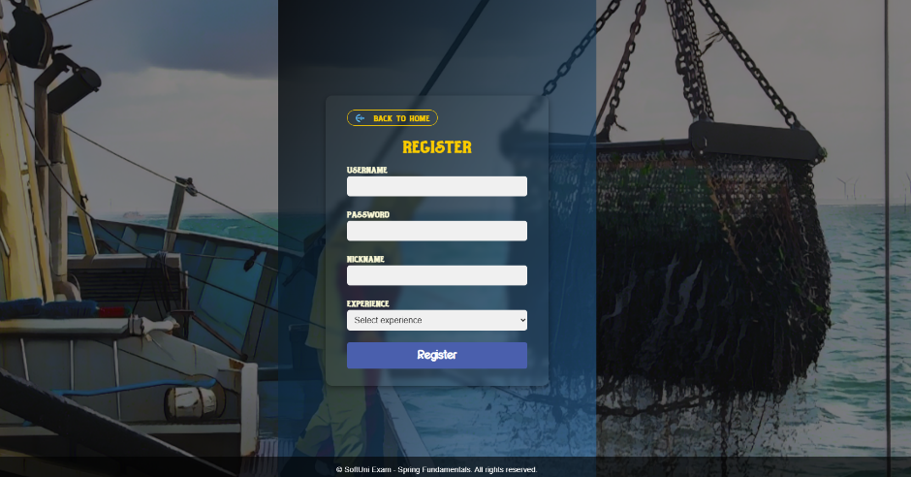

Figure 2: Registration page filled with invalid data, shows error message above the input field
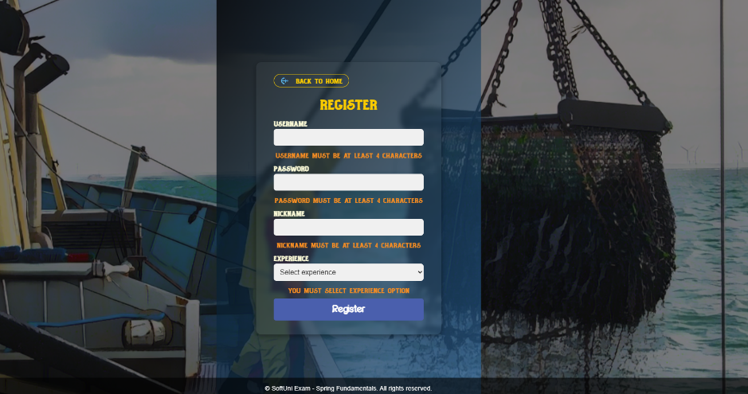

Login Page
View: login.html
Requirements:
- Implement a GET handler that serves the login.html view (See Figure 1 below).
- Implement a POST handler that authenticates a fisherman using username and password.
- On successful authentication: create a session and store the fisherman’s ID in a session attribute named user_id, then navigate the user to the Home page.
- On incorrect credentials (fisherman not found or password mismatch): throw a custom Java exception.
Figure 1: Login page, default view
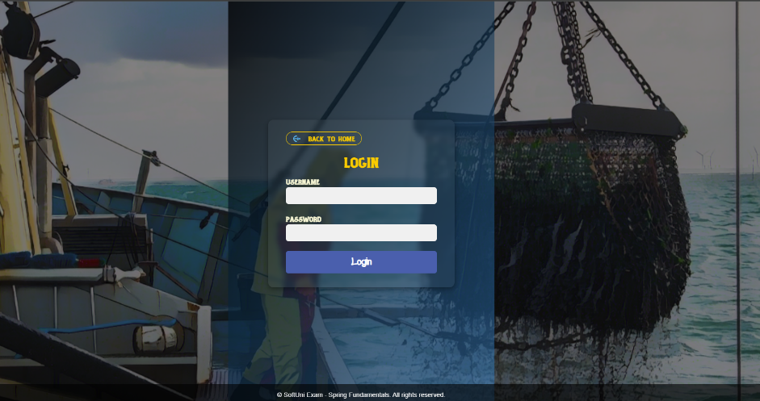

Home Page
View: home.html
Requirements:
Implement a GET handler that serves the home.html view.
The home page contains four main sections you need to implement carefully:
- Fisherman Profile Section
- Fishes for sale Section
- Fishes Section
- Pick a random fish functionality
Figure 1: Home page
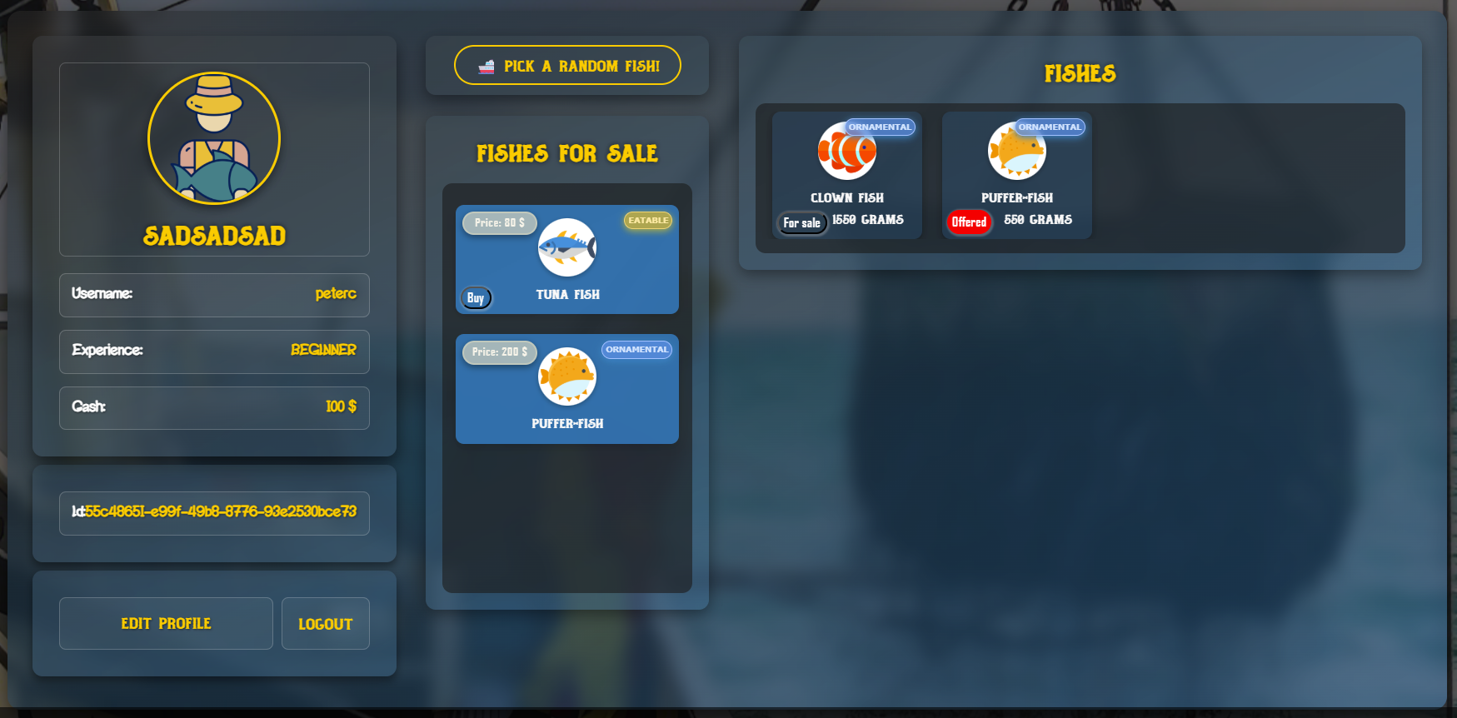

Fisherman Profile Section (See Figure 2 below)
- Displays fisherman details:image, nickname,username, experience, cash and ID.
- On this section, there are two main navigation links/buttons:
  - Edit Profile - navigates the fisherman to the Edit Profile page.
  - Logout - directly logouts the fisherman, invalidates their session and redirects them to the Index page.
Figure 2: Fisherman profile section
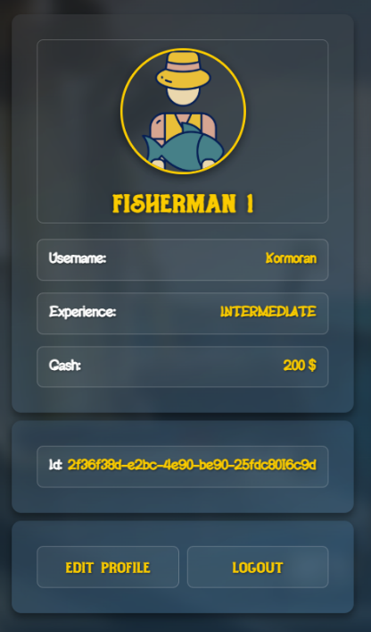

Edit Profile Page
View: edit-profile.html
Requirements:
Implement a GET handler that serves the edit-profile.html view.
The page also shows a panel you need to implement:
Edit Profile (See Figure 3 below)
- Implement a PUT handler that allows the fisherman to edit their username, nickname, password and image url.
- On page load, the form fields must be pre-filled with the fisherman’s current data (username and image URL (if there is any image URL possible null value by default)
  - Hint: Instead of passing an empty object DTO for the form (as you normally would), set the DTO fields with the fisherman’s details and then pass it.
- Validate the form input, on DTO field validation error, show the same page with the error message provided in the HTML file - the small orange messages, under the form input field.
- Form validation constraints:
  - Username - length [4 - 20] characters, not empty/blank text
  - Nickname - length [4 - 20] characters, not empty/blank text
  - Password – length [4 – 10] characters, not empty/blank text
  - Image URL - must be a valid URL or empty
- On save: update the fisherman’s data with the incoming username, nickname, password and image URL, set updatedOn to now and persist the changes. Navigate the fisherman to the Home page
On the page there is a Back to Home button that you should make to navigate the fisherman to the Home page.
Figure 3: Profile page, edit profile panel
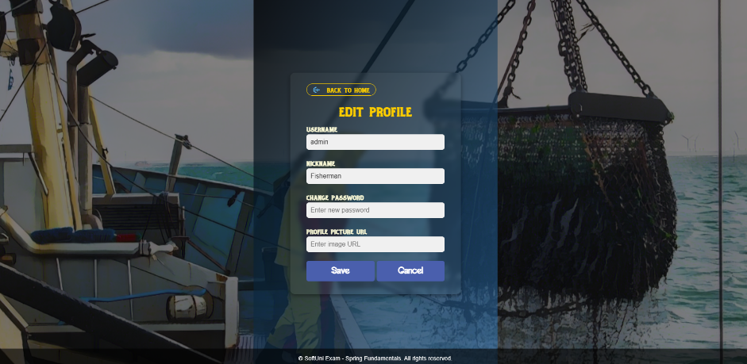

Figure 4: Profile page, with errors
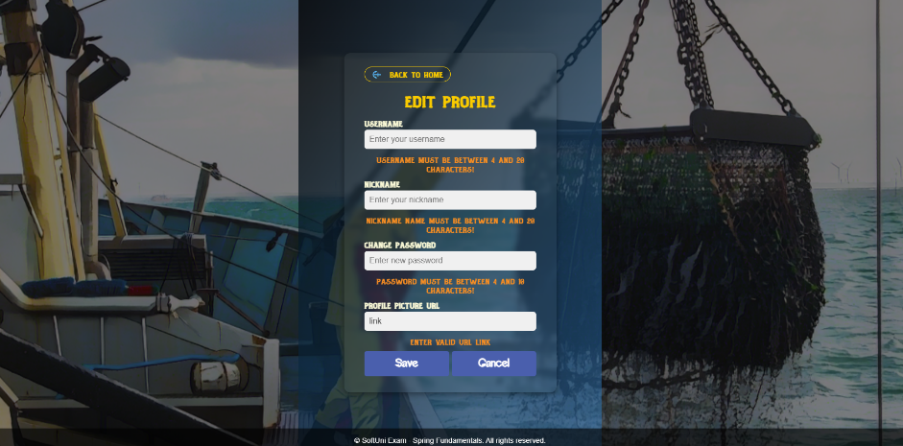

Pick a random fish
You must implement a GET handler to view fishing-spot.html
When a fisherman clicks the “Pick a random fish” button, the application must trigger the fishing logic.
- The system select a single random fish from the collection imported at application startup (from fishes.yaml).
- The fisherman is then redirected to the Fishing Spot page, where the randomly selected fish is displayed.

Figure 5: Pick a random fish
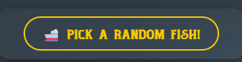

Fishing Spot Page
View: fishing-spot.html
On the Fishing Spot page, the fisherman sees the fish he just caught.
The page contain a “Back to Home” button that returns him to the Home page without taking the fish.
Take Out (catch the fish)
If the fisherman clicks the “Take Out” button:
- A new Fish entity must be created in the database using the properties of the randomly selected fish
- The fish must be added to the fisherman’s personal collection of fishes.
- The fish must be removed from the global list of available fishes so that it cannot be caught again.
- After the action is completed, the fisherman must be redirected back to the Home page.
If the fisherman chooses not to take the fish and simply navigates back, no changes are made.
Figure 6: Fishing spot page with fish caught
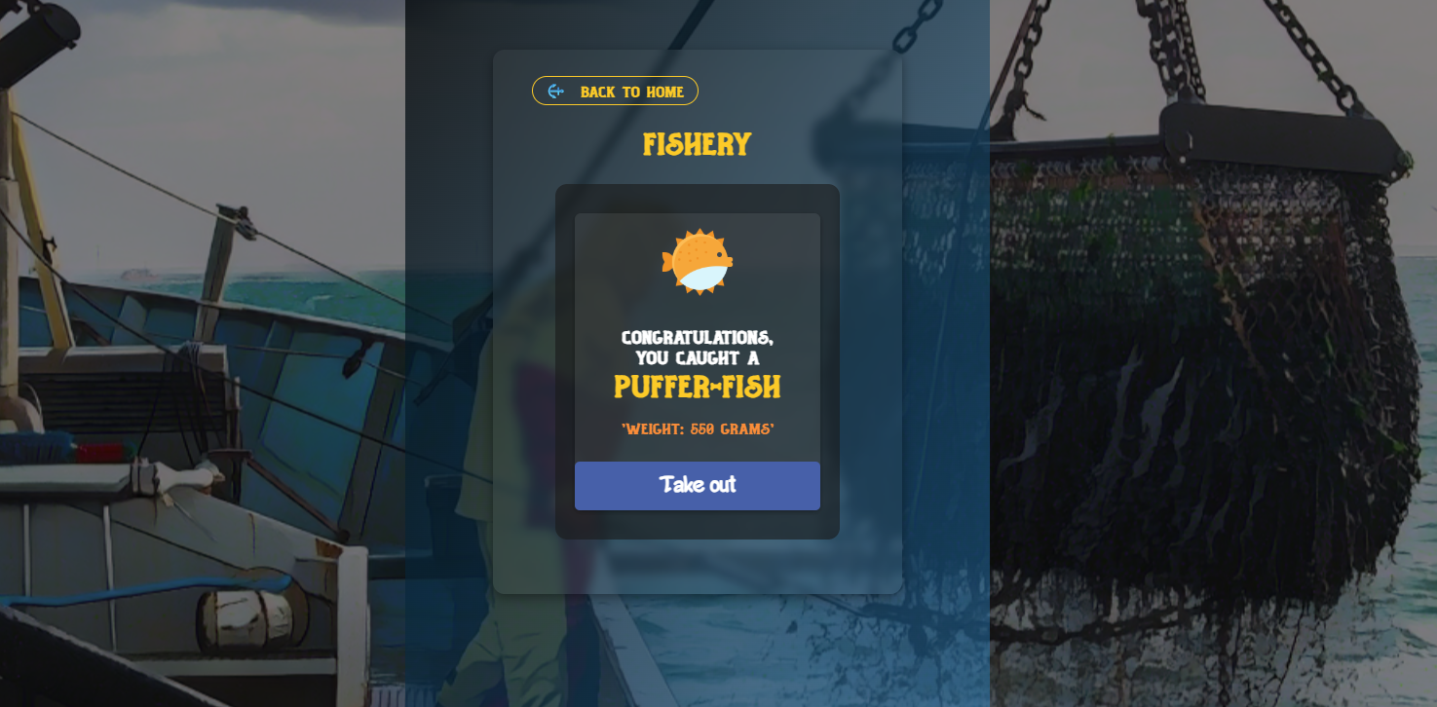

Fishes for sale Section (See Figure 7 below)
- Shows all fish from ALL fishermen put up for sale.
- If someone buy any fish it should be disappear from the owner’s list with fishes and immediately appears in buyer’s list with fishes.
- The Fish type badge shows the fish type. Show one of these possible options:
  - 
- The Fish price badge shows the fish price.
  - 
- 'Buy' button (if current logged-in fisherman is not an owner of the fish)
  - 
When a fisherman clicks the “Buy” button, the application must handle the request through a dedicated POST handler in the controller.
- The selected fish should be removed from the current owner’s collection of fishes.
- The same fish should then be added to the buyer’s collection of fishes.
- After the transaction, the fish should no longer appear in the seller’s list, but should now be visible in the buyer’s list.
Figure 7: Fishes for sale section
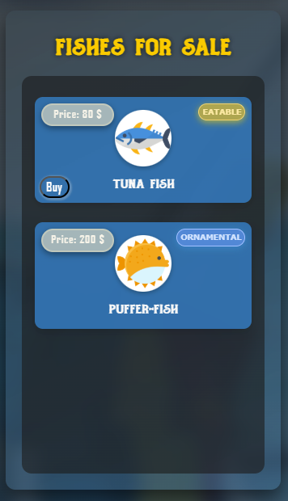

Fishes Section
- Displays all fishes that the current fisherman has caught/bought.
- The Fish type badge shows the fish type. Show one of these possible options:
Requirement: Put a Fish for Sale
When a fisherman clicks the “For Sale” button, the application must handle the request using a POST handler in the controller.
- The selected fish should immediately appear in the “Fishes for Sale” section.
- A fish that is already marked as for sale must not be allowed to be listed again.
  - These fishes must remain visible in the “Fishes” section until they are purchased by another fisherman.
- Once a fish is successfully offered for sale:
  - The “For Sale” button for that fish should change its label to “Offered”.
  - The button’s style must also change to red, clearly indicating the fish is already offered for sale.
- After successfully putting a fish for sale, the fisherman should be redirected back to the Home page.

Figure 8: Fish before announcing it for sale
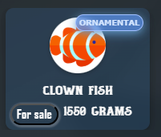
Figure 9: Fish after announcing it for sale
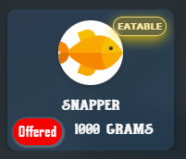
Figure 10: Fishes section
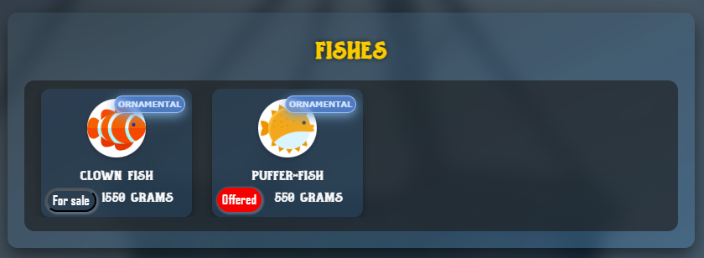

Security
The security is based on an active session. Upon login, you must store the fisherman’s unique identifier (id) in a session attribute named user_id.
A SessionInterceptor class is provided in the project skeleton - do not modify it!
Access control already enforced as part of the SessionInterceptor class:
Public: Index Page, Register Page, Login Page, Logout
Restricted (only logged-in users): Home, Edit Profile, and all related functionalities.
- Submission
To submit your solution, you must upload a single .zip archive containing the entire src folder and the pom.xml file. No other files or folders should be included in the archive.
All submissions must be uploaded through the SULS system.
You may submit multiple times; however, only the last uploaded file will be stored and evaluated.

